November
2019

The CarbonNet Project is preparing to drill an offshore appraisal well in Bass Strait. The well will provide information about the properties of the rock layers below the seabed, and help to confirm that the site is suitable for carbon storage.

CarbonNet will be drilling the offshore appraisal well (OAW) at the Pelican site in Commonwealth waters.
Drilling is expected to commence from late November subject to weather and logistics.
An Environment Plan (EP) for this activity was accepted by the regulator, the National Offshore Petroleum Safety and Environmental Management Authority (NOPSEMA), in April 2019.
What does the drilling involve?
The OAW will be drilled using the Noble Tom Prosser Mobile Offshore Drilling Unit (MODU) (see image on right). Drilling operations are expected to take between 45 and 60 days to complete.
While the drilling rig is on location there will be a 500 m radius exclusion zone in place for marine safety purposes. A map showing the proposed drilling location is provided in Figure 1.
The drilling of the OAW is being managed by AGR (Australia) Pty Ltd as the Drilling Management Contractor for CarbonNet. AGR has drilled over 40 wells in Australia and 530 globally.

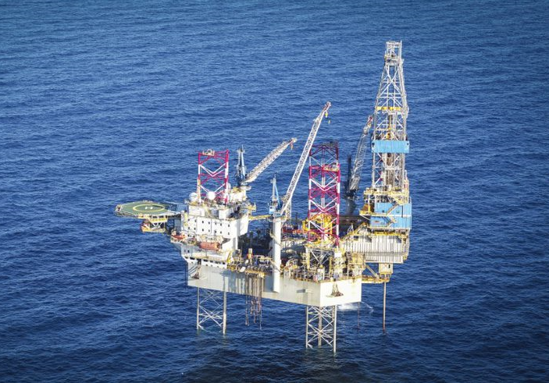
Image: The Noble Tom Prosser rig drilling in deep water.
Image courtesy of Noble Corporation
Why is drilling necessary?
The drilling of the well will enable the collection of rock core samples from the proposed carbon storage reservoir.
Core samples will provide further insights into the properties and formations of the rock layers below the seabed and confirm its suitability to store carbon dioxide.
Approach and equipment
The drilling rig will drill to a depth of about 1,500 m below the seabed. The structure of the drilling rig consists of a buoyant hull fitted with three movable legs.

To position the drilling rig:
- The drilling rig will be towed into location by support vessels;
- The three legs will be lowered to the seabed;
- Once the legs have been lowered, the hull will be elevated out of the water allowing drilling operations to commence; and
- At the end of drilling operations, the legs are raised, allowing the rig to be towed away.
Drilling will result in the discharge of cuttings (ground up rock) and muds. Drill cuttings and muds dispersion and deposition modelling has been completed and was considered as part of the approved EP.
CarbonNet will perform a water injection test as part of the drilling program to gather information on the formation characteristics. This involves pumping a small volume of water at safe pressures into the reservoir.
Vertical Seismic Profiling will be undertaken to generate a high-resolution image of the geology of the well bore and surrounding area. This involves deploying a small sound source from the side of the rig and receivers inside the well. The duration of this activity is typically less than 12 hours. The information from the processed sound signals will supplement the seismic data obtained in previous surveys. A range of other technologies will also be used within the well to assess the rock properties.
Location
The OAW is located within Greenhouse Gas Assessment Permit VIC-GIP-002 in Commonwealth waters offshore Gippsland (see Figure 1).
The drilling rig will be located approximately
8 km offshore from the townships of Golden Beach and Paradise Beach.
Environment Plan
An EP for the OAW drilling activity has been accepted by the regulator, NOPSEMA.

The EP is a comprehensive document detailing the existing environment, impacts and risks of the activity, and describes how drilling will be conducted to manage, minimise or avoid environmental risks to be ‘ALARP’ (As Low As Reasonably Practicable) and acceptable.
All drilling activities will be subject to industry best practice standards and will be undertaken in accordance with all applicable environmental and safety legislation and regulations.
An EP Summary is available on the NOPSEMA website at: https://info.nopsema.gov.au/activities/394/show_public.
Consultation
CarbonNet is committed to informing all stakeholders and the local community on key project developments.
To stay informed about the timing of information sessions and receive regular updates about the CarbonNet Project, subscribe to the e-Newsletter at www.earthresources.vic.gov.au/carbonnet.
Further information
If you have questions about the the OAW drilling program, please contact the AGR project team via the telephone number or email address below.

Email: carbonnet.drilling@agr.com.

Phone: 1800 312 966

Department of Jobs, Precincts and Regions
1 Spring Street Melbourne Victoria 3000
Telephone: 136 186

© Copyright State of Victoria, Department of Jobs, Precincts and Regions, October 2019. Except for any logos, emblems, trademarks, artwork and photography this document is made available under the terms of the Creative Commons Attribution 3.0 Australia license.

Figure 1: CarbonNet Offshore Appraisal Well proposed location

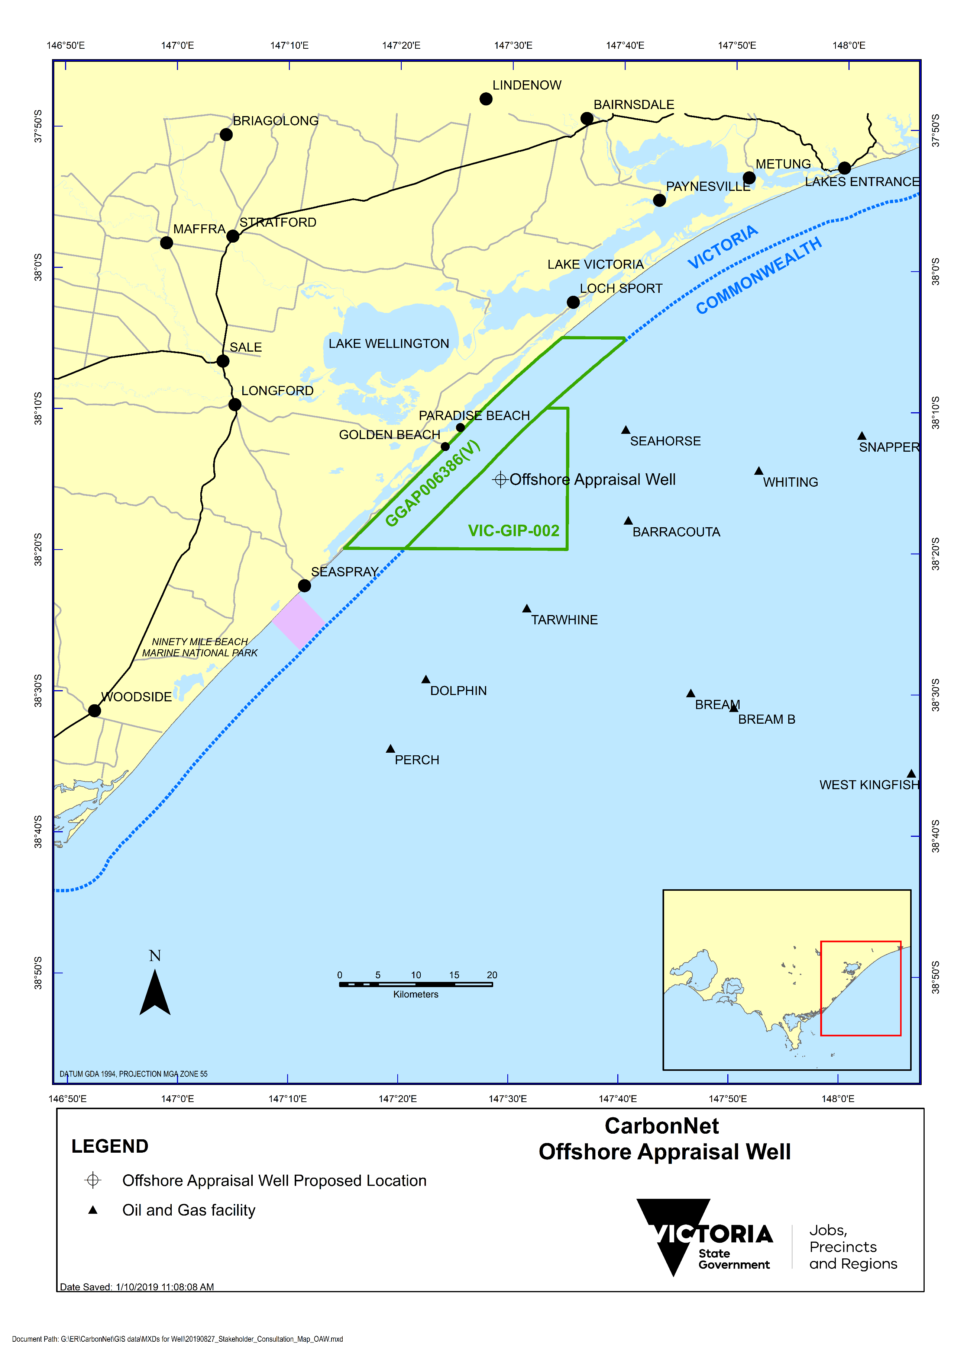

About the CarbonNet Project
The CarbonNet Project is investigating the potential for establishing a commercial-scale carbon capture and storage (CCS) network. The network would bring together multiple CO₂ capture projects in Victoria’s Latrobe Valley, transporting CO₂ via a shared pipeline and injecting it into deep underground, offshore storage sites in Bass Strait, Victoria. The project is jointly funded by the Commonwealth and Victorian governments. CCS is an important part of global action to address climate change.
For further information on CarbonNet see: http://earthresources.vic.gov.au/carbonnet

