Section: 03

Non-financial performance
Contents
Financial statements
Portfolio performance reporting – non-financial 3
Objective 1: Create and maintain jobs 3
Indicator: People employed in Victoria 3
Performance against output performance measures 5
Objective 2: Foster a competitive business environment 9
Indicator: Change in Victoria’s real gross state product 10
Indicator: Engagement with businesses 11
Performance against output performance measures 13
Objective 3: Be a globally connected economy 16
Indicator: Export sales generated from government programs 17
Indicator: International students attracted to Victoria 18
Indicator: Jobs, wages and innovation expenditure generated from international investment secured through Government facilitation services and assistance. 20
Performance against output performance measures 23
Objective 4: Build prosperous and liveable suburbs and regions, and promote
outdoor recreation 27
Indicator: Jobs and investment secured through Government facilitation services
and assistance 27
Indicator: Projects and activities delivered to support economic and community outcomes 29
Indicator: Compliance activities to protect fish and game resources 32
Indicator: Improved recreational fishing and boating services and facilities 32
Performance against output performance measures 33
Objective 5: Grow vibrant, active and creative communities 39
Indicator: Attendances at Creative Industries agencies and funded major performing
arts organisations 40
Indicator: Employment in the Creative Industries sector 43
Indicator: Employment in the Visitor Economy 44
Indicator: Tourists attracted to Victoria 46
Indicator: Increase rates of community engagement, including through participation
in sport and recreation 49
Performance against output performance measures 51
Objective 6: Deliver high-quality training and skills to meet industry needs and jobs
for a growing economy 63
Indicator: Proportion of VET students satisfied with training 64
Indicator: Proportion of VET students with an improved employment status
after training 65
Indicator: Proportion of VET students who achieved their main reason for training 66
Performance against output performance measures 66

Portfolio performance reporting – non-financial
As at 30 June 2023, DJSIR had 156 non-cost output performance measures, published in the 2022–23 Budget Papers.
The department met or exceeded 85% (132 measures) of the 2022–23 output performance measure targets. Predominantly due to the lingering impacts of COVID-19, 15% (24 measures) of performance measures did not meet their targets.
The portfolio performance reporting – non-financial section includes the:
- Report on progress towards achieving objectives, incorporating key initiatives and projects
Report on performance against output performance measures.

Objective 1: Create and maintain jobs
This objective seeks to secure a growing, sustainable and equitable jobs market for all Victorians by working with businesses to increase job opportunities, support people into meaningful and secure employment, and attract the investment and talent needed to foster job growth.

Progress towards achieving this objective
In 2022–23, the department reported progress against this objective using the following objective indicators and outputs:
Objective Indicators
People employed in Victoria
Outputs
Jobs

Indicator: People employed in Victoria
Table 1: People employed in Victoria
Measure (unit of measure) | 2019–20 | 2020–21 | 2021–22 | 2022–23
Number of people employed in Victoria* (number) | 3,391,600 | 3,354,600 | 3,478,700 | 3,561,500
*Source: FY 12-month average – ABS 6202 Victoria Employed Total Persons (Seasonally adjusted).
Figure 1: Number of people employed in Victoria
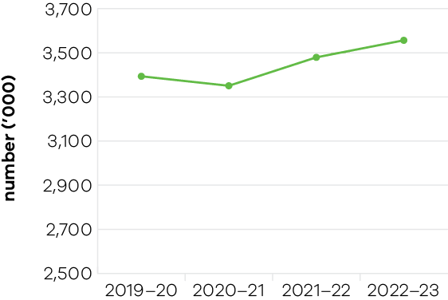
In 2022–23, the total number of people employed in Victoria was 3,561,500, an increase of 5% over the 2019–20 total of 3,391,600. The department nominated 14,900 skilled migrants to live and work in Victoria, including those with skills in critical Victorian workforce sectors. This included providing visa nomination to 4,251 skilled migrants in health, 950 in education, 398 in social services, and 6,489 in digital and advanced manufacturing sectors. More than 380 regionally-based skilled migrants were nominated in the hospitality and tourism sectors while 170 business and investor migrants were nominated to start job-creating businesses and invest in Victoria. The department also assisted overseas-qualified professionals to gain employment by assessing qualifications of more than 1,721 skilled professionals. The assessment of these professionals helped confirm that their overseas qualifications would be recognised in Australia.
The Digital Jobs program directly contributed to job creation in 2022–23 by providing 2,646 participants with technical training, career guidance, mentoring, exposure to employers, and opportunities to apply for entry-level and digital-focused jobs. A total of 226 Victorian manufacturing businesses’ employees were funded to undertake fully subsidised training through the Digital Jobs for Manufacturing program – providing individuals with opportunities to progress into more technically advanced roles.
The department’s domestic attraction and facilitation activities secured several investments in Victoria by Australian businesses. These projects will support delivery of more than 1,700 jobs to the Victorian economy as they are implemented. The investments were largely secured with grants from Victorian Jobs and Investment Fund streams and investment attraction-related programs. The projects are a mix of large and strategic, through to smaller projects aimed at supporting medium to large and high potential businesses to accelerate their growth trajectory. All are aimed at securing and growing key industry capabilities to drive ongoing economic growth and job creation.
The Local Jobs First Victorian Industry Participation policy continued to support local businesses and workers to compete for work on government contracts. In 2022–23, more than 800 industry stakeholders engaged with the policy, and the government set new local content requirements under the policy for 50 strategic projects, with a combined total value of over $28.7 billion. Since 2014, Local Jobs First strategic projects have supported over 45,000 local jobs.
Since launching in 2016, the Major Projects Skills Guarantee (MPSG) has applied to 400 projects worth over $164.8 billion. In the 12 months to March 2023, opportunities for apprentices, trainees and cadets under the MPSG grew, with an additional 3,730 positions supported.

Jobs Victoria
Jobs Victoria was established in 2016 to ensure long-term unemployed Victorians had the support they needed to achieve sustainable employment while addressing fundamental gaps and limitations in the Australian Government’s employment service system. Since then, Jobs Victoria has supported more than 64,000 people into a job, including more than 54,000 since mid-2020.
In 2022–23 the Victorian Government continued to invest in Victorian jobseekers, providing support to help them gain and sustain meaningful work that meets their aspirations as well as those of employers. This included support for Aboriginal Victorians; refugees and asylum seekers; Victorians experiencing mental health issues; Victorians in contact with the justice system; people with disability; young people leaving state care; social housing residents; people experiencing family violence; and veterans and their families. Jobs Victoria services supported people into roles in a range of sectors including disability, aged care, warehousing and distribution, land and fire management, construction, heavy vehicles, transport and logistics, hair and beauty, hospitality, government and social housing.
Despite an increase in the number of people employed in Victoria since 2020 and recent economic recovery, structural challenges remain for certain cohorts who accessed Jobs Victoria employment services in 2022–23. At the same time, businesses impacted by tight labour market conditions and workforce shortages benefitted from Jobs Victoria services that connected them with potential employees. Going forward, Jobs Victoria Mentors will target the hardest-to-place jobseekers in priority positions based on demonstrated need. Jobs Victoria services will continue to address gaps in existing services, to ensure support for those most in need and create pathways into employment.

Performance against output performance measures
Table 2 represents performance against the Jobs output. This output includes actions to increase job opportunities including initiatives to support Victorians experiencing disadvantage into employment, support Aboriginal economic inclusion, as well as attract new investment and talent into Victoria to grow the economy and share the benefits of economic prosperity.
Table 2: Output – Jobs
Performance measures | Unit of Measure | 2022–23 Actual | 2022–23 Target | Performance variation (%) | Result
Quantity
Capital expenditure from industry growth programs  Higher result due to realisation of continued private sector investment in projects supported during the COVID-19 pandemic to stimulate recovery and growth. | number | 1,238 | 500 | 147.6% | 1
Disadvantaged jobseekers who achieve sustainable employment (minimum number of 26 weeks) with the support of Jobs Victoria Services | number | 7,874 | 8,250 | -4.6% | 2
Disadvantaged jobseekers who gain employment with the support of Jobs Victoria Services  Higher result due to the raised interest for Jobs Victoria programs and pent up demand for services during this period, including amongst priority cohorts, and a strong Victorian labour market. | number | 18,021 | 6,630 | 171.8% | 1
Firms assisted from industry growth programs  Higher result due to continued assistance provided to a larger number of firms, which were supported to invest as part of COVID-19 stimulus activity and the extension of some project delivery timelines due to the current economic environment. | number | 159 | 100 | 59.0% | 1
Government Youth Employment Scheme traineeships commenced  Lower result due to changes in labour market conditions. | number | 230 | 280 | -17.9% | 3
Industry stakeholders engaged with the Local Jobs First Policy | number | 837 | 800 | 4.6% | 1
Jobs created from industry growth programs  Higher result due to a small number of projects delivering well above average job creation. | number | 1,771 | 1,500 | 18.1% | 1
Jobs Victoria Services (Advocates, Mentors, Careers Counsellors) delivered to Victorian jobseekers  Higher result due to the raised interest for Jobs Victoria programs and pent up demand for services during this period, including amongst priority cohorts, and a strong Victorian labour market. | number | 180,056 | 75,000 | 140.1% | 1
Migrant talent nominated for the Skilled, Investor and Business Migration Program  Higher result due to the Australian Government’s increased migration program for 2022–23, including additional nomination places to all states and territories. The Victorian Government requested and was granted additional places. | number | 15,070 | 4,000 | 276.8% | 1
Number of eligible workers approved for the Sick Pay Guarantee  Lower result because there were Australian Government supports available in the first part of the year, which excluded workers from claiming the Sick Pay Guarantee payment for the same period. | number | 71,852 | 130,000 | -44.7% | 3
Proportion of disadvantaged jobseekers who achieve sustainable employment (minimum number of 26 weeks) with the support of Jobs Victoria Services | per cent | 47.8 | 50 | -4.4% | 2
Proportion of Jobs Victoria Fund allocated to women | per cent | 59.9 | 60 | -0.1% | 2
Retrenched workers supported with employment assistance  Higher result as the program has developed strong networks across Victoria leading to increased referrals and demand for services. | number | 2,256 | 2,000 | 12.8% | 1
Subsidised jobs for jobseekers through the Jobs Victoria Fund  Higher result due to the raised interest for Jobs Victoria programs and pent up demand for services during this period, including amongst priority cohorts, and a strong Victorian labour market. | number | 4,766 | 2,000 | 138.3% | 1
Quality
Client satisfaction with investor, business and skilled migration services provided | per cent | 87 | 85 | 2.4% | 1
Jobseeker satisfaction with Jobs Victoria Services | per cent | 70 | 70 | 0.0% | 1
Timeliness
Average processing time for investor, business and skilled migration visa nomination applications  Higher result due to a combination of additional staff, training, system and program enhancements. | days | 14 | 20 | 30.0% | 1
Percentage of successful Sick Pay Guarantee claims approved by DJSIR within 5 business days | per cent | 92 | 90 | 2.2% | 1
Cost
Total output cost | $ million | 430.1 | 389.3 | 10.5% | 3
The 2022–23 result is higher than the 2022–23 budget mainly due to funding released for the Jobs for Victoria initiative and additional funding for the Pandemic Leave Disaster Payment initiative.
Note:
1 Performance target achieved or exceeded
2 Performance target not achieved – but within 5% variance
3 Performance target not achieved – exceeds 5% variance

Objective 2: Foster a competitive business environment
This objective seeks to grow Victorian industries and businesses by working with priority industry sectors, supporting growth and innovation opportunities for industry, supporting startups and small businesses, and assisting industries in transition.

Progress towards achieving this objective
In 2022–23, the department reported progress against this objective using the following objective indicators and outputs:
Objective Indicators
- Change in Victoria’s real gross state product
Engagement with businesses
Outputs
Industry, Innovation, and Small Business

Indicator: Change in Victoria’s real gross state product
Table 3: Change in Victoria’s real gross state product
Measure (unit of measure) | 2019–20 | 2020–21* | 2021–22 | 2022–23
Change in Victoria’s real gross state product (%) | 0.1 | -0.3 | 5.6 | Data available in November 2023
* This is the latest available data. Changes to the inputs used to produce this data have resulted in revised historical estimates that should not be compared to previously published results.
Figure 2: Change in Victoria’s real gross state product
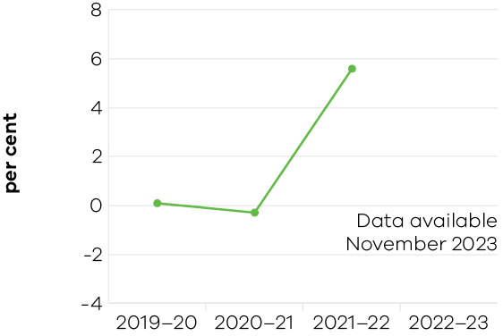
Victoria recorded an increase in real gross state product (GSP) of 5.6% in 2021–22 – the strongest growth of any state or territory. The increase follows a fall of 0.3% in 2020–21 and a small rise of 0.1% in 2019–20 when economic activity was constrained by COVID-19. Leading the recovery were the construction (7.6%), healthcare and social assistance (6.6%) and transport, postal and warehousing (12.5%) industries.
Construction, both residential and non-residential, increased with strong demand from private and public sectors. Dwelling investment was a major driver as the industry worked through a backlog of projects delayed due to COVID-19 disruptions.
Healthcare and social assistance continued to grow as output increased in response to COVID-19 challenges.
Transport services grew as a result of the removal of lockdowns and travel restrictions on Victorian households and businesses. Increased mobility throughout the state led to a rise in public transport services as well as use of toll roads.
Industries dependent on household spending rebounded in 2021–22 after 2 difficult years impacted by COVID-19 trading restrictions. Strong growth was recorded in retail trade gross value added (GVA) (8.8%), accommodation and food services GVA (10.6%) and arts and recreation services GVA (15.7%).

Indicator: Engagement with businesses
Table 4: Engagement with Businesses
Measure (unit of measure) | 2019–20 | 2020–21 | 2021–22 | 2022–23
Engagement with businesses (number) | 12,344 | 14,772 | 15,142 | 15,034

Figure 3: Engagement with Businesses
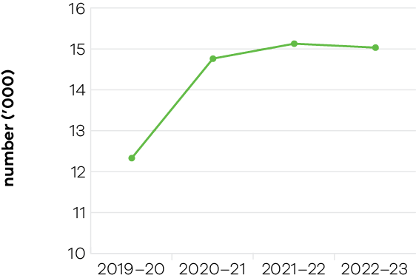
In 2022–23, the department recorded over 15,000 interactions with businesses through meetings, phone calls and involvement in business assistance programs – an increase of 21.8% over the 2019–20 total of 12,344 engagements. These engagements reflect a range of activities and services across the department. Entities engaged range from small businesses to large employers across metropolitan and regional Victoria, in areas such as investment, trade, employment and skills, agriculture, digital and ICT, creative industries and tourism.
In addition to these engagements through core service delivery, a high volume of flood relief-related engagement was undertaken to support impacted businesses, with grant payments made to over 7,700 eligible businesses. This was due to the one-off nature of the funded programs and resourcing specifically directed towards supporting businesses affected by flood events during this period.
The Victorian Government’s annual Digital Innovation Festival offered 245 live and on-demand sessions supporting 20,000 Victorians to upskill, connect and share knowledge. Other industry events supported by the department further stimulated the digital economy, including the AIIA state and national iAwards, Intersekt Fintech Conference, National Finnies Fintech Awards, Australian Cyber Conference, Connecting Up Conference and Awards, the inaugural Data Informed Design Conference and the Tech Diversity Awards.
In 2022–23, the department engaged with over 1,600 strategic priority businesses regarding investment and growth opportunities in Victoria. This cohort of large, medium and growing businesses included firms considering investment as well as employers and providers of critical goods and services of strategic importance to the state.
Small Business Victoria continued to deliver information, training, mentoring, grant programs and other services, such as emergency recovery and mental health and wellbeing supports. The Business Victoria website and other digital channels were instrumental in providing accurate and timely information to Victorian businesses, along with the Business Victoria newsletter which reached more than 145,000 subscribers.
The Digital Jobs for Manufacturing program engaged with the Victorian manufacturing sector through a range of industry-specific conferences, webinars and information sessions, including an industry briefing at Australian Manufacturing Week. The program provided grants for 111 manufacturing businesses to upskill staff with in-demand specialist digital skills in 2022–23.
In building an end-to-end mRNA capability in Victoria, the state is developing a new leading innovation industry in medical research and biotech. mRNA Victoria’s achievements in 2022–23 included:
- securing a 10-year partnership between the Victorian Government, the Australian Government and Moderna to build the first mRNA vaccine manufacturing facility in the Southern Hemisphere in Melbourne. The facility will have the capacity to produce up to 100 million vaccine doses each year. Construction of the facility commenced in December 2022
- securing the Moderna Asia Pacific Research and Development Centre in Victoria
- securing Moderna’s Asia-Pacific headquarters in Victoria
- announcing an in-principle partnership with leading German biotechnology company BioNTech to establish its Asia-Pacific mRNA clinical manufacturing, research and development centre and translational hub in Victoria. The project will see BioNTech deliver next-generation mRNA therapeutics and vaccines for research and clinical trials, including infectious diseases, cancer medicines and personalised cancer treatments
- entering a collaborative partnership with the South African Medical Research Council and Afrigen Biologics to advance mRNA vaccine collaboration between the two jurisdictions focusing on 3 key areas – best-practice mRNA advanced manufacturing, mRNA workforce training, and development and research
- ongoing management of 42 mRNA Victoria research grant projects including using mRNA vaccines to tackle global pandemic pathogens that provide broad immunity; developing a novel RNA therapeutic for chronic hepatitis B; and leveraging mRNA technology to improve cell therapy for cancer
- delivering a series of ecosystem development activities, including a public lecture series for mRNA scientists, researchers and the biotech sector in Australia
hosting leading international mRNA researchers and industry leaders in Victoria and facilitating research partnerships with Victoria’s 22 medical research institutes and universities.

Performance against output performance measures
Table 5 represents performance against the Industry, Innovation and Small Business output. This output provides access to information and connections and builds the capability of Victorian businesses and industry to develop, commercialise and effectively use new practices and technologies to increase productivity and competitiveness, advocating for a fair and competitive business environment, and supporting small businesses.
Table 5: Output – Industry, Innovation and Small Business
Performance measures | Unit of Measure | 2022–23  Actual | 2022–23 Target | Performance variation (%) | Result
Quantity
Companies and consortia supported by the Breakthrough Victoria Fund  Higher result due to a maturation in Breakthrough Victoria’s investment pipeline and operations now that it is fully established. | number | 13 | 10 | 30.0% | 1
Companies or new entrants supported through the LaunchVic initiative | number | 142 | 140 | 1.4% | 1
Individuals supported under digital skills initiatives  Higher result reflects the inclusion of 797 participants from Round 4 of the Digital Jobs program, who commenced their training in May 2022 and completed it in August 2022, and are therefore captured in this financial year. A new program, Digital Jobs for Manufacturing was launched in 2022–23 and the results also include 252 Digital Jobs for Manufacturing participants that received grants to undertake digital skills training in 2022–23. | number | 2,899 | 2,000 | 45.0% | 1
Industry roundtables and engagement forums  Higher result due to the launch of the Fair Jobs Code, increased industry consultations for investment activities and consultation sessions related to delivering digital technologies. | number | 184 | 60 | 206.7% | 1
Number of equity investments held in female founders under the Alice Anderson Fund initiative  Lower result as fewer co-investment opportunities were submitted than anticipated. However, successful applications sought co-investment in female-led start-ups at the higher end of the program’s investment range. | number | 27 | 40 | -32.5% | 3
Participation in Small Business Victoria events and access to business programs  Higher result due to increased awareness of Small Business Victoria programs, resulting from better promotion of those programs. | number | 34,387 | 20,000 | 71.9% | 1
Private sector capital leveraged under the Victorian Startup Capital Fund initiative  Lower result as no private capital was raised in the 2022–23 financial year. Changing market conditions did not make the operation of the Victorian Start-up Capital Fund as a Fund-of-Funds model viable. | $ million | 0 | 40 | -100.0% | 3
Projects supported through building and scaling up messenger Ribonucleic Acid Vaccine (mRNA) manufacturing capability in Victoria  Higher result due to the delivery of projects previously anticipated in 2021–22, and a larger than expected number of projects supported through the mRNA Victoria Activation Program. | number | 32 | 7 | 357.1% | 1
Strategic priority businesses engaged on investment and growth  Higher result due to additional targeted engagement with businesses in relation to industry transition and floods. | number | 1,602 | 1,500 | 6.8% | 1
Visits to Business Victoria digital channels  Higher result due to increased engagement as a result of the COVID-19 pandemic. | number | 6,540,000 | 4,000,000 | 63.5% | 1
Quality
Client satisfaction of small business information, referral, coaching service and business programs | per cent | 94 | 90 | 4.4% | 1
Client satisfaction with the Victorian Government Business Offices | per cent | 83.6 | 80 | 4.5% | 1
Client satisfaction with Victorian Small Business Commission mediation service  Lower result is due to increased complexity of disputes relating to the COVID-19 pandemic. | per cent | 80 | 85 | -5.9% | 3
Proportion of business disputes presented to the Victorian Small Business Commission successfully mediated  Lower result reflects increased financial stresses on retail landlords and tenants following the effects of COVID-19 on market conditions, reducing capacity for participants to be able to negotiate successful outcomes at mediation. | per cent | 66.1 | 75 | -11.8% | 3
Proportion of business disputes resolved by the Victorian Small Business Commission prior to mediation  Higher result demonstrates effective application of the alternative dispute resolution processes and early assistance by the VSBC’s dispute resolution team. | per cent | 32.0 | 30 | 6.5% | 1
Cost
Total output cost | $ million | 273.4 | 298.5 | -8.4% | 1
The 2022–23 result is lower than the 2022–23 budget due to timing of payments for industry support grant programs, with milestone payments now expected to be made in future years.
Note:
1 Performance target achieved or exceeded
2 Performance target not achieved – but within 5% variance
3 Performance target not achieved – exceeds 5% variance

Objective 3: Be a globally connected economy
This objective seeks to strengthen Victoria’s economic performance through facilitating private sector investment in Victoria, helping Victorian businesses successfully trade into global markets, and growing Victorian’s market share of international student enrolments in Australia.

Progress towards achieving this objective
In 2022–23, the department reported progress against this objective using the following objective indicators and outputs:
Objective Indicators
- Export sales generated from government programs
- Victoria’s share of international student enrolments
Jobs, wages and innovation expenditure generated from international investment secured through Government facilitation services and assistance
Outputs
Trade and Investment

Indicator: Export sales generated from government programs
Table 6: Export sales generated from government programs
Measure (unit of measure) | 2019–20 | 2020–21 | 2021–22 | 2022–23
Actual export sales generated as a result of participation in government programs ($ million) | 709 | 569 | 627 | 704

Figure 4: Export sales generated from government programs
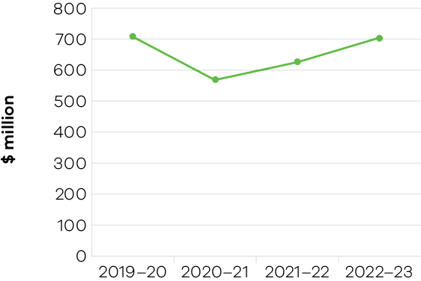
In 2022–23, the department supported $704 million of actual export sales, underpinned by strong demand for export support services delivered both domestically and internationally. Victorian exporting businesses continued to seek new business opportunities and to re-establish and re-engage with international markets as global trade began to normalise post-pandemic.
Key initiatives delivered across the financial year supported a strong result for the export sales measure, with the department delivering 47 trade missions to 21 priority international markets – with many activities heavily or often over-subscribed. In total, the department supported more than 3,080 Victorian businesses through its suite of international business engagement programs and services. In addition, a strong program of activity delivered in previous years generated positive exports sales outcomes this financial year.
The department further supported businesses in international markets through its network of 23 Victorian Government Trade and Investment offices – providing tailored support to assist firms in realising and capturing export sales. Uptake in client facilitation services delivered both domestically and internationally significantly contributed to export sales measure performance, underpinned by strong demand for services in the traditional export markets of the UK, Europe and USA.
In 2023–24 the department will continue to support businesses to maximise their international business opportunities. Prioritising limited resources and supporting the highest growth potential businesses remain key priorities for the portfolio.

Indicator: International students attracted to Victoria
Table 7: Victoria’s proportion of international student enrolments in Australia
Measure (unit of measure) | 2019–20 | 2020–21 | 2021–22 | 2022–23
Victoria’s proportion of all international student enrolments in Australia (%) | 32.3 | 32.2 | 31.7 | 29.9
Note: Financial year data on international student enrolments is not available. Figures in the table are calendar year data reflecting the academic year and capturing peaks and troughs of enrolment periods. Data includes student visa holders enrolled onshore and offshore.
Figure 5: Victoria’s proportion of international student enrolments in Australia
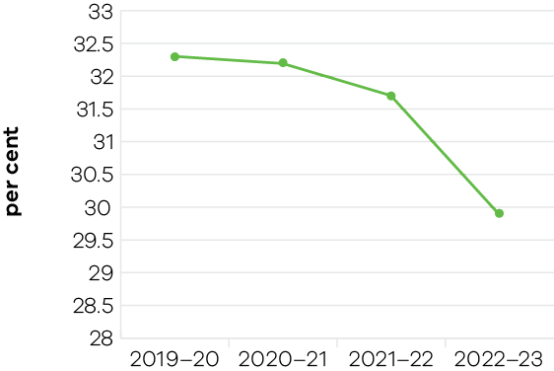
In the full year to December 2022, there were approximately 223,000 international students enrolled with Victorian providers. This represents 29.9% of Australia’s total international student enrolments, a slight decline from 31.7% in 2021 and 32.3% in 2019.
The severity of the COVID-19 pandemic’s impact on the sector and several other factors constraining growth will likely result in a varied and uneven recovery trajectory. Multiple missed intakes of international students – as a result of the pandemic and prolonged international border closures – will take time to flow through the system. Victoria’s world class education offering and Melbourne’s best Australian student city ranking will support sustained recovery and a return to growth over time.
The latest Australian Bureau of Statistics state-level calendar year data indicated that Victoria’s education exports returned to growth for the first time since the pandemic, valued at $8.4 billion in 2022. This represents an annual increase of 21.2%, slightly higher than the national growth of 20.7%. In terms of employment contribution, the international education sector contributed around 43,000 full-time equivalent jobs to the Victorian economy in 2022 – an increase of 8% compared to 2021 (DSJIR estimates).
International commencements showed promising signs across all education sub-sectors and in key markets in 2022, with a total of approximately 114,300 international commencements. This was an increase of 32% compared to 2021 (around 86,300), but still a decrease of 29% compared to 2019. Most notably, Victoria’s performance in the English language (ELICOS) sector was above the national average, with 168% growth (to around 20,200 commencements) and ahead of all jurisdictions except Queensland (231% growth). The ELICOS sector is often seen as a lead indicator of future growth, as ELICOS students historically transition to further study in higher education or vocational education and training sectors.
In September 2022, the Victorian Government launched Victoria’s International Education Recovery Plan 2025, outlining the government’s strategy to drive recovery and innovation in the sector through to 2025. Backed by $52.9 million in funding, the recovery plan articulates a vision of Victoria as a global leader in education – recognised for quality, innovation and inclusion. This vision is supported by 3 goals, 5 pillars and 19 practical actions. The department collaborated closely with sector stakeholders to deliver the recovery plan, achieving impressive student satisfaction rates for student support programs and a high level of industry engagement across key priorities, including:
- promoting of the Study Melbourne brand
- supporting graduate employment outcomes
strengthening international partnerships through Victoria’s Global Education Network.
The Victorian Government continued to support Victoria’s 10 universities to respond to impacts of COVID-19 through the $50 million International Education Resilience Fund (IERF). The IERF supported Victorian universities to deliver benefits to international students onshore and offshore, including increased student welfare and support services, improved online teaching and learning and more student engagement initiatives. Additionally, $10 million from the Melbourne City Revitalisation Fund supported activities to boost recovery and strengthen Melbourne’s status as a leading international student city.
As a testament to the concerted effort across all segments of Victoria’s international education sector, Melbourne was crowned Australia’s best student city and moved up one place to become the world’s fourth best (QS Best Student Cities 2024). This remarkable achievement reflects that, despite the pandemic, Melbourne is in a strong position as a world-class study destination, with outstanding educational offerings, exceptional quality of life and abundant opportunities for students.

Indicator: Jobs, wages and innovation expenditure generated from international investment secured through Government facilitation services and assistance.
Table 8: Jobs, wages and innovation expenditure generated from international investment secured through Government facilitation services and assistance
Measure (unit of measure) | 2019–20 | 2020–21 | 2021–22 | 2022–23
Jobs generated from international investment secured through Government facilitation services and assistance (number) | 5,241 | 5,740 | 3,721 | 2,549
Wages generated from international investment secured through Government facilitation services and assistance ($ million) | nm* | 297 | 431 | 332
Innovation expenditure generated from international investment secured through Government facilitation services and assistance ($ million) | nm* | 496 | 596 | 625
* New measure – new performance measure for 2020–21 reflects whole-of-government targets for foreign direct investment (FDI) attraction.
Figure 6: Jobs generated from international investment secured through Government facilitation services and assistance
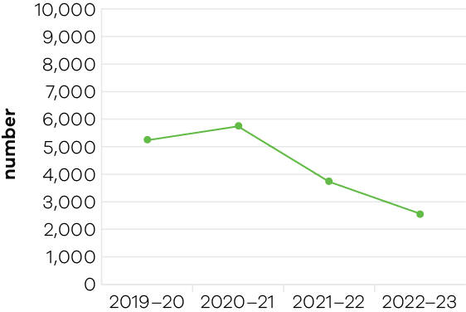
Figure 7: Wages generated from international investment secured through Government facilitation services and assistance
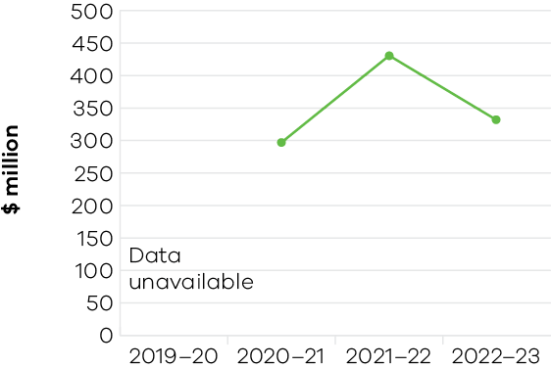
Figure 8: Innovation expenditure generated from international investment secured through Government facilitation services and assistance
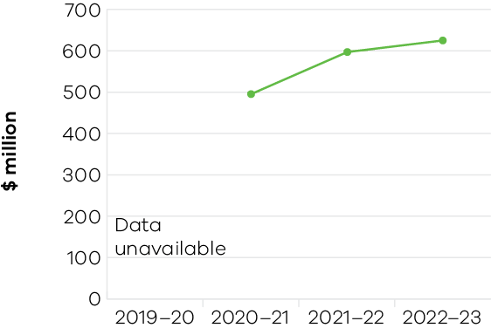
In 2022–23, 43 FDI projects were claimed against the objective indicators in the table above, achieving 2,549 direct jobs, $332 million in wages expenditure and $625 million in innovation expenditure.
The majority of FDI projects attracted aligned with priority sectors including digital technology, renewable energy, advanced manufacturing, health and life sciences, and agri-food.
Notable achievements included:
- Keywords Studios – an Irish global games development company – is redoubling its investment in Victoria and establishing its first centre of excellence for autonomous testing and quality assurance in Melbourne
- Orsted – a global leader in offshore wind power production from Denmark – is expanding into Australia, choosing Victoria for its Australian headquarters
- UST – a leading digital technology company – has relocated its ANZ headquarters from Sydney to Carlton. It has launched a new innovation lab at the University of Melbourne’s Melbourne Connect tech hub, creating 250 jobs
- CI&T – a world-leading, Brazilian-based ICT consulting and software development company – will establish its Australian headquarters in Melbourne
- SunGreenH2– a Singapore hydrogen tech startup – opened a manufacturing and R&D hub in Clayton to develop nanotechnology to improve efficiency and lower the cost of electrolyser parts used in hydrogen production. The facility will create 30 new jobs
LeadSquared – an Indian technology unicorn (a startup valued at over $1 billion) – is establishing its Oceania base in Victoria with Melbourne as its global hub for all training needs.
The department continued to provide high quality facilitation support and assisted companies to progress developments by:
- scanning property markets and off-market opportunities to identify sites that meet the requirements of investors
- advising on approval processes
- assisting businesses to understand their obligations in preparing technical studies required for assessing development proposals
- supporting companies to meet their regulatory assessment requirements
providing policy advice and advocacy across government on key regulatory settings to align with government’s economic development priorities to ensure they are conducive to securing investment and facilitating economic growth.

Performance against output performance measures
Table 9 represents performance against the Trade and Investment output. This output promotes Victoria’s global engagement activities which seeks to secure trade and international investment outcomes for the State through a range of promotion and facilitation activities in addition to providing policy advice to improve the attractiveness of Victorian exports and as an international investment destination.
This output also provides support and advice to Government on strengthening Victoria’s economic performance, including in relation to:
- ensuring Victoria is a leading destination for business, innovation and talent
- continuous enhancement of Victoria’s approach to investment attraction
- enhancing Victoria’s business investment environment
- helping Victorian businesses successfully trade into global markets
growing Victoria’s market share of international student enrolments in Australia.
Table 9: Output – Trade and Investment
Investment Attraction
This sub-output contributes to strengthening Victoria’s economic performance through facilitating private sector investment in Victoria. This is achieved through securing investments with facilitation support, grants or access to finance initiatives that enhance productivity, by introducing new skills and capabilities to the Victorian economy.
Performance measures | Unit of Measure | 2022–23 Actual | 2022–23 Target | Performance variation (%) | Result
Quantity
Innovation expenditure generated from international investment secured through government facilitation services and assistance  Higher result due to several large projects secured in 2022–23 which were the culmination of several years of engagement. | $ million | 625 | 135 | 363.0% | 1
Jobs generated from international investment secured through government facilitation services and assistance  Higher result due to several large projects secured in 2022–23 which were the culmination of several years of engagement. | number | 2,549 | 1,250 | 103.9% | 1
Wages generated from international investment secured through government facilitation services and assistance  Higher result due to several large projects secured in 2022–23 which were the culmination of several years of engagement. | $ million | 332 | 110 | 201.8% | 1
Timeliness
Delivery of key CarbonNet milestones, in line with funding agreements and agreed project deliverables  Lower result due to the timing of release of Australian and State Government funding and impact on the timelines of Front End Engineering Design procurement. | per cent | 50 | 100 | -50.0% | 3
Cost
Total output cost | $ million | 57.9 | 162.8 | -64.4% | 1
The 2022–23 result is lower than the 2022–23 budget due to timing of payments for investment grant programs, with milestone payments now expected to be made in future years.
Note:
1 Performance target achieved or exceeded
2 Performance target not achieved – but within 5% variance
3 Performance target not achieved – exceeds 5% variance
Trade and Global Engagement
This sub-output promotes business growth opportunities by connecting organisations to global business opportunities in priority markets and supporting the establishment and deepening of strategic commercial partnerships. It also positions Victoria as a destination of choice for international students.
Performance measures | Unit of Measure | 2022–23 Actual | 2022–23 Target | Performance variation (%) | Result
Quantity
Actual export sales generated as a result of participation in government programs  Higher result due to a number of ongoing trade facilitation projects being realised in the financial year. | $ million | 704 | 550 | 28.0% | 1
Clients engaged in export and trade programs  Higher result due to strong interest in government support initiatives for exporters, particularly market engagement initiatives for exporters re-engaging in export market opportunities. The result was also driven by investments provided under the Export Recovery Plan during the COVID-19 pandemic. | number | 3,084 | 2,000 | 54.2% | 1
Number of Victorian companies assisted by Wine Industry initiatives  Higher result due to the interest in new market engagement opportunities and initiatives for wineries. | number | 95 | 60 | 58.3% | 1
Significant interactions with Victorian agri-food companies and exporters, international customers and trading partners through formal meetings or involvement in trade programs that facilitate export and investment outcomes for Victoria  Higher result due to the level of interest in market engagement activities from agribusiness companies. | number | 333 | 250 | 33.2% | 1
Victoria’s proportion of all international student enrolments in Australia | per cent | 29.9 | 31 | -3.5% | 2
Visits to the Global Victoria website  Lower result despite the continued interest and demand for trade facilitation services. Realigning website content predominantly for exporters has impacted site visitation numbers. | number | 90,716 | 100,000 | -9.3% | 3
Quality
Client satisfaction with export assistance offered  Higher result reflecting positive program survey results due to the level of interest and increased volume of market engagement activities. | per cent | 95 | 90 | 5.6% | 1
International student satisfaction with Study Melbourne student programs  Higher result due to the services provided and refreshed programs with a focus on inclusion, employability, career development and leadership being well-received by international students. | per cent | 96 | 80 | 20.0% | 1
Cost
Total output cost | $ million | 54.7 | 46.4 | 17.9% | 3
The 2022–23 result is higher than the 2022–23 budget mainly due to additional expenditure on trade fairs and missions.
Note:
1 Performance target achieved or exceeded
2 Performance target not achieved – but within 5% variance
3 Performance target not achieved – exceeds 5% variance

Objective 4: Build prosperous and liveable suburbs and regions, and promote outdoor recreation
This objective seeks to ensure that Victoria’s suburbs and regions are developed to create places where all Victorians have an opportunity to participate in communities that are well-connected, prosperous, vibrant and diverse. This objective also supports the development of sustainable game hunting, fishing and aquaculture activities in Victoria and the delivery of improved recreational fishing and boating services and facilities.

Progress towards achieving this objective
In 2022–23, the department reported progress against this objective using the following objective indicators and outputs:
Objective Indicators
- Jobs and investment secured through Government facilitation services and assistance
- Projects and activities delivered to support economic and community outcomes
- Compliance activities to protect fish and game resources
Improved recreational fishing and boating services and facilities
Outputs
- Regional Development
- Suburban Development
Sustainably Managed Fish and Boating Resources

Indicator: Jobs and investment secured through Government facilitation services and assistance
Table 10: Jobs and investment secured through Government facilitation services and assistance
Measure (unit of measure) | 2019–20 | 2020–21 | 2021–22 | 2022–23
Jobs in regional Victoria resulting from government investment facilitation services and assistance (number) | 1,215 | 1,468 | 2,427 | 1,017
New investment in regional Victoria resulting from government facilitation services and assistance ($ million) | 840 | 907 | 1,410 | 682

Figure 9: Jobs in regional Victoria resulting from government investment facilitation services and assistance
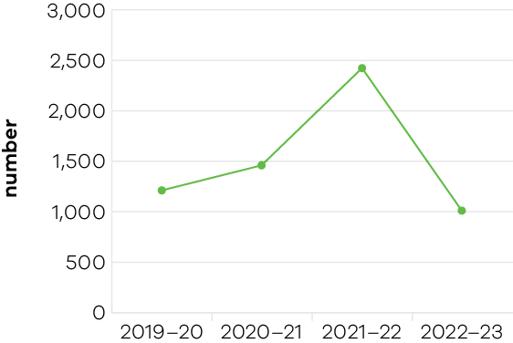
Figure 10: New investment in regional Victoria resulting from government facilitation services and assistance
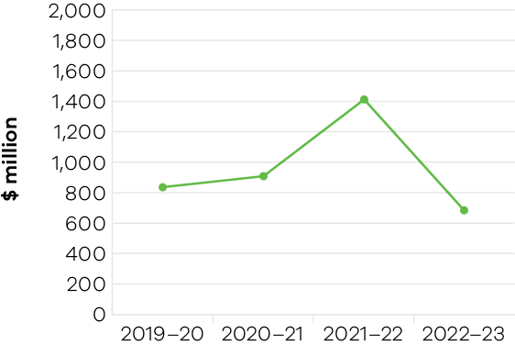
Under the Regional Development output, outcomes against the objective indicator for ‘Jobs and Investment secured through Victorian Government facilitation services and assistance’ are measured primarily through 2 output performance measure targets:
- ‘Jobs in regional Victoria resulting from government investment facilitation services and assistance’
‘New investment in regional Victoria resulting from government facilitation services and assistance.’
These BP3 measures track and report on outcomes and achievements in regional Victoria resulting from programs, assistance and projects delivered by DJSIR.
In 2022–23 the department created 1,017 jobs in regional Victoria against a target of 1,000 – within 5% of the anticipated outcome for this measure. This was a reduction of 58% against the 2021–22 outcome of 2,427. The number of new jobs in regional Victoria facilitated by the department each year is highly dependent on the number of projects supported in that financial year, which in turn is dependent on the scope and nature of programs that the department is tasked to deliver. In the 3 preceding financial years, job outcomes were higher due to recovery and stimulus programs implemented in response to the COVID-19 pandemic and the 2019–20 bushfires, which saw a marked increase in the number of projects being delivered – and by extension, an increase in the number of jobs created. This trend was visible across 2019–20 (1,215 jobs created), 2020–21 (1,468 jobs created) and peaked in 2021–22 (2,427 jobs created). The subsequent drop in 2022–23 aligns with the completion of these programs.
In 2022–23 the department facilitated $682.4 million worth of new investment in regional Victoria against a target of $500 million. This higher-than-expected outcome exceeded the target by 36.5% and was a result of significant investment in energy and advanced manufacturing projects. However, this outcome was a reduction of 52% against the 2021–22 outcome of $1.41 billion which was within 5% of that year’s target of $1.4 billion. By comparison, the 2020–21 outcome of $906.7 million was 35.2% below that year’s target of $1.4 billion. Targets were higher for both 2020–21 and 2021–22 due to a 2-year period of increased funding related to bushfire recovery programs, COVID-19 pandemic stimulus and delivery of the 2020–22 Regional Jobs and Infrastructure Fund. Despite not achieving the increased target in 2020–21, the actual outcome was higher than the $840 million achieved in 2019–20, which exceeded that year’s target of $700 million by 20%.
As with the previous measure, the amount of investment that the department facilitates each year is impacted by the scope and nature of programs it is set to deliver. Investment facilitation is particularly impacted by market conditions for private sector investment in regional Victoria, and the expected targets and outcomes for a given year reflect such conditions.

Indicator: Projects and activities delivered to support economic and community outcomes
Table 11: Projects and activities delivered to support economic and community outcomes
Measure (unit of measure) | 2019–20 | 2020–21 | 2021–22 | 2022–23
Regional economic development and service delivery projects supported (number) | 148 | 677 | 297 | 225
Suburban economic development and service delivery projects supported by Suburban Development programs (number) | 12 | 131 | 215 | 393

Figure 11: Regional economic development and service delivery projects supported
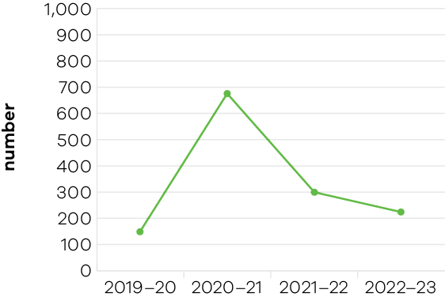
Figure 12: Suburban economic development and service delivery projects supported by Suburban Development programs
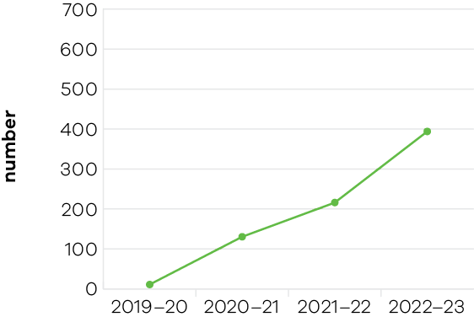

Regional Development
In 2022–23, the department continued to support the delivery of projects in rural and regional Victoria through the Regional Development output. The department measured and reported on the number of projects being delivered in regional Victoria through the BP3 measure ’Economic development and service delivery projects supported’. In total, 225 projects were supported in 2022–23 against a target of 90. This higher-than-expected outcome primarily reflected the introduction of the Living Local Regional Fund – a new initiative launched in July 2022.
The 72 projects supported through the Regional Jobs and Infrastructure Fund comprised:
- 27 projects through the Regional Jobs Fund
- 14 projects through the Regional Infrastructure Fund
- 29 projects through the Investment Fast-Track Fund
2 Portland Diversification Fund projects.
Additionally, the department supported 132 Living Local – Regional (42) and Regional Community (90) projects, 12 Regional Partnership projects and 9 projects through various other funds/programs (5 flood recovery grants, a Regional Community Leadership program and 3 election commitment projects).
The 2022–23 outcome of 225 projects supported is a reduction of 24% against the 2021–22 outcome of 297. Outcomes against this measure are highly dependent on the scope and nature of programs that the department is set to deliver each year. This was exemplified by the outcome for the 2020–21 financial year, which saw a substantial increase of 677 projects supported throughout the year. This increase was due to the considerable amount of grant funding awarded as stimulus following the 2019–20 bushfires and COVID-19 pandemic – 80% of the actual outcome in 2029–20 was attributable to one-off COVID-19 and bushfire response programs.

Suburban Development
The Office for Suburban Development continued to support 6 Metropolitan Partnerships to engage with local communities on regional issues and advise the government on community priorities. The Metropolitan Partnerships also drove action through placed-based pilots and projects to test new approaches and develop solutions to local challenges.
In 2022–23, Metropolitan Partnerships responded to community priorities by developing projects to gather local evidence, including:
- facilitating a research project to better understand why women over 55 years are the fastest growing cohort of people facing homelessness in Melbourne’s eastern suburbs
- developing a community-wide Electric Vehicle Transition plan for Melbourne’s north with a focus on the role of local government in supporting the transition to electric vehicles
- mapping feasible locations for neighbourhood batteries to empower local communities to participate in the transition to renewable energy
building a regional network to improve the capacity and capability of small-medium enterprises to win work in large-scale infrastructure projects in Melbourne’s western suburbs.
In 2022–23, the Suburban Revitalisation program continued to support 8 Suburban Revitalisation boards, with $7 million invested in 62 Suburban Revitalisation projects valued at over $9 million in Boronia, Lilydale, Melton, Noble Park, Reservoir, Tarneit, Frankston and Broadmeadows.
The Suburban Revitalisation boards were chaired by members of parliament, with representatives from local government, businesses, community organisations and other institutions. These projects delivered on local priorities to improve liveability and economic and social outcomes.
A new Living Local program was introduced in 2022–23, aimed at supporting local economic development and community strengthening through small, locally-led infrastructure projects and equipment purchases. There were 324 grants provided to local government and community non-for-profit organisations, funding projects to the value of almost $31.5 million through a competitive grants program.

Indicator: Compliance activities to protect fish and game resources
This is a new indictor published in the 2023–24 Victorian State Budget. Reporting will commence in the 2023–24 DJSIR Annual Report.

Indicator: Improved recreational fishing and boating services and facilities
Table 12: Improved recreational fishing and boating services and facilities
 | 2019–20 | 2020–21 | 2021–22 | 2022–23
Recreational fishing and boating services and facilities initiatives achieved (%) | N/A | 93.3 | 100 | 100
Recreational boating and fishing infrastructure improvements delivered (number) | 0* | 6 | 2 | 3
*Expected service delivery was impacted by COVID-19 restrictions
Figure 13: Recreational fishing and boating services and facilities initiatives achieved
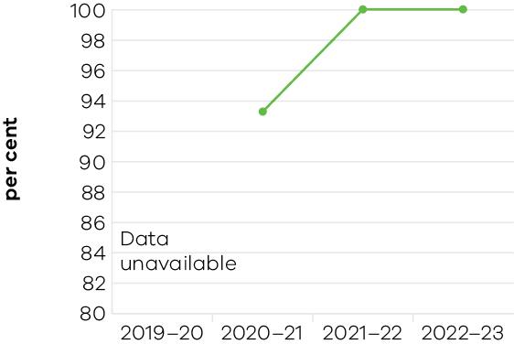
Figure 14: Recreational fishing and boating services and facilities initiatives achieved
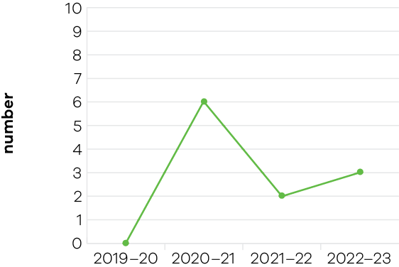
In 2022–23, the Victorian Fisheries Authority (VFA) completed 3 projects aimed at delivering improved infrastructure to make it easier and safer for recreational fishers and boat users to get out on the water. The projects were:
- Replacing the ageing wooden jetties of Warrnambool boat ramp with modern structures and a new grooved concrete surface. Completed in December 2022
- Replacing Lake Bullen Merri’s south beach ramp with new grooved concrete panels and a central pontoon, in addition to the construction of an underwater retaining wall. Completed in November 2022
Repairing the Newhaven jetty, including increasing the height of the lower deck, replacing the existing upper deck and improving the substructure. Completed in February 2022.

Performance against output performance measures
Table 13 represents performance against the Fishing, Boating and Game Management output. This output creates the conditions to ensure Victoria’s fisheries and game resources are sustainably used for both recreational and commercial purposes. This output delivers improved recreational boating and fishing services and facilities.
Table 13: Output – Fishing, Boating and Game Management
Performance measures | Unit of Measure | 2022–23 Actual | 2022–23 Target | Performance variation (%) | Result
Quantity
Community and stakeholder engagement information forums – Fisheries | number | 10 | 10 | 0.0% | 1
Complete quota setting processes for key quota managed fish stocks | number | 3 | 3 | 0.0% | 1
Complete stock assessment for key quota managed fish stocks | number | 3 | 3 | 0.0% | 1
Develop, implement and review overarching fisheries compliance strategy | number | 1 | 1 | 0.0% | 1
Enhance levels of community participation in achieving fisheries compliance through calls to the 13FISH reporting line  Lower result as call volumes can be influenced by the duration and location of major compliance operations, Fisheries Officer patrol patterns, the VFA’s increasing social media presence and subsequent education of the public of the needs for fisheries rules and regulations. | number | 1,816 | 1,950 | -6.9% | 3
Key fisheries managed in accordance with Fishery Management Plans | number | 6 | 6 | 0.0% | 1
Minimum uniformed fisheries officers maintaining operational coverage during priority fishing periods  Lower result due to existing VFA staff vacancies and extensive flood response assistance provided by VFA staff through 2022–23. | number | 19 | 20 | -5.0% | 3
Native and salmonid fish stocked  Lower result as the fish production year was impacted by unseasonal cold conditions and the state-wide floods that occurred in the spring/summer of 2022–23. These conditions impacted the breeding ability of fish from VFA and private hatcheries and therefore fish availability for stocking into public waters. | Number (000) | 8,016 | 10,000 | -19.8% | 3
Recreational boating and fishing infrastructure improvements delivered | number | 3 | 3 | 0.0% | 1
Quality
Key statutory obligations relevant to the Game Management Authority complied with (tabling annual report, audits, business plan and board appointments) | per cent | 100 | 100 | 0.0% | 1
Key statutory obligations relevant to the Victorian Fisheries Authority complied with (tabling annual report, audits, business plan and board appointments) | per cent | 100 | 100 | 0.0% | 1
Percentage of investigations into serious or organised fisheries offending that result in a prosecution, disruption or intelligence referral outcome | per cent | 90 | 90 | 0.0% | 1
Timeliness
Facilitate the delivery of game projects in line with key project milestones | per cent | 100 | 100 | 0.0% | 1
Proportion of fisheries cost recovery levies reviewed and set prior to the commencement of the licensing year | per cent | 100 | 100 | 0.0% | 1
Research project milestones and reports completed on time | per cent | 90 | 90 | 0.0% | 1
Cost
Total output cost | $ million | 98.0 | 95.4 | 2.7% | 2
Note:
1 Performance target achieved or exceeded
2 Performance target not achieved – but within 5% variance
3 Performance target not achieved – exceeds 5% variance
Table 14 represents performance against the Regional Development output. This output guides targeted place-based services and engagement with industry, communities, local councils and government departments, to enable and support economic growth. This includes facilitating jobs growth, infrastructure and new investment in regional Victoria and enhancing the liveability of Victoria’s regional cities and towns
Table 14: Output – Regional Development
Performance measures | Unit of Measure | 2022–23 Actual | 2022–23 Target | Performance variation (%) | Result
Quantity
Actual export sales generated for regional businesses as a result of participation in government programs  Higher result due to regional business’ participation in trade missions and export programs. | $ million | 57.7 | 45 | 28.2% | 1
Economic development and service delivery projects supported  Higher result reflects the introduction of the Living Local Regional Fund, which contributed significantly to this outcome. | number | 225 | 90 | 150.0% | 1
Jobs in regional Victoria resulting from government investment facilitation services and assistance | number | 1,017 | 1,000 | 1.7% | 1
New investment in regional Victoria resulting from government facilitation services and assistance  Higher result due to of a number of significant investment projects proceeding. | $ million | 682.4 | 500 | 36.5% | 1
Quality
Participant satisfaction with implementation of Regional Development Victoria programs  Higher result reflects an improvement in grant delivery, with only 3% of respondents being dissatisfied with the implementation of Regional Development programs. | per cent | 97 | 90 | 7.8% | 1
Cost
Total output cost | $ million | 166.9 | 176.2 | -5.3% | 1
The 2022–23 result is lower than the 2022–23 budget due to timing of payments for regional grant programs, with milestone payments now expected to be made in future years.
Note:
1 Performance target achieved or exceeded
2 Performance target not achieved – but within 5% variance
3 Performance target not achieved – exceeds 5% variance
Table 15 represents performance against the Suburban Development output. This output supports infrastructure and service provision to drive economic growth across metropolitan Melbourne, in partnership with local councils, business, community organisations and other government departments. The department also delivers targeted local outcomes in consultation with local communities through the Suburban Revitalisation Boards.
Table 15: Output – Suburban Development
Performance measures | Unit of Measure | 2022–23 Actual | 2022–23 Target | Performance variation (%) | Result
Quantity
Community meetings held with Metropolitan Partnerships  Higher result due to some Metropolitan Partnerships holding multiple community meetings and engagement activities based on the needs of local communities. | number | 22 | 18 | 22.2% | 1
Grants to support local communities and not-for-profit organisations  Lower result due to a program design amendment, which increased the maximum grant value per applicant for projects under the Living Local Fund – Community Grants stream (Stream 2). This amendment resulted in fewer grants being awarded, at a higher average value. | number | 190 | 470 | -59.6% | 3
Metropolitan Partnership Development Fund projects completed  Higher result as some Metropolitan Partnerships delivered multiple, lower value projects resulting in more projects being delivered than anticipated. | number | 15 | 7 | 114.3% | 1
Projects to promote local living and shopping precincts in suburbs  Higher result due to a large number of lower-value grant applications in the Suburban Grants stream (Stream 1) than anticipated. | number | 134 | 50 | 168.0% | 1
Projects to support community led recovery and revitalisation in disadvantaged suburbs  Higher result reflects recommendations of locally-led Suburban Revitalisation Boards. Those Boards recommended more projects at a slightly lower level of funding for each project than expected, resulting in more projects being funded. | number | 62 | 45 | 37.8% | 1
Quality
Participants satisfied with their experience of Metropolitan Partnership community meetings | per cent | 80 | 80 | 0.0% | 1
Cost
Total output cost | $ million | 31.1 | 19.8 | 57.3% | 3
The 2022–23 result is higher than the 2022–23 budget due to additional funding received for Our Suburbs: Living Local – supporting our suburbs to recover and thrive.
Note:
1 Performance target achieved or exceeded
2 Performance target not achieved – but within 5% variance
3 Performance target not achieved – exceeds 5% variance

Objective 5: Grow vibrant, active and creative communities
This objective seeks to increase the economic, social and cultural value of the creative, sport and recreation industries to Victoria, grow the number and yield of visitors, position Victoria as the creative state and a major events destination, and ensure the best cultural and sporting experiences are accessible to everyone.

Progress towards achieving this objective
In 2022–23, the department reported progress against this objective using the following indicators and outputs:
Objective Indicators
- Attendances at Creative Industries agencies and funded Major Performing Arts organisations
- Employment in the Creative Industries sector
- Employment in the Visitor Economy sector
- Tourists attracted to Victoria
Increase rates of community engagement, including through participation in sport and recreation
Outputs
- Creative Industries Access, Development and Innovation
- Creative Industries Portfolio Agencies
- Cultural Infrastructure and Facilities
- Sport and Recreation
Tourism and Major Events

Indicator: Attendances at Creative Industries agencies and funded major performing arts organisations
Table 16: Attendances at Creative Industries agencies
Measure (unit of measure) | 2019–20 | 2020–21 | 2021–22 | 2022–23
Attendances at creative industries portfolio agencies (number (‘000)) | 9,417 | 2,646 | 4,934 | 10,841

Figure 15: Attendances at Creative Industries portfolio agencies
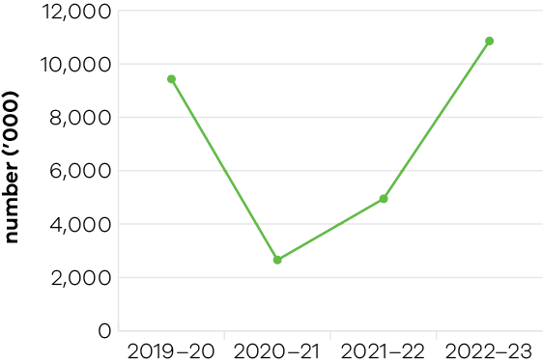
In 2022–23, Victoria’s state-owned arts and cultural institutions – Arts Centre Melbourne (ACM), Australian Centre for the Moving Image (ACMI), Geelong Arts Centre, Melbourne Recital Centre, Museums Victoria, National Gallery of Victoria (NGV), and State Library Victoria – were attended by approximately 10.8 million visitors – a significant improvement on previous years and an increase of 15.1% over the 2019–20 result. The trend data over this period shows the negative impact of closures during the pandemic but also illustrates the strong recovery and interest in the creative experiences on offer since the state re-opened.
The entire portfolio performed strongly as a result of investment in engaging exhibitions and productions, rejuvenated facilities and innovative programming such as:
- an increase in music performances, festivals and other events hosted at the Sidney Myer Music Bowl through the summer Live at the Bowl program. This contributed to the Bowl’s biggest ever season, welcoming over 335,000 people between September 2022 and April 2023
- Blockbuster exhibitions at the NGV including:
- the Melbourne Winter Masterpiece exhibitions, The Picasso Century and Pierre Bonnard: Designed by India Mahdavi
- Alexander McQueen: Mind, Mythos, Muse
- Melbourne Now
- ACMI’s Melbourne Winter Masterpiece exhibitions Light: Works from Tate’s Collection and Goddess: Power, Glamour, Rebellion
- Melbourne Museum attracted visitors to new exhibitions and attractions including Tyama: A deeper sense of knowing which brought together First Peoples knowledge of nature and cutting-edge immersive technology, and the opening of the Gandel Gondwana Garden
the State Library also achieved a record for attendance.
Table 17: Attendances at funded Major Performing Arts organisations
Measure (unit of measure) | 2019–20 | 2020–21 | 2021–22 | 2022–23
Attendances at funded Major Performing Arts organisations (number (‘000)) | 1,169 | 287 | 279 | 977

Figure 16: Attendances at funded Major Performing Arts organisations
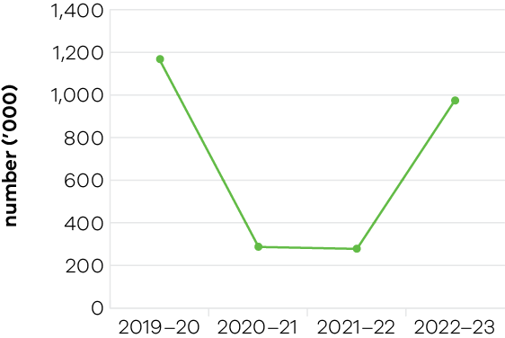
The 2022–23 full year attendances figure was 977,000, which is within 5% of the target for live attendances at performances. It is a decrease of 16.4% from the 2019–20 result of 1,169,000 attendances. The trend data over this period shows the negative impact of closures on funded major performing arts organisations during the pandemic. While some challenges remain for these companies, the significant increase in attendances in 2022–23 demonstrates a strong recovery. Victorian Government-funded major performing arts organisations in 2022–23 were:
- Ilbijerri Theatre Company
- Back to Back Theatre
- Melbourne Theatre Company
- The Australian Ballet
- Opera Australia
- Orchestra Victoria
- Melbourne Symphony Orchestra
- Malthouse Theatre
Victorian Opera.

Indicator: Employment in the Creative Industries sector
Table 18: Employment in the Creative Industries sector
Measure (unit of measure) | 2019–20 | 2020–21 | 2021–22 | 2022–23
Number of primary jobs in the creative industries (number) (2021 Census based) | 289,000 | 298,000 | 303,000 | 311,000
Prior measure (2016 Census based)* | 292,000 | 304,000 | 309,000 | –
* Following the 2021 Census, employment figures were rebased in November 2022, impacting employment figures back to 2016.
Figure 17: Number of primary jobs in the creative industries
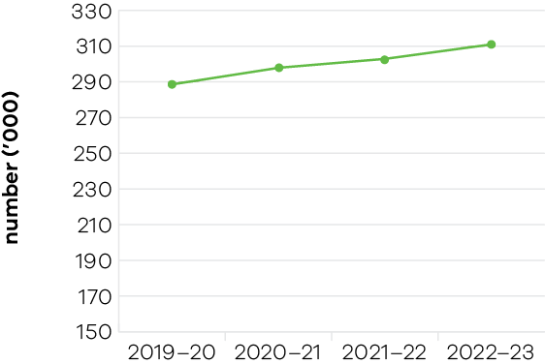
During 2022–23 an average of 311,000 people were employed in creative or cultural activities as their primary jobs, representing 8.7% of total employment across Victoria. Creative industry employment grew by 2.6% from 2021–22 to 2022–23.
- Employment across Victoria’s screen industry continued to grow. In 2022–23, 3,231 full-time equivalent jobs were created through Victorian Government-supported productions – a 79% increase from 2019. Since the introduction of the VicScreen strategy in 2021, an average of 11,215 project jobs have been generated per year, a 34% increase from 2019
- The 2023 RISING festival – backed by the Victorian Government through Creative Victoria and Visit Victoria – provided jobs for more than 1,800 people, including 800 artists and 1,000 event workers
- Set to open in August 2023, the Geelong Arts Centre’s $140 million Little Malop Street redevelopment created more than 600 jobs during construction. The redevelopment had a strong focus on local jobs, with the builder Lendlease prioritising apprenticeships, contractors and businesses through the Geelong First Commitment initiative. Of the 45 trade packages engaged to work on the project, 12 were local contractors and an additional 16 were non-local contractors committed to employing predominantly local Geelong labour. The project employed approximately 270 workers from the G21 region
- Construction works for the Melbourne Art Precinct Transformation project are underway. Work to upgrade Arts Centre Melbourne’s Theatres Building and build the foundations for the new 18,000m² urban garden commenced in May 2023 with 80 workers on site. This number is expected to reach 300 as this package of works reaches its peak
- Victoria’s creative industries portfolio agencies continued to employ more than 2500 people across Melbourne and regional Victoria
In 2022–23, Creative Victoria grants programs supported creative individuals, collectives and organisations of all sizes and creative disciplines, strengthening Victoria’s creative industries workforce. The Music Works program, Creators Fund, Creative Ventures program and Creative Projects Fund collectively created more than 4,300 paid employment opportunities.

Indicator: Employment in the Visitor Economy
Table 19: Employment in the Visitor Economy
Measure (unit of measure) | 2019–20 | 2020–21 | 2021–22 | 2022–23
Number of jobs in the visitor economy sector (number) | 232,000 | 120,000 | 171,100* | Data expected in 2024
* This is the latest available data from the State Tourism Satellite Accounts 2021–22 produced by Tourism Research Australia, May 2023.
Note: A revised approach to employment metrics has been taken in the latest 2021–22 State Tourism Satellite Accounts (STSA) release which has created a major shift in the time series due to the adoption of filled jobs from the Labour Account, rather than employed persons based on the Labour Force survey. Accordingly, historical data has been revised to 238,300 jobs in 2019–20 and 109,400 jobs in 2020–21 in the May 2023 STSA release.
Figure 18: Number of jobs in the visitor economy sector
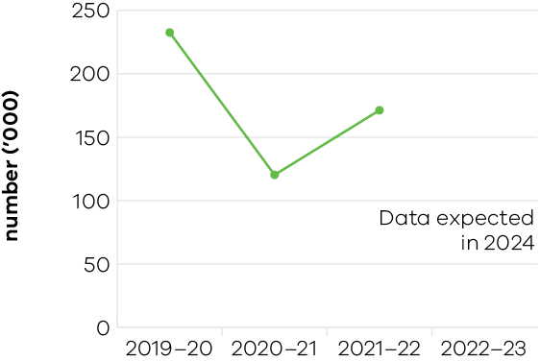
The visitor economy is a major employer in Victoria and a strong contributor to the state’s economy. In total 171,100 direct and indirect tourism filled jobs were recorded in 2021–22, up from 2020–21 levels but still below the pre-COVID-19 result.
Direct tourism filled jobs in Victoria increased in 2021–22 to reach 121,900. The distribution of tourism jobs across industries shows that cafés, restaurants and takeaway food services accounted for the largest share of direct tourism filled jobs (40.8%), followed by retail trade (16.0%), accommodation (14.2%) and clubs, pubs, taverns and bars (8.7%).
The department continued to deliver initiatives to support jobs growth in 2022–23 under the Victorian Visitor Economy Recovery and Reform Plan. These initiatives included:
- launching Experience Victoria 2033, which will provide certainty for businesses and investors within the industry, encourage new and innovative tourism products and engage with local communities
- supporting the Victoria Tourism Industry Council to deliver industry-strengthening initiatives
- supporting the Young Tourism Network to deliver the Young People in Tourism pilot program, a professional development program to engage and attract young people to a career in tourism.
- supporting the regional tourism network to develop destination management plans, local area action plans, regional workforce plans, and implement a suite of industry development and workforce initiatives to improve the capacity and capability of industry
supporting 2 registered Aboriginal parties through the First Peoples Tourism pilot to undertake tourism product analysis and develop self-determined cultural tourism plans.
Examples of projects supported include:
- the Great Ocean Road Regional Tourism Jobs Bank – a free service that promotes jobs to potential job seekers
- the Grampians Prime Mentoring program – providing support to businesses to develop refreshed visitor experiences aligned to their destination management and marketing strategies
a campaign to raise awareness of careers in tourism, targeted to refugee and migrant communities – delivered by Ballarat Regional Tourism in partnership with the Ballarat Regional Multicultural Council.

Indicator: Tourists attracted to Victoria
Table 20: Tourists attracted to Victoria
Measure* (unit of measure) | 2019–20 | 2020–21 | 2021–22 | 2022–23
Number of domestic overnight visitors (number (million)) | 28.3 | 13.4 | 18.2 | 27.5
Number of international visitors (number (million)) | 2.8 | 0.01 | 0.16 | 1.4
Visitor expenditure: domestic ($ billion) | 23.2 | 9.7 | 15.4 | 30.8
Visitor expenditure: international ($ billion) | 8.1 | 0.08 | 1.1 | 4.2
Visitor expenditure: regional Victoria (domestic) ($ billion) | 11.3 | 7.0 | 9.9 | 16.4
Visitor expenditure: regional Victoria (international) ($ million) | 538 | n/a** | n/a** | n/a**
* All figures are for the year ending March from the National Visitor Survey and International Visitor Survey (published by Tourism Research Australia).
** International visitor data is currently limited to state-wide results. Survey interviews are progressively returning and regional metrics will be available later in 2023–24.
Figure 19: Number of domestic overnight visitors
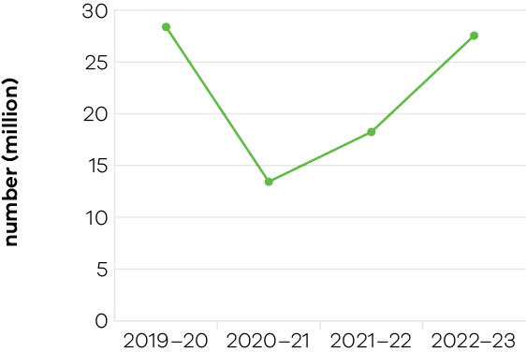
Figure 20: Number of international visitors
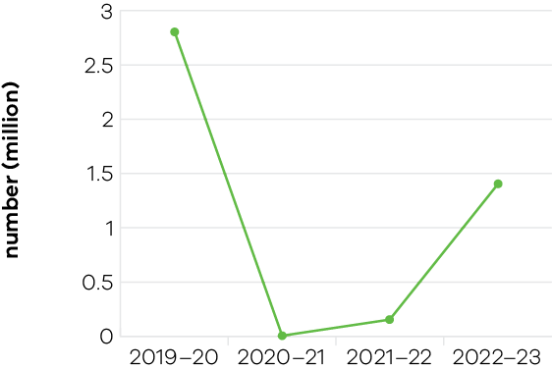
Figure 21: Visitor expenditure: domestic
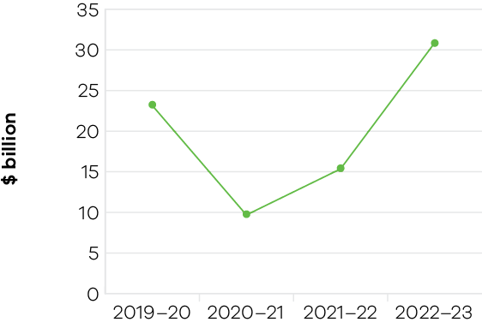
Figure 22: Visitor expenditure: international
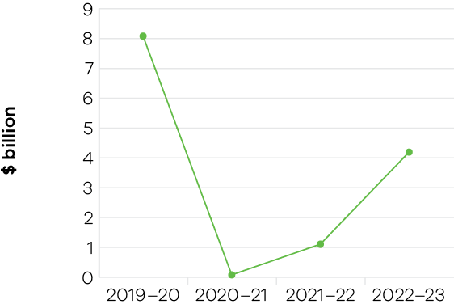
Figure 23: Visitor expenditure: regional Victoria (domestic)
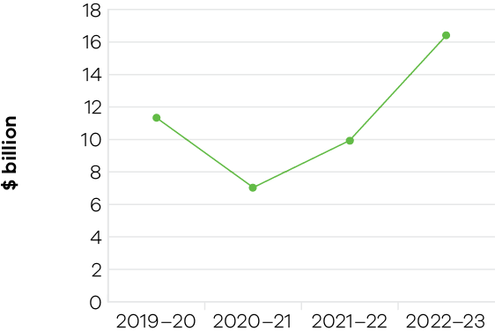
Figure 24: Visitor expenditure: regional Victoria (international)*
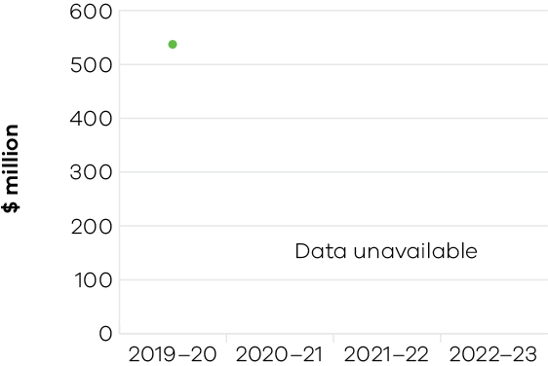
* International visitor data is currently limited to state-wide results.
Results for the year ending March 2023 show further strengthening in the sector with a full recovery in expenditure, which surpassed pre-pandemic levels, reaching a record high of $35 billion. Visitor growth has also been strong and is almost back to a full recovery at 98% of the pre-pandemic level.
Overall tourism generated $96 million per day in visitor expenditure in Victoria for the year ending March 2023.
This outcome reflects strong tourism demand for Victorian experiences, particularly in the domestic sector where spending well exceeded the pre-pandemic March 2019 level (+44%) to $30.8 billion, noting very strong growth of 101% year-on-year.
Regional Victoria continued to lead the overall recovery with domestic overnight spend, visitors and nights all above pre-pandemic levels. Domestic overnight spend in regional Victoria was 60% above the pre-pandemic performance at $10.9 billion. Domestic overnight visitor spend to/within regional Victoria also fully recovered and was 6% above the pre-pandemic performance at $18.9 million.
All Victorian regions noted record-high levels of domestic overnight spend above pre-pandemic levels, with particularly high growth noted in Phillip Island, Victoria’s High Country, Goldfields, Geelong and the Bellarine and Grampians. International travel to Victoria continued to progressively rebuild, and all key metrics were approximately halfway back to recovery. International spend was at 49% of the pre-pandemic level at $4.2 billion, while international overnight visitors were at 46% of the pre-pandemic result (1.4 million).
China returned as Victoria’s number one international market in expenditure since borders reopened in January 2023. India also continued to grow its international market with visitor expenditure 11% higher than pre-pandemic levels for the year ending March 2023.
Delivery continued for the following initiatives within the Victorian Visitor Economy Recovery and Reform Plan in 2022–23:
- Continued roll out of Visit Victoria’s marketing campaigns Stay close, go further and Get Set
- Continued work with Visit Victoria and the Melbourne Convention Bureau, delivering a strong calendar of major, business and regional events for Victoria including the Melbourne Winter Masterpieces Goddess exhibition at ACMI, SpineWeek 2023 and the Grampians Grape Escape
- Facilitated public and private sector infrastructure development through the $310 million Tourism Infrastructure program
- Launched the $3 million Visitor Servicing program in May 2023 – a new grant program to develop innovative ways to encourage people to stay longer and experience the best of Victoria
Announced the successful applicants of the Small and Medium Events program in June 2023. The program supports the recovery of the events sector across Greater Melbourne.

Indicator: Increase rates of community engagement, including through participation in sport and recreation
Table 21: Increase rates of community engagement, including through participation in sport and recreation
Measure (unit of measure) | 2019–20 | 2020–21 | 2021–22 | 2022–23
Percentage of adult Victorians participating in sport at least once per year (%) | 91.2 | 89.7 | 90.9* | 89.6**
* Updated from calendar year to financial year figure based on since released AusPlay data.
** This is the latest available AusPlay data and covers January to December 2022.
Figure 25: Percentage of adult Victorians participating in sport at least once per year
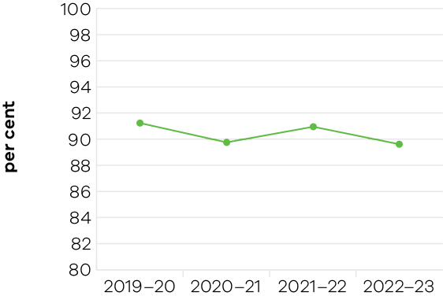
Impacts of the pandemic have continued to be felt by the Victorian community sport and active recreation sectors. While overall participation rates have largely returned to pre-pandemic levels, recovery has not been consistent, with only some demographics trending back to pre-pandemic participation rates.
By investing in targeted programs, the sector has been supported to deliver community sport and active recreation participation opportunities and reduce barriers to participation. Over 1,400 grants totalling more than $2.2 million were delivered across the Sporting Club and the Aboriginal Sport Participation grants programs to assist with accessing new uniforms and equipment, support the capacity and capability of the sector and increase participation, particularly among under-represented groups.
The Get Active Kids voucher program increased participation in organised sport and recreation activities. Eligible Victorian families were assisted with vouchers of up to $200 to meet the costs of membership and registration, uniforms and equipment to support their children to participate. To date, over 115,000 vouchers have been issued to eligible families through the program.
The Victorian Government continued to tackle barriers to gender equality in sport and active recreation through the Office for Women in Sport and Recreation (OWSR) and Change Our Game initiative, which received funding of $11.57 million over 4 years in the 2021–22 Victorian State Budget. Work on breaking down barriers was achieved through various policies, programs and initiatives to increase participation, leadership and visibility of women and girls in sport and active recreation.
Additionally, the Fair Access Policy Roadmap was launched in August 2022. An Australia-first policy, it addresses barriers to the gender equitable access and use of community sports infrastructure and is being delivered with local government and in alignment with the Gender Equality Act 2020. Through the Balance the Board policy, 96% of funded state sporting associations and state sport and active recreation bodies met the Victorian Government’s requirement to have at least 40% women board directors as at June 2023.
In 2022–23 the Victorian Institute of Sport (VIS) supported 468 athletes under VIS scholarships across 48 sports. A total of 104 Victorian athletes (24% of the national team) represented Australia at the Birmingham 2022 Commonwealth Games, including 67 VIS scholarship holders – with 17 VIS athletes winning 13 gold medals and 42 VIS athletes finishing in a podium position. Across various world championships in 2022–23, 10 world championship titles were awarded to 7 VIS athletes and 38 VIS athletes secured podium level results.
Victoria’s high-performance athletes, coaches and support staff benefitted from government investment in the world-class network of 44 state sport facilities that supported 55 professional teams. Investment in state facilities supported events of national and international significance, providing an opportunity to showcase athletes performing at their best and inspire Victorians to participate in sport and active recreation. A total of 95 sporting events of national or international level were facilitated through the Significant Sporting Events program. These events enabled Victorian athletes to compete on home soil, provided inspiration for fans to emulate their heroes and encouraged them to get active and healthy through sport.
The Victorian Government supported significant investment in community sport and active recreation infrastructure to improve facilities, spaces and environments that Victorians use to participate. Community sport and active recreation infrastructure is estimated to deliver more than $7 billion in benefits to Victoria per annum (including economic, social and wellbeing and health benefits). In 2022–23, over $100 million was allocated to support more than 210 community sport and active recreation projects. This included funding 91 projects through the 2022 Local Sports Infrastructure Fund and 11 projects through the 2022–23 Country Football and Netball Program.
Increased participation in sport was supported by the completion of the Victorian Government’s investment in AFL venue upgrades, benefitting professional women’s sport and leveraging community participation outcomes from the improved and expanded facilities. Other projects completed included delivery of the Home of the Matildas, part of the State Football Centre which provides 1,100 hours per annum of high-performance programs and a further 3,500 hours per annum for La Trobe University and community use in addition to use by Football Victoria.

Performance against output performance measures
Table 22 represents performance against the Creative Industries Access, Development and Innovation output. This output supports the creative industries to deliver economic, social and cultural benefit through talent and leadership; the creative and business ecology; innovation and social impact; participation and place making; and international engagement.
Table 22: Output – Creative Industries Access, Development and Innovation
Performance measures | Unit of Measure | 2022–23 Actual | 2022–23 Target | Performance variation (%) | Result
Quantity
Attendances at major performing arts organisations | number (000) | 977 | 1,000 | -2.3% | 2
Creative learning partnerships  Higher result due to partnership funding from the Department of Education enabling 5 more projects to be supported. | number | 19 | 14 | 35.7% | 1
Design organisations supported | number | 21 | 22 | -4.5% | 2
International market development and exchange initiatives | number | 12 | 12 | 0.0% | 1
Organisations recurrently funded  Higher result due to the introduction of additional initiatives under the Creative Enterprises Program. | number | 179 | 154 | 16.2% | 1
Project companies and artists funded  Lower result due to the conclusion of COVID-19 related programs. | number | 427 | 469 | -9.0% | 3
Project companies and artists funded which are regionally based | per cent | 24 | 23 | 4.3% | 1
Regionally based organisations recurrently funded | number | 54 | 56 | -3.6% | 2
Creative Victoria grant recipients who met or exceeded agreed milestones | per cent | 86 | 85 | 1.2% | 1
Quality
Public information rated ‘informative’ or ‘very informative’ by grant applicants  Lower result largely due to the transition to a new questionnaire format. | per cent | 83 | 90 | -7.8% | 3
Timeliness
Performance and grant agreements acquitted within timeframes specified in the funding agreement | per cent | 87 | 83 | 4.8% | 1
Cost
Total output cost | $ million | 66.4 | 55.3 | 20% | 3
The 2022–23 result is higher than the 2022–23 budget mainly due to additional funding received for a number of initiatives including the Live Music Restart package.
Note:
1 Performance target achieved or exceeded
2 Performance target not achieved – but within 5% variance
3 Performance target not achieved – exceeds 5% variance
Table 23 represents performance against the Creative Industries Portfolio Agencies output. This output promotes, presents and preserves our heritage and the creative industries through Victoria’s creative industries agencies: Arts Centre Melbourne, Australian Centre for the Moving Image, Docklands Studios Melbourne, VicScreen, Geelong Arts Centre, Melbourne Recital Centre, Museums Victoria, National Gallery of Victoria, and the State Library Victoria.
Table 23: Output – Creative Industries Portfolio Agencies
Performance measures | Unit of Measure | 2022–23 Actual | 2022–23 Target | Performance variation (%) | Result
Quantity
Additional employment from production supported by VicScreen  Higher result due to the number of high value productions, features and series secured. | number | 11,071 | 10,400 | 6.5% | 1
Agency website visitation  Higher result due to digital uplift across the portfolio. The expanded web offering includes improved access to content and ticketing. | number (000) | 30,364 | 21,200 | 43.2% | 1
Attendances at Arts Centre Melbourne  Higher result due to an increased number of performances scheduled at Sidney Myer Music Bowl and attendances at outdoor venues. | number (000) | 2,612 | 2,200 | 18.7% | 1
Attendances at Australian Centre for the Moving Image  Higher result due to attendances at ACMI exceeding expectations. | number (000) | 1,108 | 1,051 | 5.4% | 1
Attendances at Geelong Arts Centre  Higher result due to successful programming and events. | number (000) | 142 | 100 | 42.0% | 1
Attendances at Melbourne Recital Centre  Lower result reflects changed audience behaviours observed across the industry. | number (000) | 165 | 230 | -28.3% | 3
Attendances at Museums Victoria  Higher result due to strong attendance at new attractions and exhibitions. | number (000) | 2,240 | 2,000 | 12.0% | 1
Attendances at National Gallery of Victoria  Higher result due to successful major exhibitions including Melbourne Now. | number (000) | 2,461 | 2,235 | 10.1% | 1
Attendances at State Library Victoria  Lower result due to continuing recovery from impacts of COVID-19 in the first half of 2022–23. This result still represents record visitation for State Library Victoria. | number (000) | 2,113 | 2,250 | -6.1% | 3
Direct Full-Time Equivalent (FTE) roles from production supported by Vic Screen  Higher result due to the number of high value productions, features and series secured. | number | 3,231 | 2,335 | 38.4% | 1
Members and friends of agencies | number | 55,239 | 57,000 | -3.1% | 2
Students participating in agency education programs  Higher result reflecting increased confidence in schools resuming onsite excursions and increased access to online events. | number | 613,614 | 550,000 | 11.6% | 1
Value of film, television and digital media production supported by Vic Screen  Higher result due to the number of high value productions, features and series secured. | $ million | 421 | 350 | 20.3% | 1
Volunteer hours  Lower result due to program delivery changes and slow recovery of volunteer work following COVID-19 closures. | number | 54,286 | 98,900 | -45.1% | 3
Quality
Agency collections storage meeting industry standard | per cent | 85 | 86 | -1.2% | 2
Visitors satisfied with visit: Arts Centre Melbourne | per cent | 91 | 90 | 1.1% | 1
Visitors satisfied with visit: Australian Centre for the Moving Image | per cent | 97 | 95 | 2.1% | 1
Visitors satisfied with visit: Geelong Arts Centre | per cent | 95 | 98 | -3.1% | 2
Visitors satisfied with visit: Melbourne Recital Centre | per cent | 98 | 95 | 3.2% | 1
Visitors satisfied with visit: Museums Victoria | per cent | 93 | 96 | -3.1% | 2
Visitors satisfied with visit: National Gallery of Victoria | per cent | 97 | 95 | 2.1% | 1
Visitors satisfied with visit: State Library Victoria | per cent | 91 | 90 | 1.1% | 1
Cost
Total output cost | $ million | 498.0 | 427.3 | 16.5% | 3
The 2022–23 result is higher than the 2022–23 budget due to additional funding for Creative Industries Portfolio agencies.
Note:
1 Performance target achieved or exceeded
2 Performance target not achieved – but within 5% variance
3 Performance target not achieved – exceeds 5% variance
Table 24 represents performance against the Cultural Infrastructure and Facilities output. This output supports Victorian cultural venues and State-owned facilities through strategic assessment and provision of advice on portfolio infrastructure proposals and projects. The output includes consolidation of portfolio asset management plans and management of funding programs for maintenance and minor capital works.
Table 24: Output – Cultural Infrastructure and Facilities
Performance measures | Unit of Measure | 2022–23 Actual | 2022–23 Target | Performance variation (%) | Result
Quantity
All facility safety audits conducted | number | 16 | 16 | 0.0% | 1
Infrastructure development projects underway | number | 13 | 13 | 0.0% | 1
Quality
State-owned tenanted cultural facilities maintained to agreed service standards | per cent | 94 | 90 | 4.4% | 1
Success measures of projects achieved | per cent | 93 | 90 | 3.3% | 1
Timeliness
Cultural Facilities Maintenance Fund projects delivered within agreed timeframes | per cent | 94 | 90 | 4.4% | 1
Cost
Total output cost | $ million | 52.6 | 72.0 | -27.0% | 1
The 2022–23 result is lower than the 2022–23 budget due to the timing of payments for the Creative Infrastructure Program, with milestone payments now expected to be made in future years.
Note:
1 Performance target achieved or exceeded
2 Performance target not achieved – but within 5% variance
3 Performance target not achieved – exceeds 5% variance
Table 25 represents performance against the Sport and Recreation output. This output provides strategic leadership and investment in the sport and recreation industry through innovation, sector and industry development and funding support. It supports community participation and inclusion in the sport and recreation sector by strengthening the capacity of sport and recreation organisations to deliver participation opportunities, improving community sport and recreation facilities across the state and guiding the development and management of State-level sporting facilities and events, to encourage participation by all Victorians.
Table 25: Output – Sport and Recreation
Performance measures | Unit of Measure | 2022–23 Actual | 2022–23 Target | Performance variation (%) | Result
Quantity
Combat sports licences, registrations and permits issued  Higher result due to significantly higher industry demand for events, licenses and registrations following COVID-19 interruptions. | number | 751 | 550 | 36.5% | 1
Community Facility Grants: number approved  Higher result due to a higher number of individual grants funded with lower than anticipated individual grant values. | number | 214 | 170 | 25.9% | 1
Funded State Sport and Recreation Associations that have a minimum of 40 per cent women on their boards  Higher result due to increased engagement activities to monitor and support compliance. | per cent | 96 | 90 | 6.7% | 1
Local Sports Infrastructure grant recipients which are regionally based  Higher result due to the Country Football and Netball Program. This program supports projects in rural, regional, outer metropolitan Melbourne LGAs. | per cent | 52.94 | 45 | 17.6% | 1
Organisations submitting nominations for the Community Sport and Recreation Awards  Higher result due to sport and recreation activities returning following the pandemic which has spurred additional nominations. | number | 85 | 70 | 21.4% | 1
Projects in progress that relate to the planning and development of state level facilities  Higher result due to additional planning studies and infrastructure projects commencing in 2022–23. | number | 20 | 14 | 42.9% | 1
Significant Sporting Events Program – events facilitated  Higher result due to the strong recovery of the events sector following COVID-19. | number | 95 | 75 | 26.7% | 1
Sport and recreation organisations undertaking programs or activities to enhance participation | number | 109 | 112 | -2.7% | 2
Sporting club grants to recipients which are based in low socio-economic areas as identified by the SEIFA index  Higher result due to a higher proportion of eligible applications being received from low-SEIFA areas for the program. | per cent | 50 | 45 | 11.1% | 1
Sporting club grants to recipients which are regionally based  Higher result due to a higher proportion of eligible applications being received from regional areas through these programs. | per cent | 43 | 35 | 22.9% | 1
Sporting club grants: number approved  Higher result due to additional funding to support recommended grants from the Community Support Fund and DFFH. | number | 1,444 | 750 | 92.5% | 1
Sports with athletes on Victorian Institute of Sport (VIS) scholarships  Higher result due to ongoing impact of increased investment into the VIS through the ‘A sustainable Victorian Institute of Sport’ initiative enabling it to increase the number of sport programs and VIS athletes under scholarship. | number | 48 | 45 | 6.7% | 1
Victorian categorised athletes supported by the VIS  Higher result due to the continued investment in the VIS under the ‘A sustainable Victorian Institute of Sport’ initiative allowing it to offer all Victorian categorised athletes a VIS scholarship in 2022–23. | per cent | 98 | 60 | 63.3% | 1
Victorian Institute of Sport scholarship holders on national teams/squads  Higher result due to a higher number of athletes being selected on national teams/squads. | per cent | 65 | 60 | 8.3% | 1
Quality
Contract management of outdoor recreation camps meets agreed key performance indicators | per cent | 87 | 90 | -3.3% | 2
Timeliness
Community Cricket Program milestones delivered within agreed timeframes | per cent | 94 | 90 | 4.4% | 1
Cost
Total output cost | $ million | 553.4 | 361.9 | 52.9% | 3
The 2022–23 result is higher than the 2022–23 budget mainly due to additional funding received for major sporting events.
Note:
1 Performance target achieved or exceeded
2 Performance target not achieved – but within 5% variance
3 Performance target not achieved – exceeds 5% variance
Table 26 represents performance against the Tourism and Major Events output. This output maximises employment and the long-term economic benefits of tourism and major events to Victoria by developing and marketing the State as a competitive destination.
Table 26: Output – Tourism and Major Events
Performance measures | Unit of Measure | 2022–23  Actual | 2022–23 Target | Performance variation (%) | Result
Quantity
Always Live events held  Higher result as the program was able to identify an increased quantity of event concepts. | number | 68 | 50 | 36.0% | 1
Major sporting and cultural events held  Higher result due to demand for major events and additional funding available within the period resulting in a higher number of events held. | number | 40 | 27 | 48.1% | 1
Tourism infrastructure projects facilitated | number | 38 | 38 | 0.0% | 1
Visit Victoria’s total engaged digital audience | number (million) | 6.7 | 6.7 | 0.0% | 1
Visitor expenditure: domestic  Higher result due to domestic tourism expenditure recovering faster than expected influenced by strong pent-up demand to travel. | $ billion | 30.8 | 23.2 | 32.8% | 1
Visitor expenditure: international  Lower result due to lower demand for international travel. | $ billion | 4.2 | 9 | -53.3% | 3
Visitor expenditure: regional Victoria (domestic)  Higher result due to domestic tourism expenditure in regional Victoria recovering faster than expected influenced by strong pent-up demand to travel. | $ billion | 16.4 | 11.1 | 47.7% | 1
Visitor expenditure: regional Victoria (international)  Result not available as international regional expenditure estimates from the International Visitor Survey (IVS) are not currently available due to survey methodology and data limitations. IVS survey interviews are progressively returning and regional metrics will be available later in 2023–24. | $ million | N/A | 600 | n/a | 3
Visitor expenditure: regional Victoria (intrastate overnight)  Higher result due to intrastate overnight regional expenditure recovering faster than expected reflecting strong pent-up demand by Victorians to travel locally. | $ billion | 8.5 | 5.7 | 49.1% | 1
Visitors (domestic overnight)  Lower result as domestic interstate travel continues to recover post-pandemic. | number (million) | 27.5 | 29.5 | -6.8% | 3
Visitors (international)  Lower result due to lower demand for international travel. | number (million) | 1.4 | 3.2 | -56.3% | 3
Visitors: regional Victoria (intrastate overnight) | number (million) | 16.2 | 16.4 | -1.2% | 2
Quality
Value of media coverage generated: domestic | $ million | 24 | 24 | 0.0% | 1
Value of media coverage generated: international  Higher result due to Visit Victoria being able to generate significant global media coverage by hosting more journalists from around the world as international borders reopened. | $ million | 113 | 48 | 135.4% | 1
Timeliness
Completion of post-event reports and economic impact assessments of each event (where required) within agreed timeframes | per cent | 100 | 100 | 0.0% | 1
Cost
Total output cost | $ million | 441.8 | 298.4 | 48.1% | 3
The 2022–23 result is higher than the 2022–23 budget due to additional Major Events funding that was held centrally until contractual arrangements were finalised.
Note:
1 Performance target achieved or exceeded
2 Performance target not achieved – but within 5% variance
3 Performance target not achieved – exceeds 5% variance

Objective 6: Deliver high-quality training and skills to meet industry needs and jobs for a growing economy
This objective seeks to develop the skills of Victorians to meet the current and future needs of industry and business by ensuring that TAFEs and training providers deliver high-quality and accessible training.

Progress towards achieving this objective
In 2022–23, the department reported progress against this objective using the following objective indicators and outputs:
Objective Indicators
- Proportion of VET students satisfied with training
- Proportion of VET students with an improved employment status after training
Proportion of VET students who achieved their main reason for training
Outputs
Training, Higher Education and Workforce Development

Indicator: Proportion of VET students satisfied with training
Table 27: Proportion of VET students satisfied with training
Measure (unit of measure) | 2019–20 | 2020–21 | 2021–22 | 2022–23
Proportion of VET students satisfied with training (%) | 85.3 | 86.7 | 86.5 | 86.4

Figure 26: Proportion of VET students satisfied with training
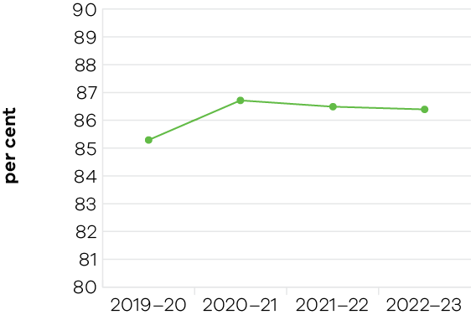
The proportion of VET students satisfied with training has remained strong over the past 4 years. The 2022–23 result of 86.4% satisfaction is a 1.3% increase over the 2019–20 result of 85.3% satisfaction.
This measure has improved since Skills First reforms were introduced in 2017. Framed by healthy increases in students’ perceptions of positive teaching and assessment practices, the high proportion of VET students satisfied with training speaks to the quality of the training system in Victoria.
The measure remained strong despite COVID-19-related disruptions to students’ studies. Business continuity support provided by the Victorian Government to training providers has allowed them to maintain suitable levels of training post-pandemic and facilitate student success.
The Victorian Government has invested in learning environments, quality teaching and contemporary curriculum support to ensure high levels of quality training and student satisfaction are maintained and realised. The stability of quality and student satisfaction with training benefitted through investments in state-of-the-art facilities, including the award-winning Warrnambool Library and Learning Centre at South West TAFE. Additionally, including the Certificate IV in Training and Assessment on the free TAFE course list, and funding curriculum resource development have contributed to high levels of stability and satisfaction.

Indicator: Proportion of VET students with an improved employment status after training
Table 28: Proportion of VET students with an improved employment status after training
Measure (unit of measure) | 2019–20 | 2020–21 | 2021–22 | 2022–23
Proportion of VET students with an improved employment status after training (%) | 50.1 | 55.4 | 55.7 | 64.8

Figure 27: Proportion of VET students with an improved employment status after training
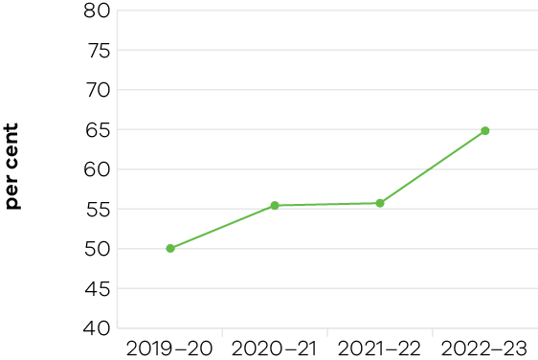
Victorian VET students have experienced increasingly positive employment outcomes as a result of Victorian Government measures to improve the quality and relevance of training, and the strong labour market. The 2022–23 result of 64.8% is an increase of 29.3% over the 2019–20 result of 50.1%.
The large increase in this measure in 2022 was partly driven by Victoria’s low unemployment rate, which was forecast to average 3.8% in 2022–23 and was at historically low levels. The job market was favourable for VET graduates, whether they were already employed or were seeking jobs across both metropolitan and regional Victoria.
With the strong labour market, students were increasingly likely to be employed at the start of their training, and subsequently complete training to gain extra skills for their job. Students increasingly sought to pursue more flexible training opportunities beyond full qualifications, such as skill sets and more external delivery modes, including online and in the workplace.

Indicator: Proportion of VET students who achieved their main reason for training
Table 29: Proportion of VET students who achieved their main reason for training
Measure (unit of measure) | 2019–20 | 2020–21 | 2021–22 | 2022–23
Proportion of VET students who achieved their main reason for training (%) | 83.5 | 85.1 | 85.3 | 89.2

Figure 28: Proportion of VET students who achieved their main reason for training
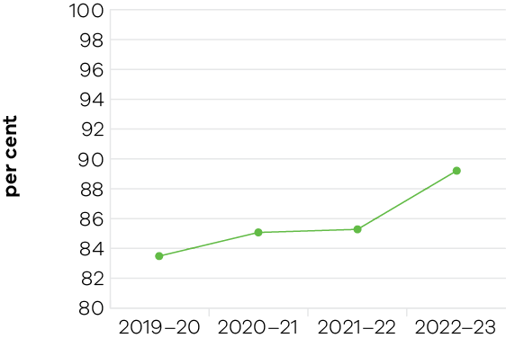
The steady increase in this measure over the past 4 years speaks to the alignment between training, job prospects and attainment. The 2022–23 result of 89.2% is an increase of 6.8% over the 2019–20 result of 83.5%.
VET students who achieved their main reason for training were well positioned to get a job or improve their employment status in the strong labour market. Priority areas such as the care economy, clean economy and the Big Build infrastructure program were attractive options for students who benefitted from strong links between training and these sectors. This allowed Victorians to complete purposeful training, achieve their personal goals and be gainfully employed.

Performance against output performance measures
Table 30 represents performance against the Training, Higher Education and Workforce Development output. This output supports Victorians to gain the skills and capabilities essential for success in employment and further training or study. The Department works with the TAFE and training sector to deliver quality training that strongly supports industry to meet the evolving needs of the economy, promotes equity and addresses disadvantage, with an emphasis on growth sectors of the economy. This output includes the functions of training system design, industry engagement, contracting and monitoring of quality and training services including accredited and pre-accredited vocational education and training through to adult community education.
Table 30: Output – Training, Higher Education and Workforce Development
Performance measures | Unit of Measure | 2022–23 Actual | 2022–23 Target | Performance variation (%) | Result
Quantity
Number of enrolments in the Free TAFE for priority courses initiative  Lower result due to the strong labour market which reduced demand for government-funded full qualifications, which includes most Free TAFE courses.  This performance measure relates to the calendar year. | number | 47,088 | 50,000 | -5.8% | 3
Number of government subsidised apprenticeship course enrolments  Higher result due to government initiatives to support apprenticeships.  This performance measure relates to the calendar year. | number | 56,657 | 49,900 | 13.5% | 1
Number of government subsidised course enrolments  This performance measure relates to the calendar year. | number | 322,475 | 317,500 | 1.6% | 1
Number of government subsidised course enrolments by students eligible for fee concession  Lower result due to training delivered through Free TAFE and JobTrainer programs, where students are not required to report fee concession eligibility.  This performance measure relates to the calendar year. | number | 50,373 | 60,000 | -16.0% | 3
Number of government subsidised course enrolments by students living in regional Victoria  This performance measure relates to the calendar year. | number | 85,244 | 81,300 | 4.9% | 1
Number of government subsidised course enrolments in the TAFE Network  This performance measure relates to the calendar year. | number | 141,215 | 145,000 | -2.6% | 2
Number of government subsidised foundation module enrolments  Lower result due to the impact of low migration levels in 2022 resulting in fewer migrants requiring foundation skills training. There was also continuing substitution from accredited foundation training to other types of training.  This performance measure relates to the calendar year. | number | 86,331 | 150,000 | -42.4% | 3
Number of government subsidised pre-accredited module enrolments funded through the Adult Community and Further Education (ACFE) Board  Higher result partly due to stronger than expected take-up of shorter pre-accredited training modules in 2022, delivering agile and responsive training.  This performance measure relates to the calendar year. | number | 52,180 | 47,400 | 10.1% | 1
Number of students without Year 12, or Certificate II or above, enrolled in a government subsidised course at Certificate III or above  This performance measure relates to the calendar year. | number | 55,374 | 58,000 | -4.5% | 2
Proportion of government subsidised enrolments related to qualifications that will lead to jobs and economic growth  Higher result may be due to the strong labour market which likely increased demand for training more closely linked to employment.  This performance measure relates to the calendar year. | per cent | 91.1 | 83 | 9.8% | 1
Quality
Proportion of employers of apprentices and trainees who are satisfied with training  This performance measure relates to the calendar year. | per cent | 77.1 | 78.1 | -1.3% | 2
Proportion of VET completers who achieved their main reason for training  Higher result could provide an indicator of the suitability of training and the availability of information on courses and providers, which enabled prospective students to choose training that was appropriate for their needs.  This performance measure relates to the calendar year. Data for the 2022–23 actual relates to the 2022 Victorian Student Satisfaction Survey of 2021 training experiences. | per cent | 89.2 | 84.1 | 6.1% | 1
Proportion of VET completers who are satisfied with their training  This performance measure relates to the calendar year. Data for the 2022–23 actual relates to the 2022 Victorian Student Satisfaction Survey of 2021 training experiences. | per cent | 86.4 | 85.7 | 0.8% | 1
Proportion of VET completers with an improved employment status after training  Higher result may be due to the low unemployment rate in 2022 which enabled a higher percentage of students to gain employment.  This performance measure relates to the calendar year. Data for the 2022–23 actual relates to the 2022 Victorian Student Satisfaction Survey of 2021 training experiences. | per cent | 64.8 | 54.4 | 19.1% | 1
Six-year completion rate for apprentice commencements in government subsidised AQF qualifications  Higher result due to government initiatives to support apprenticeships.  This performance measure relates to the calendar year. | per cent | 62.8 | 58 | 8.3% | 1
Two-year completion rate for non-apprentice commencements in government subsidised Australian Qualifications Framework (AQF) qualifications  This performance measure relates to the calendar year. | per cent | 47.2 | 46.3 | 1.9% | 1
Cost
Total output cost | $ million | 2172.4 | 2482.7 | -12.5% | 1
The 2022–23 result is lower than the 2022–23 budget mainly due to a rephase of the Victorian Training Guarantee budget and lower depreciation expenditure.
Note:
1 Performance target achieved or exceeded
2 Performance target not achieved – but within 5% variance
3 Performance target not achieved – exceeds 5% variance

