# Victorian Digital Technology Sector Factsheet

Victoria’s digital technology sector is both a direct contributor and enabler of economic growth in the state. The continued growth of the sector and workforce is lifting digitisation and productivity across all sectors of the economy.

This factsheet provides a snapshot of the sector, including opportunities and challenges, and is primarily based on ABS data and research conducted as part of the State Government’s annual Victorian Digital Technology Sector Survey (September 2023), which is delivered by Deloitte Access Economics.

## Key Findings

* Over 22,500 Victorian-headquartered ICT businesses in 2023, which accounts for 29% of ICT businesses in Australia. This has grown at an average of 2.3% per year since 2018.
* Over 279,000 people were employed in the Victorian technology workforce in 2022, accounting for 30% of the national technology workforce.
* The Victorian ICT sector contributed $33.7 billion to the economy in FY22, accounting for 5% of Victorian value added.
* From 2000 to 2023, the increased use of digital technologies across the Victorian economy has contributed to a productivity uplift equivalent to $40.2 billion in GSP and 80,278 jobs.
* FY23 revenue of 25,000 Victorian digital technology businesses was nearly $129 billion.
* Revenue increased by 7.1% ($2.3 billion) for the 11 largest Victorian digital technology businesses in FY23.
* 34% of surveyed businesses are exporting tech products or services and exports make up 40% of the revenue for exporting digital technology businesses.
* Victoria has one of the highest levels of investment in research and development by key ICT fields, having invested $742 million in FY22.

## Surveyed Businesses

Size of businesses

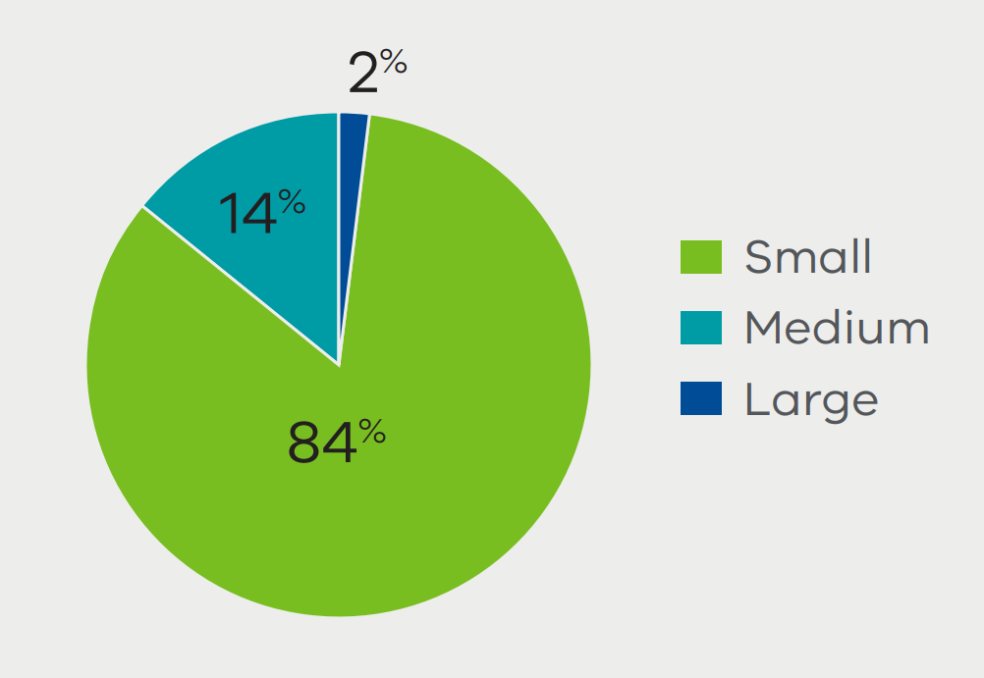

Age of businesses

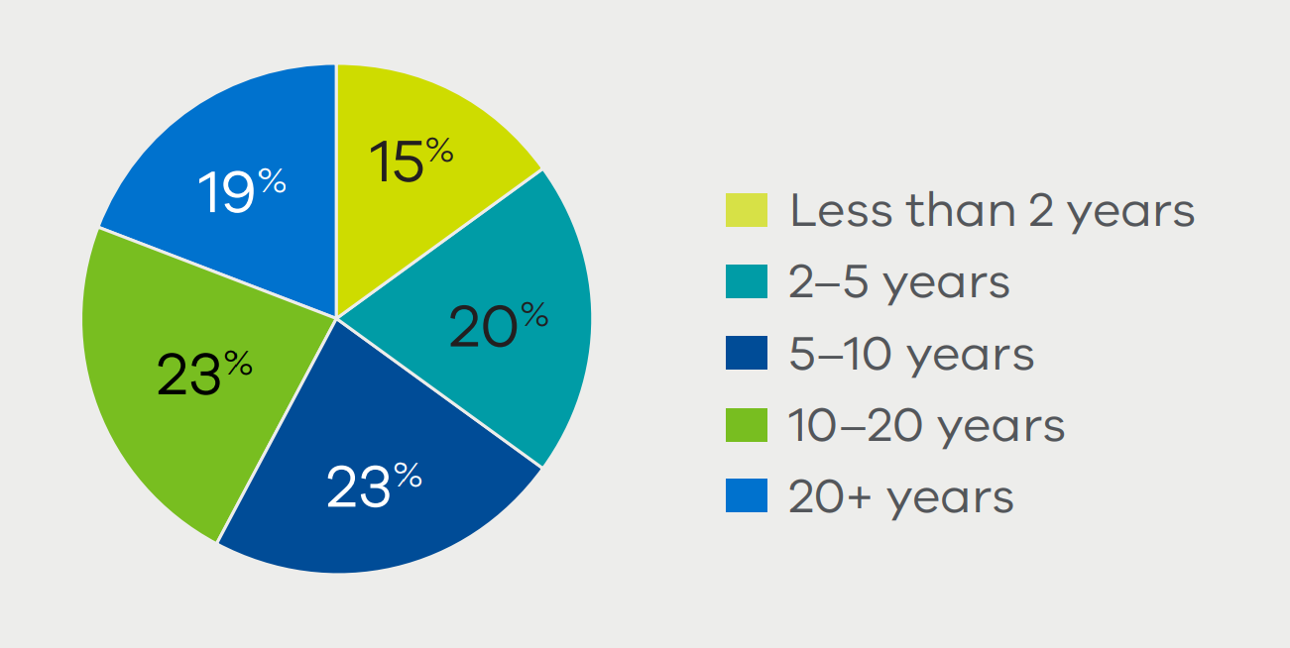

Primary location of operations

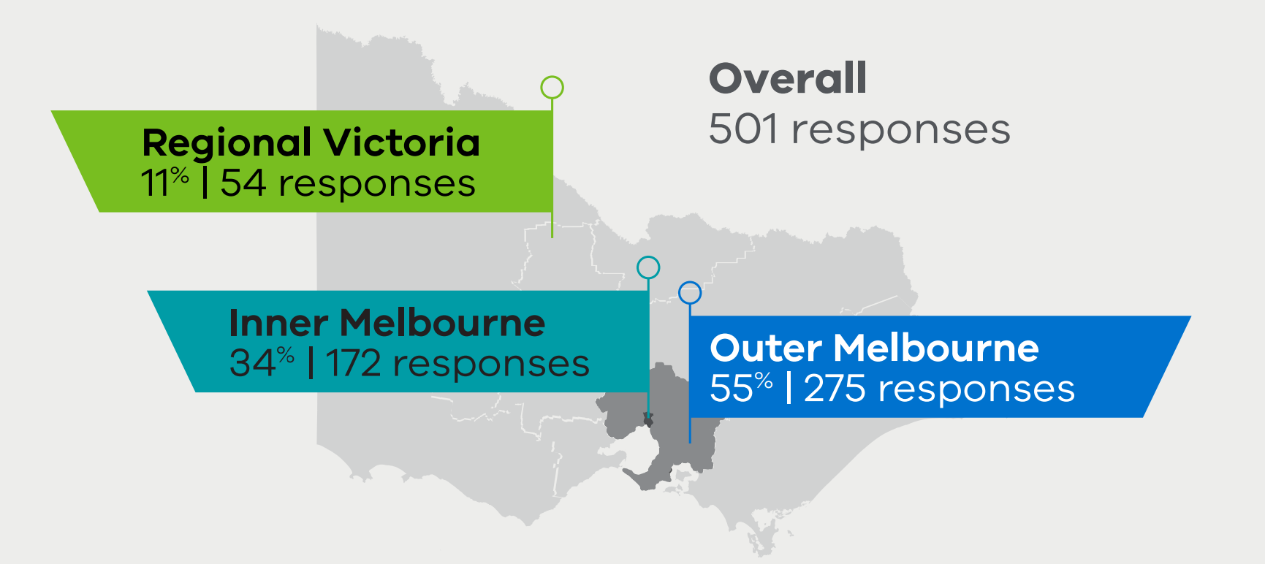

## Economic Contribution

The Victorian digital technology sector contributed $33.7 billion to the economy in FY22, accounting for 29% of the national sector.

Pie chart, which depicts the distribution of economic contribution of the national technology sector by location. Victoria is responsible for 29%, New South Wales is responsible for 43& and the rest of Australia is responsible for 28%.

Source: Deloitte Access Economics

The Victorian digital technology sector, as measured through value added, is similar in size to the entire retail trade industry in Victoria and almost twice as large as Agriculture, Forestry and Fishing.

## Productivity Modelling

From 2000 to 2023, the increased use of digital technologies across the Victorian economy has contributed to a productivity uplift equivalent to $40.2 billion in GSP and 80,278 jobs.

A map of Victoria, which depicts the breakdown of productivity uplift attributable to the increased use of digital technologies by location. Regional Victoria experienced a productivity uplift equivalent to $5.7 billion and 11,997 jobs and Metropolitan Victoria experienced a productivity uplift equivalent to $34.5 billion and 68,281 jobs. 

Source: Deloitte Access Economics

The productivity uplift from the adoption of digital technologies is concentrated in knowledge-intensive industries.

|  |  |  |
| --- | --- | --- |
| Industry | Uplift in GSP ($m) | Uplift in jobs |
| Financial & Insurance Services | 7,957 | 9,497 |
| Professional, Scientific & Technical Services | 7,404 | 12,492 |
| Public Administration & Safety | 5,208 | 12,580 |
| Information, Media & Telecommunications | 3,924 | 7,223 |
| Education & Training | 2,130 | 5,347 |

## Revenue

Nearly $129 billion in revenue was generated by Victorian digital technology businesses in FY23.

Information, media, and technology (IMT) services are the biggest customer of Victorian digital technology businesses in terms of revenue:

A graph that depicts the proportion of revenue derived from different sectors. From largest to smallest,  13% from IMT services, 13% from professional services, 10% from retail trade, 9% from financial & insurance services and 7% from health care and social assistance.

Source: Victorian Digital Technology Sector 2023

Most businesses sell intrastate, and to other businesses:

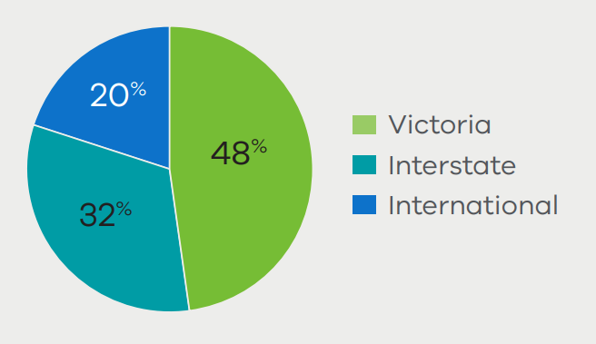

Pie chart depicting distribution of revenue by customer type. 65% of sector revenue came from business to business (B2B) sales, 19% came from business to consumer (B2C) sales, 13% came from business to government (B2G) sales, and 2% came from other sources. 

Note: figures may not add to 100% due to rounding.

Businesses forecast strong revenue growth over the short and long term:

Bar chart depicting forecasts for revenue growth. For all businesses, the one year median is 10% and the five year median is 50%. For Regional Victoria the one year median is 10% and the five year median is 30%. For Outer Melbourne, the one year median is 10% and the five year median is 35%. For Inner Melbourne, the one year median is 17% and the five year median is 75%. For medium and large businesses, the one year median is 10% and the five year median is 50%. For small businesses, the one year median is 15% and the five year median is 50%.

Source: Victorian Digital Technology Sector 2023

## Outlook

Outlook expectations for the Australian economy going forward are mixed, with optimistic businesses more likely to hire new workers.

Sentiment about the Australian economy going forward:

Stacked bar chart depicting businesses sentiment about the Australia economy going forward. Overall businesses are 6% highly optimistic, 30% optimistic, 36% neutral, 24% pessimistic and 4% highly pessimistic. Businesses in Greater Melbourne are 6% highly optimistic, 31% optimistic, 37% neutral, 23% pessimistic and 4% highly pessimistic. Businesses in the rest of Victoria are 6% highly optimistic, 22% optimistic, 35% neutral, 33% pessimistic and 4% highly pessimistic.

Source: Victorian Digital Technology Sector 2023 

Businesses intending to hire:

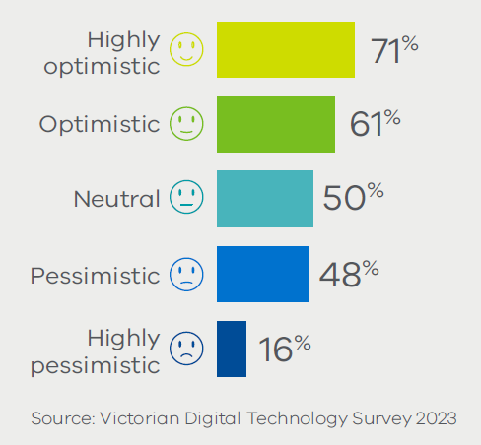

## Drivers Of Growth

The most important drivers of growth for Victorian digital technology businesses were:*

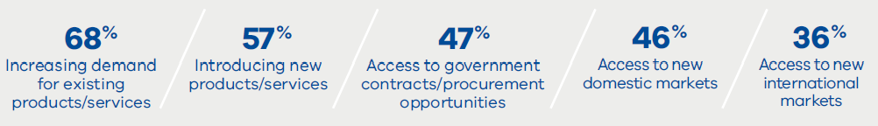

Personal investment was the largest source of investment for businesses:*

Bar chart depicting the percentages of different sources of investment for businesses. For businesses with fewer than 20 employees, the percentages for sources of investments were - investors (12%), private equity (16%), revenue-based finance (23%), loans (29%), government (31%), and personal investment (84%). For businesses with 20 or more employees, the percentages for sources of investments were - investors (14%), private equity (22%), revenue-based finance (47%), loans (51%), government (47%), and personal investment (63%) 

Source: Victorian Digital Technology Survey 2023

*% represents the proportion of businesses that selected these drivers and barriers in their top three responses

## Barriers To Growth

The largest barriers to growth for Victorian digital technology businesses were:*

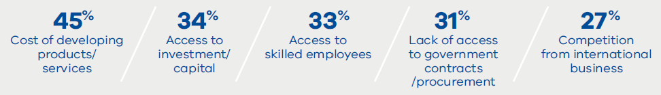

The largest barriers to commercialisation for Victorian digital technology businesses were:*

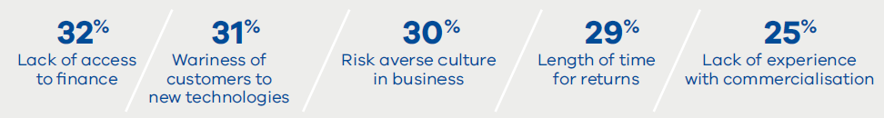

Internet access and inclusion is a larger barrier in regional Victoria than Melbourne:

Internet access and inclusion is a larger barrier in regional Victoria than in Melbourne. According to the Australian Digital Inclusion Index (ADII), which captures internet access, internet affordability and digital ability, regional areas in Victoria had lower scores than metropolitan areas. This gap was slightly larger than the national metropolitan-regional gap:

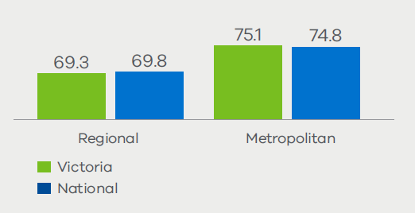

Source: Australian Digital Inclusion Index.

Note: values are the digital inclusion index, which captures “internet access, internet affordability and digital ability.

## Sector Characteristics

Products and services offered by the sector:

Bar chart depicting products and services offered by the sector - professional services (68%), software (49%), IT services (33%), cyber security (15%). and digital infrastructure (15%). 

Source: Victorian Digital Technology Survey 2023

Digital technologies used in the delivery of products and services:

Bar chart depicting the percentage of digital technologies used in the delivery of products and services - cloud (78%), digital platforms (57%), data analytics (43%), AI & ML (39%), and Internet of Things (26%). 

Source: Victorian Digital Technology Survey 2023

## Innovation

The priority technologies for deployment were:*

Graphic depicting the proportion of businesses that selected these technologies in their top five responses - 48% of businesses selected AI & ML, 31% selected data analytics, 24% selected cyber security, 24% selected Internet of Things, and 22% selected 5G. 

% represents the proportion of businesses that selected these technologies in their top five responses.

Source: Victorian Digital Technology Survey 2023

Of those who are using or trialling AI/ML, the top five benefits were in:

A graph depicting the top five benefits businesses believe would be gained from using or trialling AI/ML - information processing (63%), developing new products (56%), businesses processes (49%), promotion & marketing (32%), and human resources (28%). 

Source: Victorian Digital Technology Survey 2023

## Exports

34% of surveyed businesses are exporting tech products or services and exports make up 40% of the revenue for exporting digital technology businesses.

North America and Europe are the most common export markets for Victorian digital technology businesses and interest in UK, India, and Japan is rising.

Future interest is high than current interest for the United Kingdom, Canada, Germany, China, India, and Japan.

|  |  |  |
| --- | --- | --- |
|  | Current export markets* | Export markets of future interest* |
| United States of America | 20% | 20% |
| United Kingdom | 13% | 16% |
| New Zealand | 11% | 9% |
| Singapore | 6% | 6% |
| Canada | 5% | 6% |
| Germany | 4% | 6% |
| China | 2% | 4% |
| India | 2% | 5% |
| Japan | 1% | 4% |

% represents the proportion of businesses that selected these markets in their top three responses.

Source: Victorian Digital Technology Survey 2023

Products and services offered by exporting businesses:

Bar graph depicting the percentage of products and services offered by exporting businesses - 52% export software, 45% export professional services, 11% export e-commerce, 11% export IT services, and 8% export publishing & broadcasting. 

Source: Victorian Digital Technology Survey 2023

Digital technologies used in the delivery of products and services:

Bar graph depicting percentage of digital technologies used in the delivery of products and services by exporters and non-exporters. For exporters, 84% use cloud, 68% use digital platforms, 54% use data, 49% AI & ML, and 30% use Internet of Things. For non-exporters, 75% use cloud, 52% use digital platforms, 37% use data, 34% AI & ML, and 23% use Internet of Things.

Source: Victorian Digital Technology Survey 2023

## Technology Workforce

From 2014 to 2022, the Victorian technology workforce has increased by 100,000 to reach 279,000 employees, making up 30% of the national technology workforce. The ICT Employment Index shows that the technology workforce has grown rapidly and is forecasted to have an annual growth rate of 5% until 2030:

Left side graph depicts the ICT employment index for Victoria and Australia over 2014 to 2022. The index has generally increased for both Victoria and Australia from 2014-2022. The average annual growth for Victoria is 5.6% and for Australia it is 5.5%. 

Right side graph depicts the percentage of ICT share of workforce in Victoria and Australia over 2014 to 2022. The ICT share of the workforce has steadily increased from 2014-2022 for Australia, for Victoria it has decreased from 2014-2016 and steadily increased from then on. The average annual growth for Victoria is 8% and 6.8% for Australia. 

Source: Australian Digital Pulse

Note: For both indexes, 2014 = 100. The average annual growth rates are calculated across 2014-2022.

Of the Victorian technology workforce:

Graphic depicting statistics about the Victorian technology workforce. Of the workforce - 28% were women, 72% were in Metropolitan Victoria, 53% were born overseas, and 42% speak a language other than English. 

Source: Australian Digital Pulse

54% of the workforce work outside of the ICT industry. Technology workers account for significant shares of the workforce in knowledge-intensive industries including:

Graphic with four boxes depicting industries that technology workers account for a significant share of. Technology workers account for 15% of the financial and insurance services industry, 12%of the electricity, gas, water and waste industry, 8% of the public administration and safety industry, and 6% of the mining industry. 

Note: Only the top 4 industries for those working outside of ICT are shown

## Skills

Over three-quarters of Victorian digital technology businesses face skill and capability gaps, compared to 38% of businesses in the Australian economy. Software development is the most common skill gap, with upskilling the most common way to address this:

Bar graph depicting percentage of skills gap identified by the Victorian digital technology businesses. The skills gap identified by businesses were software development (42%), cyber security (36%), AI & ML (32%), cloud computing (31%), and IT operations and support (31%). 

Source: Victorian Digital Technology Survey 2023

Stacked bar graph depicting how the businesses feel about these following ways of addressing the skills gap. 

For international hiring - 45% have not undertaken with plans to, 21% have not undertaken with no plans to, 14% find this highly effective, 13% find this somewhat effective, and 7% find this not effective. 


For graduate hiring - 33% have not undertaken with plans to, 25% have not undertaken with no plans to, 10% find this highly effective, 20% find this somewhat effective, and 11% find this not effective. 


For outsourcing - 33% have not undertaken with plans to, 20% have not undertaken with no plans to, 12% find this highly effective, 20% find this somewhat effective, and 15% find this not effective. 


For domestic hiring - 26% have not undertaken with plans to, 26% have not undertaken with no plans to, 14% find this highly effective, 25% find this somewhat effective, and 8% find this not effective. 


For upskilling workers - 18% have not undertaken with plans to, 17% have not undertaken with no plans to, 18% find this highly effective, 40% find this somewhat effective, and 6% find this not effective. 

## Education

Victoria’s university sector produces a strong pipeline of tech graduates and is the most IT-intensive in the country, with 9% of enrolments being in IT course. Victoria had 9,429 IT completions in 2022, with 27% of those being women.

Line graph depicting the number of IT completions and Women IT completions over 2016 till 2022. Both have steadily increased from 2016-2018, rapidly increase from 2018-2022, with a plateau from 2020-2021, and a decline from 2021-2022. 

There were 9,429 IT completions in 2022 and 2,579 Women IT completions in 2022. 

Source: Federal Department of Education

## Disclaimer

Victorian State Government

The information contained in this fact sheet is provided for general guidance and assistance only and is not intended as advice.

The State of Victoria and its employees do not guarantee that the publication is without flaw of any kind or is wholly appropriate for your particular purposes and therefore disclaims all liability for any error, loss or other consequence which may arise from you relying on any information in this publication.

You should make your own enquiries as to the appropriateness and suitability of the information provided. While every effort has been made to ensure the currency, accuracy or completeness of the content, we endeavour to keep the content relevant and up to date and reserve the right to make changes as required.

The Victorian Government, authors and presenters do not accept any liability to any person for the information (or the use of the information) which is provided or referred to in this fact sheet.

Authorised and published by the Department of Jobs, Skills, Industry and Regions, 121 Exhibition Street Melbourne Victoria 3000 Telephone (03) 9651 9999

© Copyright State of Victoria, Department of Jobs, Skills, Industry and Regions, May 2024 Except for any logos, emblems, trademarks, artwork and photography this document is made available under the terms of the Creative Commons Attribution 3.0 Australia license.