# Grey kangaroo species identification

Identifying Eastern and Western Grey Kangaroos



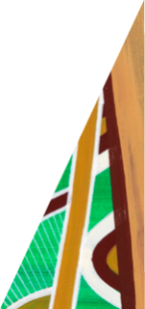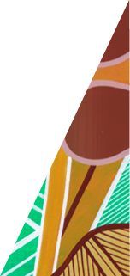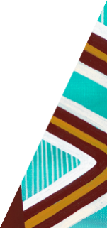

deeca.vic.gov.au

Eastern Grey Kangaroos are present throughout Victoria, and in certain areas of the state, they occupy home ranges which overlap with Western Grey Kangaroos (distribution map is shown below). In areas where the two species overlap, they can be distinguished by key differences in their appearance. The tables below compare the features of Eastern and Western Grey Kangaroos.

This document has been developed to assist kangaroo harvesters authorised under the Kangaroo Harvest Management Plan 2024-2028, identify species in areas where they overlap.

## Appearance and distinguishable features

|  |  |  |
| --- | --- | --- |
|  | **Eastern Grey Kangaroo** | **Western Grey Kangaroo** |
| **Face** | * Paler grey-brown face. * Dark fur surrounding eyes contrasting with lighter face. | * Dark brown face and muzzle. * Little contrast between eyes and dark face. * Pale throat, contrasting strongly with the rest of the pelt. |
| **Ears** | * Shorter rounded ears. * Brown fur covering entire ear. | * Longer ears, slightly concave on upper outside edge. * Darker fur covering base of the ear. Fur is sparse on the back of the ear showing black skin. * White patches on inner ear edges which strongly contrast with the rest of the face. |
| **Body** | * Lighter pelt with more even colour. * Belly usually lighter than the body sometimes almost appearing white. | * Mid-dark chocolate-brown pelt. * Belly pale brown or grey. |
| **Other** | * Does not have an odour. | * Males of all ages have a strong, curry like odour. |

Table 1: Appearance and distinguishable features of Eastern and Western Grey Kangaroos

|  |  |
| --- | --- |
| **Eastern Grey Kangaroos** | **Western Grey Kangaroos** |
|  |  |
|  |  |
|  |  |

Table 2: Images of Eastern and Western Grey Kangaroos for comparison

## Distribution

The Eastern Grey Kangaroo has a broad distribution occurring throughout Victoria (small numbers occur in the semi-arid-north-west). The Western Grey Kangaroo is less common and occurs in the west of Victoria. Harvest Zones where species overlap, include **Loddon Mallee**, **Grampians** and **Barwon South West**.

The below map (**Figure 1)** shows the distribution and estimated proportions of Eastern and Western Grey Kangaroos in Local Government Areas (LGA) throughout Victoria. The map has been developed based on spatial modelling of data from kangaroo population surveys, including the most recent survey completed in September 2024.

#### Interpreting the map

The map uses colour shading to show the average proportion of Western Grey Kangaroos in each LGA. The red contour lines on the map link locations across the state where the expected proportions of Western Greys are 90%, 50% or 10%.

**Examples:**

* Western Grey Kangaroos make up more than 90% of the grey kangaroo population in the Rural City of Mildura, (although even there, significant numbers of Eastern Greys may be encountered, particularly in areas close to the Murray River).
* Western Grey Kangaroos are either absent or occur in very low numbers in the LGAs shaded grey. Most kangaroos occurring in these areas would be Eastern Grey Kangaroos.
* Eastern and Western Grey Kangaroos occur at a roughly even ratio in areas the middle contour line crosses (50% Eastern and 50% Western).

## References:

Baker, M. Gynther, I. (2023). *Straughan's Mammals of Australia*. 4th edn. Bloomsbury Publishing.

Caughley, G., Brown, B., Dostine, P., & Grice, D. (1984). The grey kangaroo overlap zone. Wildlife Research, 11(1), 1-10.

**Photo Credits**: Nick Talbot, DEECA. Graeme Coulson, Macropus Consulting.

Figure 1: Distribution and estimated proportions of Eastern and Western Grey Kangaroos in LGAs throughout Victoria