The CarbonNet Project is planning to conduct the Pelican 3D marine seismic survey in Commonwealth and Victorian waters in Bass Strait during the summer of 2017-2018.
The purpose of the proposed marine seismic survey is to gain deeper knowledge of the underlying geology of the area. This will help confirm the potential for geological carbon dioxide (CO₂) storage. Preparation for the survey will involve stakeholder consultation, and regulatory and environmental approvals.
Location
The proposed survey will cover approximately 166 square kilometres offshore from Golden Beach (between Loch Sport and Seaspray), Gippsland.
The proposed survey will take place within the greenhouse gas assessment permits VIC-GIP-002 (in Commonwealth waters) and GGAP006386(V) (in Victorian waters) managed by CarbonNet.
For more information see the detailed map on page 3.
Survey Method and Equipment
Seismic surveying is commonly used in the resources industry to gain a better understanding of subsurface geology.
About the CarbonNet Project
The CarbonNet Project (CarbonNet) is investigating the potential for establishing a commercial-scale carbon capture and storage (CCS) network. The network would bring together multiple CO₂ capture projects in Victoria’s Latrobe Valley, transporting CO₂ via a shared pipeline and injecting it into deep underground, offshore storage sites in the Gippsland region of Victoria. The project is jointly funded by the Commonwealth and Victorian governments.
For further information on CarbonNet see: http://earthresources.vic.gov.au/carbonnet

Marine seismic surveys are carried out by a specialised vessel towing a sound wave source that produces sound pulses in a controlled frequency range at set intervals.
The sound signals are reflected back by underground rock formations and are captured by hydrophones (acoustic receivers) in ‘streamers’ that are also towed by the vessel. The data collected by the hydrophones is recorded on board the vessel for later analysis and interpretation.
Figure 1: Marine Seismic Survey

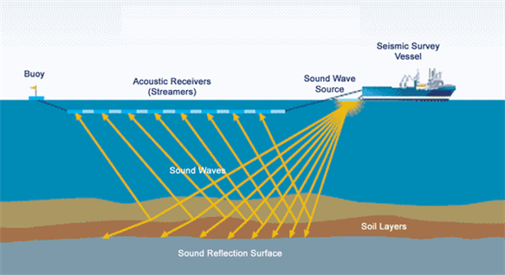
Image: used with permission from FishSAFE Information Project 2017, www.FishSAFE.eu
Survey Indicative Parameters
Vessel size | 4,000 – 7,000 tonnes
Number of streamers | Up to 6
Streamer length | 4 km
Survey area | 166 km²
Duration | Up to 15 days
Note: Final design parameters are yet to be determined and a vessel is yet to be identified
Timeframe
The seismic survey is proposed to take place between November 2017 and March 2018. The exact dates will depend on regulatory approvals, vessel availability and the weather. The survey is expected to take up to 15 days to complete.
Safety and Environment
Seismic surveying has been undertaken by the oil and gas industry in Bass Strait for more than 50 years. To assess and minimise any potential risks or impacts from the Pelican 3D Marine Seismic Survey CarbonNet will:
- Use underwater sound modelling to inform the survey design, assess and minimise any potential impacts on the ocean ecosystem
- Coordinate with commercial fishing operations, with advice from the Victorian Fisheries Authority
- Coordinate with oil and gas operations
- Meet all regulatory requirements.
Specific mitigations will include:
- One or more support vessels accompanying the survey vessel to assist with maintaining a safe area around the streamers and to maintain contact with fishing vessels
- The issue of a Notice to Mariners by the Australian Maritime Safety Authority (AMSA) advising other vessels of the presence of the seismic vessel
- One or more marine mammal observers will be on board the survey vessel to look out for cetaceans (whales and dolphins) and stop operations where required to protect these animals
Providing Feedback

If you would like to provide feedback on the proposed survey or have any questions, please contact CarbonNet at:

Phone: Customer Service Centre 136 186
Email: carbonnet.info@ecodev.vic.gov.au
Web: http://earthresources.vic.gov.au/carbonnet
- Consideration of the latest scientific research on the potential effects of seismic testing on rock lobster and scallop species will be taken into account in the survey methodology to minimise potential impacts
- An Oil Pollution Emergency Plan (OPEP) will be developed and implemented in the event of a large vessel diesel spill.
Environmental Approvals
A comprehensive Environment Plan (EP) is being prepared for the proposed survey in accordance with State and Commonwealth regulations under the Offshore Petroleum and Greenhouse Gas Storage (OPGGS) Acts. The proposed survey cannot proceed unless the Victorian Earth Resources Regulator and the National Offshore Petroleum Safety and Environmental Management Authority (NOPSEMA) accept the EP.
The EP describes the survey, the existing environment in and around the survey area and how CarbonNet plans to minimise and manage any impacts and risks to the environment or stakeholders. Once the EP is accepted, an EP Summary will be made publicly available on the regulators’ websites.
A Referral under the Environment Protection and Biodiversity Conservation Act 1999 (Cth) is also being prepared and will be submitted to the Commonwealth Department of the Environment and Energy (DoEE) for assessment for state waters.
Purpose of this Communication
This fact sheet is intended to provide an overview of the seismic survey for stakeholders.
CarbonNet is committed to establishing and maintaining meaningful engagement with all relevant stakeholders, and consultation will be ongoing during project planning and the project itself.
This consultation aims to provide relevant persons with information about the project and to allow stakeholders to raise any issues and concerns.
All feedback will be reviewed and assessed, and responses provided to respondents. All issues raised by stakeholders will be addressed in the project’s EP submitted to regulators.
Further advice will be provided to stakeholders as the approval processes progress and details for the survey are confirmed.
Figure 2: Map of proposed Pelican 3D
Marine Seismic Survey

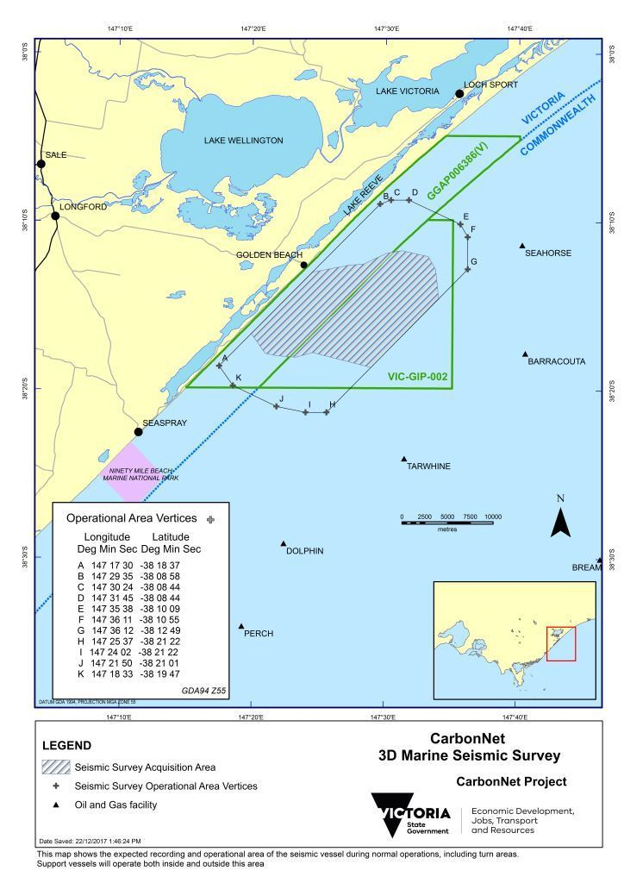

Department of Economic Development, Jobs, Transport and Resources
1 Spring Street Melbourne Victoria 3000
Telephone: 136 186
© Copyright State of Victoria,
Department of Economic Development, Jobs, Transport and Resources 2017
Except for any logos, emblems, trademarks, artwork and photography this document is made available under the terms of the Creative Commons Attribution 3.0 Australia license.
This document is also available in an accessible format at earthresources.vic.gov.au
Note: The map in this document was updated in January 2018 to reflect survey operational area changes since the publication of the original document.

