Accessible version of the PDF Fact Sheet about the CarbonNet Project

About the CarbonNet Project

CarbonNet – managing emissions from industry

What is the CarbonNet project?
The CarbonNet Project, located in Gippsland, aims to significantly reduce carbon dioxide (CO2) emissions from industry that may otherwise be released into the atmosphere. The technology used to achieve this is called carbon capture and storage (CCS).
CarbonNet has been funded by the Victorian and Commonwealth Governments since 2010 and, when operational (subject to approvals), will contribute to the Victorian Government’s 2035 interim emissions target and help achieve net zero emissions by 2045.
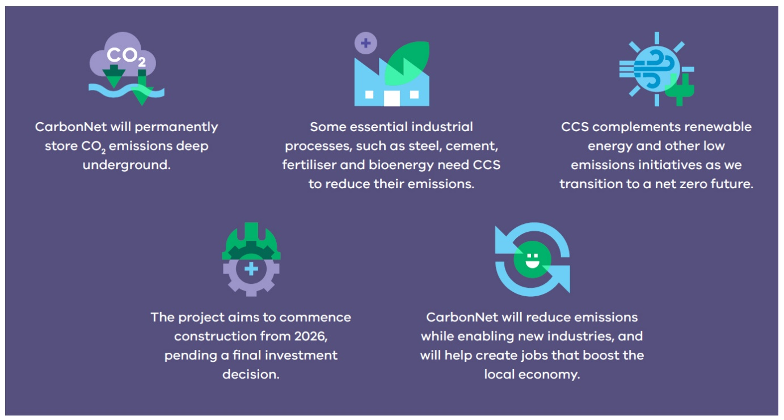
Long description of the above image: 1. CarbonNet will permanently store CO, emissions deep underground. 2. Some essential industrial processes, such as steel, cement, fertiliser and bioenergy need CCS to reduce their emissions. 3. CCS complements renewable energy and other low emissions initiatives as we transition to a net zero future. 4. The project aims to commence construction from 2026, pending a final investment decision. 5 CarbonNet will reduce emissions while enabling new industries and will help create jobs that boost the local economy.

How will CarbonNet work?
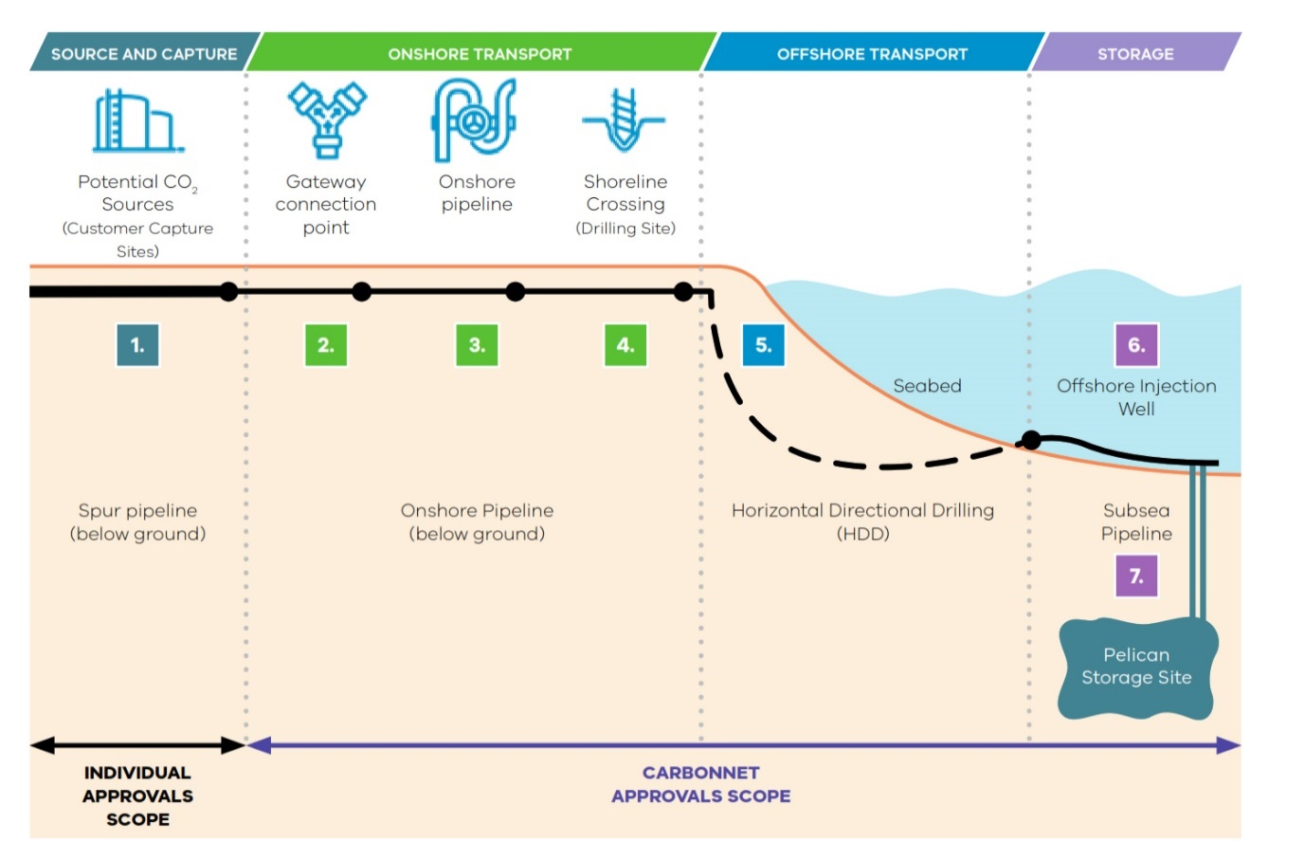
Project Element | Description
1. Customer Capture Sites  (Not CarbonNet owned or operated) | Customer capture sites will provide captured and compressed CO2 to CarbonNet for transportation and storage at Pelican. Potential industries include, but are not limited to, hydrogen, fertiliser and bioenergy.
2. Gateway Connection Point | A gateway connection point will be located at Loy Yang in the Latrobe Valley, enabling multiple planned or operating projects to connect into the CO₂ transportation and storage network. Loy Yang is therefore the proposed start point for the CO₂ transport pipeline.
3. Onshore Pipeline | Approximately 80km of 450mm* pipeline will run from Loy Yang to the shoreline crossing at Golden Beach.  *Diameter to be confirmed during Front End Engineering Design.
4. Shoreline Crossing | The pipeline will cross the shoreline likely using a horizontal directional drilling (or similar) technique, to avoid direct impacts on sensitive coastal features. The pipeline will emerge 1km offshore.
5. Offshore Pipeline | Approximately 20km of pipeline will be laid directly on the seafloor, depending on the local design requirements, to the subsea injection location at Pelican.
6. Offshore injection and monitoring wells | The seabed in Bass Strait, and one observation well to monitor for performance and required maintenance.
7. Geological CO2 storage reservoir – Pelican | Capacity of up to six million tonnes per annum over 30 years and integrity for permanent storage of compressed CO2
Authorised by the Crown in Right of Victoria
© Copyright State of Victoria,
Department of Jobs, Skills, Industry and Regions 2023
This document is also available at vic.gov.au/CarbonNet

