Accessible version of the PDF Fact Sheet 4 – Biosecurity for the CarbonNet Project

# Fact Sheet 4 – Biosecurity

## Commitment to Come Clean, Stay Clean, Go Clean

CarbonNet is committed to best practice biosecurity measures when accessing public and private land in line with the values and principles documented in Agriculture Victoria’s Biosecurity Statement and Strategy – agriculture.vic.gov.au/svbs-program.

### What you can expect from CarbonNet

CarbonNet respects how important biosecurity is to landholders, the community and the environment.

We manage biosecurity risks by minimising the potential introduction of pests, weeds, animal/plant diseases, and contaminants onto land through people, vehicles, machinery, and other equipment.

Our team regularly checks the Australian Government’s biosecurity outbreak webpage (agriculture.gov.au/ biosecurity-trade/pests-diseases-weeds/animal) for updates on potential risks.

During any planned activities, CarbonNet employees and contractors will ensure that suitable controls are implemented to safeguard individuals and the environment.

We will remain adaptable and ready to adjust our biosecurity protocols in response to new information. Our dedication extends to accommodating any additional requirements from landholders.

CarbonNet’s biosecurity commitments have been prepared with both Agriculture Victoria’s Biosecurity Strategy for Victoria and Australia’s National Biosecurity Strategy in mind.

You can get more information at:

The CarbonNet Project

Phone: 1800 878 968

Email: [carbonnet.info@ecodev.vic.gov.au](mailto:carbonnet.info@ecodev.vic.gov.au)

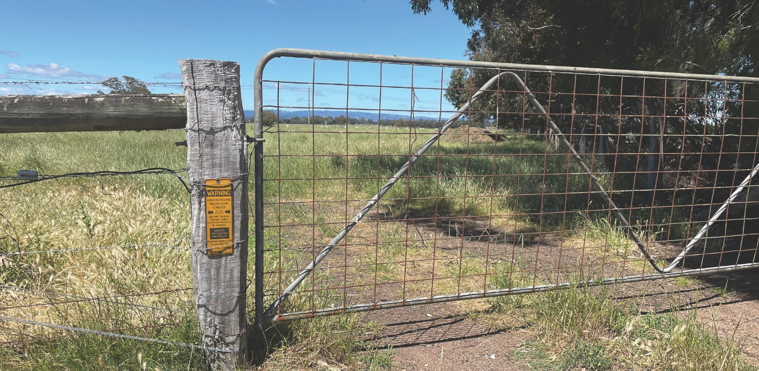Website: vic.gov.au/CarbonNet

## How CarbonNet is managing the biosecurity risk

|  |  |
| --- | --- |
| **Ensuring employees and contractors are trained in biosecurity measures** | **Planning to avoid sensitive areas and identify biosecurity risks** |
| CarbonNet actively trains our employees and contractors on biosecurity measures and ensures they are aware of their obligations. | Prior to any work carried out on a property  CarbonNet will identify biosecurity risks and implement relevant controls in consultation with the landholder/s. |
| **Decontamination of vehicles and clothing** | **Controlling vehicle and people movement** |
| CarbonNet will ensure rigorous vehicle decontamination.  Field staff will conduct daily inspections, promptly decontaminating if pests or plant material are found. They will use designated wash-down areas or portable equipment for on-site cleaning, as required. Procedures include using disinfectants and complying with an agreed biosecurity checklist. | Field employees will maintain awareness of the potential for introducing and transmitting plant and animal pests and diseases through their movements. When entering a property, they will proceed directly  to the designated meeting place, preferably away from any active farming operations to minimise the risk of contamination.  CarbonNet will strictly control vehicle movement to prevent pest and disease spread. Vehicles will access properties through designated points, park as agreed, and limit movement within the property. In sensitive areas, employees may opt for foot access in order to minimise environmental impact and prevent inadvertent pest or disease introduction. |
| **Communicating before entering properties** | **Recording inspections and decontaminations** |
| CarbonNet will contact landholders at least 5 business days prior, unless otherwise agreed, to entering a property. When contacted the landholder can specify biosecurity requirements that employees and contractors are required to follow on site. | Daily inspections, decontamination actions and checks will be recorded to provide evidence of biosecurity measures undertaken for the project.  Privacy requirements will be followed at all times. |

## Reporting risks and incidents

In the unlikely event of a biosecurity breach caused by the project, CarbonNet will ensure that this is immediately reported to the landholder and relevant authorities.

© Copyright State of Victoria,  
Department of Jobs, Skills, Industry and Regions 2024  
This document is also available at vic.gov.au/CarbonNet