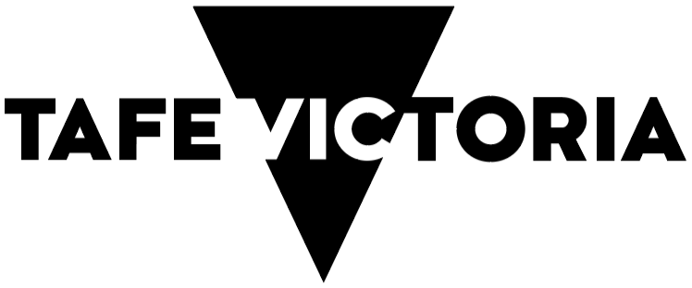

Victorian TAFE Network

Statement of Priorities

Dear Victorian Students,

The government is committed to delivering high-quality and industry relevant training through our Victorian TAFE Network.

TAFE is at the heart of the Victorian Vocational Education and Training System because everyone deserves the opportunity to upskill.

Our Free TAFE initiative is saving Victorian students an average of $3,000 per course. And as I visit campuses across the state, students are telling me what a difference their Free TAFE course has made in their life.

This Statement of Priorities is a commitment from the Government and all 12 TAFEs and 4 dual-sector universities to continually improve and work together to prepare students for jobs in Victoria’s changing economy.

TAFEs will work collaboratively so that students can draw on their collective resources, expertise, and innovation.

This is a joint commitment from the TAFEs, dual sector universities and the government to help students get the world class training for great jobs that lead to rewarding careers.

Start your training journey today.



**The Hon Gayle Tierney MP**Minister for Skills and TAFE

# The TAFE Network is focused on four areas.

## Industry

The TAFE Network will establish partnerships with industry to embed earn and learn models in our Network and increase access to high quality and industry relevant training in through the Network.

## Students

TAFEs will support student pathways across a joined-up education sector, and enable students to achieve successful outcomes, including those facing barriers to education and employment.

## Innovation

Our world class TAFE campuses and facilities will work with industry to provide cutting-edge and innovative training to students. With focuses on housing construction, foundational digital skills, care economy and clean energy.

## Staff

TAFEs will support their staff to offer excellent teaching and services so students can achieve their educational goals, and the TAFE Network leads the VET sector, setting a high benchmark for quality delivery.

Here are some examples of what TAFEs will do under the Statement of Priorities 2025:

TAFEs will develop and share teaching materials for use by all other TAFEs in Victoria. Students will have access to the best course resources no matter where they live or which TAFE they attend.

There will be more Free TAFE opportunities to meet students’ needs.

TAFEs will deliver more vocational education and training for Victorian secondary school students.

TAFEs will keep working to improve gender equality, cultural diversity and inclusion, helping to remove barriers students face to education and employment.

TAFEs will help lead the transition to a clean economy, providing the skills needed in clean energy, the circular economy and addressing climate change.

**In 2025, TAFEs will drive forward with conviction to create and innovate as Victoria’s economy evolves. Together, they will provide high-quality training to meet Victoria’s future skills needs.**

# Signing page

**The Hon Gayle Tierney MP**  
Minister for Skills and TAFE

**Sharan Burrow**BOARD CHAIR  
Bendigo Kangan Institute

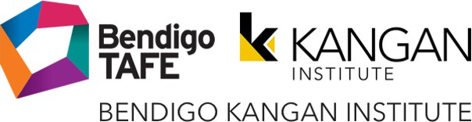

**Tracey Cooper**BOARD CHAIR  
Box Hill Institute



**Gillian Miles**BOARD CHAIR  
Chisholm Institute



**Paul Buckley PSM**BOARD CHAIR  
TAFE Gippsland

**Trish Crossin AM**BOARD CHAIR  
The Gordon Institute of TAFE



**Hon. Candy Broad**BOARD CHAIR  
GOTAFE Institute of TAFE



**Michael Gorton AM**BOARD CHAIR  
Holmesglen Institute of TAFE



**Helen Clarke**BOARD CHAIR  
Melbourne Polytechnic



**Steven Waterhouse**BOARD CHAIR  
South West Institute of TAFE



**Neth Hinton**BOARD CHAIR  
SuniTAFE



**Hon. John Pandazopoulos**BOARD CHAIR  
William Angliss Institute of TAFE



**Allison Jenvey**BOARD CHAIR  
Wodonga Institute of TAFE



**Darren Gray**PRO VICE-CHANCELLOR VET & UNIVERSITY PATHWAYS AND CHIEF EXECUTIVE TAFE  
Federation University Australia



**Mish Eastman**DEPUTY VICE-CHANCELLOR VOCATIONAL EDUCATION VICE PRESIDENT  
RMIT University



**Madelyn Bolch**PRO VICE CHANCELLOR AND CHIEF EXECUTIVE, VOCATIONAL EDUCATION AND TRAINING  
Swinburne University of Technology



**Wayne Butson**CHIEF TAFE OFFICER AND CEO OF TAFE  
Victoria University



This TAFE Network Statement of Priorities is also supported by Victoria’s dual sector universities, which provide TAFE services in Victoria with government funding.*

* While their commitment to supporting and developing the skills and students of Victoria mirrors that of the Victorian Government-owned ‘standalone’ TAFEs, the governance and financial arrangements of dual sector universities differ and priorities that specifically relate to sustainability do not apply.

Department of Jobs, Skills, Industry and Regions, 121 Exhibition Street Melbourne Victoria 3000

© Copyright State of Victoria, Department of Jobs, Skills, Industry and Regions 2025

Except for any logos, emblems, trademarks, artwork and photography, this document is made available under the terms of the Creative Commons Attribution 3.0 Australia license.