Accessible version of the PDF Fact Sheet CarbonNet's proposed pipeline

Fact Sheet 2 - CarbonNet's proposed pipeline

Fast facts
- 100 km underground pipeline
- 80 km onshore
- 20 km offshore
- Pipeline corridor avoids high impact areas
- Comprehensive planning and approvals program

Pipeline overview
CarbonNet will support industries in the Latrobe Valley by safely transporting and storing CO₂ that is generated through manufacturing processes. The project plays an important part in reducing carbon emissions.
A key component of the CarbonNet project is a proposed 100km pipeline that will transport CO₂ captured from industries in the Latrobe Valley to an offshore storage site in the Gippsland Basin. Around 80km of the pipeline would be onshore (underground) and around 20km would be offshore, laid directly on the seafloor.
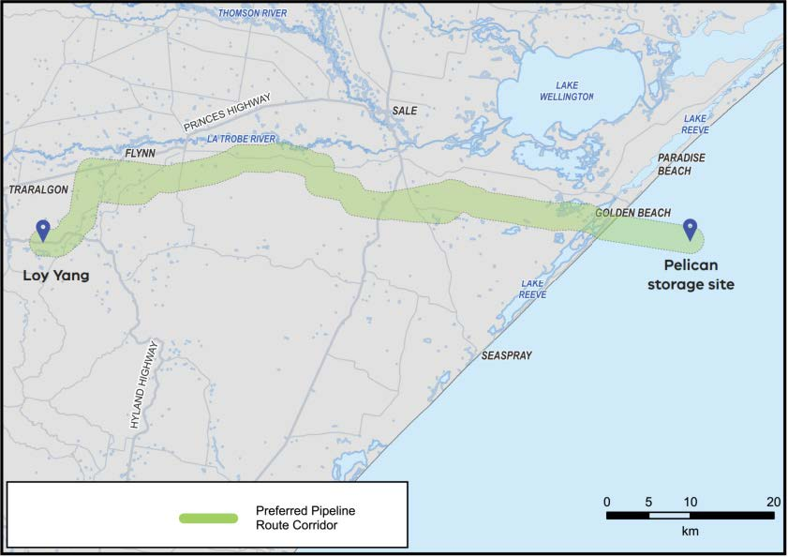

Identifying a pipeline corridor
CarbonNet has conducted an options assessment that has identified a preferred pipeline corridor from the Latrobe Valley to the proposed offshore Pelican storage site in the Gippsland Basin. The detailed assessment has included geographic reviews and mapping, preliminary stakeholder consultation and use of a multi-criteria analysis and rating framework to evaluate options.
The preferred corridor features include:
- Minimised impact on potentially affected landowners and occupiers.
- Minimised footprint of the pipeline within the marine environment.
- Minimal intersection with the Gippsland Lakes Ramsar site.
- Following existing infrastructure as much as possible.
- Avoidance of townships and densely populated residential areas.
- Avoidance of Holey Plains State Park.
- Avoidance of existing mine sites in the Latrobe Valley.
The key steps in progressing the preferred corridor include:
- Preferred corridor identified
- Landowner consultation
- Detailed studies
- Pipeline licence application
- Planning and approvals.
CarbonNet will undergo detailed planning and approvals for construction and operation of the proposed pipeline. This process includes:
- Pipeline licence (required under the Victorian Pipelines Act 2005 to allow construction and operation of the pipeline);
- Referrals under the Victorian Environment Effects Act and the Environment Protection and Biodiversity Conservation Act 1999.
More information about the planning and approvals process is available in Fact Sheet 3: Approvals and licensing.

Consultation and landholder engagement
Engaging and involving local communities and stakeholders in projects helps to achieve better outcomes. CarbonNet will work with impacted landowners and occupiers to develop and refine the preferred pipeline corridor. A series of detailed land surveys and site investigations will also be undertaken to further inform the process.

More Information
The CarbonNet Project
Ph: 1800 878 968
Email: carbonnet.info@ecodev.vic.gov.au
Website: vic.gov.au/CarbonNet

Authorised by the Crown in Right of Victoria
© Copyright State of Victoria,
Department of Jobs, Skills, Industry and Regions 2023
This document is also available at vic.gov.au/CarbonNet

