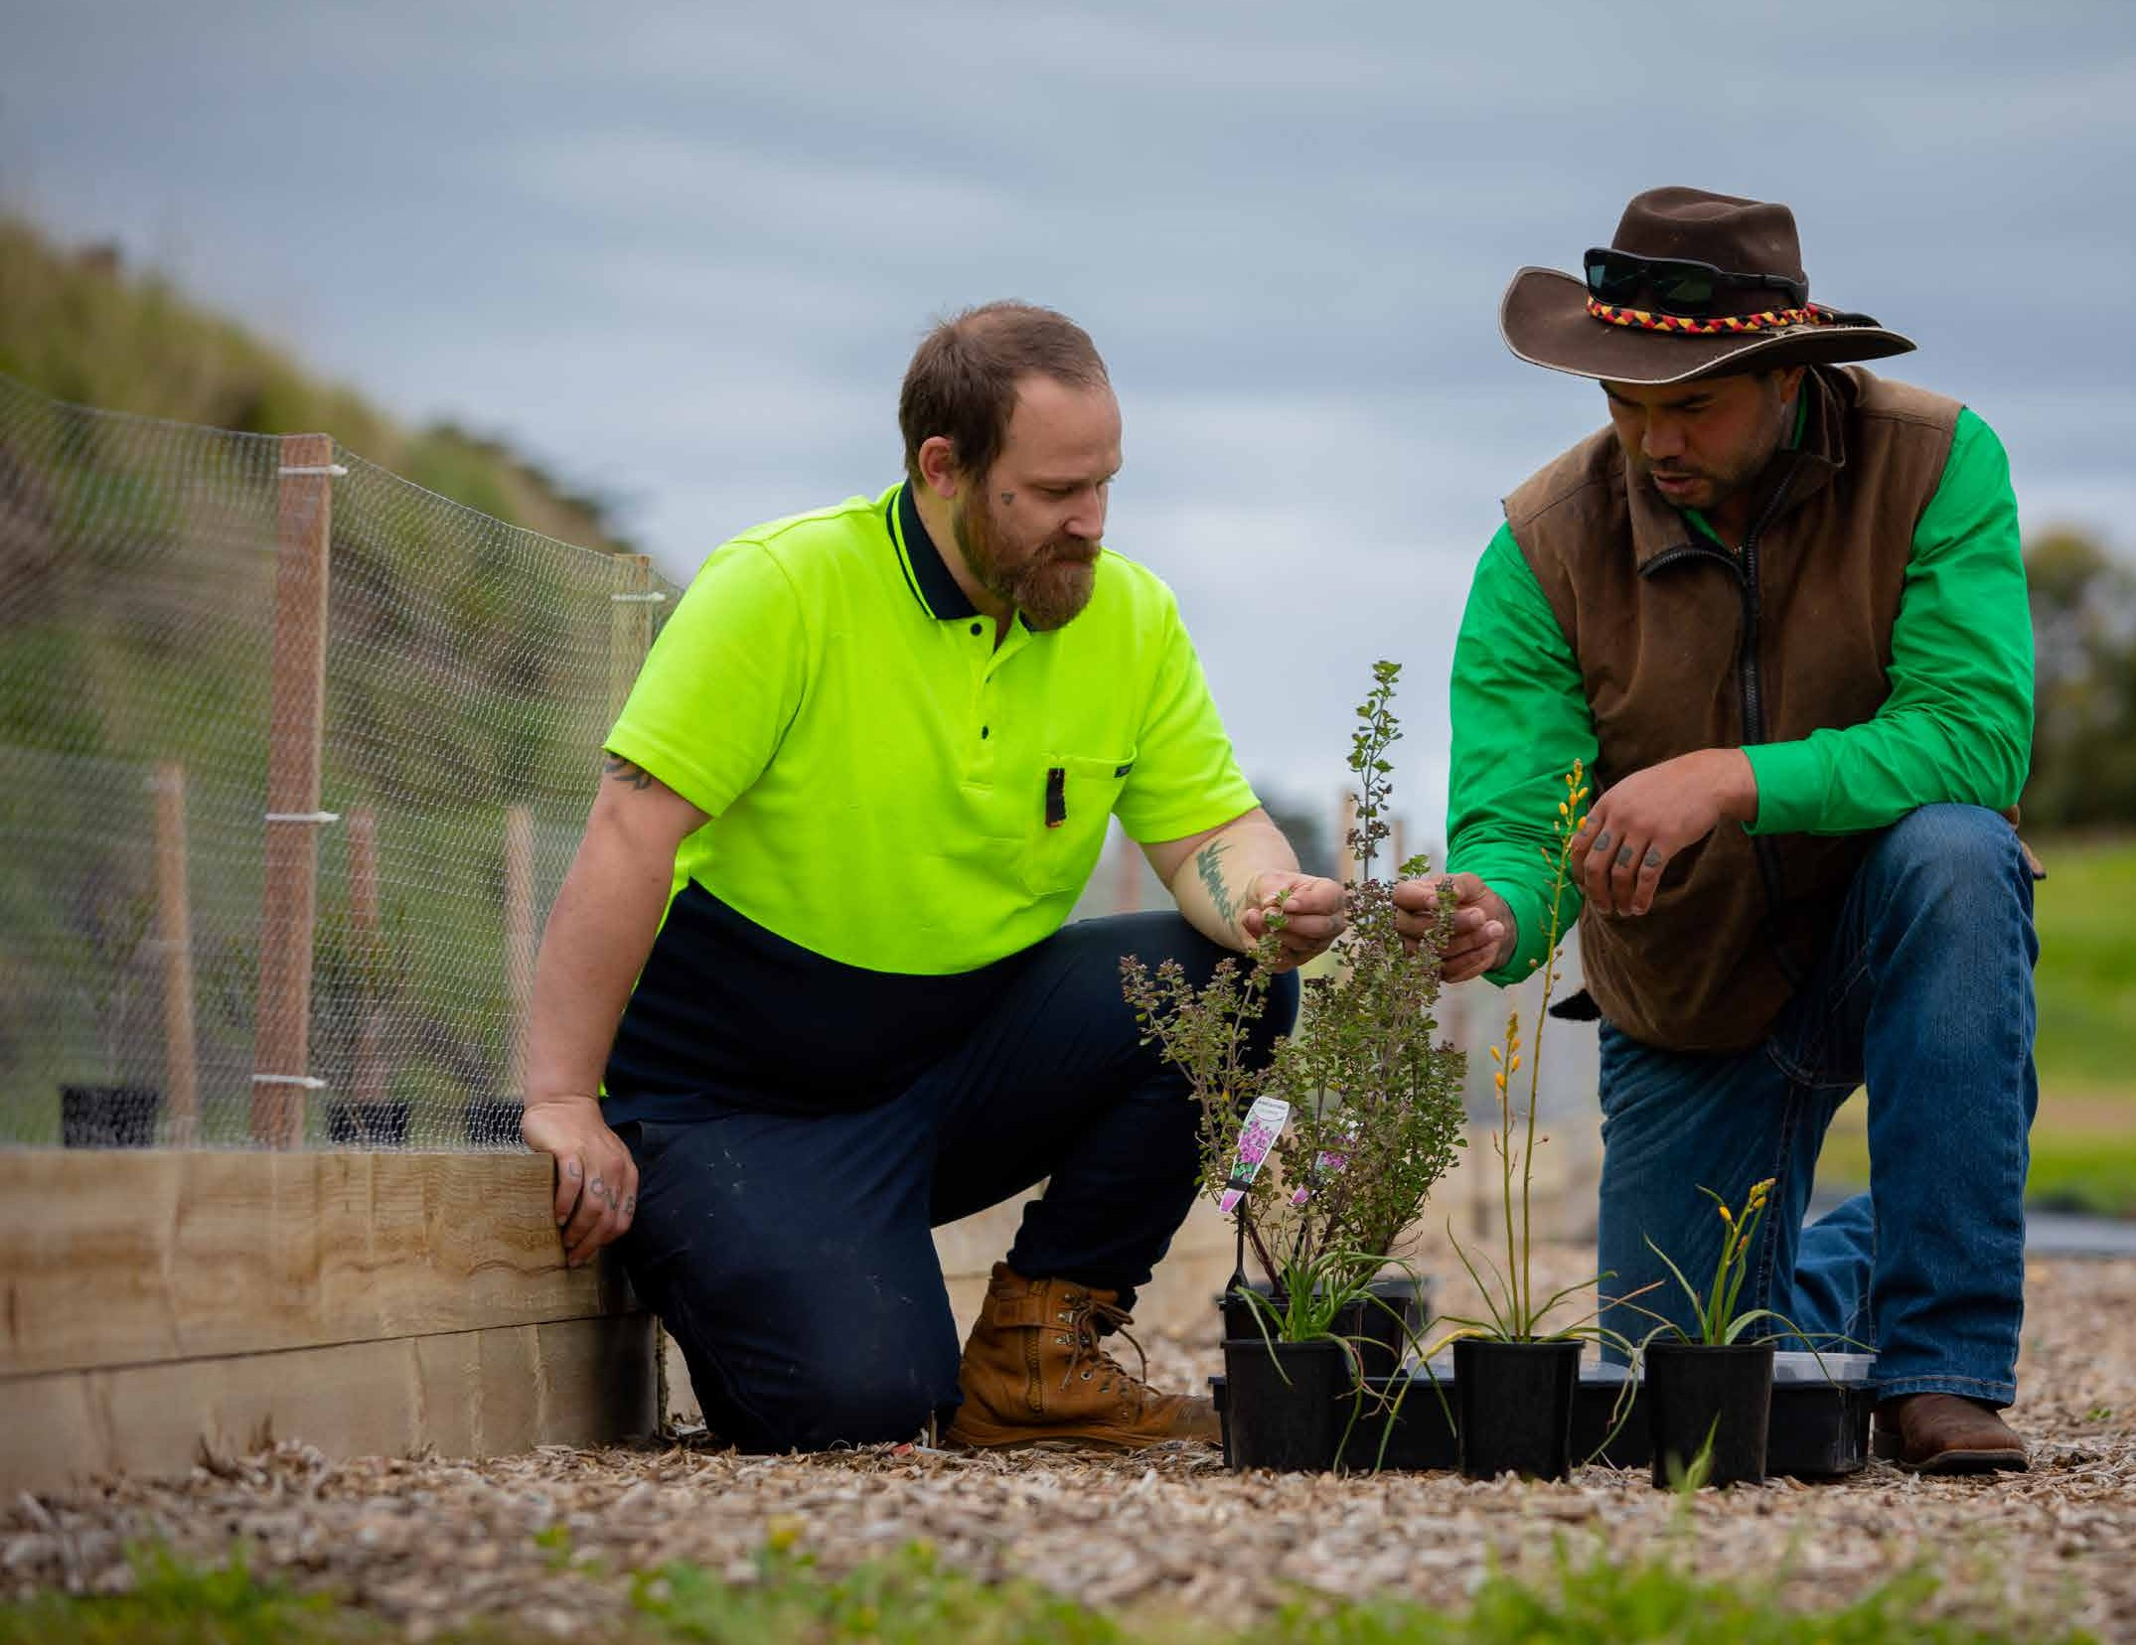

Closing the Gap

The Jurisdictional Action Plan is designed to be flexible and adaptable, allowing for adjustments based on the outcomes of Treaty negotiations and the Yoorook Justice Commission.

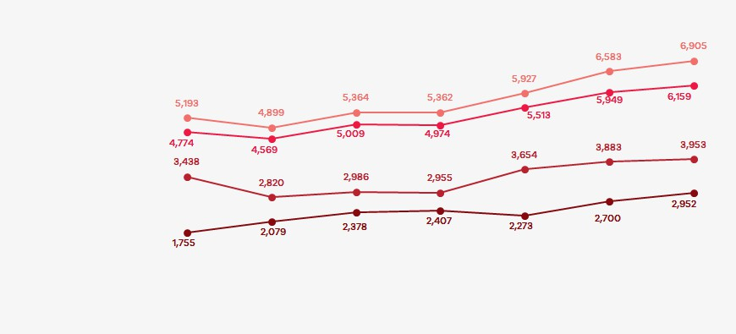
Closing the Gap in a Victorian context
ABORIGINAL GOVERNMENT-FUNDED TRAINING (EXCLUDING PRE-ACCREDITED) OVERVIEW
TOTAL ENROLMENTS TOTAL STUDENTS

COMMENCEMENTS
CONTINUING ENROLMENTS
2019
2020
2021
2022
2023
2024
2025

First Nations learners and communities bring unique strengths and potential to the vocational education and training experience, yet there remain systemic barriers that hinder access, participation, and completion of VET courses. First Nations participation and self-determination in partnership with government is addressing barriers and expanding opportunities in VET
to increase employment in more highly skilled and better paid industries.
The aspiration and opportunity to unlock better employment pathways through training may be impeded by systemic issues. Barriers may include reduced opportunities to meet literacy, numeracy and digital skill requirements; study-related costs; complex enrolment processes; and limited cultural capabilities of training providers. Many First Nations learners demonstrate resilience and determination in overcoming these challenges, but the system needs to improve to deliver equity for First Nations students and staff so we must continue to build
on the strengths and successes across the sector.
The National Centre for Vocational Education Research (NCVER) data shows an improving trend in First Nations enrolments, commencements and participation since 2019.

NCVER data for 2025 shows 30% of First Nations Victorians aged 15-64 participated in VET (up 2% from 2024). DJSIR enrolments data for 2025 shows:
- 18% increase in enrolments at TAFEs.
- 10% increase in enrolments at Aboriginal Community Controlled Organisation-led Registered Training Organisations (ACCO-led RTOs).
- 26% increase in pre-accredited training enrolments.
More First Nations students commenced training in 2025, supported by the introduction of the Skills First Aboriginal Access fee waiver. First Nations enrolments were up 5% from 2024. The Aboriginal Access Fee Waiver was introduced in January 2024 to enable First Nations Victorians to do any VET qualification under Skills First without tuition fees.

Between 2024 and 2025, enrolments also increased across the Victorian Government’s priority areas for skills and workforce in the care economy,
and in housing and clean energy.
First Nations VET completion rates for 2025, citing NCVER data unless otherwise specified, show:
- 74% for pre-accredited subject completions (DJSIR administrative unpublished data: Note pre-accredited completion rates are based on module enrolments and are not directly comparable with accredited completion rates, which are based on Course Enrolments).
- 46% for apprenticeships.
- 41% for non-apprenticeships.

Closing the Gap

Aboriginal Community Controlled Registered Training Organisations (ACC-RTO) running a curated selection of courses reported significantly higher completion rates than non-ACC-RTOs and TAFEs running a broader selection of courses in a
mainstream context with a larger student population. The way ACC-RTOs operate in their cultural context and the systems they have in place for learner support provide positive learning environments to First Nations learners, leading to high completion rates, and in some cases better completion rates compared to First Nations students studying at TAFEs. The structure and systems in place at
Bubup Wilam have led to a 96% completion rate for students studying the Certificate III and the Diploma in Early Childhood Education and Care. The Victorian Aboriginal Community Controlled Health
Organisation’s (VACCHO) effective support services have led to a completion rate of 68% in qualifications in social and emotional wellbeing and health.
Reporting on the First Nations’ workforce in the VET sector in 2023 found:
- 101.7 full-time equivalent (FTE) positions were filled by individuals identifying as First People across the 12 Victorian TAFEs.
- 3% of Victorian TAFE board members identified as First Peoples.
The Victorian Government is committed to advancing First Nations’ communities and addressing the barriers, demonstrated through its nation-leading Treaty work and underpinned by state and national strategies, plans, and frameworks. It has implemented strategies designed to build the First Nations workforce within VET providers and to increase First Nations learners’ participation and completion rates in VET, while
also supporting their transition into culturally safe, meaningful employment to help combat entrenched inequalities.
The principles of Aboriginal self-determination are enacted through ensuring that strategies and frameworks are developed in genuine partnership with First Nations communities and organisations.
The Victorian Government has partnered with the Victorian Aboriginal Education Association Incorporated (VAEAI) – the peak state-wide Aboriginal Community Controlled Organisation for education and training in Victoria – and the Victorian First Nations VET Alliance (VFNVA) comprising of three ACC-RTOs.
An ACC-RTO is a not-for-profit training provider that is controlled and governed by a board that is made up wholly of Aboriginal and Torres Strait Islander people. ACC-RTOs deliver culturally appropriate education and training programs that meet the skills needs
of Aboriginal Community Controlled Organisations (ACCO) who provide a range of services for and within Community. In addition to providing skills and training to the ACCO sector, some students also work within alternatively structured Aboriginal organisations or in mainstream services and are undertaking training to develop their knowledge and technical skills applied within a culturally appropriate framework.
As a Registered Training Organisation, ACC-RTOs meet specific national standards to deliver accredited training and assessment, focusing on empowering individuals through education and skill development to strengthen the sector. As an ACCO, ACC-RTOs
are answerable to their Community and deliver on the training needs of that Community.

Partners
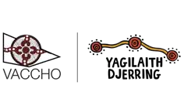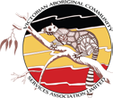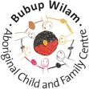

VAEAI, established in 1976, represents the Koorie Community in relation
to self-determination in education and training policy development and strategic programming at the local, state and national levels. VAEAI is the peak body for Koorie education in Victoria and represents the community through Local Aboriginal Education
Consultative Groups (LAECGs)
throughout the eight VAEAI regions. It supports the provision of education and training that reinforces its community’s cultural identity and increases awareness
in the wider community of Koorie culture and aspirations in education and training, particularly
in overseeing accountability for TAFE Wurreker Implementation Plans.
The First Nations VET Alliance (FNVA) is comprised of the three ACC-RTOs
in Victoria including the Victorian Aboriginal Community Controlled Health Organisation (VACCHO) Bubup Wilam Aboriginal Child and Family Centre Incorporated and Victorian Aboriginal Community Services Association
Limited (VACSAL).
VACCHO is recognised as the peak representative organisation for Aboriginal and Torres Strait Islander health and wellbeing in Victoria since 1996 and has a membership of 34 Aboriginal Community Controlled organisations. VACCO’s ACCO-led RTO,
Yagilaith Djerring, is the
largest ACCO-led RTO in Victoria. Over 95% of its students identify as being of Aboriginal and/or Torres Strait Islander descent.
It has a completion rate of around 68% for First Nations students in Social and Emotional Wellbeing, and Health qualifications,
which is significantly higher than First Nations students’ completion rates in TAFEs for similar qualifications.
Victorian Aboriginal Community Services Association Ltd (VACSAL) was established in 1984 and celebrates over 40 years of commitment to the advancement of Aboriginal
people. VACSAL supports and manages many community support programs and
has representation on over 85 reference committees to provide strategic advice to Aboriginal and broader
community organisations and all levels of government. A key area of focus is education.
VACSAL registered as an RTO in 2012 and a Learn Local in 2018. VACSAL prides itself
on providing pathways into meaningful and sustained employment and for being seen by Community and the education sector as a place of excellence: VACSAL awards include Wurreker Teacher
of the Year and Non-TAFE Provider of the Year, and the Victorian Training Awards (VTA) Victorian Koorie Student of the Year (multiple).
Bubup Wilam, Bubup Wilam Aboriginal Child and Family Centre, established in 2012,
is a sector leading Aboriginal early years education centre. Bubup Wilam offers education, development, health, and social and emotional wellbeing services through an embedded immersive approach that has been evidenced to significantly strengthen long-term outcomes for Aboriginal families and children.
For over 10 years, Bubup Wilam has provided training to its workforce through partnerships with other RTOs, achieving a 96% success rate in retainment and completion, and building a sustainable Aboriginal workforce in the Early Childhood Education and Care sector.
In 2023, Bubup Wilam became an ACC-RTO and is one of only 26 registered early childhood education centres nationally to be awarded as a Centre of Excellence by the Australian Children’s Education & Care Quality Authority (ACEQCA).

Closing the Gap

Partnership activities
With the right investments and support, including VAEAI leading TAFEs and the ACC-RTOs providing leadership through the Victorian First Nations VET Alliance (VFNVA), Victoria will continue to increase the First Nations learner numbers, provide enrolment assistance, course advice, and cultural support.
Continued and deepening engagement of VAEAI and the ACC-RTOs is key to building trust and ensuring that educational pathways and opportunities reflect the diverse needs and aspirations of communities, now and into the future.
Through its partnership with the Victorian Government on the Wurreker Strategy and the 10-year Marrung Education Plan 2016-2026 (Marrung Plan), VAEAI provides information and advice to the mainstream education and training sector – particularly to
TAFEs – on cultural inclusion in VET, curriculum development and effective service models for First Nations communities.
The Wurreker Strategy is a partnership agreement between the Victorian Government and VAEAI to improve educational, training and employment outcomes for First Nations people. As the primary provider of VET to First Nations students in Victoria, TAFEs have played an integral role in Wurreker. Every Victorian TAFE and dual-sector training provider maintains a Wurreker Implementation Plan that
is consistent with the objectives of the Marrung Strategy. The TAFE sector is funded to undertake Wurreker Implementation Planning. This includes Koorie Liaison Officers (KLOs), and Koorie Student Support Officers (KSSOs) who provide a range
of support and other on-campus services direct to First Nations students.
This partnership ensures a high degree of community engagement, participation, and self-determination in VET policy design and training delivery through forums such as the Marrung Central Governance Committee (MCGC) and the Koorie Skills Working Group (KSWG), which has been attended by the members of the VFNVA since November 2024. Both MCGC and KSWG support partnership with First Nations organisations including VAEAI and other ACCOs, to enable collaboration on strategies including the Marrung
Plan and Wurreker Strategy. Importantly, they identify
emerging issues and actions to improve VET outcomes for First Nations learners.
The Wurreker and Marrung Plan strategies require review with First Nations partners to ensure they remain effective in improving First Nations learners’ skills and training outcomes, while staying responsive to the changing needs and aspirations of First Nations communities. The Victorian Department of Education has developed an evaluation strategy and work has commenced on this. The final report and its findings will be used to inform the next iteration of Marrung.
Elements of the Marrung Plan and Wurreker Strategy address data development and sharing, but these could be further developed. The Victorian Government shares data and statistics with First Nations partners during MCGC and KSWG meetings to promote evidence-based decisions and actions grounded in up-to-date, relevant information. By improving access to and use of data, collaboration can strengthen informed decision-making and help drive better outcomes for First Nations learners.
Further development of institutional relationships
and technical systems is needed, with Aboriginal Data Sovereignty needing to be central to these actions.
The Wurreker Strategy and Marrung Plan continue
to provide a platform for co-design, self-determination and blueprints for reform across the TAFE sector to better support Aboriginal learners throughout Victoria.
The Bilateral Implementation Plan offers an opportunity to expand the work being done throughout the sector by key stakeholders, VAEAI and the newly formed First Nations VET Alliance. To date, ACC-RTOs have not been offered financial support through VET strategies to address operational, and compliance needs vital for their sustainability. The Bilateral Implementation Plan provides vital funds to enable sustainable operational and compliance needs for the ACC-RTOs moving forward. Enhancing the capacity of ACC-RTOs to
offer community-based training options to Aboriginal
people will build upon their highly valuable contributions to the VET landscape.
As community-led organisations, ACC-RTOs have service obligations to their members, and provide culturally safe and responsive learning environments where First Nations learners can thrive by strengthening identity and connections, in a setting where training and workforce development takes place in tandem. ACC-RTOs report that they have achieved completion rates nearly triple that of the mainstream RTO sector. These vocational services reflect the Aboriginal definition of health – encompassing more than physical wellbeing to include social, emotional and cultural wellbeing, in which each individual is able to achieve their full potential and contribute to the total wellbeing of the community.

The Victorian First Nations VET Alliance (VFNVA) launched in October 2024 to advocate for the long-term sustainability and growth of Victorian ACCO-led RTOs, as individual organisations, and collectively. Their aim is to secure and enhance vocational education provided by ACCO-led RTOs across early childhood, health, wellbeing and community services qualifications.
The VFNVA has received funding from the National Skills Agreement (NSA) for ACC-RTOs to deliver sustained, culturally appropriate and supportive training environments through activities such as the VACCHO Student Mentor model, VACSAL’s
co-facilitation model and Bubup Wilam’s model focusing on sustaining the whole RTO which operates in a strengths and potential-focused manner.
VAEAI has received funding from the NSA to develop new tools and resources that will assist VET staff to better understand the needs of Koorie learners and how to effectively meet those needs, and to deliver Professional Development for Koorie staff within
the VET sector.
With VAEAI providing ongoing support and guidance to TAFEs, and ACC-RTOs providing tailored learning options, Victoria aims to develop an environment where Aboriginal Community Controlled Organisations and RTOs have the agency to shape VET policies and deliver services to Community that create meaningful and lasting change.

Drivers of change
Making progress towards Closing the Gap priorities and targets for First Nations people involves addressing eight key drivers of change, identified by Aboriginal Community Controlled Organisations and stakeholders:
- Effective policy and governance frameworks focused on self-determination of First Nations people to drive systemic change.
- Adequate funding and resources for safe and effective learning environments, support systems, and successful transitions between skills and employment.
- Meaningful community engagement that aligns skills and training opportunities to diverse and evolving community strengths, needs and aspirations.
- Public trust in the training sector as culturally safe, respectful, and inclusive.
- Cultural competence in educators and administrators and clear understanding of educational barriers that exist.
- Culturally informed and appropriate support services for learners.
- Strong cultural connections for learners and teachers, supporting educational as well as health and wellbeing outcomes.
- Quality programs with clear pathways to quality employment.
Focusing on these drivers will enable Victoria to address the key barriers faced by First Nations learners In VET, including low participation and completion rates, limited representation of First Nations people in leadership roles, and the need for more culturally safe learning environments.
In collaboration with First Nations partners, Victoria has identified the drivers of change, and areas of opportunity that lead to closing the gap. Some of these include increasing First Nations representation across VET leadership, enhancing the visibility of First Nations culture within training institutions, supporting organisational capability of training providers including ACCO-led RTOs, and ensuring clear communication around fee-free training for First Nations learners. By leveraging these opportunities, we can work toward closing the gap in vocational education and ensuring equal opportunities for First Nations learners to thrive.

Closing the Gap

Victorian focus areas and actions contributing to this National Priority
Key focus areas emerged from NSA Closing the Gap workshops held in July 2024 in partnership with First Nations stakeholders, as well as from meetings with ACCO-led RTOs. These were:
- Funding and resourcing: Review funding and resources for VET delivery and student support, including funding for VAEAI to work with TAFEs and ACCO-led RTOs to invest in support services and capacity building specifically related to First Nations learners.
- Achieving cultural safety in skills and training: Overcome the lack of culturally safe work and study environments to ensure opportunities for learning and working effectively with First Nations learners, using culturally relevant curriculum and teaching methods that respect and incorporate Indigenous knowledge and perspective.
- First Nations access to teaching and learning: Address cultural safety, improve and simplify complex enrolment processes, and review overwhelming student eligibility requirements.

First Nations VET workforce
  - Recruitment: TAFE and ACCO-led RTOs face challenges in recruiting First Nations people in VET due to requirements for the Certificate IV Training and Assessment, a lack of cultural safety, a greater risk of isolation due to limited
First Nations employment numbers, insufficient awareness of job vacancies, and job descriptions that discourage qualified applicants.
  - Retention: First Nations TAFE and ACCO-led RTO VET staff face heavy workloads, burnout, and job classifications and remunerations that do not adequately reflect their knowledge and lived experience. These issues need to
be addressed to retain staff.
  - Progression: RTOs in the VET system need to address a lack of visibility in leadership and career progression and professional growth opportunities for First Nations people employed in TAFEs, both within their current roles and into higher positions.
- Pathways from VET to Employment: Identify and scale up best practice in Closing the Gap for First Nations people between completing VET qualifications and securing employment.
- Data capture and sharing: Access to up-to-date, relevant data for informed decision making and the development of evidence-based strategies that improve VET outcomes and Aboriginal Data Sovereignty.
- Recognition of training provider achievements: Highlight successes of training providers in delivering the National Skills Agreement framework and acknowledge the success rate of ACCO-led RTOs in student retainment and course completion.
The drivers of change, focus areas, and NSA priority reforms for Closing the Gap are reflected in Victoria’s actions under this plan.
- Priority Reform 1: Formal Partnerships and Shared Decision-Making.
- Priority Reform 2: Building the Community-Controlled Sector.
- Priority Reform 3: Transforming Government Organisations.
- Priority Reform 4: Shared Access to Data and Information at a Regional Level.

Key Actions and enabling conditions and/or partners Rationale and existing targets

ACC-RTO self-determined initiative
The three ACC-RTOs are focused on delivering sustained, culturally appropriate and supportive training environments through activities such as the VACCHO Student Mentor model, VACSAL’s co-facilitation model and Bubup Wilam’s model focusing on sustaining the whole RTO which operates in a strengths and potential-focused manner.
Strengthen formal partnerships and shared decision making on addressing the needs and interests of First Nations communities.
Increase growth, capacity and sustainability of the ACC RTO sector.
Aligns to Priority Reforms 1 and 2.
Measure impact by NSA Outcome Measure
6.5 – completion rates by Indigenous status.

VAEAI self-determined initiative
VAEAI is committed to developing both cultural awareness resources to facilitate more welcoming and engaging learning environments across the VET Sector for Koorie Students, and to developing and delivering Professional Development for Koorie staff within the VET sector.
The initiative involves consultation with key stakeholders and community consultation in conjunction with the Local Aboriginal Education Consultative Groups (LAECGs) across Victoria. These efforts will provide invaluable feedback towards the context of the resources VAEAI develops for the VET Sector.
Strengthen formal partnerships and shared decision making on addressing the needs and interests of First Nations communities.
Transform government organisations in the VET sector by increasing cultural inclusion of First Nations students and staff.
Increase Satisfaction with Training by Indigenous Status (NSA Outcomes Framework Measure 6.1), completion rates by indigenous status (Measure 6.5) and student satisfaction with Training by Indigenous Status (Measure 8.2).
Aligns to Priority Reforms 1, 2, 3 and 4.

Aboriginal Access Fee Waiver (commenced 1 January 2024)
State Government funding means First Nations learners can enrol in any Skills First VET qualification at Skills First providers without paying tuition fees.
To increase the number of First Nations learners in the VET sector by removing tuition fees for Skills First courses.

Closing the Gap

Key Actions and enabling conditions and/or partners Rationale and existing targets

Teaching and Strengthening First Nations languages and VET courses
Develop and deliver formal qualifications designed to preserve First Nations languages and foster cultural identity.
- Certificates II and III in Teaching and Learning First Nations languages.
Delivery of Cert II and Cert III courses commenced in late 2025 at two institutes. Several other TAFEs expressed an interest in delivering the courses in the near future.
Deliver VET courses in partnerships with Traditional Owners of Country in Victoria; First Nations peak bodies such as VAEAI; TAFEs; Aboriginal Community Controlled Organisations; and the Victorian Government. This will prepare First Nations learners for employment or further education while strengthening personal connections and exploring First Nations cultures and communities.
- Certificates I and II and III in Mumgu-dahl tyama-tiyt.
Delivery of the following course is run across a number of institutes. The course provides an opportunity for Aboriginal and/or Torres Strait Islander learners to develop or strengthen community connections, develop their vocational and/or study skills to support transitions into employment, and/or further training or study.
To preserve and promote the teaching and learning of First Nations languages and increase the number of First Nations teachers delivering language courses.
To foster cultural connection while equipping learners with literacy, numeracy, and vocational skills that strengthen cultural connection and prepare them
for future employment or education pathways.
Aligns to Priority Reforms 1, 2, and 3.

Wurreker Brokers and Local Aboriginal Education Consultative Groups (LAECGs)
Strengthen partnerships between training providers and First Nations communities through VAEAI and Victorian Government partnership on Government-funded, VAEAI-based positions to ensure VET and employment pathways are culturally relevant and appropriate.
Victoria’s VET workforce has been designed to better support First Nations learners, with 8 Wurreker Brokers and one Wurreker Manager employed by VAEAI via Wurreker funding. The Brokers are embedded in Victoria’s TAFE Network through their partnership/collaborative approach of connecting TAFEs to local First Nations communities – supporting cultural inclusivity, advancing self-determination, and providing advice and opportunities for First Nations learners to succeed.
Through the Wurreker Strategy, VAEAI reports on the identified training needs of the First Nations community. VAEAI promotes training opportunities to First Nations communities and industry groups, VAEAI is also consulted in the development and endorsement of relevant training curriculum and products.
Increase First Nations learners in VET by providing culturally informed advice about access to training and tertiary education opportunities.
Build trust in culturally safe, respectful, and inclusive practices.
Aligns to Priority Reforms 1, 2, and 3.

Koorie Liaison Officers (KLOs) and Koorie Learner Support Officers (KSSOs)
Rationale and existing targets
Key Actions and enabling conditions and/or partners
Work with training providers and communities to support First Nations VET learners, ensuring culturally inclusive education, better outcomes, and smooth transitions to employment through partnership between TAFEs and the State Government. The initiative has employed 17 Koorie Liaison Officers and 32 Koorie Student Support Officers.
Increase rates of participation and completion
by providing support to First Nations VET learners with enrolment, course advice and cultural support.
Build trust in culturally safe, respectful, and inclusive practices.
Aligns to Priority Reforms 1 and 3.

Koorie Units
Dedicated services within TAFEs that provide culturally inclusive environments, offering support and guidance to First Nations learners to enhance their education and promote employment pathways through partnership with the Victorian Government.
To increase rates of participation and completion by providing a safe space for First Nations learners in VET.
Build trust in culturally safe, respectful, and inclusive practices.
Aligns to Priority Reforms 1 and 3.

