Accessible version of the PDF Fact Sheet - Approvals and licensing

Fact Sheet 3 - Approvals and licensing

CarbonNet approvals and licensing program

Pipeline regulatory approvals
To support government emissions reduction targets, CarbonNet plans to transport and permanently store up to six million tonnes of CO2 per year from essential industries. Key to this vision is a 100km pipeline that will transport CO2 captured by multiple industries at Loy Yang to the offshore storage site in the Gippsland Basin.
Approximately 80km of the proposed pipeline would be onshore (underground) with around 20km connecting to the offshore Pelican storage site, located 1.5km under the seabed.
The project will be subject to comprehensive assessment and approvals, including to allow construction and operation of the proposed pipeline.
Pipeline licence (under the Victorian Pipelines Act 2005) to allow construction and operation of the CO2 pipeline
- A licence to construct and operate an offshore pipeline in Commonwealth waters under the Offshore Petroleum and Greenhouse Gas Storage Act 2006
- Referrals, assessment and approval under the Victorian Environment Effects Act (1978) and the Commonwealth Environment Protection and Biodiversity Conservation Act 1999
- A greenhouse gas Injection Licence under the Commonwealth Offshore Petroleum and Greenhouse Gas Storage Act 2006.
- Consent to use or develop marine and coastal Crown Land under the Victorian Marine and Coastal Act 2018.
- Approval of a Cultural Heritage Management Plan (CHMP) under the
Victorian Aboriginal Heritage Act 2006.

Fast Facts
- Approvals include:
  - Pipeline Consultation Plan.
  - Environment Effects Statement (State).
  - Environment Impact Statement (Commonwealth).
- Extensive community consultation planned.
- Public submission process to be outlined.
- Minister’s assessment needed prior to construction.

Key Primary Approvals
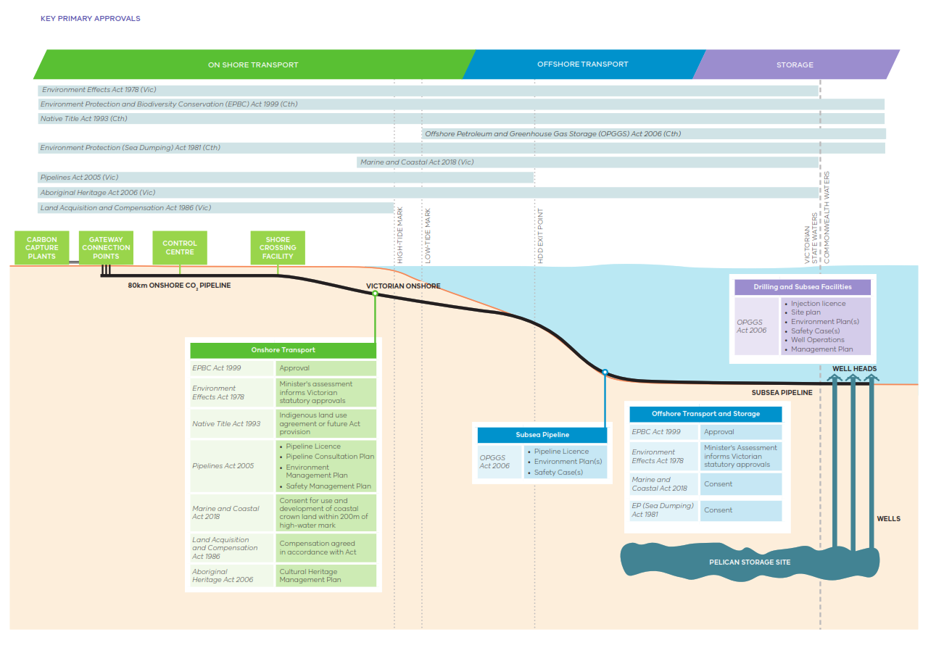
Long description of the above image: Key Primary Approvals. The image is a graphical representation of the proposed pipeline with a number Acts of Parliament listed. The Acts, both Victorian and Commonwealth are positioned around the image in proximity to and labelled with the parts of the project they apply to.
- Onshore Transport: Environment Protection and Biodiversity Conservation Act 1999 (Commonwealth), Environment Effects Act 1978 (Victorian), Native Title Act 1993 (Commonwealth), Pipelines Act 2005 (Victorian), Marine and Coastal Act 2018 (Victorian), Land Acquisition and Compensation Act 1986 (Victorian), Aboriginal Heritage Act 2006 (Victorian)
- Subsea Pipeline: Offshore Petroleum and Greenhouse Gas Storage Act 2006 (Commonwealth)
- Offshore Transport and Storage: Environment Protection and Biodiversity Conservation Act 1999 (Commonwealth), Environment Effects Act 1978 (Victorian), Marine and Coastal Act 2018 (Victorian), Environment Protection (Sea Dumping) Act 1981 (Commonwealth)
- Drilling and Subsea Facilities: Offshore Petroleum and Greenhouse Gas Storage Act 2006 (Commonwealth)

The EES process
In Victoria, it has been determined by the Minister that an assessment of the potential environmental impacts or effects of a proposed development may be required under the Environment Effects Act 1978. Under this Act, an Environment Effects Statement (EES) is required and includes a comprehensive process for assessing potential impacts of large-scale projects and how those effects will be managed. Confirmation of the project won’t occur until the Minister’s assessment has been completed, and regulatory approvals are in place.
The EES is not an approval permit itself, rather it enables statutory decision-makers (Ministers, local government, and statutory authorities) to make decisions about whether a project with potentially significant environmental effects should proceed or not.
If the Minister for Planning decides that an EES is required, CarbonNet is responsible for preparing the EES and undertaking the necessary investigations.
Further information on the EES process can be found on the Planning Victoria website.
A range of studies are generally required to support the statutory approvals including, but not limited to:
Onshore Key Assessments | Offshore Key Assessments
- Flora and Fauna  - Aboriginal Cultural Heritage  - Historical Heritage  - Land Use  - Noise  - Landscape and Visual  - Social  - Business impacts  - Surface water  - Groundwater  - Traffic and Transport  - Air Quality  - Ground Contamination  - Safety Hazard and Risk  - Greenhouse Gas | - Benthic Ecology, Fish, and invertebrates  - Marine Mammals  - Seabirds and shorebirds  - Marine Protected areas  - Commercial and recreational fisheries  - Maritime Heritage (non-Aboriginal)

Community and stakeholder engagement and consultation
Engaging and involving local communities and stakeholders in projects helps to achieve better outcomes. CarbonNet has created a Consultation Plan that illustrates how we will engage with our community and seek input and feedback throughout the assessment and approvals process, including the EES. Information about our engagement program is available on our website www.vic.gov.au/ CarbonNet and all consultation activities are advertised in local media and online.
CarbonNet will ensure that all engagement activities align with:
- The Victorian Government’s Public Engagement Framework 2021–2025, which builds on the values and standards developed by the International Association of Public Participation (IAP2).
- NOPSEMA’s ‘Consultation in the course of preparing an Environment Plan’ guideline, for the regulatory approval process.
Engagement under the Public Engagement Framework 2021–2025 must be meaningful, inclusive, transparent, informed, accountable and valuable. CarbonNet understands that best practice consultation is critical to achieving the best outcomes for impacted communities.

Traditional Owners
CarbonNet recognises and acknowledges the Gunaikurnai people as Traditional Owners of Country across the Gippsland region and their ongoing connection to lands, waters and communities. Traditional Owners will continue to be actively engaged as the project moves into the cultural heritage assessment process, including development and implementation of the project’s Cultural Heritage Management Plan (CHMP).

Land access
Landowners and occupiers are key stakeholders. CarbonNet aims to engage in a respectful, honest, and open way with all landowners and occupiers impacted by the project.
Where land access is required along the proposed pipeline route, CarbonNet will seek landowner and occupier agreements for access. The type and nature of access agreements will depend on the activities to be completed for the project. CarbonNet may typically seek the following agreements with landholders:
- Land access agreement: An agreement to enable us to access land to carry out surveys and studies through the initial and detailed discussions and investigations.
- Option agreement: Through the detailed discussion phase we will provide an Option Agreement which, when signed will secure the ability to construct and operate the pipeline on your land. Once the Option Agreement is executed, it will clearly state the processes for notification and timeframe for the construction and operation of the pipeline.

Independent advice
Impacted landowners and occupiers are permitted to seek independent advice in relation to dealings with CarbonNet and the proposed pipeline on their property. Agreed reasonable costs associated with independent advice provided by legal and professional services firms in relation to the proposed pipeline will be met by CarbonNet.

More Information
The CarbonNet Project
Ph: 1800 878 968
Email: carbonnet.info@ecodev.vic.gov.au
Website: vic.gov.au/CarbonNet

Authorised by the Crown in Right of Victoria
© Copyright State of Victoria,
Department of Jobs, Skills, Industry and Regions 2023
This document is also available at vic.gov.au/CarbonNet

