

TAFE Network Statement of Priorities for 2026-2028
Minister’s Foreword 2
Victoria’s TAFE Network Statement of Priorities 4
Why the TAFE Network Statement of Priorities matters 4
A new strategic planning framework 4
The skills and TAFE landscape 5
Victoria’s TAFE Network 6
How the TAFE Network supports Victorians 6
The TAFE Network approach is our roadmap to success 7
Drivers for a strong, effective TAFE Network 8
TAFE Network priorities for 2026-2028 9
Priority 1 - Our industry partners 10
Priority 2 - Our students 11
Priority 3 - Our people and places 12
Signing page 13

Acknowledgement
We acknowledge and pay respects to Elders and all First Peoples in Victoria. We honour and respect Traditional Custodians past and present and the strength of First Peoples in practising the world’s oldest living culture, which enriches our society more broadly.
We recognise the leadership of First Peoples in advocating tirelessly for future generations’ rights to education and our responsibility to partner with First Peoples through Treaty and Truth‑telling to support self‑determination in post‑secondary education and training.

Minister’s Foreword
Victoria’s TAFES lead the nation in the innovation and creativity needed to grow our economy and build the future industry, clean energy and housing Victorian families need.
Free TAFE began in Victoria and is reducing the cost of living for Victorian families and creating our future workforces in priority areas such as clean energy and housing construction.
Our successful Free TAFE program is building the pipeline of skilled workers our state needs and giving more Victorians access to quality vocational education. More than 229,200 students in Victoria have accessed Free TAFE since it began in 2019 (to December 2025), saving them $777 million in tuition fees. This includes more than 132,000 women, 22,700 students with a disability, and 55,900 students experiencing unemployment.
That is why we have legislated to enshrine Free TAFE in law and guarantee a minimum of 70% of funding to Vocational Education and Training goes to TAFE. We have also formalised the TAFE network in law.
The Allan Labor Government has invested more than $16 billion new and base funding into our TAFE and training system since 2014, including more than $660 million into quality TAFE facilities. We have built or upgraded 45 TAFE campuses across Victoria since 2014.
Victoria’s TAFE Network, comprising TAFE institutions and dual sector universities, provides world‑class training for the workers who power the industries that keep our economy thriving. A collaborative and coordinated TAFE Network is critical to building the skilled workforce our state needs.
So much more can be achieved when we work together towards shared goals. Through the TAFE Network, there are opportunities to align training, share facilities and expertise, and create efficiencies.
One of the key actions of our state’s Economic Growth Statement (EGS) is to build skills - particularly skills needed in priority sectors like advanced manufacturing and the clean economy. Our state also needs skilled workers in housing, health care and digital jobs.
Bendigo Kangan Institute is leading the delivery of an AI‑enabled Recognition of Prior Learning tool for the Victorian TAFE Network which will make the Recognition of Prior Learning process faster and more consistent, transforming how skilled workers gain formal qualifications so that they are work‑ready sooner.
We’re also working hand‑in‑glove with the TAFE Network, industry, businesses and the community to invest in the industries and jobs of the future. Centres of Excellence are great examples of how this collaboration is delivering improved outcomes for the state, not just a single institute.
Through the National Skills Agreement, Victoria is leading efforts to develop a highly skilled workforce through new national Centres of Excellence in priority fields such as artificial intelligence, cybersecurity, modern home-based care, renewable energy and modern methods of construction.
Combined Victorian and Commonwealth investment of $50.6 million will establish the Digital, AI and Technology Centre of Excellence at Chisholm Institute and the Home and Community Care Centre of Excellence at Holmesglen Institute - to drive national improvements in digital literacy across critical industries including home-based care.
A further investment of $50 million will establish the Victorian Renewable Energy TAFE Centre of Excellence to respond to industry skills gaps in the energy workforce and support Victoria’s aim for 95% renewable energy generation by 2035.
This is in addition to a previous commitment of $50 million to deliver the Future of Housing Construction Centre of Excellence at Melbourne Polytechnic which will drive innovation in modern methods of construction.
These centres sit alongside the development of the $36 million Gordon TAFE Centre of Excellence in Disability Inclusion which will set the benchmark for accessible training and education to people with disability. Victoria’s TAFE Network approach and the program of work being delivered by the TAFE Network under the National Skills Agreement ensures that Victoria will continue to play a key role in contributing to, and harnessing, the collective strength of the National TAFE Network.
Everything we do continues to be guided by our ambition to drive a strong pathway from skills to jobs, and to grow the productive capacity of our economy for the benefit of all Victorians.
The TAFE Network plays an essential role in helping us meet these goals. By working together, we can achieve incredible outcomes for our students, our communities and our state’s prosperity
The Hon Gayle Tierney
MP Minister for Skills and TAFE.

Victoria’s TAFE Network Statement of Priorities

Why the TAFE Network Statement of Priorities matters
The TAFE Network Statement of Priorities (the Statement) is the agreement between the Minister for Skills and TAFE and Victoria’s public TAFE Network. It sets out the strategic objectives, priority activities and outcomes expected of the network for the next 3 years (2026-2028).
Now in its fifth year, the Statement continues to support our ambition for a stronger TAFE Network that is collaborative, coordinated and strategically aligned with the changing demands for skills. It provides a clear set of strategic priorities for the Network and guides TAFEs and dual sector universities to work together to address critical skills gaps and advance training and career outcomes for Victorians.

A new strategic planning framework
The Statement is now enshrined in the Education and Training Reform Act 2006 embedding a strategic planning framework that supports TAFEs and dual sector universities to work as a network to align TAFE delivery and activities with Government’s priorities and expectations.
For standalone TAFE institutes the Statement informs TAFEs’ strategic plans to enable effective corporate planning and sits alongside annual budgets which support TAFE financial sustainability

The skills and TAFE landscape
The Victorian Skills Plan - Victoria’s skills roadmap - states that around 373,000 new workers are expected to enter the Victorian labour market over the next three years, rising to around 1.5 million new workers over the next decade. Nearly half of the new workers projected in the next 10 years are expected to be in jobs typically requiring a VET qualification.
The Economic Growth Statement and Victorian Industry Policy identify sectors such as construction and advanced manufacturing, digital technologies and the clean economy as priority industries key to Victoria’s economic growth and prosperity. Over the next decade an additional 162,500 workers will be needed in the construction industry to build homes for Victoria and 87,700 new workers will be required in digital technology occupations to engage with Artificial Intelligence (AI) and other technological change.
The clean economy transition is expected to create 10,000 new jobs per year until 2030 and other critical industries like health care and social assistance are also expected to grow with over 363,300 new workers needed over the next 10 years.

Free TAFE will help us get there
Victoria’s Free TAFE program, which is now embedded in legislation, makes training for these in-demand roles more accessible by removing the financial barrier to training.

TAFE at the centre, backed by national skills reform
Government has committed to legislating that 70% of VET funding be directed to TAFE - affirming the central role of the TAFE Network within Victoria’s VET system which is echoed in national skills reform through the National Skills Agreement.

A joined-up system for lifelong learning and rewarding careers
TAFE offers pathways from schools through the Victorian Certificate of Education (VCE) and VET Delivered to School Students (VDSS), while also creating routes to and from university and the workforce, supporting tertiary harmonisation and the objectives of the Universities Accord to deliver a more integrated and accessible tertiary education system.

Advancing First Peoples’ Self-Determination
Guided by the Wurreker strategy and Marrung Aboriginal Education Plan, Victoria’s TAFE Network continues to be critical to supporting positive outcomes for both First Nations students and staff by embedding cultural safety, cultural capability and self-determination into curriculum and the workplace

Victoria’s TAFE Network

How the TAFE Network supports Victorians
The TAFE Network is at the heart of Victoria’s VET system. The Network has the locational reach, scale and industry connections that are critical to sustaining Victoria’s economic growth and leading the development of the workforces that power the Victorian economy.
Comprising 11 standalone TAFEs and 4 dual sector universities, these are Victoria’s public providers of vocational training. Victoria hosts 4 of Australia’s 6 dual sector universities, and this dual perspective adds to the strength of the Network.
Operating across 90 campuses with state-of-the-art training facilities, our TAFE Network delivers over 860 courses including more than 80 Free TAFE courses to over 221,000 students each year, supported by 9,000 staff.
As public providers, they ensure broad access to training and offer targeted and tailored support for disadvantaged and under-represented learner groups. TAFEs and dual sector universities provide a diverse range of services to Victorians - supporting local communities, including in regional Victoria, and generating social and economic benefits both as training providers and local employers.
TAFEs respond to local and statewide workforce needs, support emerging industries and enable lifelong learning through flexible pathways, including between TAFE and higher education - enhanced through the Network’s dual sector universities.
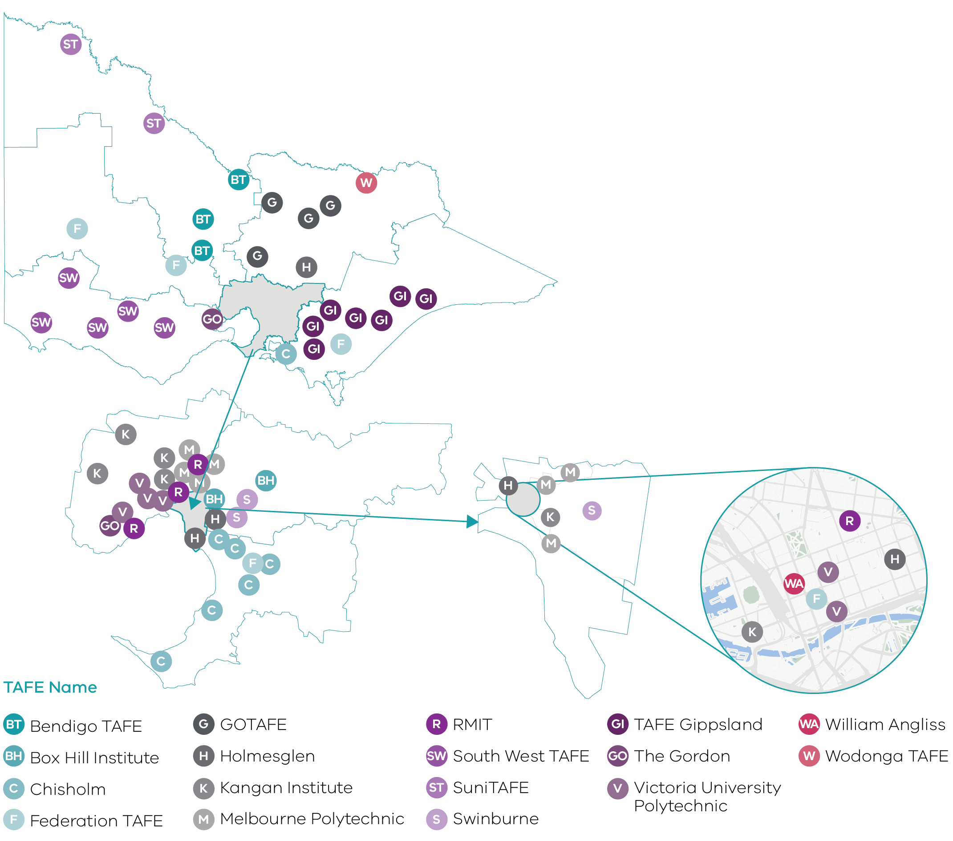

Northern Victoria Institute of TAFE - Strength through collaboration
The amalgamation of GOTAFE and Wodonga TAFE to create the Northern Victoria Institute of TAFE is an example of how collaboration can enhance sustainability, capability and local responsiveness.
The larger scale brought about by this amalgamation creates efficiencies and wider reach in student services strengthening regional education delivery, deepening industry connections, and improving access to training across northern, central and north-eastern Victoria.
The blending of these institutes demonstrates how collaboration can create opportunities, consistent with the Victorian Government’s response to the Independent Review of the Public Sector. Voluntary partnerships remain one option available to support a strong and connected TAFE Network.

The TAFE Network approach is our roadmap to success

Our Vision
A Victorian TAFE Network that is the benchmark for quality, outcomes and innovation - the first choice for industry, employers and students - that meets emerging skills needs, and increases economic participation for all Victorians.
The TAFE Network’s success is driven by its collaborative network approach where TAFEs and dual sector universities work together, to plan network services and draw on the strengths and efficiencies that can be gained by a shared vision. By working collaboratively to overcome sector fragmentation, we reduce duplication and increase consistency and quality across the network, generating savings and boosting efficiency and effectiveness.
We are working to deliver a training and skills sector that is efficient, responsive to industry and student needs, produces high-quality outcomes and innovates for the future.
This approach is backed by wider policy trends that champion more joined-up, collaborative systems across education.

TAFE Network objectives
Network objectives orientate TAFEs’ individual efforts towards a common purpose, driving stronger collective performance and impact. The TAFE Network Statement aligns its actions to TAFE Network objectives and TAFEs and dual sector universities consider these objectives when preparing responses to the Statement and as part of other strategic planning and decision-making processes.
Skills that matter: A joined-up approach to planning and delivering training that delivers the skills Victoria needs
Access for all: Collaborative, responsive and flexible solutions to removing barriers to TAFE
Aboriginal self-determination: Working in partnership with Aboriginal communities to support self-determination in VET
High quality support: High-quality learning, career and wellbeing services for every student.
Research and innovation: Driving new ideas and applied research in emerging and existing skills areas
Specialist training: Delivering specialist training in priority or emerging skills areas.
Lifelong learning: Clear pathways from school to TAFE to university, and support for career changers

Drivers for a strong, effective TAFE Network
An effective TAFE Network is built on shared direction, connected systems and strong governance. These foundations enable institutes to deliver on the Network vision for an effective, responsive, innovative and high-quality network which operates as one cohesive and coordinated system while remaining responsive to local needs.
TAFEs and dual sector universities commit to working together and making decisions for the benefit of the Network. These drivers and ways of working bring the TAFE Network vision to life.

Victorian TAFE Network drivers of success
Shared vision and purpose
Governance and accountability
Common systems and infrastructure
Coordinated planning and design
Collaboration and shared expertise

TAFE Network priorities for 2026-2028
The Statement is focused on 3 priority areas - our industry partners, our students and our people and places.
Priority area | Summary
Our industry partners | A TAFE Network powered by strong industry and employer partnerships, delivering industry-relevant training that builds job-ready graduates.
Our students | A connected TAFE Network delivering equitable and consistent access to high-quality education and clear pathways to meaningful learning and employment for every student.
Our people and places | A TAFE Network that empowers its workforce and strengthens its learning environments - fostering excellence in teaching, professional development, staff wellbeing, and the effective use of our campuses and facilities.
Note that not all actions outlined under the three priority areas apply to dual sector universities due to their different governance, reporting and financial arrangements.

Priority 1 - Our industry partners
A TAFE Network powered by strong industry and employer partnerships, delivering industry-relevant training that builds job-ready graduates.
The Victorian TAFE Network supports local innovation to translate into system-wide excellence, improving student outcomes and making TAFEs more relevant to industry, ensuring that TAFE delivers training that gives local employers the skills they need.
Actions for 2026-2028
Area | Actions
Coordinated TAFE training delivery | Undertake a networked approach to course delivery planning aligned to the Victorian Skills Plan to ensure efficient, effective and accessible state-wide TAFE that meetings Victoria’s skills needs and delivers improved outcomes in priority courses, including Free TAFE, apprenticeships and traineeships.
Industry engagement, collaboration and innovation | Establish and strengthen formal partnerships with industry groups and local employers, including First Nations organisations to:  - co-design innovative responses to priority workforce and skills needs  - improve apprenticeship and traineeship completions  - improve student employment outcomes  - support the TAFE workforce, and address skills needs.  This includes implementing and utilising common ICT platforms to better support and maximise industry engagement and delivering initiatives such as TAFE Centres of Excellence and the Skills Solutions Partnership program.

Priority 2 - Our students
A connected TAFE Network delivering equitable and consistent access to high-quality education and clear pathways to meaningful learning and employment.
The TAFE Network gives students a consistent, high-quality learning experience which includes learning, wellbeing and employment support, creating diverse and inclusive learning environments.
Actions for 2026-2028
Area | Actions
High-quality and consistent student experience | Implement a network-wide approach to courseware development which promotes best practice and excellence in teaching and learning by developing and sharing high-quality teaching and assessment materials. These will be used by all TAFE Network members, including in relation to VET Delivered to School Students (VDSS) where the TAFE Network will be the primary deliverer of VET training to secondary students in selected, high priority areas.
Modernised student experience through shared ICT solutions | Progressively implement common ICT platforms across the TAFE Network to drive a consistent and effective experience across the student lifecycle, including in relation to student enrolment and acquisition, learning and support and placements and workplace learning.
Safe and supportive student learning environments, including access to education | Identify collective approaches to student access, support, inclusion and completion informed by appropriate research and funding levels to ensure that all students - regardless of background, ability, or circumstance - have access to consistent, high-quality support services and inclusive, culturally safe learning environments across all TAFE institutes.
First Peoples’ self-determination - through Treaty and Truth | Identify Network approaches to promote cultural safety and self-determination for First Nations students across the TAFE network, supported by Victoria’s commitment to Treaty and Truth. Identify and disseminate best practice examples, informed by First Peoples’ expertise and experiences, which supports inclusive access to training, involves First Nations students in decision-making and enables First Nations students to achieve their learning and employment goals.

Priority 3 - Our people and places
A TAFE Network that empowers its workforce and strengthens its learning environments - fostering excellence in teaching, professional development, staff wellbeing, and the effective use of our campuses and facilities.
Actions for 2026-2028
Area | Actions
Build the pipeline of TAFE teachers and develop our workforce | Partner with industry and collaborate across the network on initiatives which identify, attract and retain TAFE teachers in areas of high demand to drive improved outcomes including promoting cultural safety and self-determination for First Nations staff and supporting continued excellence in teaching and increased staff satisfaction and wellbeing.
Common, modernised systems | Progressively implement common systems across the TAFE Network, including shared TAFE ICT architecture, to support the TAFE workforce from recruitment and onboarding to professional development of staff and teachers.
Digital capability and intelligence | Embed digital skills and capability into TAFE operational functions to support the TAFE workforce to adapt to change in technology, including AI, and to increase the training capacity of the TAFE system. Ensure educators have the digital and AI skills to teach learners to thrive in the changing work environment.
A sustainable, high-quality and fit for purpose TAFE asset base | Collaborate for efficient use of the TAFE Network asset base, maximising the returns from public investment through the reduction in inefficient duplication of delivery and services and enabling TAFEs to focus and streamline delivery.

Signing page

[signed]
The Hon Gayle Tierney MP
Minister for Skills and TAFE

[signed]
Sharan Burrow
Board Chair
Bendigo Kangan Institute
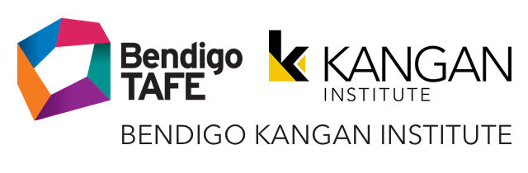

[signed]
Jane Foley
Board Chair
Box Hill Institute


[signed]
Gillian Miles AM
Board Chair
Chisholm Institute


[signed]
Paul Buckley PSM
Board Chair
TAFE Gippsland

[signed]
Darryl Mohr
Acting Board Chair
The Gordon Institute of TAFE


[signed]
Michael Gorton AM
Board Chair
Holmesglen Institute of TAFE


[signed]
Helen Clarke
Board Chair
Melbourne Polytechnic

[signed]
Hon. Candy Broad
Board Chair
Northern Victoria Institute of TAFE


[signed]
Brian Crook
Board Chair
South West Institute of TAFE


[signed]
Neth Hinton
|Board Chair
Suni TAFE


[signed]
Chris Altis
Board Chair
William Angliss Institute of TAFE

This TAFE Network Statement of Priorities is also supported by Victoria’s dual sector universities, which provide TAFE services in Victoria with government funding*.

[signed]
Darren Gray
Pro Vice-Chancellor VET and University Pathways and Chief Executive TAFE
Federation University Australia


[signed]
Mish Eastman
Deputy Vice-Chancellor Vocational Education Vice President
RMIT University


[signed]
Madelyn Bolch
Pro Vice Chancellor and Chief Executive, Vocational Education and Training
Swinburne University of Technology


[signed]
Wayne Butson
Chief TAFE Officer and CEO of TAFE
Victoria University

*While their commitment to supporting and developing the skills and students of Victoria mirrors that of the Victorian Government‑owned ‘standalone’ TAFEs, the governance and financial arrangements of dual sector universities differ, and some priorities outlined in the Statement will not apply.

DJSIR and Victorian Skills Authority modelling, 2025.
Ibid.
Ibid.

