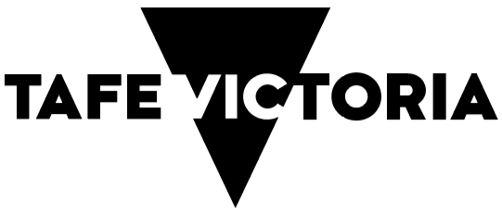

TAFE Network Statement of Priorities for 2026-2028

Message from the Minister for Skills and TAFE
Dear Victorian students,
The government is committed to delivering high‑quality and industry‑relevant training through our Victorian TAFE Network.
TAFE is at the heart of the Victorian Vocational Education and Training System because everyone deserves the opportunity to upskill.
This is a joint commitment from the TAFEs, dual sector universities and the Government to help students get the world‑class training for great jobs that lead to rewarding careers.
Start your training journey today.
The Hon Gayle Tierney
MP Minister for Skills and TAFE.

Our priorities

Our Industry Partners
Coordinated TAFE training delivery
Industry engagement
Industry collaboration and innovation

Our Students
High‑quality and consistent student experience
Modernised student journey through shared ICT solutions
Safe and supportive student learning environments
Focused on self‑determination for First Nations students

Our People and Places
Build the pipeline of TAFE teachers and develop our workforce
Common, modernised systems
Digital capability and intelligence
A sustainable, high‑quality and fit‑for‑purpose TAFE asset base

Outcomes
Delivering skills that matter
Ensuring access for all
Advancing Aboriginal self‑determination
Offering high quality student support
Driving research and innovation
Delivering specialist training in emerging skills
Creating lifelong learning and pathways.

How we’ll do it
We’ll work toward a shared vision driven by evidence‑informed network priorities
We’ll be transparent and accountable across the Network
We’ll reduce duplication and improve efficiency through common systems
We’ll undertake coordinated planning and design
We’ll leverage collective expertise and resources

Principles driving the Victorian TAFE Network approach
Responsiveness
Efficiency
Quality
Innovation

