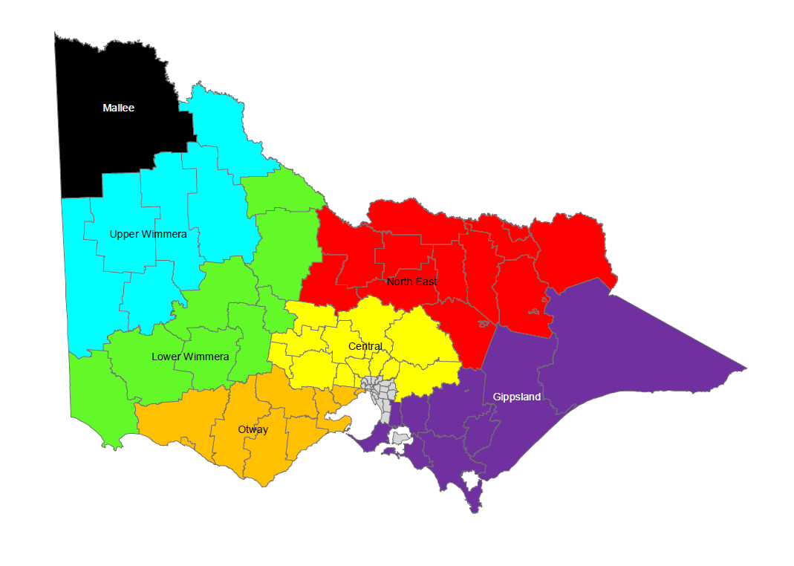
Kangaroo Harvest Zones in Victoria 2024
Exclusion Zone

