# Victoria’s Visitor Servicing Framework

May 2023

## Acknowledgement of Country

We proudly acknowledge the First Peoples of Victoria and their ongoing strength in practicing the world’s oldest living culture. We acknowledge the Traditional Owners of the lands and waters throughout Victoria, and we pay our respects to their Elders past, present and future.

The diverse landscapes of Victoria have been the home of diverse First Peoples since time immoral, where they have cared for and nurtured Country throughout this time. The lands and waters on which Victorians and visitors draw enjoyment and inspiration continue to be a living cultural landscape.

We recognise the rights and aspirations of Victorian First Peoples and acknowledge that First Peoples’ Self Determination is a human right as enshrined in the United Nations Declaration on the Rights of Indigenous Peoples. Building on this and guided by the 11 principles of First Peoples’ Self Determination, we are committed to developing strong, respectful and enduring relationships and partnerships with First Peoples in the visitor economy, as decided for and by First Peoples.

## TABLE OF CONTENTS

Acknowledgement of Country 1

1 Introduction 3

1.1 Who is this framework for? 3

2 Setting the scene 4

2.1 What is visitor servicing and why is it important? 4

3 Principles guiding the future of visitor servicing in Victoria 6

1. Visitor servicing is everyone’s business 7

2. Curate online and in-person services that put customer needs first 8

3. Adopt an integrated stakeholder approach 8

4. Evolve and strengthen the italicised i trademark 9

5. Support modern visitor information centres 9

## 1 Introduction

The success of any tourism destination rests heavily on the quality of the visitor experience. Visitor information servicing plays a pivotal role in enhancing this experience, through the delivery of physical and digital content that provides visitors with information at critical stages in the visitor journey.

The rapid adoption of smart technology and changes in consumer behaviour have dramatically altered how people access this information, make travel decisions and purchase tourism products and experiences and this will continue to change at an even faster pace.

In particular, the widespread availability of digital information has raised expectations by visitors of personalised service, tailored to individual needs and via multiple information sources (both digital and in person) throughout their journey.

This expectation of a seamless omni-channel experience highlights the critical need for visitor servicing providers in Victoria to expand outside the traditional realm of information delivery by creating new and innovative approaches to ensure visitor services are available when, where and how visitors want them. Victoria’s Visitor Servicing Framework aims to help government, the tourism industry and community work together to better plan and deliver visitor servicing for Victoria’s cities, regions, and visitors.

The framework has been prepared by the Department of Jobs, Skills, Industry and Regions drawing upon national and international research and consultation with tourism industry stakeholders and will support the delivery of the Victorian Government’s objectives for the visitor economy, as detailed in Experience Victoria 2033.

The Victorian Government recognises the importance of visitor servicing and has committed funding of $3 million to support partnerships with industry to implement improved approaches to visitor servicing that meet contemporary visitor needs.

### 1.1 Who is this framework for?

This framework aims to provide guidance to a range of industry stakeholders, including local councils, Regional Tourism Boards (RTBs), tourism businesses and local communities, on the development and delivery of contemporary visitor servicing models and processes.

## 2 Setting the scene

### 2.1 What is visitor servicing and why is it important?

Visitor servicing is the delivery of timely, high quality and accurate information that has the potential to influence a person’s travel and spending behaviour at any stage of the visitor journey and enhance the overall visitor experience - both outside and inside a destination. This potential is amplified when the information is delivered through a customer service lens.

Visitor servicing can include online and in-person sources of information and inspiration for visitors at various touchpoints in their journey, as demonstrated in Figure 1 below.

Figure 1.

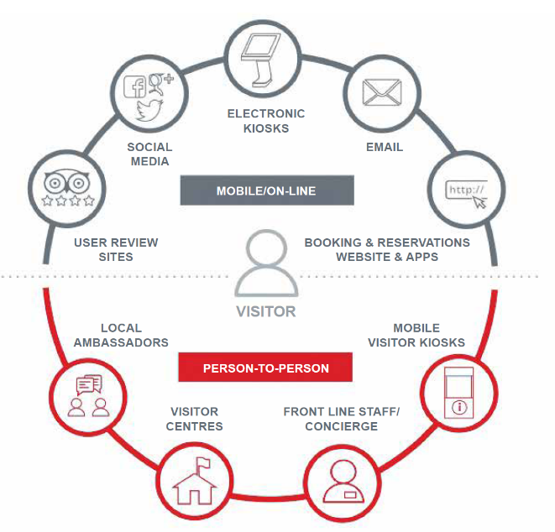

Alt text: Infographic of on-line and in-person visitor touchpoints. Online visitor touchpoints include user review sites, social media, electronic kiosks, email, booking and reservation websites and apps. In-person visitor touchpoints include local ambassadors, visitor centres, front line staff, concierge and mobile visitor kiosks.

Adapted from *A New Visitor Services Model for Alberta: Engaging Visitors in an Era of Technology; Government of Alberta 2017.*

Exceptional visitor servicing can encourage visitors to form a genuine connection with a destination, enabling them to become strong advocates or ambassadors which in return can help build the reputation of a destination and attract new visitors. Figure 2 outlines four key visitor servicing benefits to consider across visitor servicing touchpoints.

Figure 2.

Alt text: A diagram of four key visitor servicing benefits:
1. Inspiring – Potential visitors learn about and are attracted to visit the destination.
2. Converting - Potential visitors find it easy to source information and book travel, converting intention to action.
3. Adding value – Visitors receive information about things to see and do, inspiring them to engage in multiple experiences and extend their length of stay. Visitors receive exceptional service from arrival to departure.
4. Creating advocates – Visitors become destination advocates, wanting to repeat their visit and telling friends and family about their amazing experience, encouraging new visitors.

Alt text: A diagram of four key visitor servicing benefits:

1. Inspiring – Potential visitors learn about and are attracted to visit the destination.
2. Converting - Potential visitors find it easy to source information and book travel, converting intention to action.
3. Adding value – Visitors receive information about things to see and do, inspiring them to engage in multiple experiences and extend their length of stay. Visitors receive exceptional service from arrival to departure.
4. Creating advocates – Visitors become destination advocates, wanting to repeat their visit and telling friends and family about their amazing experience, encouraging new visitors.

Adapted from Visitor Servicing Toolkit; Victoria Tourism Industry Council 2019, p.9.

Furthermore, through the information shared and the skilful advice provided in person and online, visitor servicing providers can unlock visitor spending, facilitating a flow on effect by increasing the number of activities that a visitor engages in, increasing dispersal across a region and by increasing the length of time that a visitor will stay at a destination. For instance, research has consistently found that visitors spend more time in a region as a result of visiting a visitor information centre.

## 3 Principles guiding the future of visitor servicing in Victoria

These five principles will assist the Victorian tourism industry to remain competitive nationally and globally, be a leader in customer centric visitor servicing and grow yield and length of stay.

The five principles are:

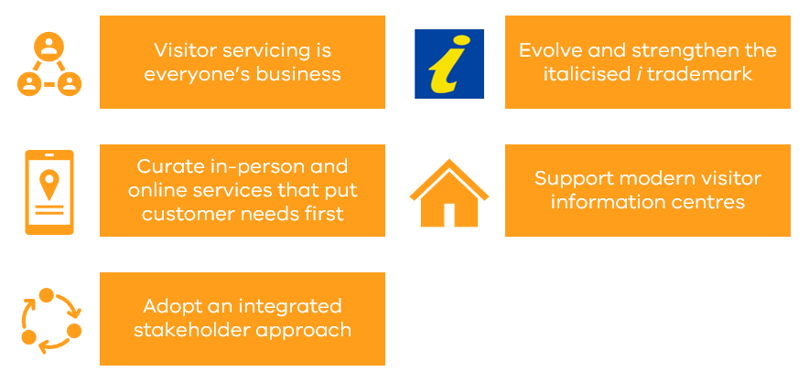

Alt text: A group of orange rectangular signs listing the five visitor servicing principles.

### 1. Visitor servicing is everyone’s business

We will recognise that visitor servicing is everyone’s business and exemplary visitor servicing is delivered at all touchpoints in the visitor journey.

Visitors are increasingly expecting to be able to access the information and support they need when and where they need it. This means that visitor servicing is everyone’s business as a range of tourism stakeholders interact with visitors at various points in the visitor journey.

An example of the visitor journey in Figure 3 outlines the various stages to influence visitor decision-making.

Figure 3.

**Alt text: A diagram of online and in-person visitor servicing along the visitor journey.
1. Dream – deciding where to go
a. Online
i. Web search
ii. Social media
iii. Destination websites
b. In-person
i. Word of mouth
2. Plan – confirming destination and activities
a. Online
i. Review sites
ii. Social media
iii. Destination websites
iv. Aggregator websites
b. In-person
i. Accredited visitor information centres
ii. Word of mouth
3. Book – book major product
a. Online
i. Destination websites
ii. Aggregator websites
iii. Apps
b. In-person
i. Accredited visitor information centres
ii. Travel agents
4. Experience – continue to book product and experiences
a. Online
i. Destination websites
ii. Social media
iii. Review sites
iv. Apps
b. In person
i. Word of mouth
ii. Accredited visitor information centres
iii. Local knowledge
5. Advocate – Share with family and friends
a. Online
i. Social media
ii. Review sites
b. In-person
i. Word of mouth
**

Alt text: A diagram of online and in-person visitor servicing along the visitor journey.

1. Dream – deciding where to go
   1. Online
      1. Web search
      2. Social media
      3. Destination websites
   2. In-person
      1. Word of mouth
2. Plan – confirming destination and activities
   1. Online
      1. Review sites
      2. Social media
      3. Destination websites
      4. Aggregator websites
   2. In-person
      1. Accredited visitor information centres
      2. Word of mouth
3. Book – book major product
   1. Online
      1. Destination websites
      2. Aggregator websites
      3. Apps
   2. In-person
      1. Accredited visitor information centres
      2. Travel agents
4. Experience – continue to book product and experiences
   1. Online
      1. Destination websites
      2. Social media
      3. Review sites
      4. Apps
   2. In person
      1. Word of mouth
      2. Accredited visitor information centres
      3. Local knowledge
5. Advocate – Share with family and friends
   1. Online
      1. Social media
      2. Review sites
   2. In-person
      1. Word of mouth

Adapted from: A National Perspective on Visitor Information Servicing; State Tourism Organisation Visitor Information Servicing working group 2019, p. 12.

Because of this, and despite the introduction of outreach programs in some regions, visitor servicing cannot solely be the responsibility of ‘bricks and mortar’ accredited visitor information centres. Tourism businesses and residents are also well positioned to provide invaluable and bespoke insights into a local area.

Leading tourism organisations around the world have recognised this important role and developed programs to support businesses and residents to engage with visitors and help them make informed choices to ensure they get the most from their visit.

#### iKnow Partner Programme – Visit Scotland

The iKnow Partner Programme was introduced in 2017 by Visit Scotland as part of the organisation’s focus on visitor servicing ‘to ensure that there is an information touchpoint in every corner of Scotland’.

The programme recognises and supports the efforts of businesses who provide good quality, accurate information to help visitors make informed choices and get the most from their visit. To become a certified IKnow Partner, business must demonstrate that they provide local information, in both printed and online formats or through knowledgeable staff.

Participating businesses received a window sticker, staff badges and a certificate to promote their commitment to providing local information.

### 2. Curate online and in-person services that put customer needs first

We will engage visitors via a blend of online and in-person channels, ensuring the provision of high-quality, on-brand, and streamlined visitor servicing across the whole visitor journey.

Digital technologies are continuously changing how people live, work and interact with each other. While COVID-19 has accelerated a focus on digital needs and requirements, it has also reminded society of our need to connect as humans. The combination and balance of in-person and digital visitor servicing creates opportunities to reach visitors throughout all stages of the visitor journey and influence them to increase how much they spend, where they go and how long they stay.

Importantly, fully embracing digital visitor servicing will require high-quality mobile and broadband coverage across Victoria with the capacity and resilience to meet demand during events, peak seasons and emergencies.

### 3. Adopt an integrated stakeholder approach

We will promote a partnership approach to visitor servicing to ensure stakeholders focus on greater collaboration, strategic planning, and brand alignment to deliver customer-centric visitor servicing solutions.

It is crucial to apply a broad region-based approach to the visitor’s decision-making matrix to appropriately address visitor servicing opportunities and challenges. Visitors don’t see geographical or organisational boundaries and there is an opportunity for stakeholders to work together and ensure that the delivery of visitor servicing within a region is seamless and focused on the needs of the visitor.

Local councils play a key role in visitor servicing as both a significant investor in visitor services and conduit to strategic stakeholder partnerships. A whole of region approach should include multiple local councils and be driven by the relevant RTBs to strategically align planning and branding, delineate roles and responsibilities, share training programs, and involve industry and community.

There is not a ‘one-size-fits-all’ approach to visitor servicing stakeholder partnerships as it will depend on partnerships and relationships within a region, the tourism offering, its brand and the visitor profile.

### 4. Evolve and strengthen the italicised i trademark

We will continue to evolve and strengthen the italicised i trademark by ensuring the underpinning accreditation program aligns with changes to visitor servicing and reflects contemporary visitor expectations.

The Victoria Visitor Information Centre Accreditation Program was first initiated in 1997. Over subsequent years it has provided visitor information centres nationally with access to the trademarked yellow italicised ‘i’ with the blue background brand and signage, as well as other benefits. Accreditation has fostered high standards in visitor servicing by ensuring delivery of quality information and visitor facilities, and the professional development of staff and volunteers who are passionate about the brand. The brand offers peace of mind to visitors that they are receiving authoritative local information.

The benefits that visitor information centres and their stakeholders receive from accreditation and associated use of the brand determines the value of the program. To maintain value, the model must continue to evolve with changes in visitor servicing and visitor expectations.

The Victorian Visitor Information Centre accreditation guidelines have regularly been reviewed and updated over the past twenty years. The most recent update in 2018 paved the way for a more flexible approach to visitor servicing and enabled delivery of information to be tailored to suit the changing needs of the visitor. There are further opportunities to harness and strengthen the brand value of the distinctive yellow and blue italicised ‘i’ by applying the guidelines across a range of visitor servicing models, without compromising the integrity of the brand.

### 5. Support modern visitor information centres

We will embrace a contemporary approach to ‘bricks and mortar’ accredited visitor information centres, extending their reach and exploring best practice modelling and benchmarking.

‘Bricks and mortar’ accredited visitor information centres remain an integral part of Victoria’s visitor servicing ecosystem, providing a positive impact on the overall visitor experience and unlocking visitor spending. They are also a source of pride for many communities, play a critical role during times of emergency and often service the broader community and local tourism businesses/associations.

However, changing visitor behaviour means that, unless a centre is located in prominent high traffic, central location, or become or be part of a ‘must do’ attraction in its own right, the number of visitors coming through the front door will continue to fall.

Best practice modelling and benchmarking can strengthen and evolve accredited visitor information centres, in line with current and future visitor expectations, by identifying opportunities for business improvements and operational efficiencies and guiding future investment in in-person and digital visitor servicing.

Authorised by Tourism and Events.

Department of Jobs, Skills, Industry and Regions

1 Spring Street Melbourne Victoria 3000

Telephone (03) 9651 9999

© Copyright State of Victoria,

Department of Jobs, Skills, Industry and Regions 2023

Except for any logos, emblems, trademarks, artwork and photography this document is made available under the terms of the Creative Commons Attribution 3.0 Australia license.

This document is also available in an accessible format at https/www.djsir.vic.gov.au