Board’s Report 2023-24

A message from the Chair
I am pleased to provide this report on behalf of the Board to highlight the extent of progress and key achievements over the last 12 months. The Board has sought to align its resources to achieve maximum impact through regulating a consistently large program of promotions, operating in an environment with increasing key stakeholder and community expectations in relation to health and safety, while addressing the government’s priority activities outlined in the Statement of Expectations (SoE).
Over the last 12 months the Board has:
- sought to formalise and modernise its governance framework and policies;
- worked proactively to support the State Coroner’s Inquest and recommendations into the death of Shane Tuck;
- established a structured and consistent approach to promote contestant safety from the time of initial application and through application of modified rules where required to accommodate competency and skills;
- supported the work of Medical Advisory Sub-Committee through the development of its work program and the appointment of a research expert to address priority health and safety issues;
- commenced structured and ongoing engagement with the sector; and
- taken a range of actions and decisions to strengthen the integrity of the regulatory approach to the sport.
(Alan Clayton PSM)

Introduction
The 2023-24 Professional Boxing and Combat Sports Board (Board) Report is the initial annual report provided in response to 2023-25 SoE issued by the Victorian Government.
The SoE articulates Government’s priority areas of focus, highlighting its expectations of the Board in contributing to the review of the regulatory and self-regulatory frameworks in place for combat sports and the digitisation of the Board’s licensing, permit and registration system. It also emphasises a commitment to the promotion of contestant safety, a responsive approach in addressing coronial findings, effective engagement and education of stakeholders, applying good governance principles and the highest regulatory standards to ensure the safety and integrity of the sport.

Legal framework
Professional boxing and combat sports in Victoria is regulated under the Professional Boxing and Combat Sports Act 1985 (the Act) and the Professional Boxing and Combat Sports Regulations 2018 (the Regulations) to promote safety, reduce the risk of malpractice and uphold industry integrity.
The Board is the principal regulatory body responsible for ensuring that standards are upheld, community expectations are met and contestant safety is prioritised.
- Safety
Critical consideration of contestant competency at baseline and ongoing suitability
The Board is legally required to promote contestant safety. The legislation requires that all prospective participants must provide the Board with evidence of competency and medical confirmation of health status to satisfy the Board of their eligibility to register as a professional contestant. Registration requirements include ongoing medical assessments and testing, compliance with the Board’s Rules for competitions and adherence to non-fight periods. The Board can cancel or suspend a contestant’s registration if the Board considers that it is not in the interests of the health and safety of a contestant to engage in professional contests. During the period the Board cancelled one professional contestant registration on the basis that it was not in the interests of their health and safety to continue to engage in professional contests.
Modified rules for corporate promotions and exhibition bouts
In recognition of the increasingly prevalent practice of convening ‘corporate promotions’ and ‘exhibition bouts’ involving celebrities and participants who are not sufficiently skilled to compete in professional contests but meet certain legal definitions that require the Board’s regulation, modified rules and clarification of the Board’s requirements have been developed to ensure participant safety, while allowing showcasing of the discipline consistent with the Board’s legal requirements.
Medical Advisory Sub-Committee
The Medical Advisory Sub-Committee (MASC) to the Board has become an important advisory mechanism to support the Board in its consideration and implementation of measures to enhance contestant safety.
Membership of the MASC consists of:
- Alan Clayton, Chair of the Professional Boxing and Combat Sports Board
- Christopher Shen, Member of the Professional Boxing and Combat Sports Board
- Professor Tissa Wijerathe, Neurologist – https://www.tissawijeratne.net/
- Associate Professor Christopher Barnes, Haematologist and Ringside Physician - Assoc. Prof. Chris Barnes - Australian Clinical Labs
During the reporting period the MSAC was instrumental in supporting the Board’s response to findings and recommendations made by the State Coroner of Victoria in the Shane Tuck Inquest about the association of repetitive brain trauma (not necessarily with a concussion diagnosis) and the causal relationship of the increased risk of developing traumatic brain injury (TBI), including chronic traumatic encephalopathy (CTE). This analysis informed the development and finalisation of TBI/concussion education videos for the sector and will continue to inform the consideration of potential future rule changes and/or the introduction of additional safety measures in the interests of contestants' short and longer-term health and safety. This will include a medically informed approach to identify and support contestants’ transition to retirement and further research to inform revisions to the Board’s concussion management and non-fight period protocols.
The MASC facilitated structured engagement between the Board and the community of ringside doctors regarding ringside medical etiquette and the Board’s requirements for promoting contestant safety. This resulted in the Board, on advice from the MASC, issuing its statement of requirements to ringside doctors and will lead to targeted recruitment and ongoing professional development of ringside doctors and second medical officers in 2024-2025.
Over the period, the MASC has successfully finalised and satisfied the ethics and access requirements to secure all case studies and data files from the national coronial information system to support its research into combat sport related deaths in Australia and New Zealand over the last 20 years. Access to the coronial information was endorsed by the State Coroner of Victoria who has encouraged sharing any research insights that may result in preventable deaths in combat sport settings. Completion of this thematic analysis is a priority project in 2024-2025.
Bespoke traumatic brain injury and concussion education videos for the sector:
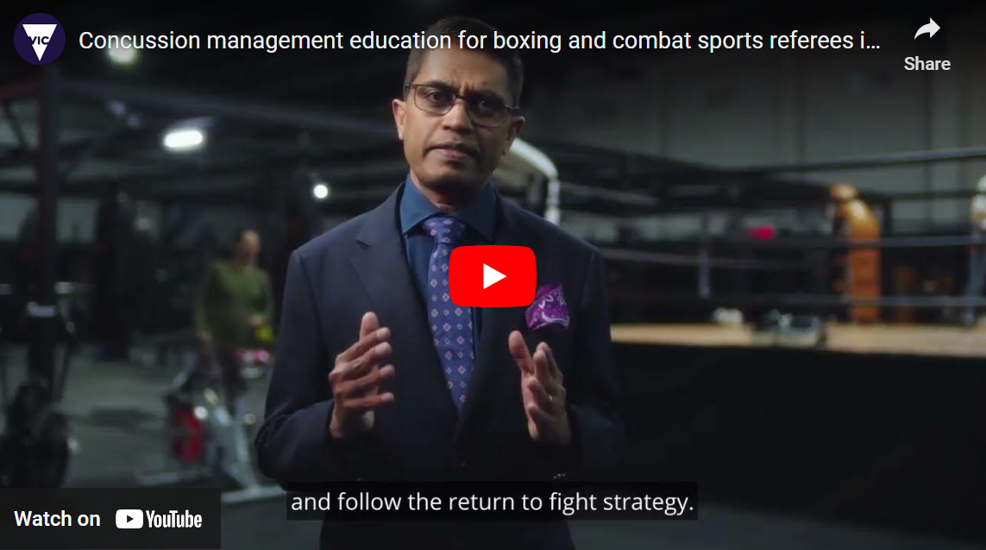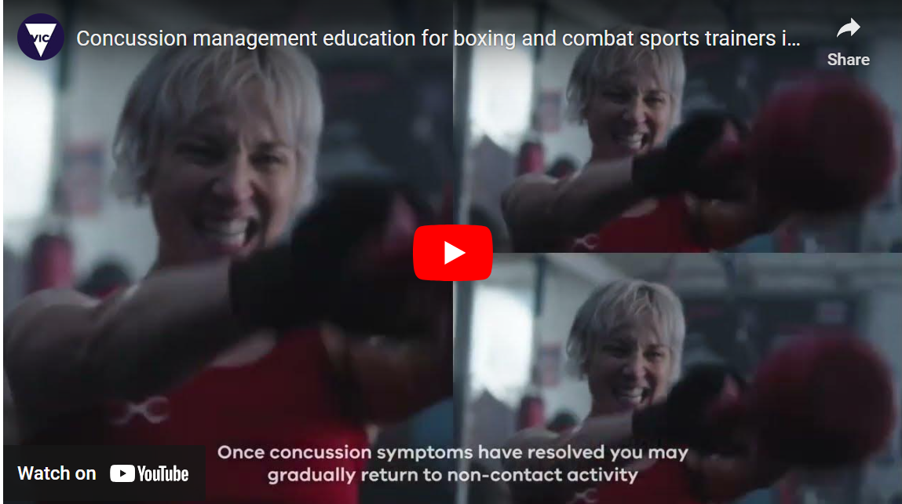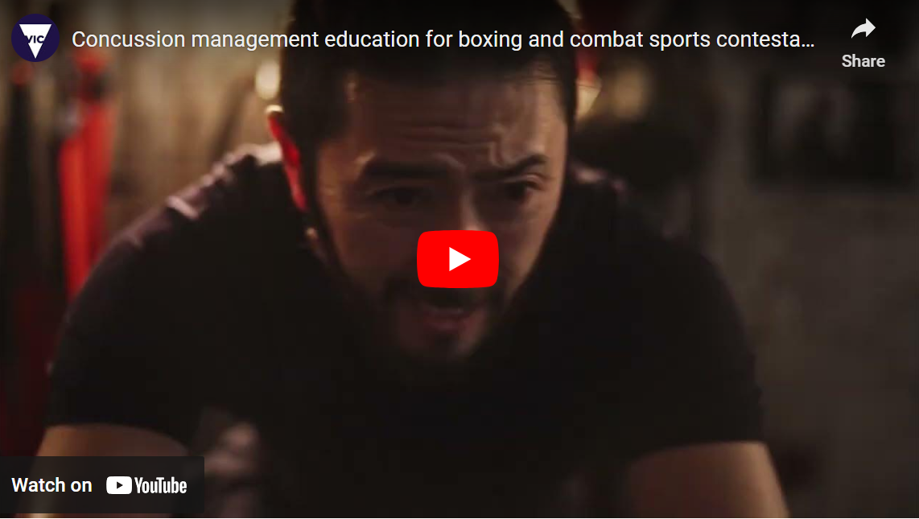

- Integrity

Licence holders must be held to the highest standards
Licensed officials (referees, judges, timekeepers, trainers, promoters and match-makers) play a significant role in ensuring contestant safety and upholding the highest levels of integrity. The Board specifies the duties and conditions of all licensed officials as the minimum standards expected in fulfilling their roles during the three-year term of their licence.

The legislation requires that all licence applications are provided to Victoria Police for assessment of suitability to be granted a licence. Applicants are assessed through consideration as a fit and proper person and that it would not be contrary to the public interest to issue them a licence.
During the last 12 months, the Board has had a number of discussions with Victoria Police to ensure that the Board can adequately take into account the advice of Victoria Police and its responses to applicants who are not assessed as fit and proper and/or in the public interest to be awarded a licence, particularly given that the legislation requires the Board to give special consideration to the advice received from the Chief Commissioner. During the reporting period four applications of the 61 considered were not supported by the Board on the basis of Victoria Police’s assessment.
The legislation provides the Board with the power to hold an Inquiry to determine whether licensees continue to meet probity requirements, particularly if the Chief Commissioner advises the Board that it is no longer of the view that the person is fit and proper or it is not in the public interest for the person to hold a licence. During the last 12 months the Board convened one Inquiry and subsequently cancelled a promoter’s licence informed by the advice of the Chief Commissioner.

Integrity of contests
The Board has prioritised an elevated focus on match-making over the last 12 months, clarifying its expectations of licensed match-makers who are responsible for proposing match-ups of contestants that are premised on protecting contestant safety and ensuring the integrity of a proposed contest. The Board has clarified the criteria that it considers when assessing proposed match-ups and the circumstances in which it will require additional explanation from match-makers as to the suitability of proposed match-ups. Over the reporting period, the Board assessed and approved 652 proposed match-ups and sought additional rationale for about 10% of match-ups. The Board ultimately rejected about 1% of the total final match-ups proposed on the basis of this consistent approach.
Integrity of outcomes of contests
The Board’s practice of post promotion meetings with licensed officials and ringside doctors provides an important opportunity for referees and judges to share insights and learnings as well as establish transparent accountability for decisions made and actions taken that directly relate to the outcome of each contest, including where injuries could have been prevented. This has enabled the Board to provide ongoing feedback to referees and judges and improve arrangements and responsibilities for responding and managing injured contestants.
The Board’s Rules provide for applications for decision reviews of contest outcomes and over the period the Board reviewed six decisions and upheld the decision of the referee in all cases with one exception. The Board’s review of a contest held in May 2023 was a complex process that resulted in the Board overturning the referee’s decision which changed the outcome from awarding a win to one professional boxer to a no contest outcome for this competition. This was the first time the Board had taken such a decision and demonstrated the Board’s thorough consideration and accountability of ensuring the licensed officials and ringside doctors correctly apply the Board’s Rules to professional contests.
Victoria Police – Sport Integrity and Intelligence Unit and Organised Crime Unit
The Board continued to work closely with the relevant local area commands of Victoria Police and the Sport Integrity and Intelligence Unit within the Organised Crime Unit in assessing and mitigating safety and integrity risks associated with regulating combat sports.
The Chair engaged with the Deputy Commissioner - Public Safety and Security and Assistant Commissioner - Intelligence and Covert Support Command as a precursor to the development of a Memorandum of Understanding between the Board and Victoria Police that will codify the roles and responsibilities of both parties in regulating combat sports.
Sport Integrity Network
The Board is represented at the Sport Integrity Network, alongside representatives from law enforcement, regulatory bodies, state sporting associations, Victorian-based national sports associations, the Victorian racing industry, and leading sports academics. The Chair regularly attends these network meetings as it provides a valuable platform for the Victorian sports sector to share knowledge and intelligence.

Industry engagement
The Board has developed and commenced implementation of its structured communication and engagement plan with stakeholders to raise awareness and understanding of the role of the regulator and its priority focus on contestant safety and upholding integrity.
Targeted engagement sessions were convened, and all ringside doctors, licensed promoters and match-makers, trainers and referees/judges were invited to provide an opportunity to voice challenges and ideas. The sessions were well attended and received, and the feedback provided has informed the Board’s priority focus on supporting and building the capacity of ringside doctors, referees and judges through a commitment to establishing clear accreditation criteria, pathways and recruitment opportunities to ensure sustainability, regulatory rigour and the highest performance and compliance standards.
The Board has committed to facilitating these sessions on an ongoing basis as an opportunity for the sector to have structured access to Board members and share relevant insights about priorities and challenges. The Board has established a periodic newsletter, titled Board Rounds, as another mechanism to share information updates to the sector about matters relevant to the Board’s role in regulating professional boxing and combat sports in Victoria.
The Chair has attended and presented at several industry forums, including recognised combat sport amateur bodies, highlighting the Board’s priorities specific to regulation, safety, and integrity and the opportunities for alignment in the approach to contestant safety.
Board Rounds issued to the sector over the last 12 months:
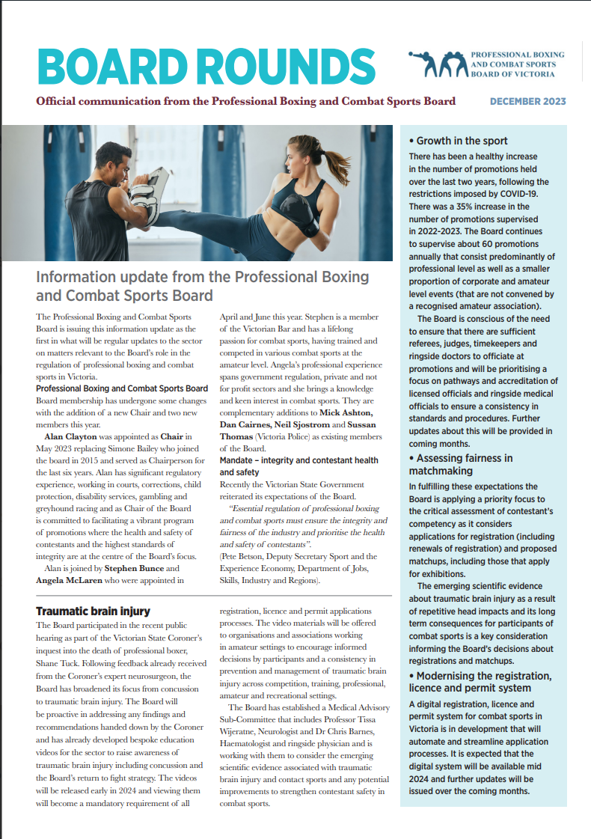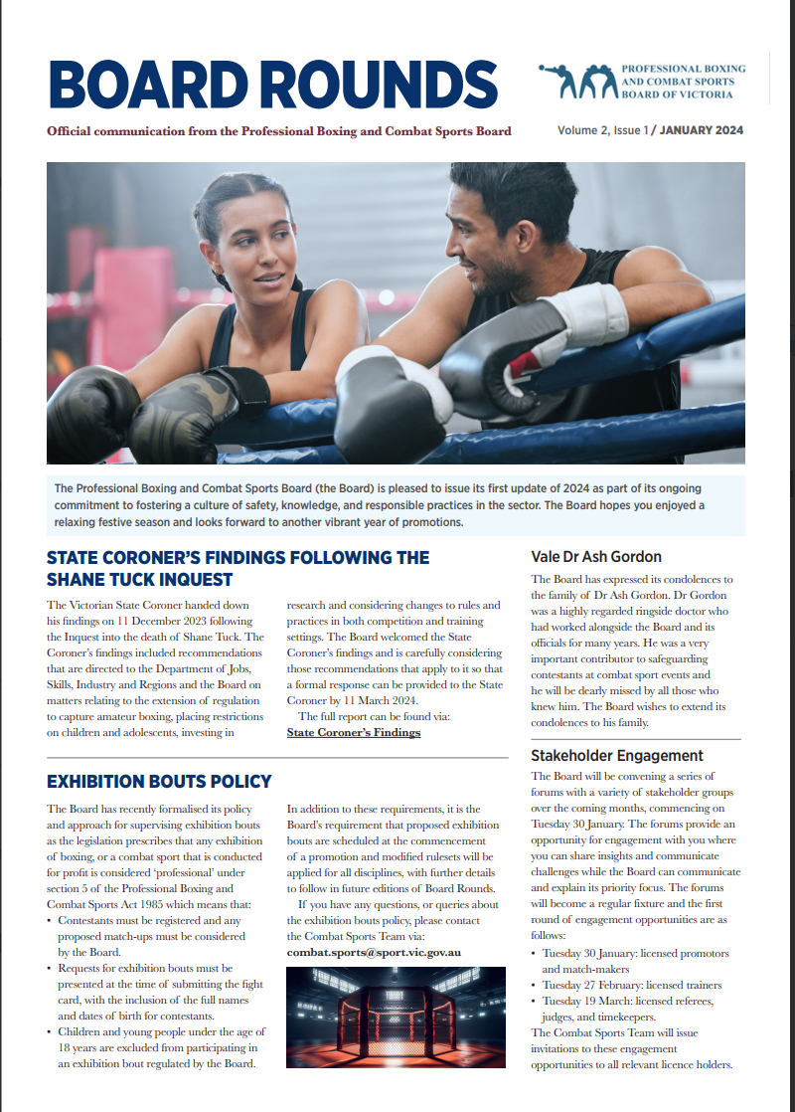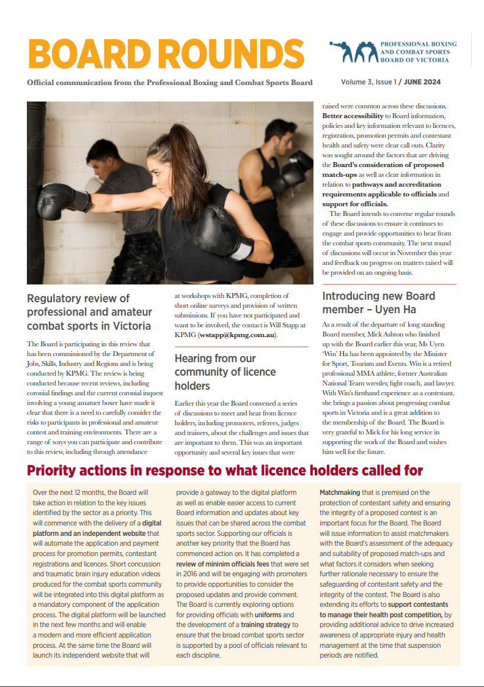

Coronial investigation
Inquest into the death of Shane Tuck
In December 2023, the State Coroner of Victoria released his findings following the inquest into the death of Shane Tuck. The inquest highlighted the safety risks to athletes who train and compete in contact sports, specifically, the risks associated with repetitive head knocks, TBIs (including concussion) and CTE.
The Chair appeared as a witness at the inquest in July 2023 and provided two statements, presenting evidence of the Board’s progress and position in implementing measures recommended by Sports Medicine Australia and observations from the Court’s expert witness Dr Robert Cantu about the Board’s approach to raising awareness of the risks associated with TBI including concussion.
The Board collaborated with the Department of Jobs, Skills, Industry and Regions in the preparation of a response to the State Coroner’s recommendations and highlighted the action it had taken to broaden its concussion education materials to capture the risks of TBI and CTE.
The Board is actively progressing consideration of other recommendations relating to research evidence and effective medical interventions that may inform rule or practice changes that can achieve better health and safety outcomes for contestants and will look to share its insights and any subsequent educational and care/treatment responses across the professional and amateur sectors.

Supporting the Government’s 2023-2024 investment in combat sports
Regulatory review
The Board has actively participated in the regulatory review commissioned by the Department of Jobs, Skills, Industry and Regions to examine and assess the current regulatory framework for professional contests and self-regulatory framework for training and amateur contests in Victoria. It has participated in consultations and provided a submission that highlights key issues that should be considered as part of this regulatory review. The submission has called for a review of resourcing to ensure the Board is able to fulfil operational functions and progress its commitment to respond to a range of safety issues alongside a growing operational workload, while ensuring mechanisms are in place to deliver high standards of compliance and respond to emerging scientific research and community expectations about contestant and participant health and safety.
Digitisation of the registration, licence and permit system
The development of the Board’s digital registration, licence and permit system has been supported and welcomed by the Board who have been forecasting updates and release dates to the sector over the last 12 months. The digital system will produce efficiencies for the Board’s workflow and considerations that will be realised in the next reporting period.
Website
Development of the Board’s independently branded website has been another priority focus and a necessary pre-cursor to the release of the Board’s digital registration, licence and permit system and improved communication materials for the sector.

Operations – BP3 targets
The combat sport sector has continued to experience a strong recovery from the COVID-19 pandemic. Over the reporting period, the Board approved 619 contestant registrations, licences, and permits, resulting in a 12.5% increase over the BP3 target for the year. A total of $136,992 was generated in revenue from the payment of associated application fees.
Figure 1 provides a 3-year comparison of the summation of all registrations, licences, and permits against the BP3 target, demonstrating a consistency in above targets being sustained.

Operations – trends in combat sport disciplines
The Board supervised 58 professional promotions during the reporting period. Promotions consist of several combat sports disciplines including boxing, mixed martial arts (MMA), Muay Thai, K1, and Kickboxing. A breakdown of promotion by discipline is provided below.
Boxing continues to represent the largest percentage of professional promotions, however in 2023-24, there was a relative increase in Muay Thai promotions (+6%) and a relative reduction in MMA promotions (-9%) compared to the previous financial year.

Of the 58 promotions held in 2023-24, 95% were conducted in metropolitan Melbourne and 5% were conducted in regional locations such as Sale, Traralgon and Geelong.

Operations – safety threats
The Board is required to ensure that its officials and members are in a safe work environment, consistent with its obligations under the Occupational Health and Safety Act 2004. During the reporting period there was one occasion where the participation of a registered contestant and the planned attendance of their associates posed an unacceptable risk to the health and safety of the workforce and the general public. The promotion venue was targeted by an arson attack at the Furlan Club in Thornbury on 22 February 2024, 48 hours prior to the approved boxing promotion, resulting in the venue being deemed unsafe to host a public event. The Board subsequently did not approve a permit for this promotion to be held at an alternative event given the continued participation of the contestant posed an unacceptable safety risk.

The Board continues to liaise closely with Victoria Police to assess, mitigate and address safety risks associated with participants and spectators attending promotions.

Board meetings
Board meetings are scheduled on a monthly basis to consider a range of operational, governance, policy and risk management matters. During the reporting period, extraordinary meetings were also convened to resolve matters requiring additional focused discussion or immediate resolution.
The Board has developed and adopted a range of formal governance policies over the last 12 months to ensure application of good governance principles in executing its responsibilities. The completion of Board policies as well as the implementation of consistent procedures has enabled it to improve the transparency and quality of its decision-making practices.
Table 2. Board members attendance at Board meetings, weigh-ins and promotions in 2023-24.
Name | Board meetings attended* | Weigh-ins supervised | Promotions  supervised
Alan Clayton | 16 | 13 | 12
Stephen Bunce | 16 | 14 | 14
Daniel Cairnes | 15 | 12 | 16
Uyen Ha (appointed Mar 2024) | 6 | 1 | 7
Neil Sjostrom | 15 | 11 | 18
Angela McLaren (July 2023-Feb 2024) | 9 | 2 | 7
Michael Ashton (July 2023-Mar 2024) | 6 | 5 | 13
Sussan Thomas | 10 | 0 | 0

*Board meetings include monthly and extraordinary meetings.

Board membership
During the reporting period, there were several Board member appointments resulting from vacancies generated on the Board.
- Daniel Cairnes was appointed for a third term.
- Uyen Ha was appointed to replace outgoing member Michael Ashton.
- Christopher Shen was appointed to replace outgoing member Angela McLaren.
Table 3: Board membership as at 30 June 2024
Name | Position | Gender | Period of appointment | Term
Alan Clayton | Chair | Man | 02/05/2023 – 01/05/2026 | First term
Stephen Bunce | Member | Man | 21/04/2023-20/04/2026 | First term
Daniel Cairnes | Member | Man | 01/08/2023-31/07/2026 | Third term
Uyen Ha | Member | Woman | 04/03/2024 – 04/03/2027 | First term
Christopher Shen | Member | Man | 22/06/2024 – 21/06/2027 | First term
Neil Sjostrom | Member | Man | 08/07/2021 - 07/07/2024 | First term
Sussan Thomas | Member  (serving police officer) | Woman | 01/09/2022 – 31/08/2025 | Second Term

Board member Biographies
Alan Clayton PSM (Chair)

Mr Clayton is the Principal of Clayton Contracting Services which offers a range of strategic management services to Government services. His prior roles include Chief Executive Officer (CEO) of Greyhound Racing Victoria, where he implemented major reforms in Victoria’s greyhound racing industry and inaugural CEO of Court Services Victoria. He has also held positions with the Victorian Government as an Executive Director (Department of Human Services) and Deputy Secretary (Police, Emergency Services and Corrections). He was appointed to the Board in May 2023.

Stephen Bunce JD BBus GDLP GAICD MIPA

Stephen Bunce is a barrister at the Victorian Bar. Prior to this he worked for over a decade as CEO of a non-profit medical research institute and has also worked in various consulting and regulatory affairs roles. He holds a Bachelor of Business (Information Systems), a Juris Doctor and is currently completing a Master of Laws at the University of Melbourne. He is on various boards and committees including the Medicolegal Society of Victoria, the Professional Boxing and Combat Sports Board of Victoria and the Western District Health Service. Stephen is a member of the Victorian Bar, the Institute of Public Accountants and the Australian Institute of Company Directors. Stephen has a lifelong passion for combat sports and has trained and competed in various combat sports at the amateur level. He was appointed to the Board in April 2023.

Daniel Cairnes

Mr Cairnes currently works in the commercial construction industry and is a graduate of the Royal Military College, Duntroon. He holds both a trade qualification and has completed an MBA (Exec). Mr Cairnes served in the Australian Defence Force for over a decade where he fulfilled a variety of regimental, training and operational appointments as an Army Officer. His interest in combat sports is derived from military service where he instructed in defensive tactics that are based on BJJ techniques and incorporate military weapon systems and equipment. He was first appointed to the Board in August 2017 and has served two terms.

Uyen Ha

Ms Ha is a retired professional MMA athlete, former Australian National Team wrestler and fight coach. Ms Ha is a lawyer and brings a passion for progressing combat sports in Victoria. She was first appointed to the Board in March 2024.

Christopher Shen

Mr Shen is a psychologist, wrestling coach, and former combat sports referee. He has represented Australia in freestyle and greco-roman wrestling and officiated for the Ultimate Fighting Championship mixed martial arts sports league. Mr Shen holds a Bachelor of Science in Psychology from Monash University and since 1996 he has partnered with organisations across the private, public, educational, and sport sectors to deliver psychology solutions, executive coaching, leadership development, resilience programs, and mental health treatment and support. He was first appointed to the Board in June 2024.
Neil Sjostrom
Mr Sjostrom is senior lecturer at Torrens University - Bachelor of Health Science (Clinical Myotherapy) and Sessional Lecturer at Chisolm Institute in Certificate III & IV in Fitness and Sports and Recreation programs. Owner and operator of Functional Therapies, specialising as a strength conditioning coach to prevent injury and support rehabilitation. Expert coach, including the Australian Women’s boxing champion. He was appointed to the Board in July 2021.

Sussan Thomas

Ms Thomas is the current Victoria Police representative on the PBCSB. Her career with Victoria Police has involved various roles from frontline duties and detective duties at various ranks, where she has investigated serious and complex crimes (family violence, armed crime, sex crimes and sporting integrity). Ms Thomas holds a bachelor’s degree in applied science (Human Movement) and an Advanced Diploma in Executive Leadership. She was first appointed to the Board in September 2019.

This decision is being appealed in VCAT.
One applicant is appealing this decision in VCAT.
This decision is being appealed in VCAT.

