**Victorian game Duck Harvest Strategy**

**Acknowledgment**

We acknowledge and respect Victorian Traditional Owners as the original custodians of Victoria’s land and waters, their unique ability to care for Country and deep spiritual connection to it. We honour Elders past and present whose knowledge and wisdom has ensured the continuation of culture and traditional practices.

We are committed to genuinely partner, and meaningfully engage, with Victoria’s Traditional Owners and Aboriginal communities to support the protection of Country, the maintenance of spiritual and cultural practices and their broader aspirations in this century and beyond.

# Introduction

Background

In the Victorian Government’s response to the recommendations of theLegislative Council Select Committee Inquiry into Victoria's Recreational Native Bird Hunting Arrangements *(29 January 2024),* the Government reiterated its commitment to safe, sustainable, and responsible game bird hunting. In its response, the Victorian Government committed that from 2025, Adaptive Harvest Management (**AHM**) will be used as the scientific basis to set game duck hunting season settings. It will inform annual duck season arrangement decisions. The establishment of AHM puts Victoria in the position of

world’s best practice for game duck management. This commitment follows a detailed exploration of the benefits of using science-based population models to help improve decision-making related to regulatory settings for annual game duck hunting seasons (See <https://www.gma.vic.gov.au/research/duck-research>).

# Purpose

The primary purpose of the Victorian Game Duck Harvest Strategy (the **Strategy**) is to describe how the recreational harvest of game ducks in Victoria will be planned and regulated to ensure that it is sustainable.

A secondary purpose of the Strategy is to increase public understanding of and input into how and why game duck hunting season settings are to be adopted from 2025.

# Scope

The Strategy focuses exclusively on ensuring game duck harvests are sustainable.

Other objectives and regulatory mechanisms for managing duck hunting - such as reducing impacts on non-target species, the broader environment and Aboriginal cultural heritage, as well as actions to reduce wounding rates - are dealt with by other policies, strategies, and processes. Management arrangements relevant to duck hunting in Victoria that are not dealt with in the Strategy are articulated in the legislative framework and in other strategies and plans. Further details can be found in Appendix A.

The Strategy does not apply to duck hunting undertaken by Traditional Owners operating under a Traditional Owner group agreement made under the *Traditional Owner Settlement Act 2010.*

# Objective

The objective of the Strategy is:

***To ensure that the recreational harvest of game ducks is sustainable.***

To achieve this objective, the following actions have been identified:

1. Apply an adaptive management approach for setting the annual duck season harvest arrangements in Victoria.
2. Establish precautionary reference points to ensure that the Seasonal Harvest Quota falls within sustainable limits (Maximum Sustainable Harvest) while continuing to provide hunting opportunities.
3. Factor in wounding losses and climate change effects into the Seasonal Harvest Quota.
4. Set a daily bag limit that operates to the Seasonal Harvest Quota.
5. Annually review the monitoring and modelling performance to evaluate its effectiveness in achieving the Seasonal Harvest Quota and adjust season settings as needed to ensure continuous improvement.

# Adaptive Harvest Management:

## Context

In Victoria, duck hunting is a regulated activity undertaken each year by approximately 14,000 licensed hunters who collectively harvest on average 320,000 game ducks per year. Only game duck species may be hunted and taken in accordance with the Wildlife (Game) Regulations 2024. See Appendix A for more information on the prescribed harvest management settings.

Adaptive management is an internationally accepted scientific approach to the design, implementation, and evaluation of the effects of decisions related to managing natural resources. Adaptive management is characterised as “learning by doing”. With respect to wild harvest, it provides a framework for making objective harvesting decisions that are optimal in the face of uncertainty. The eventual goal of applying an AHM process is to reduce uncertainty about the effects of harvest through a cycle of monitoring, assessment and decision-making. AHM also increases our capacity to learn about the system that drives waterfowl abundances and the impact of harvesting.

Since it may take numerous iterations to reduce any uncertainty regarding the impact of harvest, implementing AHM requires a long-term commitment to all the facets of the process. AHM requires:

* Setting one or more management objectives and reviewing these periodically
* Selecting the preferred management actions to achieve the management objective/s
* Implementing the selected management action/s
* Reviewing and evaluating the performance of the selected management actions
* Revising the management actions if required
* Repeating the process

AHM is currently used to inform game harvest levels in several international jurisdictions, including since 1995 for the management of recreational duck hunting in the United States. In Australia, commercial fisheries are also looking to AHM to more precisely manage the resource, as recommended by CSIRO and the Australian Fisheries Management Authority.

The use of AHM in determining harvest arrangements for game duck hunting in Victoria was first considered in 2002. In 2009-10, an independent expert panel, consisting of national and international experts, developed an approach to implement AHM in Victoria. In 2016 the government committed to the adoption of AHM through its Sustainable Hunting Action Plan. A considerable amount of research, analysis and development has gone into it since that time. For further information, see <https://www.gma.vic.gov.au/research/duck-research>.

# Applying Adaptive Harvest Management to Game Duck Harvesting in Victoria

In its Sustainable Hunting Action Plan 2021-2024, Government committed to identifying sustainable levels of harvest to be used in setting a proportional harvest scheme, being a percentage of the total game duck population that could be harvested each year within sustainable limits. An independent expert has identified that a proportional offtake of up to 20% represents a sustainable harvest level.[1] This modelling includes factoring in a wounding rate of 23%.

Taking the above into consideration, the key elements that will be used to inform the annual duck season settings in Victoria and achieve the objective of ensuring the recreational harvest of game ducks is sustainable include:

* estimating absolute game duck abundance;
* identifying a sustainable percentage of take (Seasonal Harvest Quota) that factors in wounding losses and climate change effects; and
* determining what daily bag limit would achieve the Seasonal Harvest Quota.

AHM in Victoria is ‘adaptive’ because aspects of it, such as population and harvest modelling, will be updated annually based on: (i) estimated harvest in the previous hunting season, (ii) estimated wetland area, and (iii) estimated waterfowl abundance. It is also adaptive, as it employs a continuous cycle that integrates new knowledge to enhance predictive accuracy and identify the optimal harvest management settings to meet the harvest objectives.

By its nature, the AHM process improves the reliability of harvest management over time. Recognising that this improvement is a multi-year process and, in order to manage risks, the Strategy requires that a precautionary approach is adopted when setting initial harvest management parameters. This will ensure that the harvest remains within sustainable limits while the process is in its infancy.

# Reference points informing the Adaptive Harvest Management process

As a science-based process, the Strategy uses quantifiable reference points to inform harvest management settings for the Victorian recreational duck harvest. These reference points, their roles and interactions, and their applications within the AHM process are provided below.

## *Total Victorian Game Duck Abundance*

**Total Victorian Game Duck Abundance** refers to the modelled population of all game duck species within Victoria. It is an annual calculation, determined through a combination of aerial and ground abundance surveys and surface water modelling, which estimates the population of all game duck species within Victoria. Species-specific abundances can be determined for each game duck species. This can be done with greater confidence for the more abundant species, including those that make up the majority of the annual harvest. This will assist in setting species-specific harvests if required and where adequate data is available.

Total Victorian Game Duck Abundance is the number of game ducks estimated to be present in Victoria at the time of survey each year.

## *Maximum Sustainable Harvest*

A key reference point of the Strategy’ application of AHM is a **Maximum Sustainable Harvest.** The Maximum Sustainable Harvest is the highest harvest level that could occur without adversely affecting the sustainability of the game duck population.

Statistical modelling of sedentary and highly mobile game duck species (Chestnut teal, Grey teal, Pacific black duck and Wood duck) has identified a level of sustainable harvest that can provide ongoing recreational hunting opportunities without compromising the sustainability of these game duck populations[2]. This harvest level was determined by simulating populations of Victorian game ducks over a 50-year period under scenarios of varying harvest levels, environmental conditions and factoring in wounding losses. The upper limit of the sustainable harvest level indicated by this modelling varied across game species and, depending on species, was found to be at least up to 20% of the total population in any given year. In other words, provided that the recreational harvest does not exceed 20% of game duck populations each year, hunting does not pose a threat to the conservation status of the species.

Maximum Sustainable Harvest in a Victorian game duck context is 20% of Total Victorian Game Duck Abundance.[3]

## *Seasonal Harvest Quota*

As the Strategy’s objective is to ensure that the recreational harvest of game ducks is sustainable, and with the expectation that the AHM process will improve the accuracy and effectiveness of harvest management settings over time, the Strategy adopts a precautionary approach and sets a **Seasonal Harvest Quota** at a level below the Maximum Sustainable Harvest. It will be applied for at least the first three seasons starting 2025 to evaluate the performance of the system.

Setting the Seasonal Harvest Quota at a precautionary level for a three-year period will allow a thorough assessment of the model's performance and the relative contribution that harvest management settings make, without risk of exceeding the Maximum Sustainable Harvest level of 20%. As the ability to predict a given season’s harvest is refined over time, the size of the Seasonal Harvest Quota may be reconsidered, noting that it can never be greater than the Maximum Sustainable Harvest.

Seasonal Harvest Quota will be set at a 10%* of the total population of game ducks in Victoria for at least the first three seasons of AHM application in line with the precautionary approach adopted by the Strategy.

*Note that this is the minimum Seasonal Harvest Quota. The actual quota may be slightly higher to achieve the nearest whole number Bag Limit

## *Closed Season*

When the Modelled Daily Bag Limit is below one game duck, the game duck season will be closed.

A closed season occurs when the Modelled Daily Bag Limit is below one game duck.

## *Wounding Rate*

A wounded bird is defined as a bird that is struck by pellets, but not recovered. In Victoria, wounding losses have not historically been factored into determining harvest arrangements for duck hunting. Only hunter-reported retrieved birds are used in determining the total seasonal harvest, and wounding losses (i.e. birds that are struck but not retrieved) are not accounted for. Research shows that the majority of wounded birds die either directly from their injuries or indirectly, due to factors such as starvation, predation, or extreme cold weather conditions.[4] Therefore, when determining harvest arrangements, total mortality caused by recreational hunting (i.e. retrieved and unretrieved birds) will be considered. Including wounded ducks in total harvest metrics is an important consideration when formulating harvest management settings.

The Wounding Rate is the proportion of struck birds that are unretrieved. The Wounding Rate from duck hunting in Victoria is currently unknown. In Australia, wounding rates have varied between different reporting methods, including some that underestimate the actual rate. Previous Australian research has shown wounding rates range from 10 per cent to 40 per cent (average 20 per cent) for hunter-reported rates and the limited field observer studies recorded wounding rates of approximately 30 per cent.

Research will soon be undertaken to determine the Victorian Wounding Rate. In the meantime, a 23% proxy Wounding Rate has been factored into determining the Seasonal Harvest Quota.

Proxy Wounding Rate will be set at 23%, until Victorian specific data is available.

## *Modelled Daily Bag Limit*

**The Modelled Daily Bag Limit** represents the calculated number of ducks that could be taken per hunter per day in order to achieve that year’s Seasonal Harvest Quota.

A cornerstone of AHM is its ability to predict the effect of altered hunting regulations on harvest levels. A model has been developed to recommend a daily bag limit, based on the statistical relationship between seasonal settings (bag limits and season length), the number of licensed hunters and the estimated size of the total harvest. It was found that the model provided a reasonable basis for managers to predict the likely total harvest for a given bag limit, season length and number of licensed hunters.[5] The model will be continually reviewed as future data are collected.

Modelled Daily Bag Limit is determined by taking the Seasonal Harvest Quota and modelling what bag limit is required to achieve this quota. This will be represented as a numeric daily game duck bag limit.

# Harvest Management Settings

Bag limit as the primary harvest management setting

The regulatory options employed to control the recreational duck harvest usually consist of varying the daily bag limit and/or the length of the hunting season (the regulated duck hunting season in Victoria is around 90 days and runs from the third Wednesday in March to the second Monday in June). Options may also include other harvest management settings (e.g., allowing or prohibiting particular hunting methods) and include an option of a closed season.

Based on the current understanding of the impacts of various harvest management settings, bag limits have been recommended as a more effective harvest regulation tool than season length, as Victorian duck hunters appear to operate to a consistent level of effort each season, irrespective of environmental or regulatory settings.[6] As AHM is implemented, daily bag limits will be used as the key harvest management setting, operating within the prescribed open season. If, over time, the AHM review process reveals that regulating bag limits is not sufficiently effective in achieving the Seasonal Harvest Quota, then changes to or the use of other regulatory controls may be considered.

Bag limits have historically been specified independent of duck species (i.e. bags have consisted of a combined total of any combination of game duck species) for the most part. There was a reduced daily bag limit on Blue-winged Shoveller (two birds per day), and limits have been applied to other species when the seasonal arrangements were modified from those set out in regulation. In future and with improved abundance monitoring and modelling capability, it may be possible to introduce species-specific controls.

Overall harvest management settings

The preceding reference points inform the development of harvest management settings to ensure the recreational harvest of ducks is consistent with the objective of the Strategy. Harvest management settings that can be used to achieve this include:

* + - *Season length and timing* – specifies when and for how long game ducks can be hunted within a year. The start and finish dates of the duck hunting season are situated within a known biological window which is timed to avoid periods of vulnerability for game waterfowl. Season timing is set so that hunting does not occur during the game duck breeding period, and avoids moulting periods when birds are flightless. When the season opens, young birds are sufficiently mature to fly strongly. The season closes in early winter, after which food supplies become limited.
    - *Number of hunters* – the number of licences issued to hunters for game ducks. This harvest management setting is not capped. The number of hunters is known and is used to calculate the Modelled Bag Limit.
    - *Hunting methods* – the methods and equipment that can be legally used to hunt game ducks (e.g. not allowing punt guns). Permitted and prohibited hunting methods relevant to recreational game duck hunting are contained in the *Wildlife Act 1975* and the Wildlife (Game) Regulations 2024.
    - *Daily Bag Limit* – the number of ducks each hunter is permitted to harvest per day.

Using the reference points outlined earlier, the following diagram shows the decision process that will be used to arrive at Harvest Management Settings for each duck hunting season, including the bag limit:

Figure 1. Harvest Management Settings Decision Process

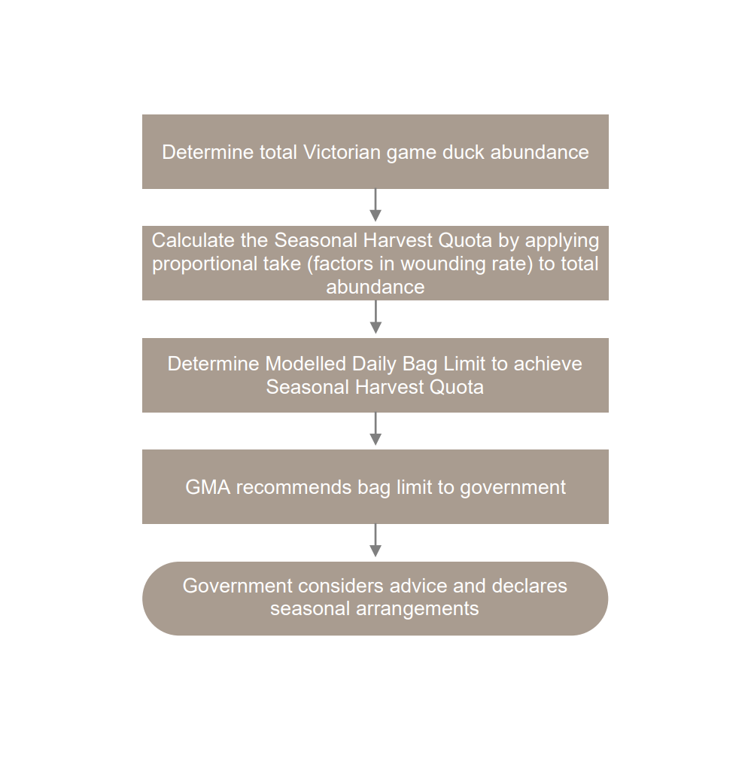

Figure 2. Demonstration of the ways in which the AHM process is refined year on year

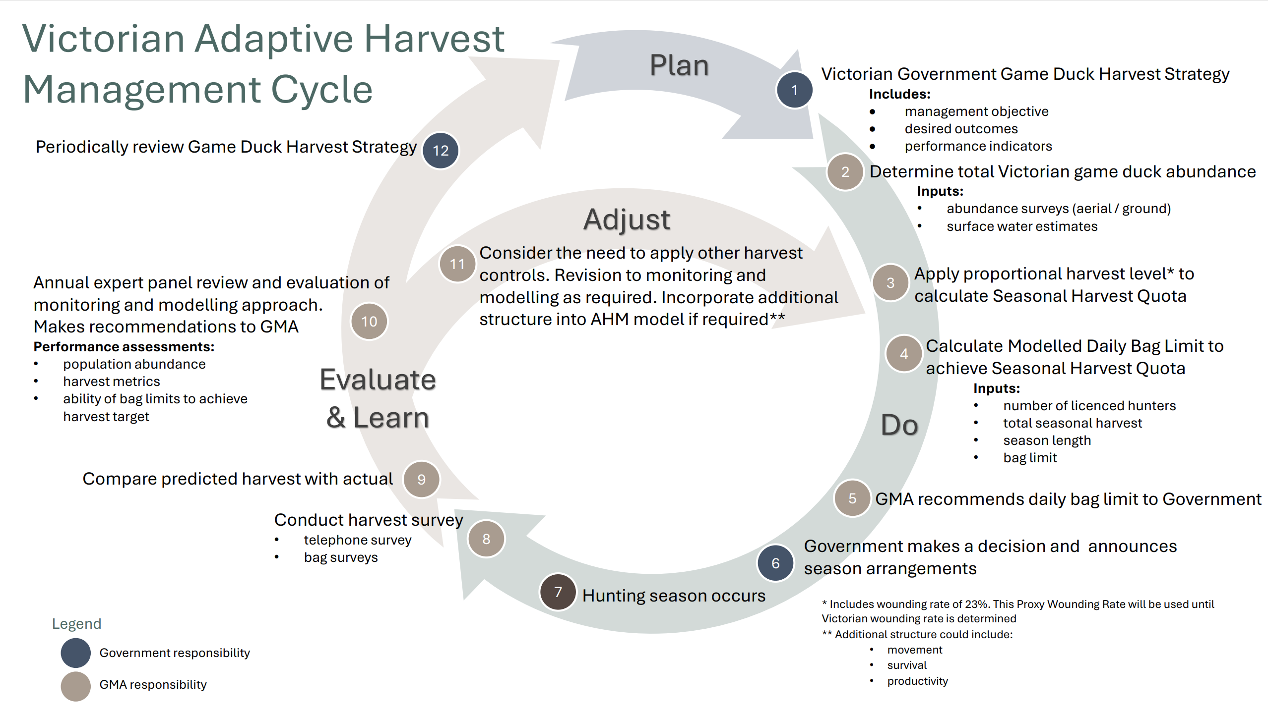

# Data inputs used to determine the Seasonal Harvest Quota

## Current data inputs[7]

A state-space modelling framework for modelling waterfowl population dynamics will be used and the base model will incorporate a time series of population counts. As additional data sources become available, the modelling approach may be expanded and additional structure to the base model could incorporate movement and demographics (survival and recruitment, adult/juvenile survival rates and productivity). This approach allows AHM to be introduced relatively quickly.

The base model requires the following inputs:

## Game duck abundance surveys

* Total Victorian Game Duck Abundance is estimated by conducting aerial and ground surveys. Aerial surveys are usually undertaken in Spring of each year at randomly selected and stratified waterbodies across Victoria.
* Ground surveys are conducted at waterbodies that cannot be surveyed from the air due to airspace or safety restrictions. Both aerial and ground surveys use a similar double-observer method.
* The abundance of game duck species at each of the sampled waterbodies is estimated using appropriate statistical models.
* Design and model-based procedures are used to derive statewide abundance estimates for each species.

## Surface water estimates

* Estimates of surface water area for waterbodies in Victoria (wetlands, dams, sewage treatment ponds, rivers, and large streams) are derived from the most recent Landsat and Sentinel-2 satellite imagery available at the time of the surveys to derive the number of waterbodies of each type in Victoria containing surface water.
* Sampling methods are then used to estimate total game duck abundance for each species by extrapolating abundance estimates from sampled waterbodies to the number of available waterbodies with surface water of each type across the state.

## Harvest metrics

* Harvest estimates are derived from data for each year from 2009 onwards. These data include:
  + the size of the total game duck harvest for each year, estimated from telephone surveys of hunters;
  + the number of licensed duck hunters for each of those years; and
  + the season settings (daily bag limit and season length) that were in place during that year.

## Wounding rate

* A proxy wounding rate of 23% has been applied to the Seasonal Harvest Quota modelling as part of the AHM process.

## Additional data inputs

## Should additional structure be included in population modelling, information on the following will be collected:

1. age-sex harvest composition
2. game duck dispersal/spatial ecology
3. age-sex specific survival.

## A) above is currently collected through bag surveys and research to address b) and c) will commence in 2025.

## Refined wounding rate

* Research to improve the understanding of the actual game duck wounding rate in Victoria will be undertaken as part of the Waterfowl Wounding Reduction Action Plan. Once a Victorian-specific wounding rate is determined, this will be substituted for the 23% proxy currently used in the AHM process.

Further details of the statistical and sampling techniques used to determine various input values can be found on the Game Management Authority’s website <https://www.gma.vic.gov.au/research/duck-research>

# Assessment and review

At its core, AHM is an evaluative process. The following performance assessments and indicators will be used to measure the effectiveness of AHM in strengthening regulatory decision making related to game duck harvest management.

|  |  |
| --- | --- |
| **Performance measure** | **Indicator** |
| Maintaining a sustainable game duck harvest by not exceeding a proportional total annual take of 20% (including wounding losses). | * Has the harvest exceeded the 20% Maximum Sustainable Harvest level? |
| Abundance modelling accurately estimates absolute abundance. | * Are the population models accurately assessing absolute abundance? |
| Game duck harvests are accurately determined. | * Are the harvest surveys accurately reflecting actual harvest metrics? |
| Harvest management settings are effective in achieving the Seasonal Harvest Quota. | * Is the Modelled Daily Bag Limit accurately predicting the Seasonal Harvest Quota? |

## Expert panel review

To assist in ensuring the monitoring and modelling program remains contemporary and fit for purpose, the AHM Monitoring and Modelling Technical Expert Review Panel (expert panel) has been assembled to provide independent expert advice to the Game Management Authority on:

* the design and operation of the monitoring and modelling program to achieve the government’s stated game duck seasonal harvest objectives
* ways to improve the monitoring and modelling program within available resources.

The expert panel will meet at least at least twice per year. It will meet after release of the game duck abundance and Modelled Daily Bag Limit technical report to consider any recommendations contained in the report for areas of improvement and after the season to consider the performance of the models to predict the total seasonal harvest and any other issues that may emerge.

## Strategy review

A review of the Strategy will be undertaken three years after inception and every five years thereafter. The strategic review will have a wider scope than the annual reviews and will include a review of any movements in the scientific understanding of duck populations. It will also examine whether the harvest management settings are adequate for achieving the sustainable harvest objectives or whether additional controls (e.g., adjusting season length) might be warranted. The Strategy review will also provide opportunities for stakeholder input and the consideration of social values including whether there is a need for an upper bag limit. If appropriate, the findings of the external review would then be incorporated into regulations.

# References

Kirby, R. E., Riechman, J. H., and Schoenfelder, T. W. 1981. Recuperation from crippling in ducks. Wildlife Society Bulletin 9, 150–151.

Klaassen, M. and Kingsford, R. 2021. Relationships among duck population indices and abiotic drivers to guide annual duck harvest management Version 2, 29 November 2021

Prowse, T. 2023. Conservation and Sustainable-Harvest Models for Game Duck Species. Unpublished report produced for the Department of Jobs, Skills, Industry and Regions.

Ramsey, D.S.L. 2020. Design of a monitoring program for game ducks in Victoria. Arthur Rylah Institute for Environmental Research Technical Report Series No. 314. Department of Environment, Land, Water and Planning, Heidelberg, Victoria.

Van Dyke, F. 1981. Mortality in crippled mallards. Journal of Wildlife Management 45, 444–453.

# Appendices

Appendix A: Management settings and instruments relevant to duck hunting in Victoria

|  |  |
| --- | --- |
| **Feature** | **Details** |
| Authorisation for recreational duck hunting | A game licence issued under the *Wildlife Act 1975* that allows:   * The hunting, taking, or destroying of game birds |
| Relevant game hunting legislation/regulation and Codes of Practice | *Wildlife Act 1975*  Wildlife (Game) Regulations 2024  Wildlife (State Game Reserves) 2024  Code of Practice for the Welfare of Animals in Hunting, under the *Prevention of Cruelty to Animals Act 1986* |
| Other relevant legislation/regulation | *National Parks Act 1975*  *Flora and Fauna Guarantee Act 1988*  *Prevention of Cruelty to Animals Act 1986*  Wildlife Regulations 2024  *Crown Land (Reserves) Act 1978*  *Land Act 1958*  *Forests Act 1958*  Wildlife (State Game Reserves) Regulations 2024 |
| Relevant government policies | Sustainable Hunting Action Plan – 2016-2020  Sustainable Hunting Action Plan – 2021-2024  Waterfowl Wounding Reduction Action Plan |
| Game duck species | Grey Teal  Chestnut Teal  Hardhead  Mountain Duck  Pink-eared Duck  Pacific Black Duck  Wood (Maned) Duck  Blue-winged (Australasian) Shoveler (NB. Hunting of this species is not currently permitted due to threatened status) |
| Methods | Shotgun no greater than 12 gauge  Only non-toxic shot permitted to be used  Gundogs permitted to locate, flush, point or retrieve game ducks |
| Bag limits | A maximum of 10 game ducks on any day during an open season* |
| Season length/timing | Third Wednesday in March until second Monday in June for all game ducks except Blue-winged Shoveler*  Hunting for Blue-winged Shoveler is closed for the whole of each year. |
| Hunting times | Starts: 8:00am for the first 5 days of the season and 30 minutes before sunrise thereafter.  Ends: 30 minutes after sunset* |
| Hunting locations | On public land - set by public land classification*  On private land – with the approval of the landowner* |
| Minimising impacts on non-game species and the environment | Measures include:   * Waterfowl Identification Test * Closure of, or the further regulation of hunting at, wetlands to protect significant numbers of threatened species or breeding waterbirds * Ban on the use of lead shot |

* The Minister can modify these arrangements via a s.86 or s.86A notice under the *Wildlife Act 1975*.

1. Prowse, T. 2023. *Conservation and Sustainable-Harvest Models for Game Duck Species*, Report to the Department of Jobs, Skills, Industry and Regions.
2. Prowse, T. 2023 *Conservation and Sustainable-Harvest Models for Game Duck Species*, Report to the Department of Jobs, Skills, Industry and Regions
3. Ibid.
4. Van Dyke, F. 1981. Mortality in crippled mallards. Journal of Wildlife Management 45, 444–453; Kirby, R. E., Riechman, J. H., and Schoenfelder, T. W. 1981. Recuperation from crippling in ducks. Wildlife Society Bulletin 9, 150–151.
5. Ramsey, D.S.L. 2020. Design of a monitoring program for game ducks in Victoria. Arthur Rylah Institute for Environmental Research Technical Report Series No. 314. Department of Environment, Land, Water and Planning, Heidelberg, Victoria.
6. Klaassen, M. and Kingsford, R. 2021. Relationships among duck population indices and abiotic drivers to guide annual duck harvest management Version 2, 29 November 2021
7. For more information on the models used to inform AHM, see Ramsey, D.S.L. 2020. Design of a monitoring program for game ducks in Victoria. Arthur Rylah Institute for Environmental Research Technical Report Series No. 314. Department of Environment, Land, Water and Planning, Heidelberg, Victoria.