Conservation and Sustainable-Harvest Models for Game Duck Species

Thomas Prowse
July 2023

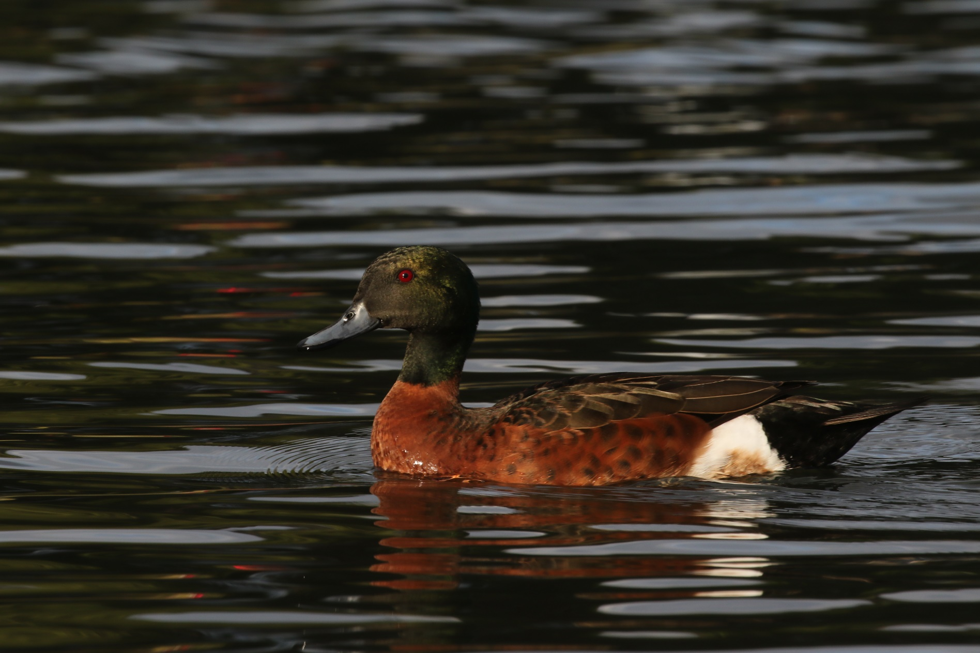
Chestnut teal, image provided by Dr Rowan Mott

Contents
Contents i
Figures ii
Tables iii
Executive Summary iv
Acknowledgments vi
1 Introduction 1
1.1 Background 1
1.2 Aims 2
2 Methods 3
2.1 Study region and subregions 3
2.2 Environmental variability 3
2.2.1 The Standardised Precipitation-Evapotranspiration Index 3
2.2.2 Linking SPEI and the relative abundance of game ducks 5
2.2.3 Correction factors 5
2.2.4 Relationships between subregion carrying capacities and SPEI 9
2.3 Simulation model 10
2.3.1 Spatial structure 11
2.3.2 Model flow, age/sex structure, initialisation and simulation runs 11
2.3.3 Demographic rates 11
2.3.4 Dispersal 11
2.3.5 Demographic stochasticity 12
2.3.6 Environmental stochasticity 12
2.3.7 Climate change 12
2.3.8 Harvesting 14
2.3.9 Crippling loss 14
2.3.10 Scenario testing 14
2.3.11 Global sensitivity analysis 14
3 Results 15
3.1 Scenario analysis 15
3.1.1 Baseline scenario with no dispersal between subregions 15
3.1.2 Baseline scenario with species-specific dispersal between subregions 15
3.1.3 Trade-offs between cumulative harvest and population size 15
3.1.4 Climate change 17
3.2 Global sensitivity analysis 17
4 Discussion 21
4.1 Sustainable harvest rates 21
4.2 Simulating the metapopulation dynamics of game ducks 21
4.3 Recommendations for future research 22
Glossary 23
References 23

Figures
Figure 1. Map of Australia showing the four subregions used for game duck metapopulation modelling. Abbreviations are: VIC, Victoria; NB, Northern Basin; LEB, Lake Eyre Basin; SA, South Australia. The background grid shows the average annual Standardised Precipitation-Evapotranspiration Index (SPEI) over the period between 1950 to 2020 (inclusive). 4
Figure 2. Time series of annually averaged (July to June) values of the Standardised Precipitation-Evapotranspiration Index (SPEI) for each subregion. 4
Figure 3. Coefficient estimates for the impact of SPEI (top row) and relative abundance in the previous year (bottom row) on log₁₀-transformed relative abundance of game ducks derived from the EAWS monitoring program. Estimates that exceed zero indicate positive relationships between SPEI or preceding relative abundance and relative abundance in the survey year. Colours illustrates the sign and statistical significance (P < 0.05) of these effects (see the legend). 7
Figure 4. Time series effects of SPEI on the log₁₀-transformed relative abundance of game ducks derived from the EAWS monitoring program. Lines represent partial responses (conditional on an average relative abundance in the preceding year) and ribbons represent 95 % confidence intervals. Line and ribbon shading illustrates the sign and statistical significance (P < 0.05) of the SPEI effect (see the legend). Points represent partial residuals and illustrate the fit of the autoregressive models to the EAWS data. 7
Figure 5. Estimated correction factors for conversion between EAWS relative abundance and absolute game duck abundance, based on 3 and 6 years of data for Victoria and the NSW Riverina, respectively. Correction factors calculated for Victoria using design- and model-based estimates of absolute abundance are shown separately. Jittered points represent the independent correction factor estimated for each year. Horizontal back bars represent the average correction factor for each group. 8
Figure 6. Relationships between subregion carrying capacities and SPEI that were used for the baseline model parameterisation. Note that carrying capacities are presented on a log₁₀ scale. The dashed horizontal guidelines within panels in the first column represent the absolute Victorian population estimate for each species in the spring of 2020, 2021 and 2022 (Ramsey and Fanson 2021; 2022; 2023). 9
Figure 7. Baseline parameterisation of the multinomial dispersal function for mobile species (Black Duck and Grey Teal) and sedentary species (Chestnut Teal and Wood Duck). The figure shows the probability an individual duck will disperse away from its current subregion (to one of the remaining three subregions) as the relative carrying capacity of the current subregion is increased. The dashed vertical guideline indicates a relative carrying capacity of 0.25, which would occur when each of the four subregions is at equal carrying capacity. 13
Figure 8. Corrections applied to SPEI time series in each subregion to simulate a scenario of climate change. The vertical dotted guideline indicates the end of the burn-in period and the beginning of the simulated climate-change impacts. 13
Figure 9. Mean subpopulation sizes (from 1,000 simulation iterations) as a percentage of carrying capacity for a scenario allowing no dispersal between subregions. Coloured lines represent the different proportional harvesting regimes in Victoria. Ducks in the Northern Basin and South Australian subregions were subject to an annual cull of 5 % for the entire simulation period, whereas the Victorian harvest was implemented at the end of the burn-in period (after year 0). 16
Figure 10. Mean subpopulation sizes (from 1,000 simulation iterations) as a percentage of carrying capacity for a scenario permitting dispersal between subregions. Other details are as for Fig. 8. 16
Figure 11. Cumulative harvest for the four game duck species calculated over the 50-year simulation period, for different proportional harvest rates in Victoria. Error bars represent 95 % confidence intervals derived by simulation. 18
Figure 12. Mean population size and expected minimum population size (as a percentage of carrying capacity) calculated over the 50-year simulation period, for different proportional harvest rates in Victoria. Error bars represent 95 % confidence intervals derived by simulation. The dashed horizontal guideline illustrates an arbitrary expected minimum population threshold of 20%. Note the different y-scales for the two variables plotted. 18
Figure 13. Absolute mean population size and expected minimum population size under a climate-change scenario, for different proportional harvest rates in Victoria. Error bars represent 95 % confidence intervals derived by simulation. Note the different y-scales for the two variables plotted. 19
Figure 14. Boosted regression tree (BRT) summary of the metamodel sensitivity analysis for the mean and minimum Victorian population size (as a percentage of carrying capacity) for each game duck species. Relative influence metrics from the BRT analyses are shown to cover the four most important simulation parameters for each species × simulation output combination. 19
Figure 15. Boosted regression tree (BRT) summary of the metamodel sensitivity analysis for the mean and minimum metapopulation size (as a percentage of carrying capacity) for each game duck species. Relative influence metrics from the BRT analyses are shown to cover the four most important simulation parameters for each species × simulation output combination. 20

Tables
Table 1. Example comparison of relative and design-based absolute abundance estimates for game ducks in Victoria in spring 2022. 8
Table 2. Simulation parameters for game duck species, showing baseline values for each parameter, as well as the uniform (U) ranges used for sensitivity analysis using Latin hypercube sampling. In the sensitivity analysis column, x refers to the baseline parameter value, and U(lcl,ucl) means lower and upper 95% confidence limits from a previous analysis were used to define the range of the uniform distribution. For the sensitivity analysis of EAWS correction factors, the uniform distribution used for all subregions was the same as that for Victoria. 10

Executive Summary
In Victoria, up to eight species of game duck can be hunted recreationally depending on the annual hunting season arrangements. The duck hunting arrangements are prescribed in regulation but may be varied based on seasonal conditions (e.g., the extent of habitat) and game duck population status. Variations can be made to the duration of the season, the species permitted to be hunted, and bag limits allowable per hunter per day, while specific wetlands may also be closed to hunting. Decisions regarding these arrangements are controversial and affect a diverse range of stakeholder groups with different interests.
To increase the transparency of, and confidence in, annual harvest regulations, the Victorian Government is currently shifting towards an Adaptive Harvest Management (AHM) approach for game duck species. As part of that process, a stratified aerial survey of game ducks is now being conducted annually in spring. As this survey yields state-wide estimates of absolute abundance for different species, a proportional harvest system could be implemented while additional data is collected to facilitate the planned AHM approach.
This report aimed to identify sustainable proportional harvest quotas which can maximise cumulative harvests over the long-term while not compromising the viability of game duck species, either in Victoria or eastern Australia more broadly. To test the expected performance of different proportional harvests, a metapopulation model was developed and parameterised for four representative game ducks: two highly mobile species (Black Duck [Anas superciliosa] and Grey Teal [Anas gracilis]) and two more sedentary species (Chestnut teal [Anas castanea] and Wood Duck [Chenonetta jubata]).
The metapopulation model consisted of component models for duck subpopulations occupying four subregions (Victoria, Northern Basin, Lake Eyre Basin and South Australia) that were linked by dispersal. To estimate the relationship between environmental conditions and carrying capacity in each subregion: (1) statistical relationships between relative abundance (i.e., species-level counts from the annual Eastern Australian Waterbird Survey [EAWS]) and water availability were developed separately for each species; (2) correction factors were estimated to convert relative abundance to absolute abundance based on datasets for Victoria and the NSW Riverina; and (3) these correction factors were applied to scale relative abundance to absolute abundance.
Simulations over a 50-year timeframe were used to consider how the cumulative harvest, mean population size and expected minimum population size might respond to different proportional harvests in Victoria. Uncertainty in key parameters and processes (including in demographic parameters, harvest-induced crippling loss and species-specific dispersal rates) was considered through sensitivity analysis.
Under the baseline model parameterisation, cumulative harvests for the two mobile species (Black Duck and Grey Teal) increased as proportional harvests were increased up to 50 % because harvesting in Victoria was ameliorated by immigration from other subregions. However, a smaller 30 % annual harvest for these species produced cumulative harvests close to (around 90 % of) those achieved for a 50 % harvest. In contrast, cumulative harvests were optimal at 30 % harvesting for the more sedentary Wood Duck, and at just 20 % harvesting for the Chestnut teal because the models assumed a large fraction of this species’ metapopulation is found in Victoria. For Grey Teal and Wood Duck, long-term mean and minimum population size (for Victoria and the entire simulated metapopulation) could be reliably maintained above 20 % of carrying capacity for up to 30 % proportional harvests. However, with 30 % harvesting the expected minimum Victorian population size for Black Duck and Chestnut Teal was just 18 % and 7 % of carrying capacity.
Sensitivity analysis identified that simulated Victorian population sizes were most sensitive to variation in the Victorian proportional harvest, along with parameters controlling density-dependent population growth and dispersal between subregions. However, the impact of Victorian harvesting on the duck metapopulation size was less clear, as uncertainty in density-dependent demography and parameters governing carrying capacities in each subregion were more important at this level.
Based on the metapopulation simulation results, along with considerable uncertainty regarding species’ demography and dispersal, crippling loss rates and the impact of climate change, a precautionary proportional harvest quota of 10 to 20 % is recommended for these species.
Importantly, the correction factors estimated in this report varied substantially between years and between Victoria and the New South Wales Riverina, which indicates there is substantial variation in detectability over space and time. Consequently, the relative importance of Victorian harvesting to the total metapopulation size is difficult to estimate. Future research (e.g., double-observer surveys) to quantify detectability in different habitats along the EAWS transect lines would help clarify the importance of Victoria to the game duck metapopulations of eastern Australia.

Acknowledgments
Thanks to David Ramsey and Simon Toop who provided comments and feedback which substantially improved a draft version of this report. Thanks also to John Porter and Richard Kingsford for providing access to EAWS datasets for 2021 and 2022, and to Rowan Mott for providing the cover image.

Introduction

Background
Recreational duck hunting is currently permitted in three Australian states (Victoria, South Australia, and Tasmania) and one territory (the Northern Territory). Additionally, the large-scale Native Game Bird Management program of New South Wales allows landholders, primarily in the Riverina district, to manage native game ducks on agricultural land with the help of licensed hunters. Other states also allow the control of problem ducks on a site-by-site basis under authorisations.
In Victoria, eight species of game duck can be hunted recreationally depending on the annual hunting season arrangements: the Australasian Shoveler (Anas rhynchotis), Australian Shelduck (Tadorna tadornoides), Australian Wood Duck (Chenonetta jubata), Chestnut Teal (Anas castanea), Grey Teal (Anas gracilis), Hardhead (Anas australis), Pacific Black Duck (Anas superciliosa) and Pink-eared Duck (Malarcorhynchus membranaceus). These waterfowl species typically form mating pairs around June and hatch their eggs in late winter and spring (between August and November). Chicks take several months to develop their flight skills and independence, and adult birds moult after reproducing (typically around February) which impairs their flight capacity. The Victorian duck hunting open season, which is timed to avoid these vulnerable life-history stages while allowing sustainable hunting when duck abundance permits, occurs from the third Saturday in March until the second Monday in June.
The duck hunting season arrangements are prescribed in regulation but may be varied based on seasonal conditions (e.g., the extent of habitat) and game duck population status. Variations can be made to the duration of the season, the species permitted to be hunted and bag limits allowable per hunter per day. Specific wetlands may also be partially or fully closed to hunting, or hunting can be further regulated (e.g., the use of boats prohibited) where there is a need to protect concentrations of threatened species or waterbird breeding colonies. In 2023, for example, the season was shortened by approximately six weeks, hunting of Australasian Shoveler and Hardhead was completely prohibited, and a bag limit of four game ducks per day was applied over the entire season.
The decisions regarding the annual harvest regulations in Victoria are controversial due to several factors. Firstly, a diverse range of stakeholders including government, recreational hunters, scientists and community groups represent a range of (sometimes competing) interests. Secondly, game duck species are not endemic to Victoria; rather, their distributions span much of eastern Australia and hence, cross state boundaries. Thirdly, the ecology of these species is complex – most species are highly mobile, can travel long distances to exploit ephemeral wetlands following rainfall events (Roshier et al. 2008a; Roshier et al. 2008b), and can breed rapidly when conditions are favourable. Finally, there is considerable uncertainty regarding the impact of harvesting (and associated crippling or wounding loss) in Victoria on game duck populations in that state and elsewhere. This uncertainty stems largely from the difficulty disentangling environmental and harvest-mediated effects on these species, and the difficulty of estimating absolute duck population sizes and total harvest offtake from limited survey data.
To increase the transparency of, and confidence in, annual harvest regulations, the Victorian Government is currently shifting towards an Adaptive Harvest Management (AHM) approach for game duck species (Ramsey et al. 2010; Ramsey et al. 2017). AHM attempts to improve our management of wildlife resources through carefully structured learning by doing. A key component of AHM is the development of mathematical population models that are used to learn about and predict how wildlife populations respond to changing environmental conditions and harvest regulations. The performance of different models can then be evaluated over time, by comparing model predictions to real data from wildlife monitoring programs.
Ramsey et al. (2017) reviewed the literature on AHM and sought to identify the minimum monitoring requirements and a suitable modelling approach to support an expanded AHM program for waterfowl in Victoria and possibly other states (New South Wales, South Australia and Tasmania). They recommended the development of a Bayesian state-space population model for each game species which could be used to generate one-year-ahead predictions of waterfowl population size, under different harvest regulations and environmental scenarios. To inform this modelling, they also recommended aerial (fixed-wing and/or helicopter) surveys should be undertaken to allow estimation of absolute duck abundance in Victoria each year. Dedicated aerial surveys of Victorian game ducks were conducted for the first time in 2021, based upon the survey design considerations of Ramsey (2020). These surveys allowed the total abundance of game ducks in spring of 2021 and 2022 to be estimated at around 2.9 and 2.4 million, respectively, and also permitted species-specific estimates for the most abundant species (Ramsey and Fanson 2022; 2023). However, the planned development of the Bayesian adaptive harvest model will be delayed until sufficient high-quality data has accumulated to inform this approach. Nevertheless, improvements could possibly be made to the current harvest management approach in the interim (Prowse et al. 2019; Ramsey and Fanson 2021).
The current method of harvest management (i.e., manipulation of season length and bag limits) is a form of “fixed effort” harvesting. This approach seeks to ensure that harvest offtake is low if the population size is low, which should reduce the probability of overharvesting occurring. Proportion harvesting is a related but more rigorous approach that explicitly specifies the proportion of the total population that can be harvested each year. In theory, setting proportional harvest quotas prospectively is a sustainable strategy provided: (1) the proportional quota does not exceed the maximum population growth rate of the target species; and (2) the population size can be estimated accurately. Assuming abundance estimates are to be produced for Victoria each spring, it is now feasible to develop a proportional harvest system for game ducks. Proportional harvest quotas of 10% are currently used to set control targets for ducks in the Riverina (Dundas et al. 2020), and harvesting of kangaroos in Australia’s rangelands is typically set at no more than 20% of their estimated population size (Pople et al. 2010). In the absence of long-term data for game ducks, a conservative proportional harvest threshold of 10 % has been suggested as suitable target for recreational hunting (Ramsey and Fanson 2021), which is consistent with sustainable harvest offtake rates estimated for waterfowl in North America (Mattsson et al. 2012). However, this recommendation has not been tested with quantitative modelling.
In 2010, a panel of scientists was convened to identify a harvest management model that could be delivered at minimal cost. The panel developed a prototype model (termed the ‘Waterfowl Conservation and Harvesting Model’ or WHCM) that used mathematical expressions to describe how waterfowl populations in eastern Australia might respond to environmental variability (particularly the availability of wetland habitat) and harvesting (Ramsey et al. 2010). The prototype models in the 2010 report consisted of age-structured, spatial population models for two example waterfowl species, the highly mobile Grey Teal and the more sedentary Wood Duck. These models used a mixture of data and expert opinion to parameterise mathematical functions governing how the birth, death and dispersal rates of these species are expected to respond to climate, wetland availability, waterfowl density, and harvesting. The models were deterministic, meaning that any given set of inputs (i.e., starting values, parameters and environmental drivers) but uncertainty about key mechanisms was considered by developing candidate models with different assumptions. Using the prototype models, the 2010 report presented simulation results showing how the population size of the two waterfowl species would be expected to respond to zero harvesting or an annual 20% proportional harvest over a 50-year time period. However, the modelling approach recommended by the 2010 report was never adopted.

Aims
The overall goal of this report is to inform sustainable proportional harvest quotas that will not compromise the viability of game duck populations in Victoria or eastern Australia more generally, This report builds on prior work to develop the WCHM, by developing metapopulation models for four game ducks: two highly mobile species (Grey Teal and Pacific Black Duck) and two more sedentary species (Chestnut Teal and Australian Wood Duck) (Ramsey et al. 2010). The models are then used to consider sustainable rates of harvest offtake that could be used to inform a framework for setting the annual recreational harvest regulations. For the purposes of this report, sustainable harvest management is defined as management with the following objective:
To maximise the cumulative harvest over a 50-year period, under the constraint that populations are maintained above some minimum population threshold (i.e., some fraction of carrying capacity).
This objective recognises that total harvest will eventually decrease if harvesting is too intense and causes too much population decline. Therefore, maximising cumulative harvest over a sufficiently long timeframe necessarily means populations should also be safeguarded from extinction. Importantly, the minimum population thresholds have not been set a priori for each game duck species. Rather, simulation studies conducted as part of this project are used to explore how different proportional harvest regimes are expected to influence the mean and minimum Victorian and eastern Australian population sizes.

Methods

Study region and subregions
The study region was confined to eastern mainland Australia and was further divided into four subregions (Fig. 1): Victoria, the Northern Basin (i.e., all areas of the Murray-Darlin Basin that occur outside Victoria), the Lake Eyre Basin and eastern South Australia. Given that Chestnut Teal prefer brackish coastal waters, the eastern boundary of the Northern Basin subregion was extended to the coast throughout New South Wales by inclusion of the South-East Coast basin. Furthermore, the Lake Eyre Basin subregion was extended in an easterly direction to meet the westerly boundary of the Northern Basin subregion by inclusion of the Bulloo-Bancannia Basin (Fig. 1).

Environmental variability

The Standardised Precipitation-Evapotranspiration Index
Whereas the WCHM was developed as a model for specific wetlands (or wetland complexes) and included the capacity to simulate different trajectories of wetland area over time, the current report takes a different approach to modelling temporal variation in the extent of wetland habitat in each subregion. Here, the Standardised Precipitation-Evapotranspiration Index (SPEI) is used as a proxy for water availability in the landscape. The SPEI is a multiscalar water balance model derived from the difference between precipitation (wetting) and evapotranspiration (drying) events. It has recently been shown that the SPEI index is a good predictor of population change for some game ducks (Dundas et al. 2016). Furthermore, the SPEI index can be easily calculated through both space and time.
A monthly, gridded SPEI data at a 0.5° resolution was downloaded from the global SPEI database http://spei.csic.es and cropped to the required study region. For each subregion, annually averaged SPEI values were calculated over successive July to June periods between 1950 and 2020 using all grid cells with centroids falling within that subregion. The resultant time series of annual SPEI values is shown in Figure 2.
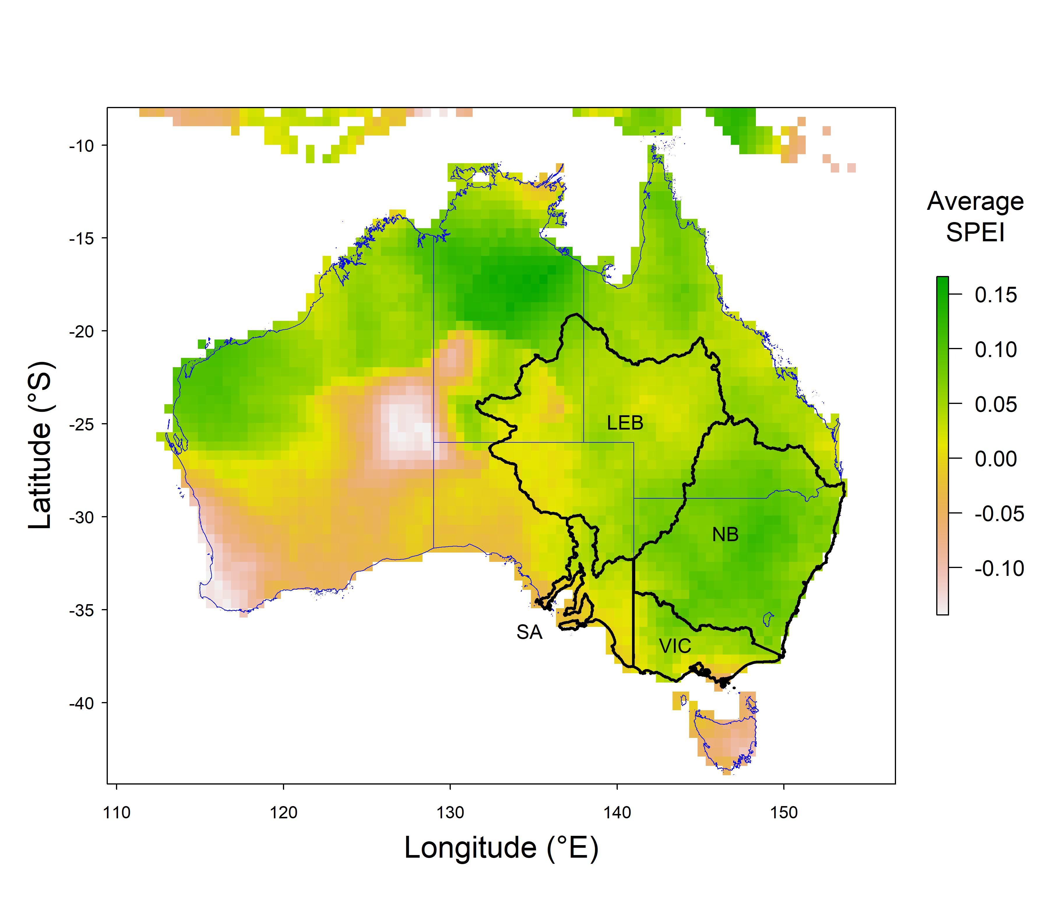
Figure 1. Map of Australia showing the four subregions used for game duck metapopulation modelling. Abbreviations are: VIC, Victoria; NB, Northern Basin; LEB, Lake Eyre Basin; SA, South Australia. The background grid shows the average annual Standardised Precipitation-Evapotranspiration Index (SPEI) over the period between 1950 to 2020 (inclusive).

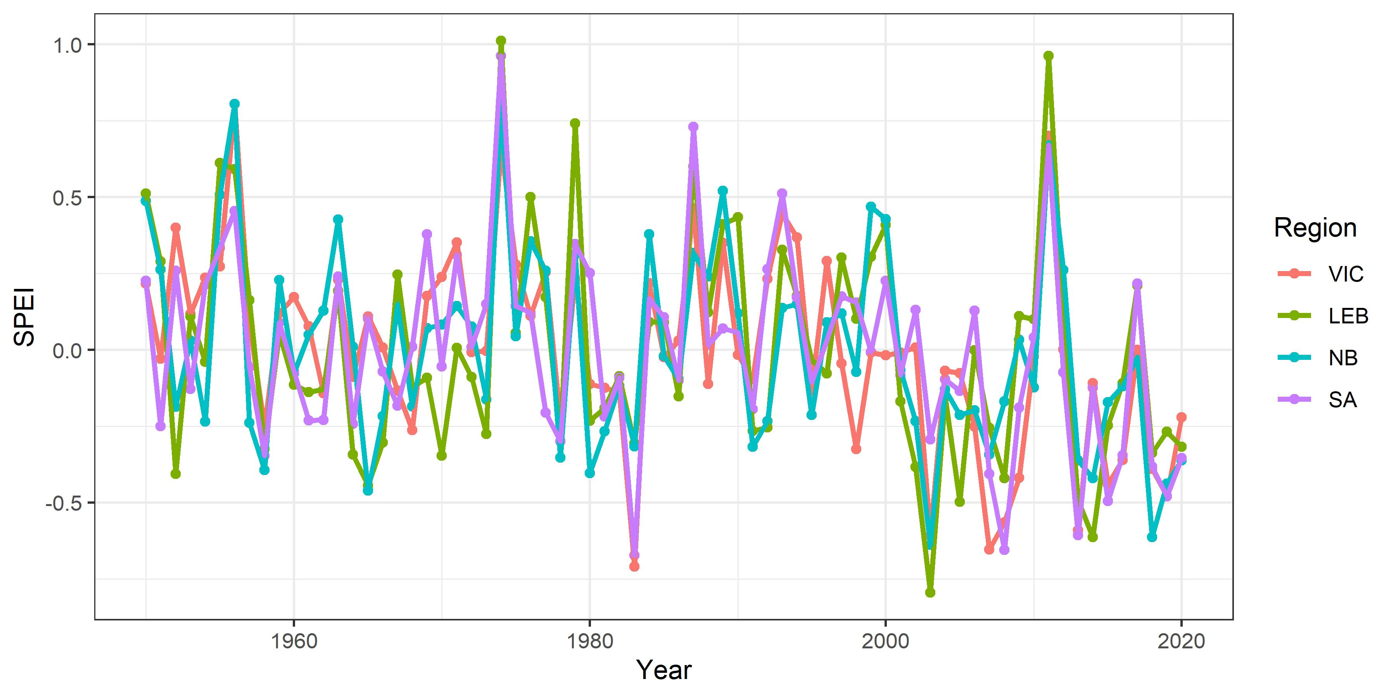
Figure 2. Time series of annually averaged (July to June) values of the Standardised Precipitation-Evapotranspiration Index (SPEI) for each subregion.

Linking SPEI and the relative abundance of game ducks
To develop scenarios of environmental variability and its impact on game duck populations, the relationship between water availability (indexed by annual SPEI) and the abundance of game ducks in each subregion was investigated using long-term monitoring data collected as part of the Eastern Australian Waterbird Survey (EAWS) (Kingsford 1999; Kingsford et al. 2020). The EAWS monitors waterbird species in eastern Australia using annual aerial surveys flown in September/October along east-west transect bands of 30 km width that are separated by 2° of latitude. Wetlands that contain water and fall within these bands are surveyed in their entirety (Kingsford et al. 2020).
The EAWS does not provide an absolute estimate of game duck abundance but rather an index of their abundance which is commonly termed “relative abundance”. In the absence of any datasets providing long-term absolute population estimates for game ducks, the relationship between SPEI and EAWS relative abundance was modelled. Specifically, log₁₀(relative abundance + 1) was used as the response variable for each subregion/species combination and modelled using first-order autoregressive models with three terms: an intercept and the linear effects of average SPEI and relative abundance in the preceding year. Prior to analysis, several outlying zero counts were removed – 1 zero for Wood Duck in Victoria, 3 zeroes for Wood Duck in South Australia, and 1 zero for Black Duck in South Australia – however, zeroes for Chestnut Teal were not removed because these were common in the dataset. The relationship between transformed relative abundance and SPEI was strong for Black Duck, moderate for Grey Teal and Wood Duck, but weak for Chestnut Teal (Figs 3 & 4). The relationship between relative abundance and abundance in the preceding year was strongest for Black Duck, and for Grey Teal and Wood Duck in the Northern Basin subregion.

Correction factors
The development of correction factors to scale relative abundance from the EAWS to absolute abundance estimates is fraught with difficulty. For example, Caley et al. (2022) recently modelled trends in waterbird populations using the EAWS dataset, but elected not to incorporate a correction for imperfect detectability of waterbirds from aircraft because bias in the EAWS counting methods has not been calibrated. However, development of a metapopulation model for game duck species requires that differences in absolute population size between subregions are considered, so the likely impact of harvesting in Victoria can be evaluated on the entire metapopulation. Therefore, relationships between EAWS relative abundance and more robust population estimates for specific regions were considered where possible.
Firstly, EAWS data for Victoria in three years (spring of 2020, 2021 and 2022) were compared to absolute estimates of game duck abundance from dedicated aerial and ground surveys conducted in the same season (Table 1 provides an example for the year 2022). Briefly, first a multiplier of 6.58 was applied to the total EAWS counts based on a nominal Victorian survey coverage of 15.2 % (i.e., the 30-km-wide EAWS transect bands were estimated to cover 15.2 % of Victoria’s area). A correction factor was then calculated for each species × year combination as the ratio of the design- or model-based estimate of absolute Victorian population size (Ramsey and Fanson 2021; 2022; 2023) and the adjusted relative abundance value (Table 1). Because Chestnut Teal and Grey Teal were not discriminated in 2020 (Ramsey and Fanson 2021), calculations for that year assumed Chestnut Teal comprised 11.9 % of the estimated Teal population (the average contribution of this species across 2021 and 2022). Correction factors calculated for each species varied substantially between years (Fig. 5)
Secondly, EAWS relative abundance in the NSW Riverina over six years (2017 to 2022) was compared to absolute estimates of abundance from dedicated surveys conducted by the NSW Department of Primary Industries in July of the same years (McLeod 2022; NSW DPI 2020; 2021). The DPI surveys differentiated Chestnut and Grey Teal, but as no Chestnut Teal were observed by the EAWS in the Riverina over this period, correction factors could not be considered for that species. A single EAWS survey band crosses the centre of the NSW Riverina and covers c. 12.4% of that region, so a multiplier of 8.06 was applied to account for partial coverage of the survey. As above, a correction factor was then calculated independently for each species × year combination (Fig. 5).
Notably, mean correction factors calculated for Victoria were substantially larger than those calculated for the NSW Riverina. This could be due multiple factors, including systemic differences between the two regions, such as differences in the density of wetlands less than 1 ha in area (e.g., farm dams are only sampled in an ad hoc fashion by the EAWS) (Kingsford et al. 2020), differences in the timing of dedicated surveys for absolute abundance estimation between Victoria and NSW, and/or different detectability of game ducks using the EAWS methodology between the two regions.
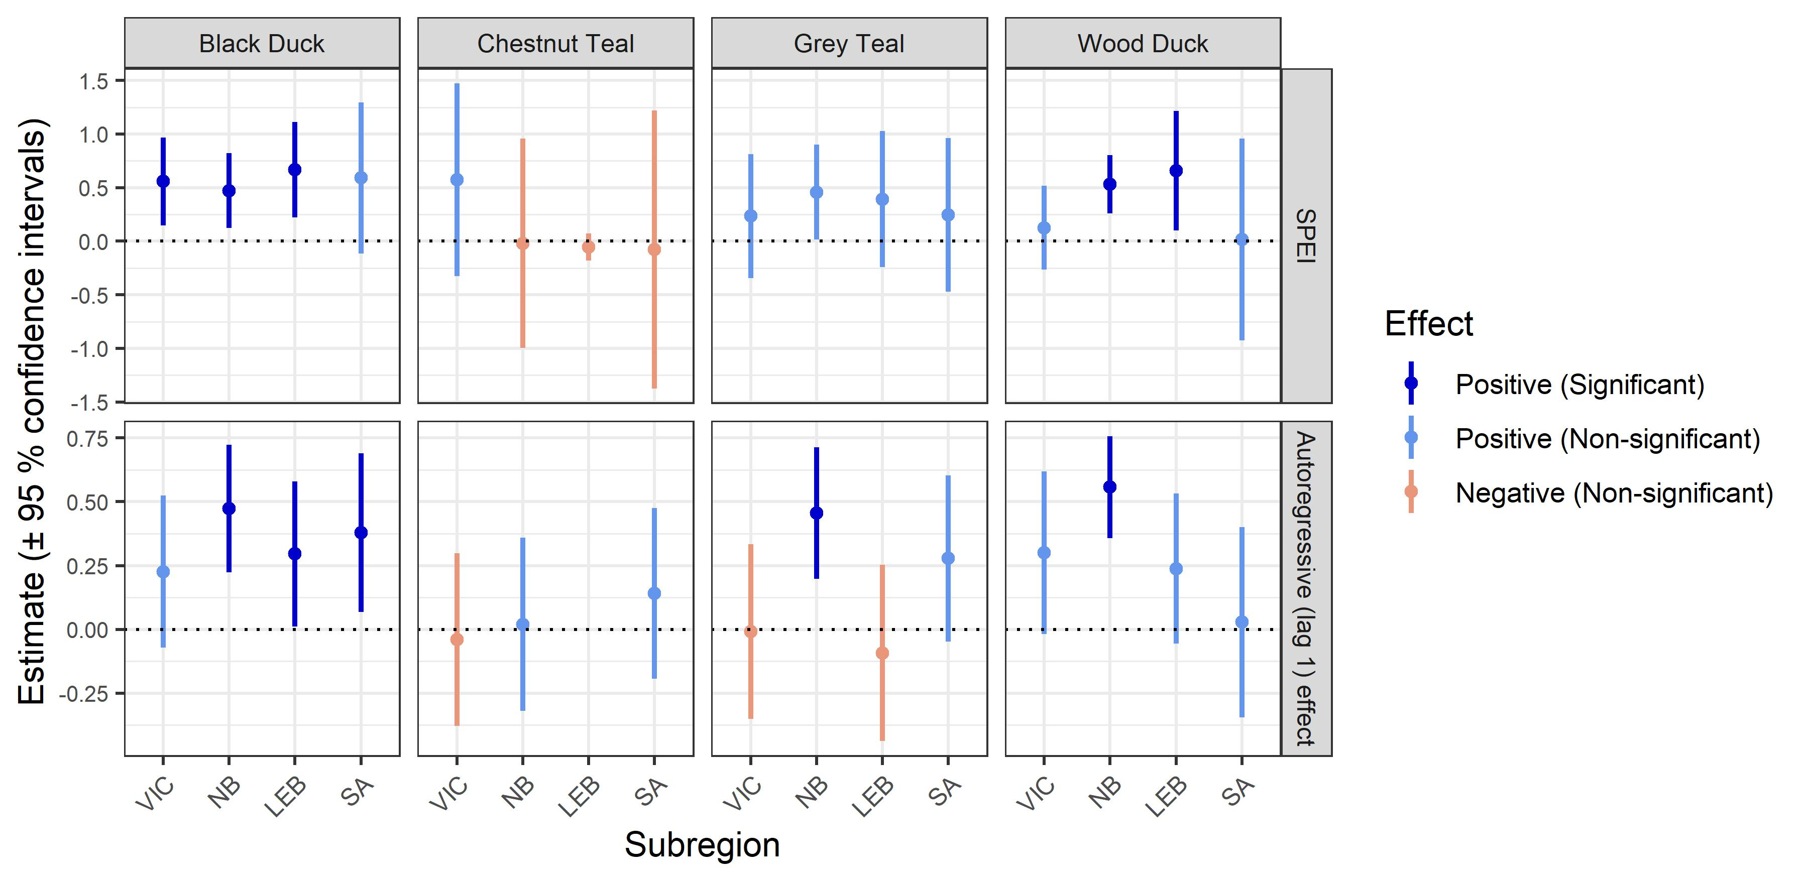
Figure 3. Coefficient estimates for the impact of SPEI (top row) and relative abundance in the previous year (bottom row) on log₁₀-transformed relative abundance of game ducks derived from the EAWS monitoring program. Estimates that exceed zero indicate positive relationships between SPEI or preceding relative abundance and relative abundance in the survey year. Colours illustrates the sign and statistical significance (P < 0.05) of these effects (see the legend).
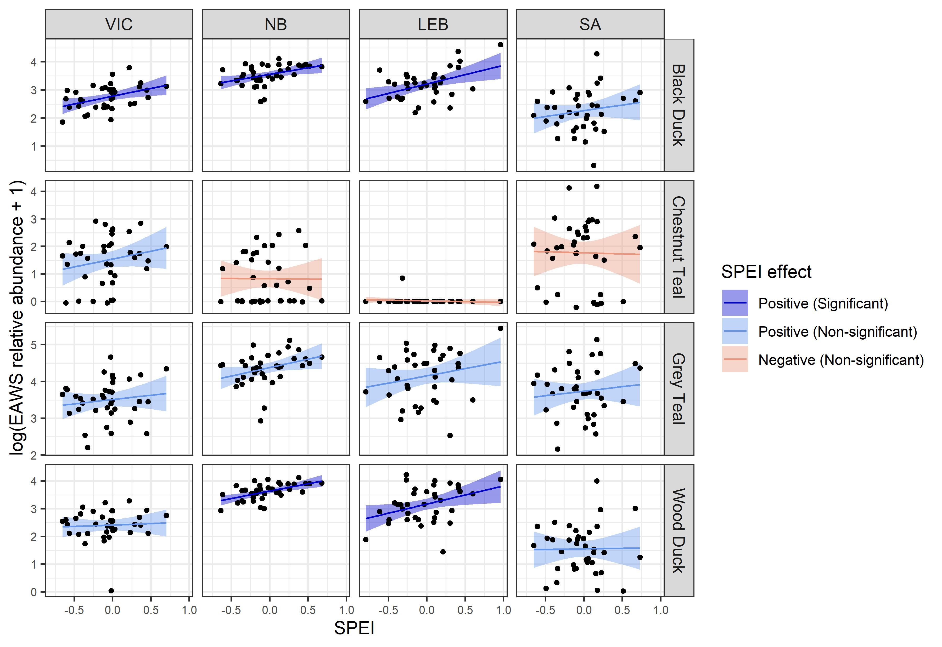
Figure 4. Time series effects of SPEI on the log₁₀-transformed relative abundance of game ducks derived from the EAWS monitoring program. Lines represent partial responses (conditional on an average relative abundance in the preceding year) and ribbons represent 95 % confidence intervals. Line and ribbon shading illustrates the sign and statistical significance (P < 0.05) of the SPEI effect (see the legend). Points represent partial residuals and illustrate the fit of the autoregressive models to the EAWS data.
Table 1. Example comparison of relative and design-based absolute abundance estimates for game ducks in Victoria in spring 2022.
Species | EAWS relative abundance | Multiplier to adjust for survey coverage | EAWS relative abundance corrected for survey coverage | Absolute population estimate^{b} for Victoria in spring 2022 [95% confidence intervals] | Correction Factor
Black Duck | 366 | 6.58 | 2,408 | 464,800  [385,700 – 556,500] | 193.0
Chestnut Teal | 38 | 6.58 | 250 | 88,900  [58,200 – 129,000] | 355.6
Grey Teal | 443 | 6.58 | 2,915 | 349,800  [271,000 – 444,000] | 120.0
Wood Duck | 468 | 6.58 | 3,079 | 823,700  [661,300 – 998,700] | 267.5
ªThis multiplier is based on the nominal EAWS coverage of Victoria of 15.2%.
^{b}The model-based population estimate of Ramsey and Fanson (2023) is used here.

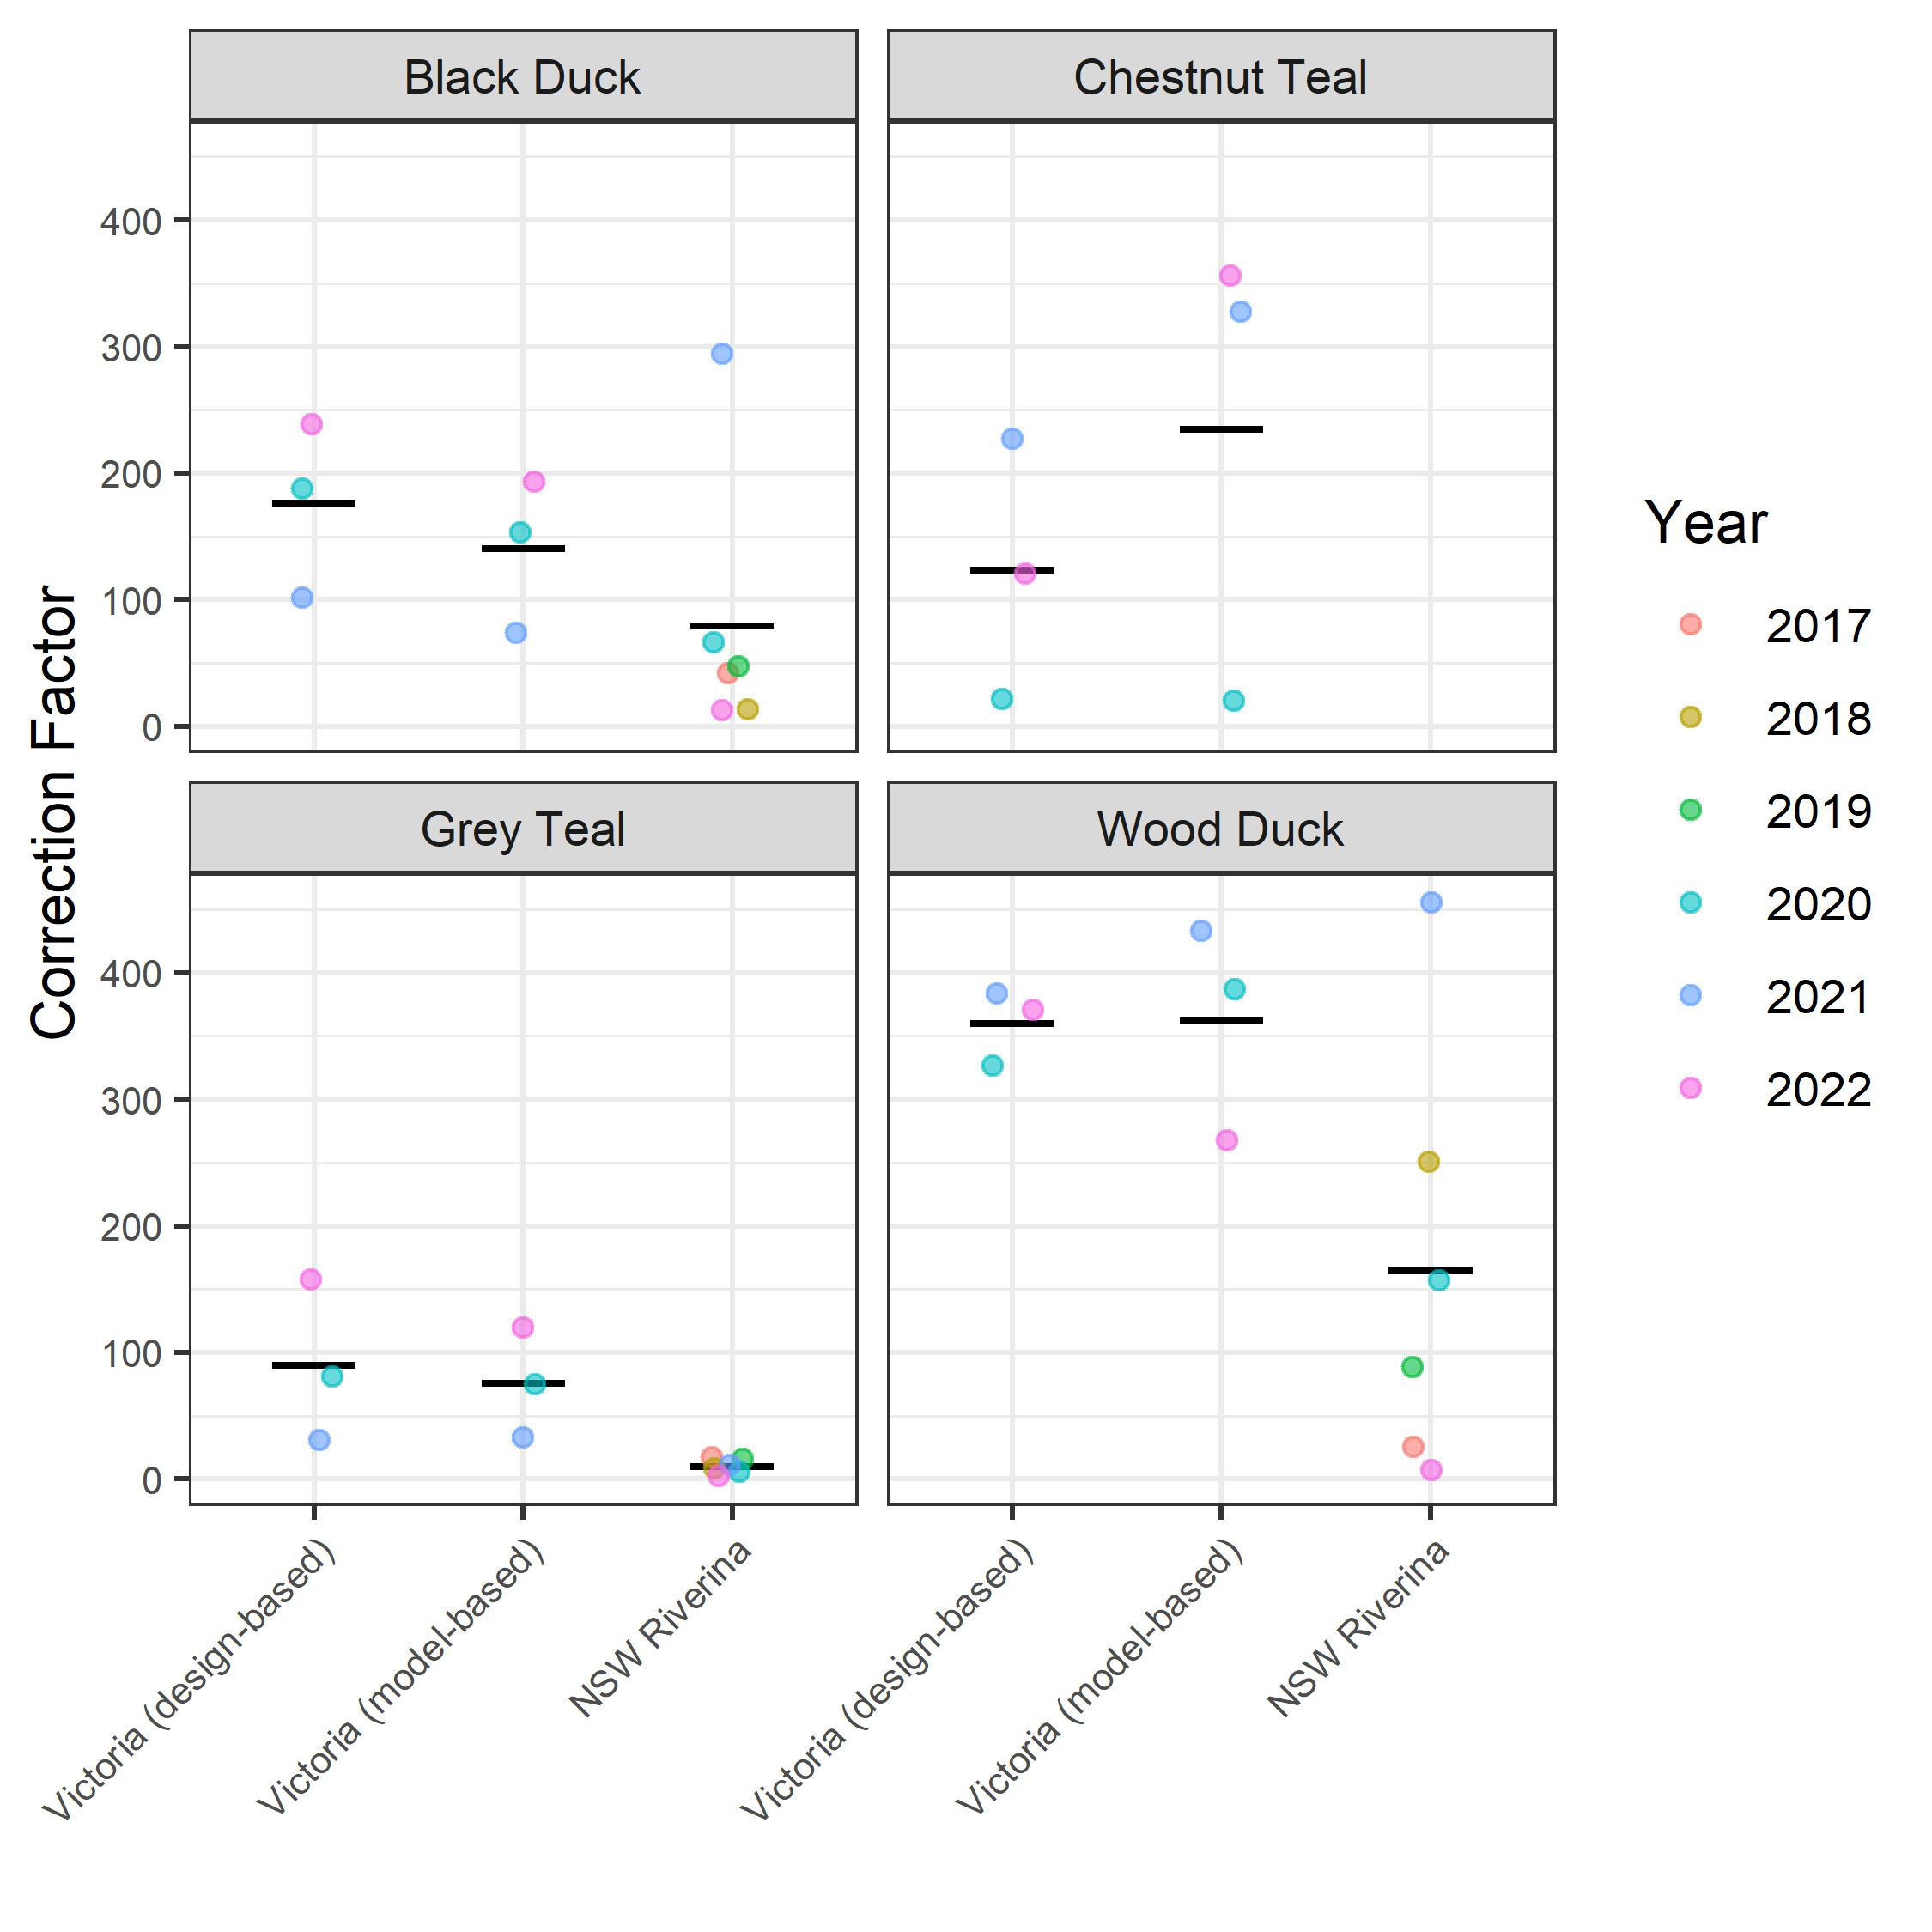
Figure 5. Estimated correction factors for conversion between EAWS relative abundance and absolute game duck abundance, based on 3 and 6 years of data for Victoria and the NSW Riverina, respectively. Correction factors calculated for Victoria using design- and model-based estimates of absolute abundance are shown separately. Jittered points represent the independent correction factor estimated for each year. Horizontal back bars represent the average correction factor for each group.

Relationships between subregion carrying capacities and SPEI
To develop a baseline scenario characterising the impact of environmental variability on game duck carrying capacity in the four subregions, the correction factors estimated above were used. Specifically, the mean correction factors calculated for the NSW Riverina were applied in the Northern Basin, Lake Eyre Basin and South Australian subregions. However, for the Victorian subregion, we used a weighted average of correction factors from both regions (for Black Duck, Chestnut Teal and Grey Teal) or the mean estimate for Victoria (for Wood Duck) to ensure the simulation model could re-create game duck abundances encompassing the most recent Victorian estimates (Ramsey and Fanson 2021; 2022; 2023). The relationships between SPEI and relative abundance (Figs 3 & 4) were combined with these correction factors to derive an assumed relationship between SPEI and carrying capacity in each subregion (Fig. 6). However, because the relative-abundance models for Chestnut Teal in the Northern Basin, Lake Eyre Basin and South Australia estimated a weak negative effect of SPEI, these models were first refitted without a SPEI term (i.e., assuming no effect of SPEI on this species in these subregions) (Fig. 6). Given significant uncertainty regarding the correction factors used, different correction factors were later tested as part of a sensitivity analysis (detailed below).

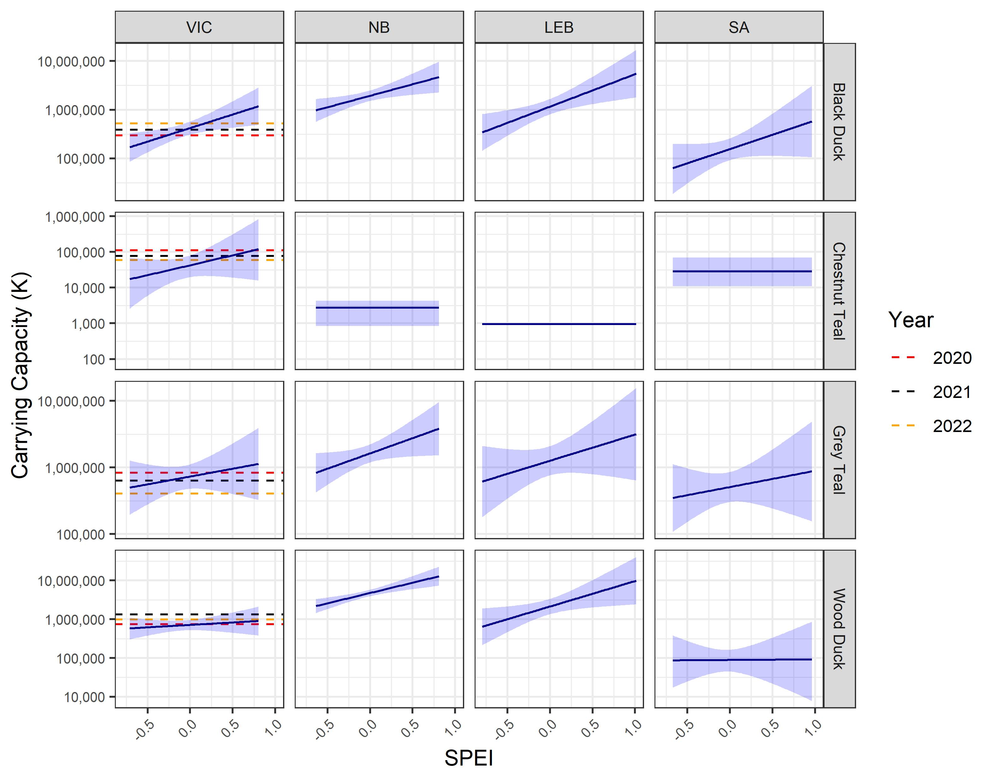
Figure 6. Relationships between subregion carrying capacities and SPEI that were used for the baseline model parameterisation. Note that carrying capacities are presented on a log₁₀ scale. The dashed horizontal guidelines within panels in the first column represent the absolute Victorian population estimate for each species in the spring of 2020, 2021 and 2022 (Ramsey and Fanson 2021; 2022; 2023).

Simulation model
Metapopulation models were developed for the four species (Black Duck, Chestnut teal, Grey Teal, Wood Duck) from first principles based on prior knowledge of the target species’ biology and several standard assumptions. The models were coded in R software (v 4.2.1) for statistical computing (R Development Core Team 2022). Parameterisation of a baseline model is detailed in Table 2, along with the parameter ranges tested as part of a global sensitivity analysis. The key simulation-based components of the metapopulation model are detailed below.

Table 2. Simulation parameters for game duck species, showing baseline values for each parameter, as well as the uniform (U) ranges used for sensitivity analysis using Latin hypercube sampling. In the sensitivity analysis column, x refers to the baseline parameter value, and U(lcl,ucl) means lower and upper 95% confidence limits from a previous analysis were used to define the range of the uniform distribution. For the sensitivity analysis of EAWS correction factors, the uniform distribution used for all subregions was the same as that for Victoria.
Parameter | Black Duck | Chestnut Teal | Grey Teal | Wood Duck | Sensitivity Analysis
Demographic constants
Maximum population growth rate (r_{max}) | 0.34 ª | 0.34 ª | 0.34 ª | 0.34 ª | U(0.24, 0.44)
Annual survival probability of 0-1 year olds (s₀) | 0.56 ^{b} | 0.48 ^{c} | 0.48 ^{d} | 0.60 ^{e} | U(x-0.1, x+0.1)
Annual survival probability of 1+ year olds (s₁₊) | 0.63 ^{b} | 0.55 ^{d} | 0.55 ^{b} | 0.69 ^{f} | U(x-0.1, x+0.1)
Clutch size assumed at carrying capacity (m_{K}) | 10 ^{g} | 10 ^{g} | 10 ^{g} | 10 ^{g} | U(8, 12)
Density dependence function ^{h}
Curvature parameter (θ_{dd}) | 1 | 1 | 1 | 1 | U(0.5,2)
Dispersal function
Intercept (a_{disp}) | 2.33 | 5.7 | 2.33 | 5.7 | U(x-2, x+2)
Coefficient (b_{disp}) | 1 | 1 | 1 | 1 | U(x-0.99, x+0.99)
Carrying capacity function
Intercept (a_{K}) | SR-specific | SR-specific | SR-specific | SR-specific | U(lcl, ucl)
SPEI Coefficient (b_{K}) | SR-specific | SR-specific | SR-specific | SR-specific | U(lcl, ucl)
EAWS correction factors
VIC | 105.5 | 178.7 | 34.3 | 361.4 | U(0.1x, 1.2x)
NB, LEB, SA | 79.2 | 52.3 | 10.0 | 164.1 | U(range as for VIC)
Harvesting
VIC proportional harvest | 0, 0.1, … , 0.5 | 0, 0.1, … , 0.5 | 0, 0.1, … , 0.5 | 0, 0.1, … , 0.5 | U(0, 0.4)
NB/SA proportional harvest | 0.05 | 0.05 | 0.05 | 0.05 | U(0, 0.1)
Crippling loss | 0.23 | 0.23 | 0.23 | 0.23 | U(0.1, 0.4)
ª Equivalent to λ_{max} = 1.4 as used for Grey Teal and Wood Duck by Ramsey et al. (2010).
^{b} Estimate from Halse et al. (1993).
^{c} Estimate set to preserve the same juvenile:adult survival ratio as that reported for Black Duck in Halse et al. (1993).
^{d} Estimate for Chestnut Teal was set equal to that for Grey Teal.
^{e} Over three years, Kingsford (1989) reported a mean probability of surviving from hatching to fledgling of 64 % for Wood Ducks (this included one year of drought). Ramsey et al. (2010) used an annual survival probability of 0.67 for juveniles of this species.
^{f} Estimate set to preserve the same juvenile:adult survival ratio as that used by Ramsey et al. (2010).
^{g} Estimate from Frith (1982).
^{h} Estimates from Ramsey et al. (2010).

Spatial structure
Given waterfowl species are highly mobile and can travel large distances to exploit ephemeral wetlands, modelling of sustainable harvest levels within Victoria needs to account for waterfowl populations inside and outside the state (Ramsey et al. 2010). Therefore, game duck populations in eastern Australia were simulated as a metapopulation, consisting of subpopulations in each of the four subregions linked by dispersal. To account for the impact of variable water availability in these regions, historical SPEI time series were used to simulate realistic variation in carrying capacities over time, and dispersal between subregions was also influenced by these variable carrying capacities.

Model flow, age/sex structure, initialisation and simulation runs
The metapopulation model was developed using an annual timestep and a post-breeding census design, with the following events occurring in sequence each year: reproduction, census, mortality (natural and harvest-mediated), dispersal, and aging. The model accounted for two age classes (juveniles [0 year old] and adults [≥ 1 year old]) and two sexes. It assumed an equal sex ratio at birth and that all adults were capable of reproducing each year. Subregion populations sizes were initialised at carrying capacity, with the proportion of juvenile/adult birds set using the stable age distribution calculated from a population projection matrix calculated to produce no population growth. For each simulation scenario, the metapopulation model was run for an initial 50 years (the ‘burn-in’ period), and then simulation output was collected and summarised over a subsequent 50-year period.

Demographic rates
Annual age-structured survival rates and average clutch sizes were sourced from the scientific literature (Frith 1982; Ramsey et al. 2010). Given populations cannot grow without limit and intra-specific competition likely increases with increasing density, the following procedure was used to parameterise a density-dependent function which modified the expected clutch size as a function of subregion population size and carrying capacity each year. Varying clutch size can be considered to represent the combined impact of density on clutch size and first-year survival rates.
Firstly, available survival and clutch size estimates were used to parameterize an initial population projection matrix for each species for which the resultant annual population growth rate ($r$) was calculated. Secondly, survival rates were optimised (via a multiplier of the survival rates of all age/sex classes) to achieve r = 0 (i.e., no population growth), thereby deriving the projection matrix used for a subregion at carrying capacity. Thirdly, a maximum clutch size ($m_{max}$) was calculated to produce the maximum rate of population increase (r_{max}) conditional on the previously calculated survival rates. Finally, as detailed in Ramsey et al. (2010), average clutch size was modified using the function
$$m(Q)=\frac{m_{max}}{1+a_{dd}{\left(\frac{Q}{K\left(S\right)}\right)}^{θ_{dd}}}$$
where $m(Q)$ is the average clutch size produced by reproducing females at population size $Q$, $K\left(S\right)$ is the carrying capacity in subregion $S$, and $θ_{dd}$ is the theta-logistic parameter determining the strength of density dependence (higher values of $θ_{dd}$ reflect increased rebound potential). The parameter $a_{dd}$ was set equal to $({m_{max}}/{m_{K})-1}$ where $m_{K}$ is the fertility rate required for a stable population, thereby ensuring a stable subregion population when $Q= K\left(S\right)$, in the absence of harvesting and stochastic effects. The baseline model parameterisation assumed weak density dependence for all species with $θ_{dd}$ = 1 (Ramsey et al. 2010).

Dispersal
Dispersal probabilities ($P_{ij})$from subregion $i$ to $j$ were assumed to be a function of carrying capacity in each subregion and the total carrying capacity of the metapopulation
$$P_{ij}=\frac{η_{ij}}{\sum_{j=1}^{S}{η_{ij}}} η_{ij}= a_{disp}1_{i=j}+ b_{disp}\left(\frac{K_{j}}{K_{tot}}\right)$$
where $η_{ij}$ is the linear model for the probability of dispersal from subregion i to subregion $j$, $1_{i=j}$ is an indicator variable equal to one if $i=j$ and zero otherwise, $K_{j}$ is carrying capacity in subregion $j$, and $K_{tot}$ is the sum of carrying capacities across all subregions. The parameters $a_{disp}$ and $b_{disp}$ were set in a species-specific fashion, with larger positive values of $a_{disp}$ meaning dispersal away from the currently occupied subregion is less likely, and larger positive values of $b_{disp}$ meaning dispersal towards subregions with higher relative carrying capacities is more likely. As summarised in Ramsey et al. (2010), detailed information on waterfowl dispersal is lacking, but reasonable dispersal functions can be developed for each species, noting that Grey Teal and Pacific Black Duck frequently move long distances in response to wetland availability while Chestnut Teal and Wood Duck are more sedentary. The baseline parameterisation of the dispersal function is illustrated in Fig. 7 for each species.

Demographic stochasticity
Demographic stochasticity (i.e., random variation in the outcome of probabilistic life history events) was simulated at each step detailed above. The overall reproductive output of each subregion was sampled from a Poisson distribution with mean $λ= m\left(Q\right)N_{F_{a}}$, where $N_{F_{a}}$ is the number of reproducing adult females in that subregion. The survival of each age/sex class was modelled with binomial distributions while the numbers of harvested animals in each group was drawn from multinomial distributions assuming harvesting probabilities in each age/sex class are in proportion to the contribution of each group within each subregion. Similarly, the outcome of the dispersal step was sampled from multinomial distributions based on the dispersal probabilities detailed above.

Environmental stochasticity
Environmental stochasticity (i.e., variation in vital rates and dispersal due to variation in environmental conditions) is a key driver of wildlife population dynamics. As detailed above, environmental stochasticity was introduced through a time-varying carrying capacity which was, in turn, a function of SPEI in each subregion. To simulate different SPEI time series while preserving the correlation between SPEI in the four subregions, each simulation iteration used a randomly generated SPEI series produced by sampling ten decades of data (with replacement) from the historical series.

Climate change
To develop a scenario of climate-change impacts on duck carrying capacities, linear trends in annual SPEI over the period between 1950 and 2020 were estimated separately for each subregion. Consistent with the pattern of recent drying in south-eastern Australia, the strongest negative trend was estimated for Victoria (trend estimate per annum = -0.0066, P < 0.05), while negative trends were also estimated for the Northern Basin and South Australia (-0.0045 and -0.0039; both P < 0.05). The estimated SPEI trend for the Lake Eyre Basin was negative (-0.0032) but not statistically significant. To simulate a climate change effect, these trends were used to define an annual correction to be applied to the sampled SPEI time series following the initial 50-year burn-in period (Fig. 8)

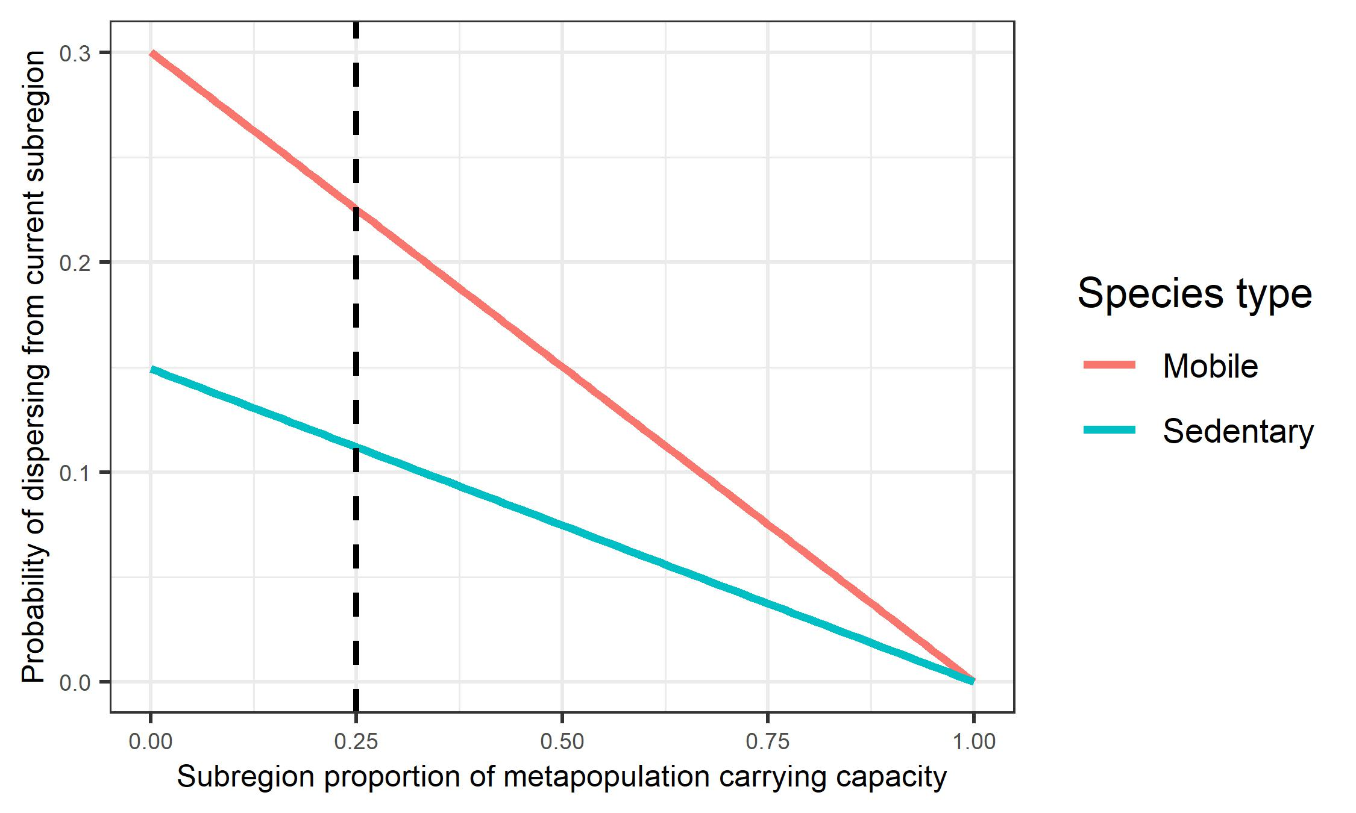
Figure 7. Baseline parameterisation of the multinomial dispersal function for mobile species (Black Duck and Grey Teal) and sedentary species (Chestnut Teal and Wood Duck). The figure shows the probability an individual duck will disperse away from its current subregion (to one of the remaining three subregions) as the relative carrying capacity of the current subregion is increased. The dashed vertical guideline indicates a relative carrying capacity of 0.25, which would occur when each of the four subregions is at equal carrying capacity.

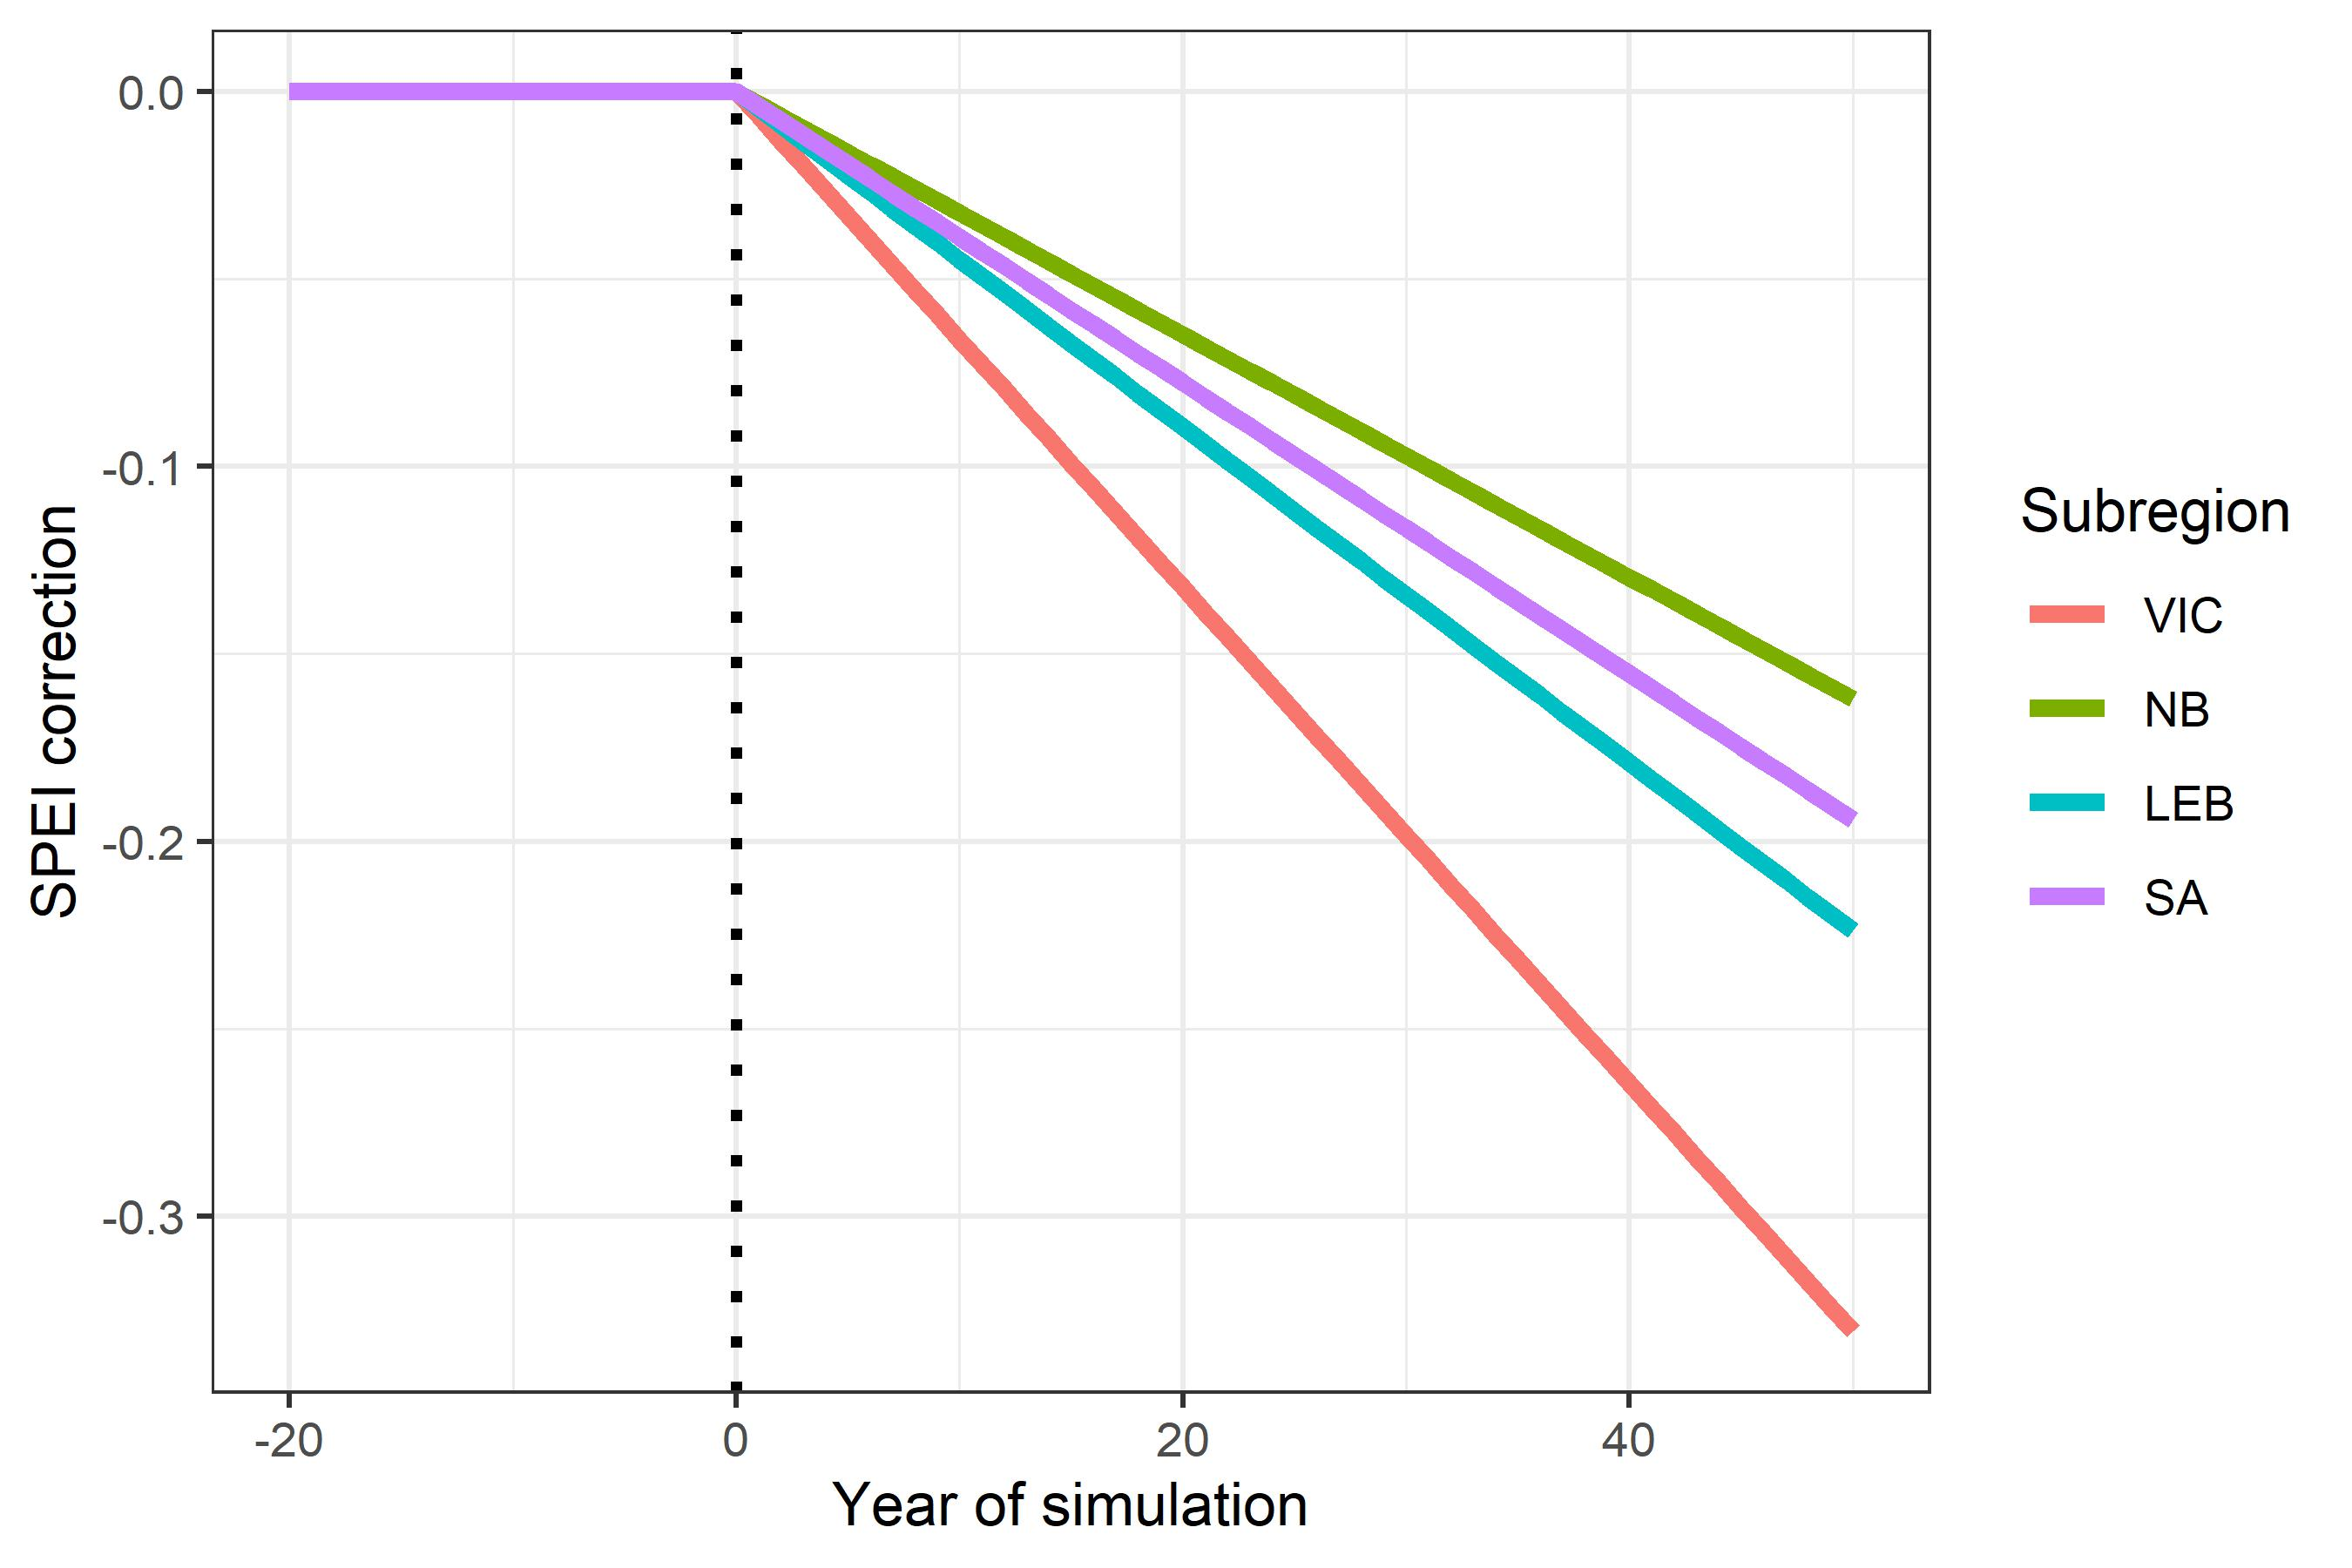
Figure 8. Corrections applied to SPEI time series in each subregion to simulate a scenario of climate change. The vertical dotted guideline indicates the end of the burn-in period and the beginning of the simulated climate-change impacts.

Harvesting
The number of birds harvested each year was assumed to be a fixed proportion of the subregion population size, which was itself derived from the census conducted immediately after breeding and assumed to be known without error. The simulated harvest was implemented across age/sex cohorts in proportion to their contribution to each subregion’s population size. Given some recreational harvesting occurs within the Northern Basin and South Australia, but is likely to be a maximum of 10 % in the relatively small areas where harvesting is strongest (NSW DPI 2021), the proportional harvest rate in these subregions was set at 5 % of the subpopulation size per year. In contrast, the Lake Eyre Basin subregion was left unharvested. Different proportional harvest rates implemented in Victoria were then tested as part of the scenario analysis.

Crippling loss
Hunting ducks with shotguns carries the risk that animals are struck but not immediately killed, and in these cases the struck animals might die later as a result of their injuries (known as “crippling loss”) (Ellis et al. 2022) or survive with no obvious long-term effects (GMA 2023). In North America, estimates of crippling loss range from c. 10% to 40% of total harvest (Ellis et al. 2022; Nieman et al. 1987; Norton and Thomas 1994). In Victoria, the mean crippling loss estimated from six years of data (between 1972 and 1977) was 23 % of the reported harvest (Norman and Powell 1981). The baseline model therefore assumed a crippling loss rate of 23 %, while a broader range was tested through sensitivity analysis. For comparison, the USA applies a crippling loss rate of 20% in its AHM (U.S. Fish and Wildlife Service 2022).

Scenario testing
The metapopulation model was used to test different proportional harvest strategies in Victoria over a 50-year timeframe. As the simulation model included both demographic and environmental stochasticity, 1,000 iterations were run to characterise the expected simulation output from each scenario. Specifically, different harvest levels were evaluated with respect to the expected cumulative long-term harvest and expected mean and minimum population sizes produced. Given substantial uncertainty in the absolute abundance of game ducks in the different subregions, population sizes are presented as percentage of available carrying capacity. A minimum population threshold of 20 % of carrying capacity was used as an arbitrary target for management. A range of proportional harvest rates for Victoria was tested via simulation, under different scenarios including those that: (a) prevented dispersal between subregions; (b) allowed dispersal between subregions; and (c) assumed SPEI decreased linearly over time under the climate-change scenario.

Global sensitivity analysis
To investigate whether the scenarios tested above produced results for Victoria that were robust to different model parameterisations, including assumptions regarding EAWS correction factors in the different subregions, a global sensitivity analysis was performed (Table 2). To cover the multi-dimensional parameter space thoroughly, 10,000 distinct parameter sets were generated for each species using Latin hypercube sampling, implemented using the R package ‘lhs’ (Carnell 2012). A single 100-year simulation iteration was run per parameter set (Prowse et al. 2016), the initial 50 year burn-in period was discarded, and the mean and minimum of Victorian subpopulation size and total metapopulation size (as a percentage of carrying capacity) were calculated from data for the remaining 50 years. The relationship between simulation input parameters and these output variables was analysed with boosted regression trees (BRT) using functions in the R package ‘dismo’ (Hijmans et al. 2013). The BRT models were fitted with a learning rate of 0.01, a bag fraction of 0.75 and a tree complexity of 2 (i.e., allowing first order interactions only). The fitted BRT models produced a measure of the relative influence of each parameter which was used as an index of parameter importance.

Results

Scenario analysis

Baseline scenario with no dispersal between subregions
To consider the impact of dispersal assumptions for the sedentary and mobile species, simulations from the metapopulation model were first run with no dispersal allowed between subregions (Fig. 9). In this scenario, a Victorian proportional harvest was only initiated after the burn-in period, to allow visualisation of the impact of different harvesting levels. As expected, based on the maximum population growth rate used for these game ducks, annual proportional harvests of 30 % or more (plus associated crippling loss) overwhelmed the rebound potential of these species and the simulated Victorian population was driven to extinction (Fig. 9). The annual proportional harvest of 5 % in the Northern Basin and South Australian subpopulations also lowered the population size in these subregions to just below 80 % of carrying capacity.

Baseline scenario with species-specific dispersal between subregions
When dispersal was included, proportional harvesting in Victoria had clear population-level impacts, both in Victoria and, except for the Wood Duck, more broadly through the simulated metapopulations (Fig. 10). The local impacts of harvesting were ameliorated by immigration into Victoria for all species, such that a proportional harvest of 50 % no longer resulted in extinction of the Victorian subpopulation. Although the harvest impacts were felt most strongly in Victoria, as the harvest proportion increased, game duck subpopulations were also reduced in the other subregions. Harvesting had the largest impact on the sedentary Chestnut Teal. Harvesting impacts in Victoria were less severe for the mobile Black Duck and Grey Teal but subpopulations declined in the other subregions due to high connectivity between them. For the sedentary Wood Duck, Victorian harvesting had little impact on the neighbouring subpopulations.

Trade-offs between cumulative harvest and population size
Under the baseline model parameterisation with dispersal, cumulative harvests for the two mobile species increased as the proportional harvest increased from 0 to 50 % because harvesting in Victoria was ameliorated by immigration from other subregions (Fig. 11). However, the cumulative harvest achieved with an annual harvest of 30 % was similar to that realised by a 50 % harvest (Black Duck: c. 470 thousand versus 536 thousand individuals; Grey Teal: c. 777 thousand versus 846 thousand individuals). In contrast, cumulative harvests were maximised by a 30 % annual harvest rate for the more sedentary Wood Duck, and at just a 20 % harvest for the Chestnut teal (Fig. 11).
The local impacts of Victorian harvesting were strongest for the two sedentary species (Chestnut Teal and Wood Duck) (Fig. 12). For example, for Chestnut Teal the long-term mean Victorian population size (as a percentage of carrying capacity) decreased from 95 % with no harvesting to 7 % with a proportional harvest of 50 %. In contrast, application of the same harvest saw the Victorian mean population size of highly mobile Grey Teal from 92 % to 28 % of carrying capacity.
For Grey Teal and Wood Duck, long-term mean population size and expected minimum population size (for Victoria and the entire simulated metapopulation) could be reliably maintained above 20 % of carrying capacity for up to (and including) 30 % proportional harvests (Fig. 12). However, the same 30 % harvest for Black Duck and Chestnut Teal produced expected minimum Victorian population sizes below the 20 % threshold used here (i.e., to 18 % and 7 % of carrying, respectively)
At the metapopulation level, the impact of Victorian harvesting was most severe for Chestnut Teal, for which mean total population size decreased from 87 % with no harvesting to 26 % with a 50 % harvest (Fig. 12). For the two mobile species (Black Duck and Grey Teal), the same harvest dropped the total population size by around 25 %. Reflecting its more sedentary nature, the Wood Duck metapopulation was relatively robust to Victorian harvesting and a 50 % harvest produced just a 11 % metapopulation decline on average. Simulation-based estimates of absolute mean and minimum
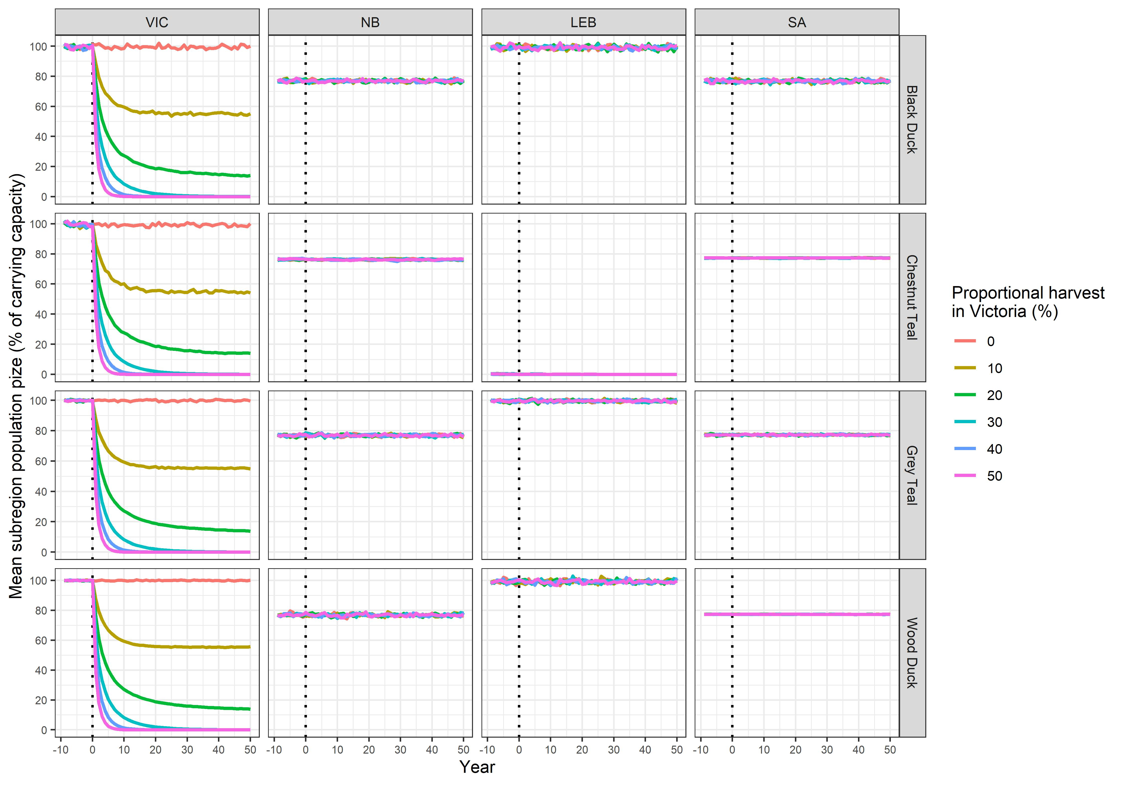
Figure 9. Mean subpopulation sizes (from 1,000 simulation iterations) as a percentage of carrying capacity for a scenario allowing no dispersal between subregions. Coloured lines represent the different proportional harvesting regimes in Victoria. Ducks in the Northern Basin and South Australian subregions were subject to an annual cull of 5 % for the entire simulation period, whereas the Victorian harvest was implemented at the end of the burn-in period (after year 0).
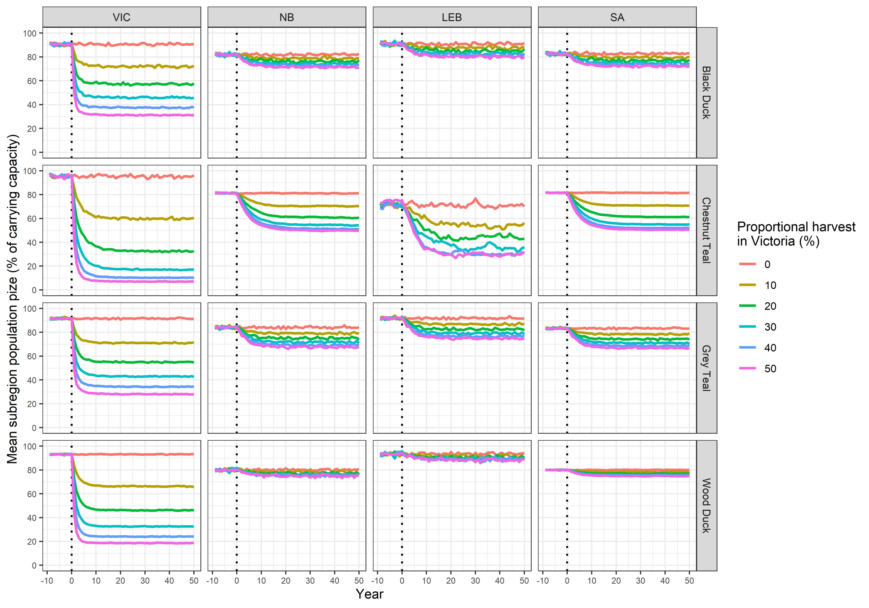
Figure 10. Mean subpopulation sizes (from 1,000 simulation iterations) as a percentage of carrying capacity for a scenario permitting dispersal between subregions. Other details are as for Fig. 8.
abundance under different harvest scenarios highlighted the substantial impact of harvesting on Chestnut Teal, at both the Victorian and metapopulation levels (Fig. 13).

Climate change
Under a scenario of climate change, modelled as a linear decrease in SPEI over time in each subregion, the impacts of proportional harvesting in Victoria were exacerbated (Fig. 13). This climate-change effect was strongest for the Black Duck and Wood Duck because the strongest relationships between carrying capacity and SPEI were estimated for this species.

Global sensitivity analysis
The global sensitivity analysis relating input parameters to the mean and minimum population sizes expected (as a percentage of carry capacity) for Victoria consistently identified a small set of parameters with the strong influence on simulation outputs regardless of the species (Fig. 14). The combined relative influence of the top four most important parameters ranged between 94 % and 99 % depending on the species and simulation output. Key parameters were the proportional harvesting rate in Victoria, the curvature parameter used in the density dependent reproduction function (θ_{dd}), and the two parameters controlling the dispersal of ducks between subregions (a_{disp} and b_{disp}). However, the most important variable was clearly the proportional harvesting rate in Victoria which had a relative influence ranging between 45 % and 83 % depending on the species and output. Notably, uncertainty in the slope of the relationship between Victorian carrying capacity and SPEI (b_{K}) also had a strong impact on the expected minimum abundance of all species (Fig. 14). At the metapopulation level, the intercept used for the carrying-capacity function in each subregion (a_{K}) also exerted strong influence on mean metapopulation size, while again the slope of the relationships between carrying capacity and SPEI (b_{K}) impacted the expected minimum metapopulation size for all species.

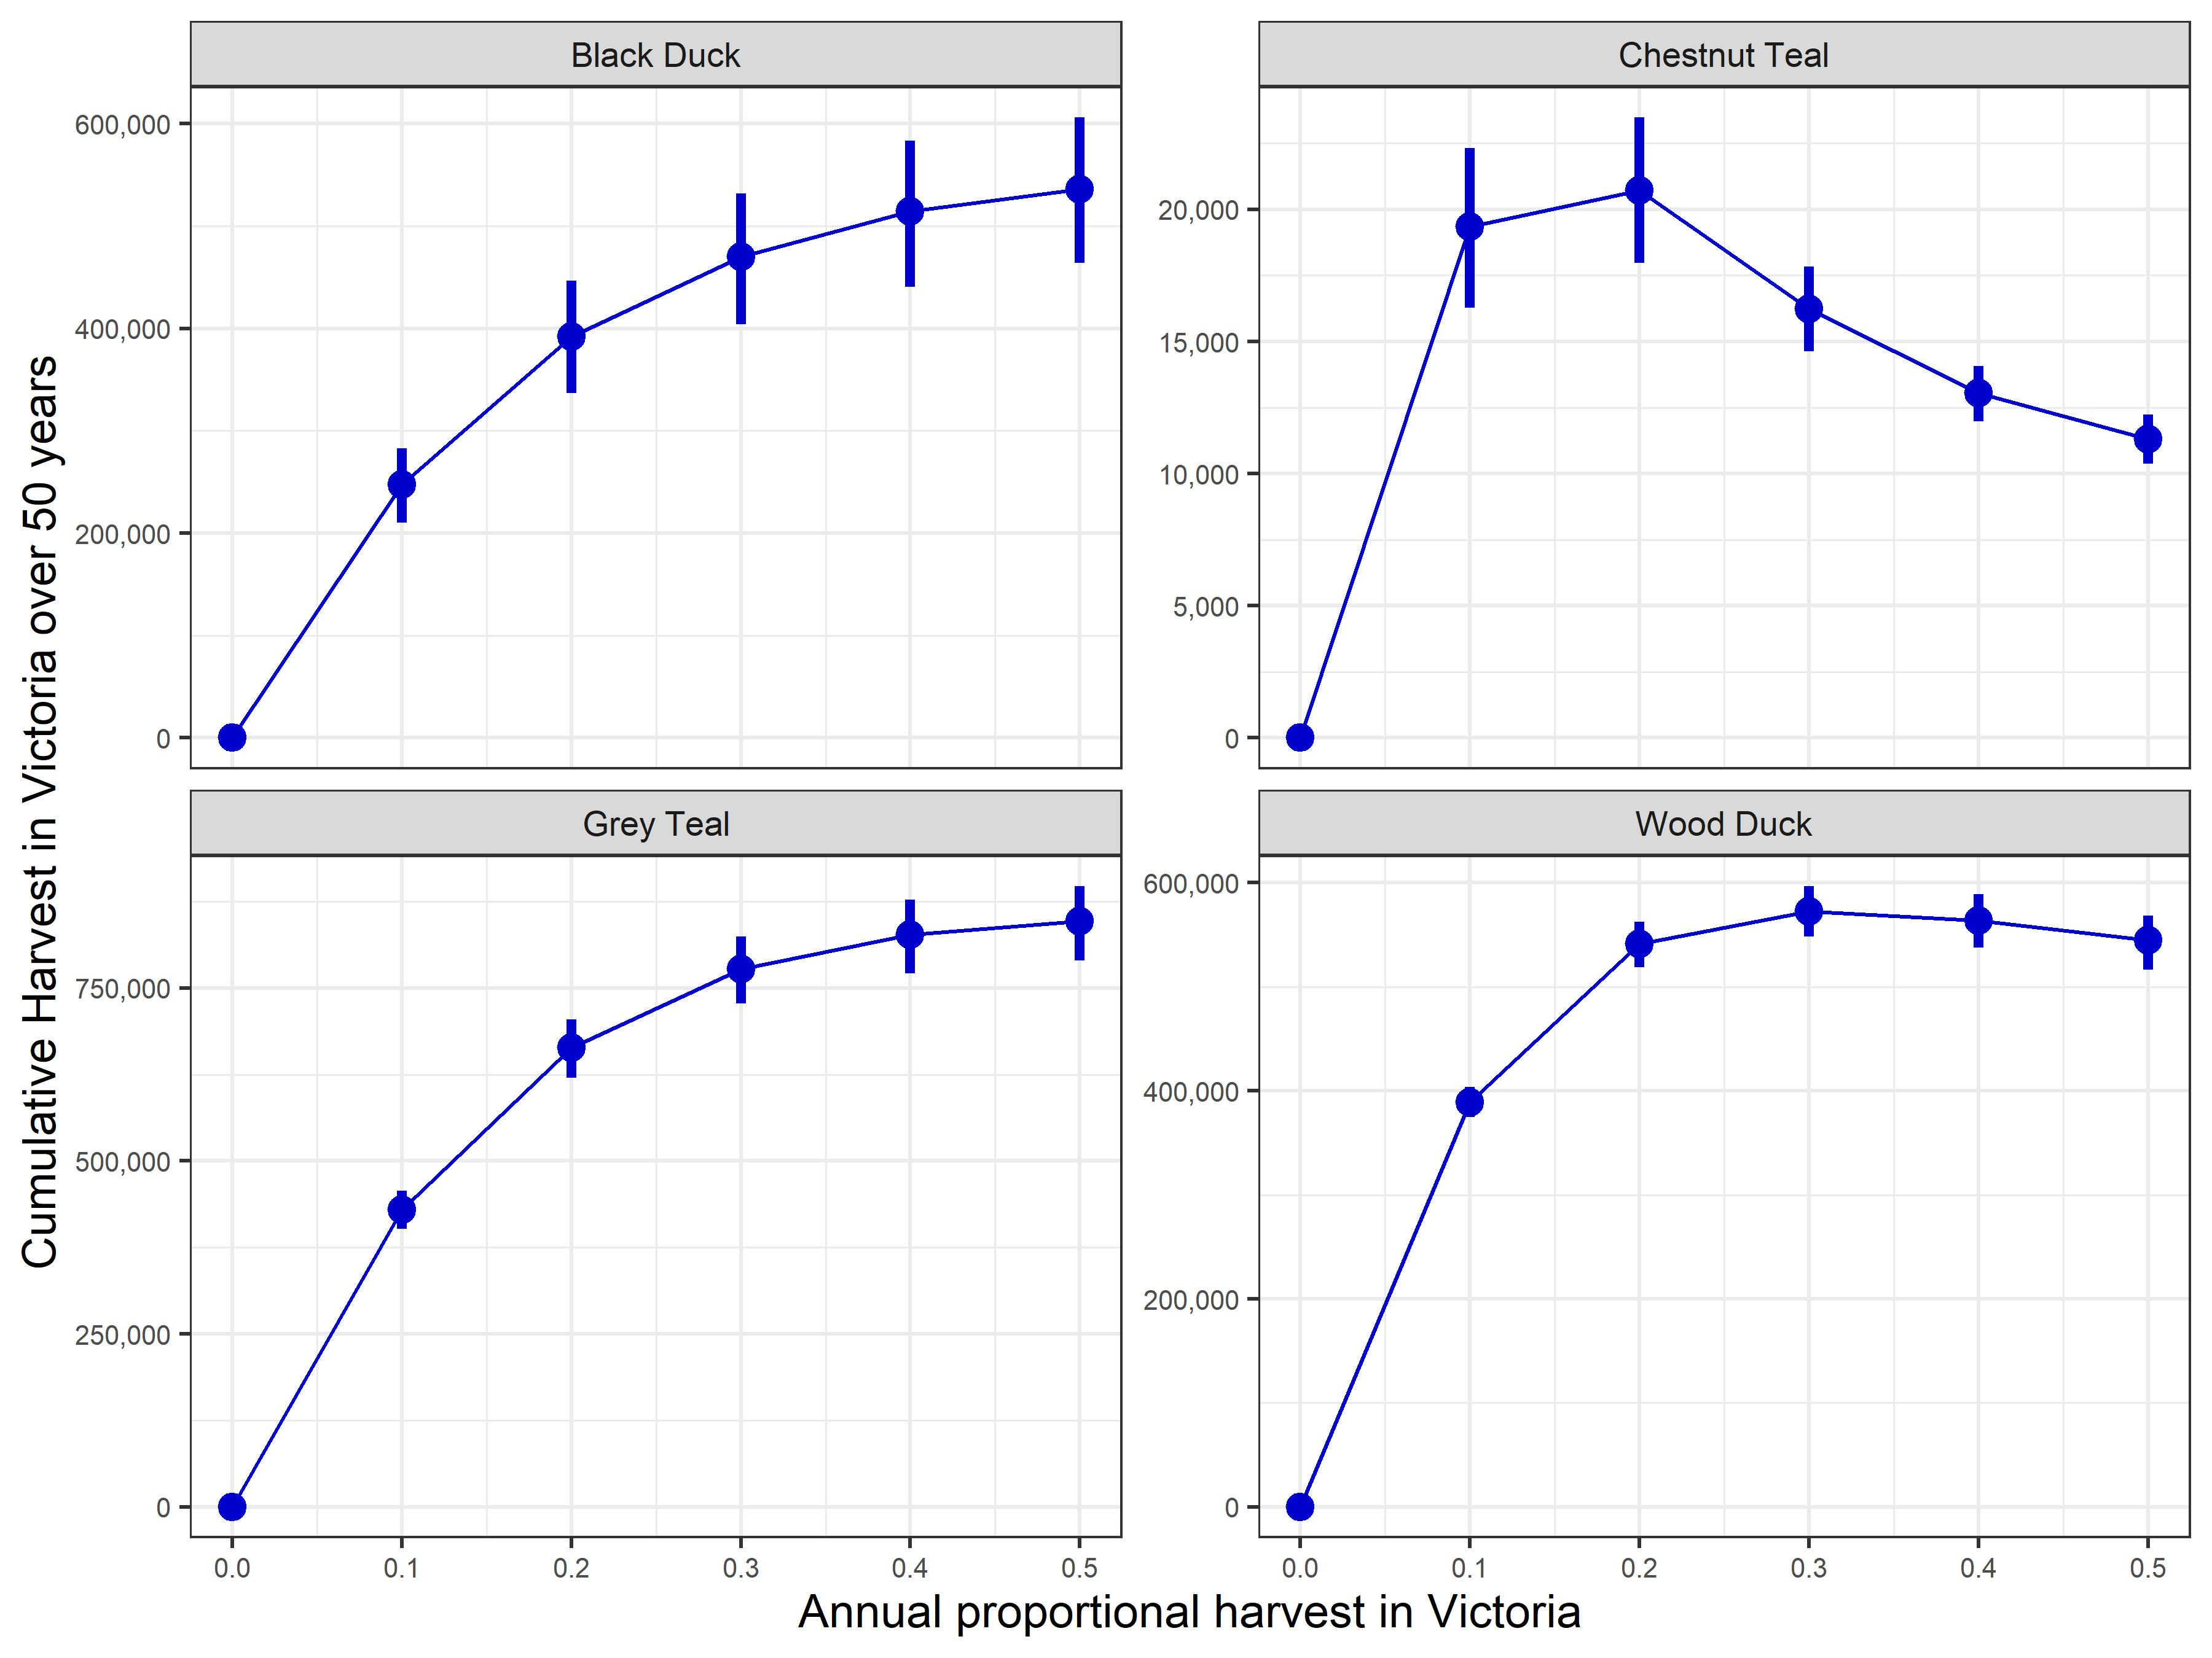
Figure 11. Cumulative harvest for the four game duck species calculated over the 50-year simulation period, for different proportional harvest rates in Victoria. Error bars represent 95 % confidence intervals derived by simulation.

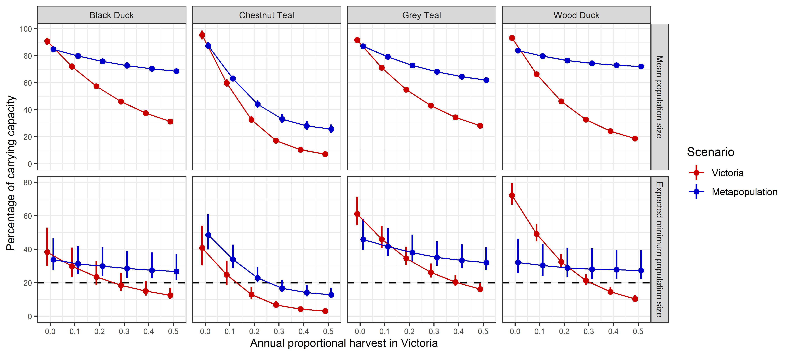
Figure 12. Mean population size and expected minimum population size (as a percentage of carrying capacity) calculated over the 50-year simulation period, for different proportional harvest rates in Victoria. Error bars represent 95 % confidence intervals derived by simulation. The dashed horizontal guideline illustrates an arbitrary expected minimum population threshold of 20%. Note the different y-scales for the two variables plotted.

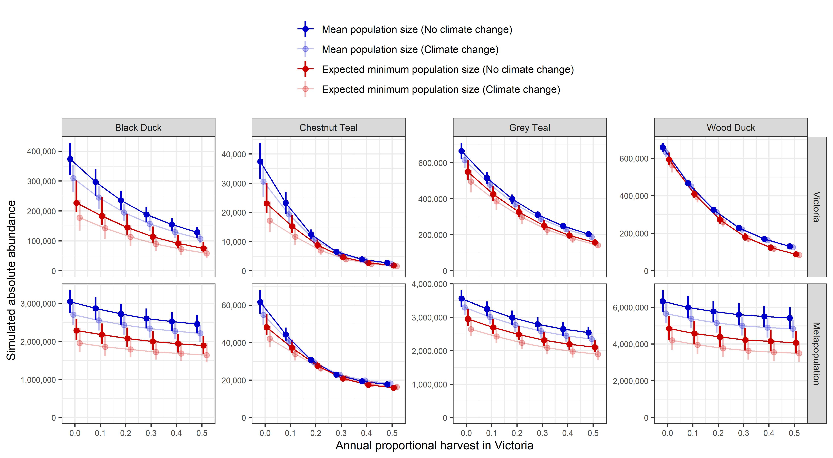
Figure 13. Absolute mean population size and expected minimum population size under a climate-change scenario, for different proportional harvest rates in Victoria. Error bars represent 95 % confidence intervals derived by simulation. Note the different y-scales for the two variables plotted.

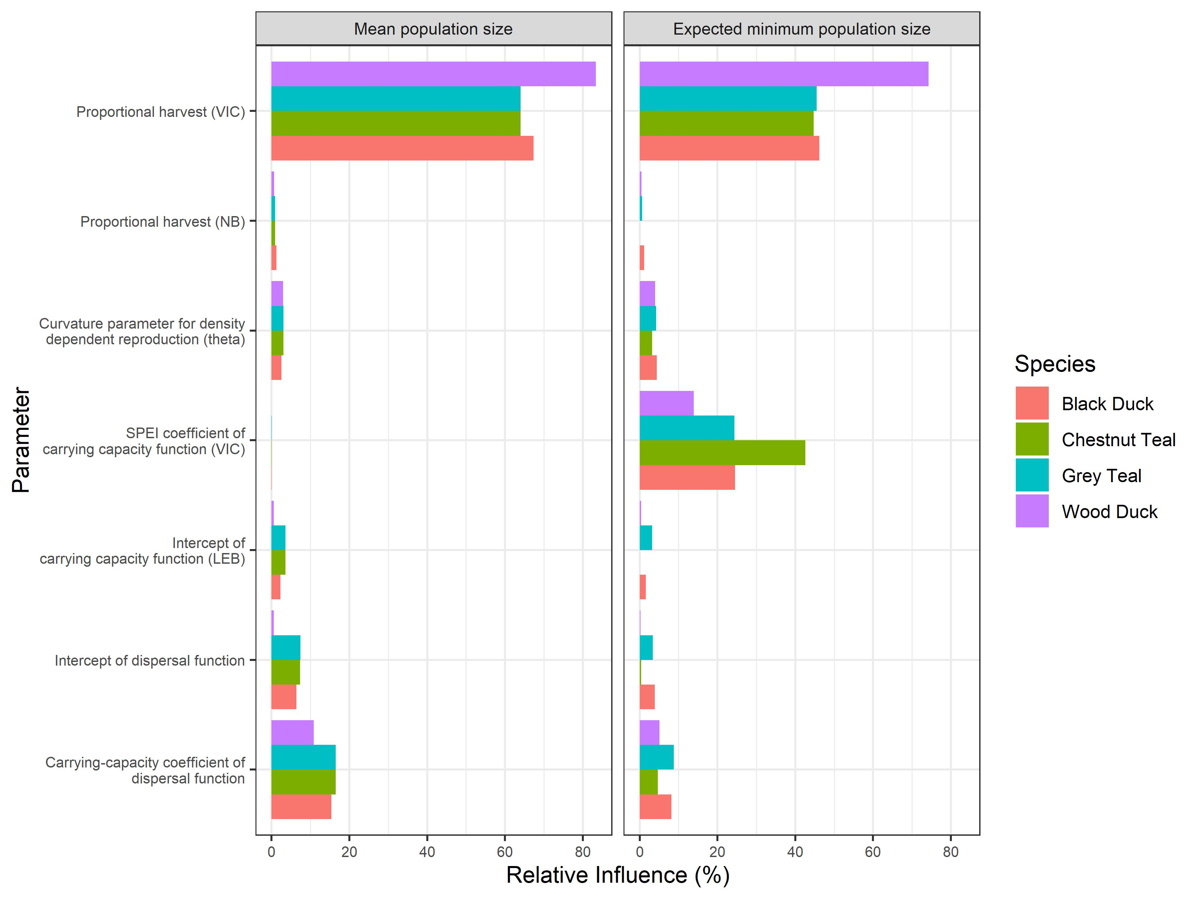
Figure 14. Boosted regression tree (BRT) summary of the metamodel sensitivity analysis for the mean and minimum Victorian population size (as a percentage of carrying capacity) for each game duck species. Relative influence metrics from the BRT analyses are shown to cover the four most important simulation parameters for each species × simulation output combination.

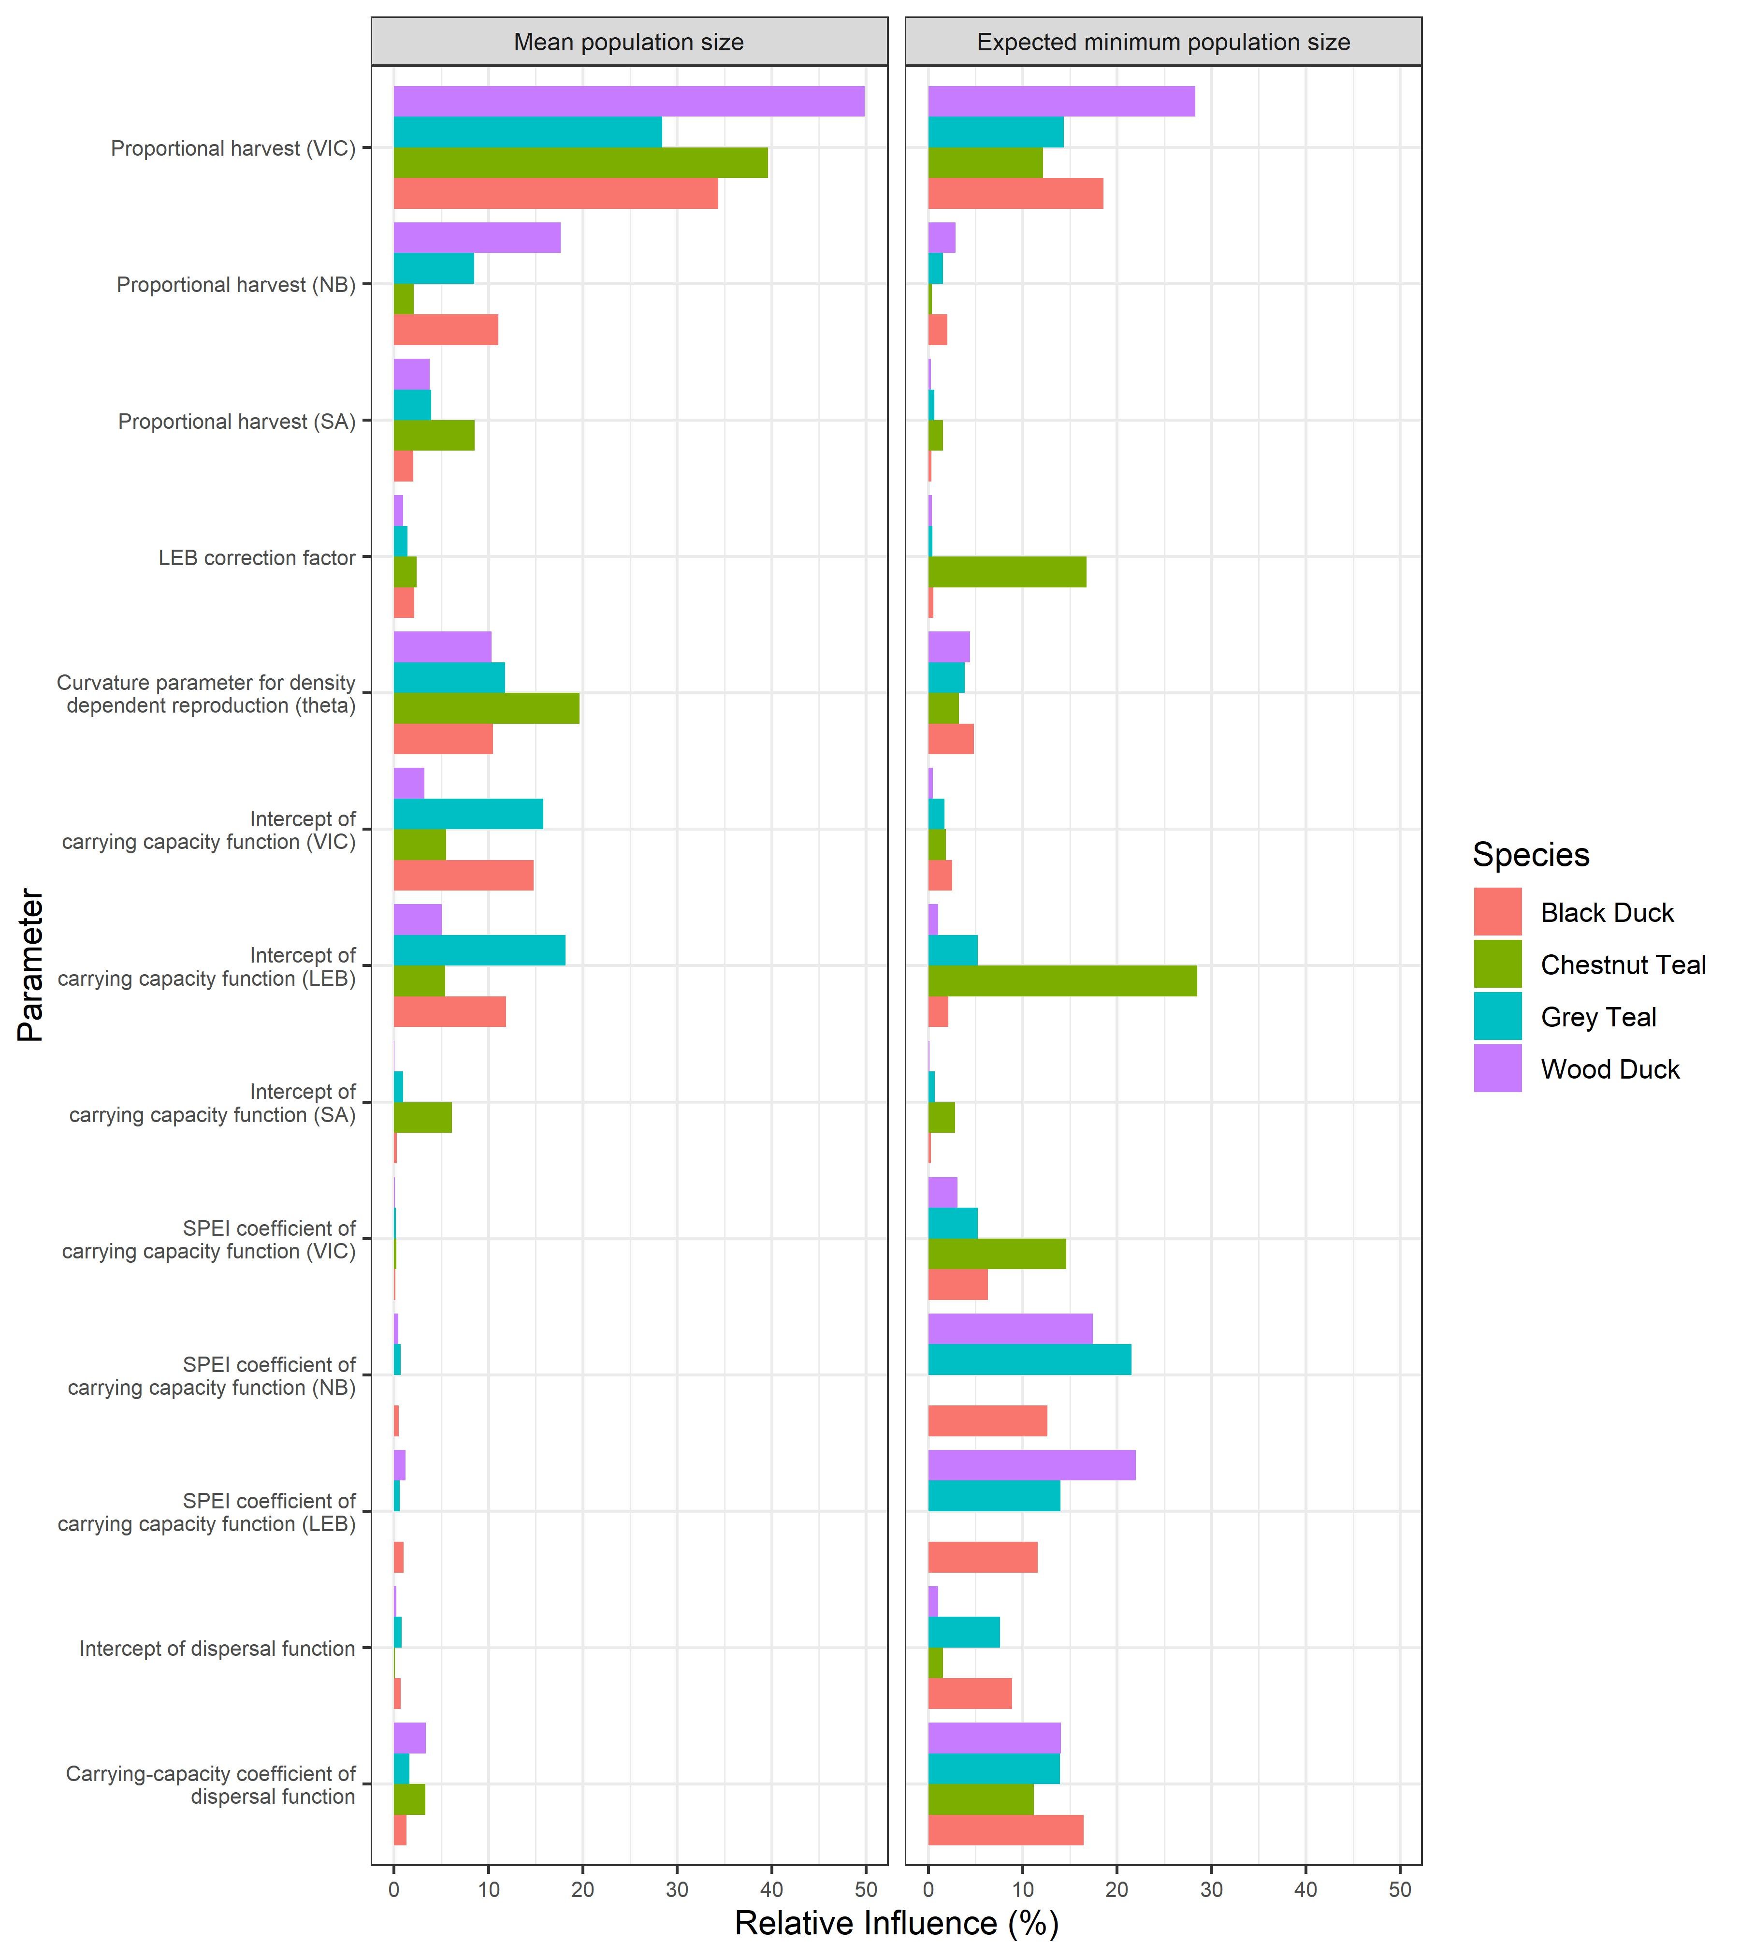
Figure 15. Boosted regression tree (BRT) summary of the metamodel sensitivity analysis for the mean and minimum metapopulation size (as a percentage of carrying capacity) for each game duck species. Relative influence metrics from the BRT analyses are shown to cover the four most important simulation parameters for each species × simulation output combination.

Discussion

Sustainable harvest rates
This report aimed to identify sustainable proportional harvest quotas which, if implemented, would allow some harvesting while not compromising the viability of the game duck species, either in Victoria or in eastern Australia more broadly. For this report, sustainable harvest management is defined as management seeking to maximise the cumulative harvest over a 50-year period, under the constraint that populations are maintained above some minimum population threshold (defined here arbitrarily at 20 % of carrying capacity). The latter constraint acknowledges that the viability of wildlife species may be compromised if their abundance is reduced so much that demographic, genetic and environmental stochasticity begin to dominate their population dynamics (Gilpin and Soulé 1986).
Under the baseline model parameterisation, cumulative harvests for the two mobile species (Black Duck and Grey Teal) increased as the proportional harvest increased from 0 to 50 %, since harvesting in Victoria was ameliorated by immigration from other subregions. However, cumulative harvests of these species were around 90 % of that achieved with a 50 % harvest if harvesting was reduced to 30 % per annum. In contrast, cumulative harvests were maximised at lower harvest levels for the two more sedentary species – at a 30 % harvest for the Wood Duck and just a 20 % harvest for the Chestnut Teal.
While the baseline model suggested harvest returns could be maximised at different harvesting rates depending on the species, high proportional harvests resulted in low expected minimum population sizes over the long term. Simulation results for Grey Teal and Wood Duck suggested that long-term mean population size and expected minimum population size (for Victoria and the entire simulated metapopulation) could be maintained above 20 % of carrying capacity for up to (and including) 30 % proportional harvests. Results for Black Duck and Chestnut Teal suggest a more precautionary approach, however, with 30 % harvesting dropping the expected minimum population size in Victoria below 20 % of carrying capacity for these species. Given these results, a precautionary proportional harvest quota of 10 to 20 % is recommended for these species.

Simulating the metapopulation dynamics of game ducks
According to Ramsey et al. (2010), the population dynamics of the mobile Grey Teal and Pacific Black Duck are primarily driven by wetland availability, whereas Wood Ducks are more affected by the availability of farm dams and pasture. The results presented here for Black Duck are consistent with this hypothesis, since the relative abundance of this species is closely related to SPEI (Fig. 3), and this translates into low simulated minimum population sizes due to high variation in SPEI over the long term (Figs 12 & 13). In contrast, relationships between relative abundance and SPEI were weakest for Chestnut Teal, which has a preference for coastal estuaries and wetlands (Rogers et al. 2019) and is therefore less sensitive to inland water availability. For all species, uncertainty in the slope of the relationship between subregion carrying capacity and SPEI had a strong impact on the expected minimum population sizes simulated for Victoria and the entire metapopulation.
Ramsey et al. (2010) also noted that one potential downside of developing spatial population models for game ducks is the lack of empirical data to inform dispersal functions describing how individuals of different species move between spatial units (i.e., subregions or specific wetlands). It is clear that ducks can travel large distances very rapidly; for example, telemetry studies show that grey teal can travel hundreds of kilometres in a few days and many long-distance movements could represent scouting behaviour (Roshier et al. 2008a; Roshier et al. 2008b). However, it is much less clear how subpopulations of ducks will respond if neighbouring subpopulations are reduced through harvesting. In this report, dispersal functions are used that: (1) capture differences in dispersal tendency between two highly mobile and two sedentary species; and (2) produce simulation outcomes consistent with an a priori belief that population size (in Victoria and beyond) should decrease as harvesting intensifies, while immigration into the harvested subregion should be more likely for more dispersive species. However, it should be stressed that the baseline dispersal functions used could not be estimated from empirical data. Uncertainty in the relationship between subregion carrying capacity and dispersal between subregions was an important determinant of the size of the simulated Victorian populations (Fig. 14).
In the metapopulation model developed, intense harvesting in the Victorian subregion can create a ‘sink’ subpopulation, because the local population decline reduces the pool of individuals available to disperse to other areas, and therefore the relative strength of emigration weakens in comparison to immigration. Although immigration buffers the local population decline, the reduction in emigration can negatively impact the size of neighbouring subpopulations. This simulated result is clear for the two highly mobile game ducks, the Black Duck and Grey Teal, for which subpopulations outside Victoria decline as harvesting intensity is increased. The same phenomenon is seen for Chestnut Teal despite the more limited dispersal capacity of this species (Fig. 9). The metapopulation model assumes a large fraction of the Chestnut Teal metapopulation is found in Victoria, so simulated harvesting in this state has a substantial impact on this species. In contrast, the model assumes a smaller Victorian fraction for the Wood Duck for which simulated harvesting in Victoria has less metapopulation impact (Fig. 9).
Reassuringly, the sensitivity analysis suggested that uncertainty in the correction factors used to shift from relative to absolute abundance had little effect on simulation outcomes for the Victorian subpopulation. This demonstrates one of the key advantages of a proportional harvesting strategy – in theory, and unlike a fixed quota system, a proportional harvest rises or falls along with the population size of the target species. However, at the metapopulation level, uncertainty in density-dependent demography and parameters governing carrying capacities in each subregion were the more important.
The simulation studies described in this report make a range of assumptions, some of which should be emphasised. Firstly, the models assume that a population census is conducted each year such that the population size is known without error. In reality, only uncertain estimates of population size are available. Secondly, it is assumed that proportional harvests can be effectively implemented. Importantly, the link between annual harvest regulations (i.e., season length and bag size for each species) and harvest offtake is not explicitly considered here. Finally, the models assume that the impact of environmental variability on game ducks can be adequately captured through statistical relationships that link SPEI to relative abundance. If these relationships underestimate the impact of environmental stochasticity on duck populations, expected minimum population sizes could be positively biased.

Recommendations for future research
Given the influence of dispersal parameters on the Victorian subpopulation size (as a percentage of carrying capacity), GPS tracking studies could be used to provide useful information on dispersal distances in these species, and to estimate the probability of individuals moving between the four subregions in response to changing wetland availability within them. Furthermore, the correction factors estimated in this report, which were required to convert between relative and absolute abundance, varied substantially between species, between years and between Victoria and the New South Wales Riverina (Fig. 5). This result indicates there is substantial variation in detectability of the four game duck species over space and time. Consequently, the relative contribution of the Victorian subpopulation to the overall metapopulation is difficult to estimate. This result is highlighted by the global sensitivity analysis on mean and minimum metapopulation size which shows that uncertainty in functions linking relative abundance to SPEI in each subregion were very influential at the metapopulation level. Future research to quantify detectability in different habitats along the EAWS transect lines would help clarify the importance of Victoria to the game duck metapopulations of eastern Australia and assist with refinement of the metapopulation models presented in this report. For example, double-observer methods for aerial surveys allow estimation of (possibly observer-specific) detection probabilities and allow counts (or ‘relative abundance’) of waterfowl to be adjusted for incomplete detection (Koneff et al. 2008). Double-observer waterbird counts could be conducted as part of future EAWS monitoring, either along all aerial transects flown or for a sample of different habitat types along each transects.

Glossary
Absolute abundance | The actual abundance (i.e., count) of a species in region of interest.
Adaptive harvest management (AHM) | A ‘learning by doing’ approach to harvest management that seeks to improve harvest decision-making despite uncertainty, usually with the help of a mathematical model.
Correction factor | A multiplier used to scale relative abundance to absolute abundance.
Crippling loss | The delayed and often unreported mortality of hunted individuals due to hunting-related injury.
Metapopulation model | A mathematical model for a population that consists of component models for subpopulations that are linked by migration.
Proportional harvesting | A harvesting strategy that seeks to harvest a fixed proportion of the true population size.
Relative abundance | An index of abundance that is assumed to be corelated with absolute abundance to some extent.
Vital rates | Survival probabilities and fertility rates measured over some time interval (often a year).

References
Caley P, Reid JRW, Colloff MJ and Barry SC (2022). On inferring population trends of mobile waterbirds from aerial transect surveys in variable environments. Environmental and Ecological Statistics 29(1): 3-31.10.1007/s10651-021-00510-7.

Carnell R (2012). lhs: Latin Hypercube Samples. R package version 0.10. http://CRAN.R-project.org/package=lhs.

Dundas S, McLeod S and Tracey J (2016). Background information for the estimation of the 2016-2017 waterfowl quota for NSW. Canberra, Australia.

Ellis MB, Miller CA and Pallazza SG (2022). The effect of individual harvest on crippling losses. Wildlife Society Bulletin 46(4): e1352. https://doi.org/10.1002/wsb.1352.

Frith HJ (1982). Waterfowl in Australia [revised edition]. Angus & Robertson, Sydney.

Gilpin ME and Soulé ME (1986). Minimum viable populations: processes of species extinction. In: Soule ME (ed.) Conservation biology: the science of scarcity and diversity. Sinauer, Sunderland, MA, 19–34.

GMA (2023). Monitoring trends in waterfowl wounding 2022. Game Management Authority, Victoria.

Halse SA, James IR, Fitzgerald PE, Diepeveen A and Munro DR (1993). Survival and Hunting Mortality of Pacific Black Ducks and Grey Teal. The Journal of Wildlife Management 57(1): 42-48. 10.2307/3808998.

Hijmans RJ, Phillips S, Leathwick J and Elith J (2013). dismo: Species distribution modeling. R package version 0.9-3. URL: http://CRAN.R-project.org/package=dismo.

Kingsford R (1989). The Effect of Drought on Duckling Survival of Maned Ducks. Wildlife Research 16(4): 405-412. https://doi.org/10.1071/WR9890405.

Kingsford RT (1999). Aerial survey of waterbirds on wetlands as a measure of river and floodplain health. Freshwater Biology 41(2): 425-438. https://doi.org/10.1046/j.1365-2427.1999.00440.x.

Kingsford RT, Porter JL, Brandis KJ and Ryall S (2020). Aerial surveys of waterbirds in Australia. Scientific Data 7(1): 172. 10.1038/s41597-020-0512-9.

Koneff MD, Royle JA, Otto MC, Wortham JS and Bidwell JK (2008). A double-observer method to estimate detection rate during aerial waterfowl surveys. Journal of Wildlife Management 72(7): 1641-1649. https://doi.org/10.2193/2008-036.

Mattsson BJ, Runge MC, Devries JH, Boomer GS, Eadie JM, Haukos DA, Fleskes JP, Koons DN, Thogmartin WE and Clark RG (2012). A modeling framework for integrated harvest and habitat management of North American waterfowl: Case-study of northern pintail metapopulation dynamics. Ecological Modelling 225: 146-158. https://doi.org/10.1016/j.ecolmodel.2011.10.028.

McLeod S (2022). 2022-2023 Annual Waterfowl Quota Report to NSW DPI Hunting, NSW Department of Primary Industries. \.

Nieman DJJ, Hochbaum GSS, Caswell FD, Turner BCC, Caswell DF and Turner BCC (1987). Monitoring hunter performance in Prairie Canada. Transactions of the North American Wildlife and Natural Resources Conference 52: 233–245.

Norman F and Powell D (1981). Rates of Recovery of Bands, Harvest Patterns and Estimates for Black Duck, Chestnut Teal, Grey Teal and Mountain Duck Shot during Victorian Open Seasons, 1953-1977. Wildlife Research 8(3): 659-664. https://doi.org/10.1071/WR9810659.

Norton MR and Thomas VG (1994). Economic Analyses of 'Crippling Losses' of North American Waterfowl and Their Policy Implications for Management. Environmental Conservation 21(4): 347-353.

NSW DPI (2020). 2020-2021 Annual Waterfowl Quota Report to the Game Licensing Unit. NSW Department Primary Industries.

NSW DPI (2021). 2021-2022 Annual Waterfowl Quota Report to DPI Hunting. NSW Department Primary Industries.

Pople AR, Grigg GC, Phinn SR, Menke N, McAlpine C and Possingham H (2010). Reassessing the spatial and temporal dynamics of kangaroo populations. In: Coulson G and Eldridge M (eds) Macropods: the biology of kangaroos, wallabies and rat-kangaroos. CSIRO Publishing, Melbourne, 197-210.

Prowse TAA, Bradshaw CJA, Delean S, Cassey P, Lacy RC, Wells K, Aiello-Lammens ME, Akcakaya HR and Brook BW (2016). An efficient protocol for the global sensitivity analysis of stochastic ecological models. Ecosphere 7: e01238. 10.1002/ecs2.1238.

Prowse TAA, Briggs S, Cooney R, Kingsford R, Klaassen M, Webb G and Whitehead P (2019). Waterfowl adaptive harvest model: expert panel review. Report to the Department of Jobs, Precincts and Regions.

R Development Core Team (2022). R: a language and environment for statistical computing. R Foundation for Statistical Computing., http://www.R-project.org/.

Ramsey DSL (2020). Design of a monitoring program for game ducks in Victoria. Arthur Rylah Institute for Environmental Research Technical Report Series No. 314. Department of Environment, Land, Water and Planning, Heidelberg, Victoria.

Ramsey DSL and Fanson B (2021). Abundance estimates of game ducks in Victoria: results from the 2020 aerial survey. Arthur Rylah Institute for Environmental Research Technical Report Series No. 325. Department of Environment, Land, Water and Planning, Heidelberg, Victoria.

Ramsey DSL and Fanson B (2022). Abundance estimates for game ducks in Victoria: results from the 2021 aerial and ground surveys. Arthur Rylah Institute for Environmental Research Technical Report Series No. 335. Department of Environment, Land, Water and Planning, Heidelberg, Victoria.

Ramsey DSL and Fanson B (2023). Abundance estimates of game ducks in Victoria: results from the 2022 aerial and ground surveys. Arthur Rylah Institute for Environmental Research Technical Report Series No. 357. Department of Energy, Environment and Climate Action, Heidelberg, Victoria.

Ramsey DSL, Forsyth DM, Conroy MJ, Hall GP, Kingsford RT, Mitchell G, Roshier DA, Veltman CJ, Webb G and Wintle BA (2010). Developing a sustainable harvest model for Victorian waterfowl. Arthur Rylah Institute for Environmental Research Technical Report Series No. 195. Department of Sustainability and Environment, Heidelberg, Victoria.

Ramsey DSL, Pacioni C, McLeod S and Dundas S (2017). Towards the implementation of adaptive harvest management of waterfowl in south-eastern Australia. Arthur Rylah Institute for Environmental Research Technical Report Series No. 284. Department of Environment, Land, Water and Planning, Heidelberg, Victoria.

Rogers D, Menkhorst P and Davies J (2019). Ageing and sexing Victorian native game birds using plumage characters. Arthur Rylah Institute for Environmental Research Technical Report Series No.294. Department of Environment, Land, Water and Planning, Heidelberg, Victoria.

Roshier D, Asmus M and Klaassen M (2008a). What drives long-distance movements in the nomadic Grey Teal Anas gracilis in Australia. Ibis 150: 474−484.

Roshier DA, Doerr VA and Doerr ED (2008b). Animal movement in dynamic landscapes: interaction between behavioural strategies and resource distributions. Oecologia 156: 465–477.

U.S. Fish and Wildlife Service (2022). Adaptive harvest management: 2023 hunting season. U.S. Department of Interior, Washington, D.C., https://fws.gov/project/adaptive-harvest-management.

