Department of Jobs, Precincts and Regions

Annual Report 2021-2022
Section 3 – Non-Financial Performance
Table of Contents
Portfolio Performance Reporting – non-financial 2
Objective 1: Create and maintain jobs 2
Progress towards achieving this objective 2
Objective Indicators 2
Outputs 2
Objective 2: Foster a competitive business environment 5
Progress towards achieving this objective 5
Objective Indicators 5
Outputs 5
Objective 3: Be a globally connected economy 9
Progress towards achieving this objective 9
Objective Indicators 9
Outputs 9
Objective 4: Build prosperous and liveable regions and precincts 13
Progress towards achieving this objective 13
Objective Indicators 13
Outputs 13
Objective 5: Grow vibrant, active and creative communities 21
Progress towards achieving this objective 21
Objective Indicators 21
Outputs 21
Objective 6: Promote productive and sustainably used natural resources 36
Progress towards achieving this objective 36
Objective Indicators 36
Outputs 36

Portfolio performance reporting – non-financial
As at 30 June 2022, DJPR had 183 non-cost output performance measures, published in the 2021-22 Budget Papers.
The department met or exceeded 74 per cent (136 measures) of the 2021-22 output performance measure targets. Predominantly due to the impacts of COVID-19, 26 per cent (47 measures) of performance measures did not meet their targets. Many of these measures relied on physical/social interactions and travel or were impacted by diverted resources to recovery efforts.
For those performance measures which were not as significantly affected, mitigation strategies included a greater emphasis on an online presence to replace usual activities or services where feasible. In addition, the economic recovery following the COVID-19 pandemic resulted in some measures exceeding their targets.
The portfolio performance reporting – non-financial section includes the:
- Report on progress towards achieving objectives, incorporating key initiatives and projects
- Report on performance against output performance measures.

Objective 1: Create and maintain jobs
This objective seeks to secure a growing, sustainable and equitable jobs market for all Victorians by working with businesses to increase job opportunities, support people into meaningful employment, and attract the investment and talent needed to foster job growth.

Progress towards achieving this objective
In 2021-22, the department reported progress against this objective using the following objective indicators and outputs:

Objective Indicators
- People employed in Victoria

Outputs
- Jobs

Indicator: People employed in Victoria

Table 1: People employed in Victoria
Measure (unit of measure) | 2018-19 | 2019-20 | 2020-21* | 2021-22
Number of people employed in Victoria (number) | 3,352,000 | 3,391,600 | 3,354,600 | 3,478,700
Source: FY 12 month average – ABS 6202 Victoria Employed Total Persons (Seasonally adjusted).
*This is the latest available data. Changes to the inputs used to produce this data have resulted in revised historical estimates that should not be compared to previously published results.

Figure 1: Number of people employed in Victoria
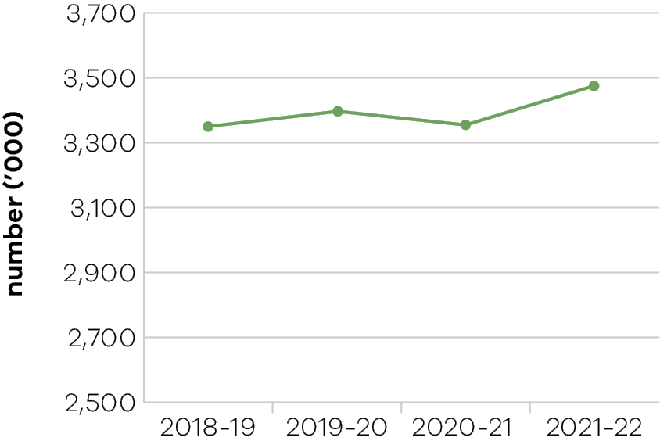
In 2021-22, the department nominated 4250 migrants employed in Victoria to remain in the state on a skilled visa. This includes more than 2100 filling crucial workforce shortages in the health sector, more than 600 in the hospitality and early childhood teaching sectors, and more than 1500 others in the advanced manufacturing, agri-food, digital and new energy and emissions reduction sectors. The department assisted overseas qualified professionals to gain employment in Victoria by assessing more than 1300 overseas qualifications. The department also nominated more than 250 business and investor migrants to start job creating businesses and invest in Victorian venture capital to support Victorian employers access start-up funding.
The Digital Jobs Program facilitated more than 500 paid work placements during the 2021-22 financial year with Victorian employers across a range of industries. Seventy-two per cent of placements in the first round were new positions created for the program, representing genuine job creation.
The department secured a number of investments by businesses to Victoria through its attraction and facilitation activities. The investments were largely secured with grants from Victorian Jobs and Investment Fund streams and related investment attraction programs. The projects are of various scales supporting medium to large businesses to accelerate their growth trajectory. All are designed at securing and growing key industry capabilities to drive ongoing economic growth and job creation. These projects will support delivery of more than 3300 jobs to the Victorian economy as they are implemented.
The Local Jobs First policy continues to support local businesses and workers to compete for work on government contracts. In 2021-22, the government set new local content requirements under the policy for 55 Strategic Projects, with a combined value of over $19.6 billion. Since 2014, Local Jobs First Strategic Projects have supported over 45,000 local jobs. The department has formal reporting obligations in relation to the Local Jobs First policy which are available in Appendix 6.
Since launching in 2016, the Major Projects Skills Guarantee (MPSG) has applied to 265 projects worth over $117.4 billion. In the 12 months to March 2022, opportunities for apprentices, trainees and cadets under the MPSG grew, with an additional 2340 positions supported in this period.

Jobs Victoria
Since Jobs Victoria was established in October 2016, it has supported more than 46,000 people into a job through its services, most of whom were long-term unemployed or at risk of long-term unemployment.
The Victorian Government’s $619.4 million Jobs for Victoria package, announced in the 2020-21 Budget, tripled government investment in employment services to support workers and businesses impacted by the pandemic. Through this investment, Jobs Victoria has evolved from a small program into a digitally enabled employment system that supports jobseekers back to work and helps businesses connect with the workers they need.
Between July 2021 and June 2022, almost 100,000 Victorians received advice and support from Jobs Victoria’s network of mentors, careers counsellors, and advocates. Almost half of all people accessing mentors services have been supported into a job.
Victoria’s economy and labour market have been volatile, particularly since 2021. Strong recent economic recovery has resulted in tight labour market conditions, exacerbating skills shortages across occupations and regions. Despite low unemployment, structural challenges remain for certain cohorts.
Jobs Victoria has adapted employment services to enable continuity throughout lockdowns and to address the emerging needs of jobseekers and employers.

Performance against output performance measures
Table 2 represents performance against the Jobs output. This output includes initiatives to support existing workers and businesses by connecting Victorians experiencing disadvantage to job opportunities, supporting Aboriginal economic inclusion, working with the community to create and support social enterprises; as well as attracting new investment and talent into Victoria to grow the economy and share the benefits of economic prosperity.

Table 2: Output – Jobs
Performance measures | Unit of measure | 2021-22 actual | 2021-22 target | Performance variation (%) | Result
Quantity
Disadvantaged jobseekers who achieve sustainable employment (minimum number of 26 weeks) with the support of Jobs Victoria Services | number | 2,505 | 4,000 | -37.4% | #
Lower result due to the impacts of COVID-19 and extended state health restrictions throughout 2021 as delivery of face-to-face services was restricted, and many employers paused recruitment activities in 2021.
Disadvantaged jobseekers who gain employment  with the support of Jobs Victoria Services | number | 13,416 | 12,500 | 7.3% | *
Higher result due to economic recovery in 2022 resulting in high levels of employer demand for workers during this period.
Firms assisted from industry growth programs | number | 134 | 100 | 34.0% | *
Higher result due to the introduction of new sector specific funding streams of the Victorian Jobs and Investment Fund (VJIF) and accelerated assistance to companies driven by recovering business investment activity.
Government Youth Employment Scheme  traineeships commenced | number | 174 | 280 | -37.9% | #
Lower result due to the impacts of COVID-19 and extended state health restrictions throughout 2021.
Industry stakeholders engaged with the Local  Jobs First Policy | number | 798 | 600 | 33.0% | *
Higher result due to increased volume of projects applying Local Jobs First and higher numbers of bidders responding to tenders.
Jobs created from industry growth programs | number | 3,317 | 1,250 | 165.4% | *
Higher result due to accelerated assistance to companies driven by increased business investment activity as the economy recovers from COVID-19.
Jobs Victoria Services (Advocates, Mentors, Careers Counsellors) delivered to Victorian jobseekers | number | 118,582 | 70,000 | 69.4% | *
Higher result as new services scaled up to full capacity in 2021 and experienced strong demand for employment services from jobseekers.
Migrant talent nominated for the Skilled,  Investor and Business Migration Program | number | 4,509 | 2,000 | 125.5% | *
Higher result due to the Australian border re-opening in February 2022 to all fully vaccinated visa holders. These changes together with increased demand for skilled migration enabled the department to nominate more migrants than anticipated.
Proportion of disadvantaged jobseekers who achieve sustainable employment (minimum number of 26 weeks) with the support of Jobs Victoria Services | per cent | 42 | 50 | -16.0% | #
Lower result due to the impacts of COVID-19 and extended state health restrictions throughout 2021.
Proportion of Jobs Victoria Fund allocated to women | per cent | 59 | 60 | -1.7% | –
Retrenched workers supported with  employment assistance | number | 2,053 | 2,000 | 2.7% | *
Subsidised jobs for jobseekers through the Jobs Victoria Fund | number | 4,249 | 4,000 | 6.2% | *
Higher result due to high demand for workers and wage subsidies from employers.
Quality
Client satisfaction with investor, business  and skilled migration services provided | per cent | 88 | 85 | 3.5% | *
Jobseeker satisfaction with Jobs Victoria Services | per cent | 82 | 70 | 17.1% | *
Higher result as participants across a range of Jobs Victoria services were surveyed, and the reception to those services was better than anticipated.
Timeliness
Average processing time for investor, business and skilled migration visa nomination applications | days | 16.5 | 20 | 17.5% | *
Higher result due to reprioritisation of resources to increase capacity for assessment of skilled visa nomination applications to assist Victorian employers address skill shortages.
Cost
Total output cost | $ million | 743.4 | 310.0 | 139.8% | #
The 2021-22 result was higher than the 2021-22 budget mainly due to additional funding received for Test Isolation Payments and Pandemic Leave Disaster Payments.
Note:
* Performance target achieved or exceeded
– Performance target not achieved – within 5 per cent variance
# Performance target not achieved – exceeds 5 per cent variance

Objective 2: Foster a competitive business environment
This objective seeks to grow Victorian industries and businesses by working with priority industry sectors, supporting growth and innovation opportunities for industry, supporting startups and small businesses, and assisting industries in transition.

Progress towards achieving this objective
In 2021-22, the department reported progress against this objective using the following objective indicators and outputs:

Objective Indicators
- Change in Victoria’s real gross state product
- Engagement with businesses

Outputs
- Industry, Innovation, Medical Researchand Small Business
- Industry, Innovation and Small Business
- Medical Research

Indicator: Change in Victoria’s real gross state product

Table 3: Change in Victoria’s real gross state product
Measure (unit of measure) | 2018-19 | 2019-20* | 2020-21 | 2021-22
Change in Victoria’s real gross state product  (per cent) | 3 | 0.1 | -0.4 | N/A**
*This is the latest available data. Changes to the inputs used to produce this data have resulted in revised historical estimates that should not be compared to previously published results.
** Data unavailable at time of writing.

Figure 2: Change in Victoria’s real gross state product
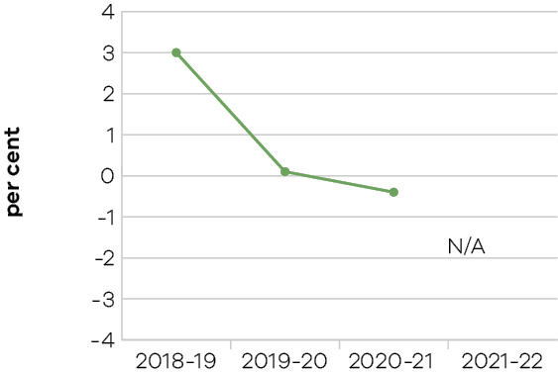
Following steady growth over the past decade, Victoria’s real gross state product (GSP) fell by 0.4 per cent in 2020-21 as economic activity was impacted by COVID-19. The largest contractions were recorded in the construction (-4.6 per cent), administrative and support services (-9.0 per cent), and transport, postal and warehousing (-8.7 per cent) industries.
These falls were offset by strong growth in the agriculture, forestry and fishing (18.6 per cent) industries, driven by increased grain, fruit, nut, vegetables and dairy production. Strong growth was also observed in the health care and social assistance (4.0 per cent), and public administration and safety (4.7 per cent) industries due to increased resourcing in response to managing the COVID-19 pandemic.

Indicator: Engagement with businesses

Table 4: Engagement with business
Measure (unit of measure) | 2018-19 | 2019-20 | 2020-21 | 2021-22
Engagements with businesses (number) | 14,630 | 12,344 | 14,772 | 15,142

Figure 3: Engagements with businesses
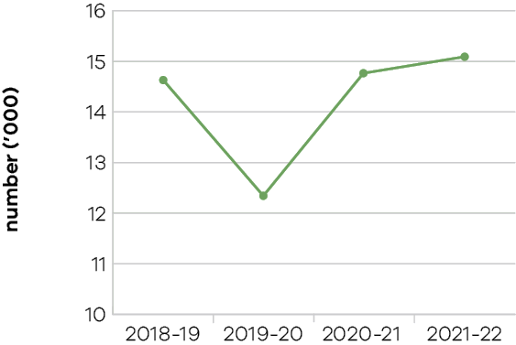
In 2021-22, the department recorded over 15,000 engagements with businesses through meetings, phone calls, and involvement in business assistance programs. These engagements reflect a range of activities and services across the department. They range from small businesses to large employers across metropolitan and regional Victoria, in areas such as investment, trade, employment and skills, agriculture, digital and ICT, creative industries and tourism.
In addition to these engagements through core service delivery, a high volume of COVID-19 related engagement was undertaken to support businesses and industries impacted by restricted operations during this period. The funded programs and resourcing that were specifically directed during this period were one-off in nature.
The department offered 400 live and on-demand sessions supporting 20,000 Victorians to upskill, connect and share knowledge as part of Victoria’s annual Digital Innovation Festival. Other events and conferences supported by the department further stimulated the digital economy, such as the Australian Information Industry Association iAwards, Advancing Analytics Conference, Connecting Up Conference, Australian Technologies Competition, Australian Computer Society industry development and engagement events, the Women in Artificial Intelligence Awards and the Tech Diversity Awards.
The department continued to deliver information, training, mentoring, grant programs and other services, such as bushfire recovery and mental health and wellbeing supports. The Business Victoria website and other digital channels have been instrumental in providing accurate and timely information to Victorian businesses, along with the Business Victoria newsletter which reached more than 142,000 subscribers by June 2022.
The department also supported fostering a competitive business environment by improving digital connectivity across the state. This included announcing new mobile and broadband infrastructure improvements though the Connecting Victoria program as well as delivering 11 new mobile base stations in 2021-22.
In building an end-to-end mRNA capability in Victoria, the state is developing a new leading innovation industry in medical research and biotech.
The achievements to date by mRNA Victoria include:
- reached an agreement to establish a Moderna mRNA commercial manufacturing facility in Victoria, Moderna’s Asia Pacific Headquarters and regional research centre
- secured investments from a number of leading international biotech companies, including US-based international biotech companies, InterVenn Biosciences and Ginkgo Bioworks (the world’s largest synthetic bio company)
- provided financial support to Victorian biotech companies and medical research institutes, building an end-to-end mRNA ecosystem for Australia and the Asia-Pacific region
- entered into collaborative partnerships with the UAE and Korea to progress collaboration on mRNA vaccine research and development, clinical trials, and manufacturing
- provided research grants to 15 projects including Australia’s first COVID-19 mRNA vaccine candidate.

Performance against output performance measures
Table 5 represents performance against the Industry, Innovation, Medical Research and Small Business output. This output provides access to information and connections and builds the capability of Victorian businesses and industry to develop and effectively use new practices and technologies to increase productivity and competitiveness, advocating for a fair and competitive business environment, and supporting small businesses.

Table 5: Output – Industry, Innovation, Medical Research and Small Business
Performance measures | Unit of measure | 2021-22 actual | 2021-22 target | Performance variation (%) | Result
Industry, Innovation and Small Business
This sub-output supports Victorian businesses, from global enterprises to small, medium and startup businesses,
to grow, create more job opportunities, lead innovation, promote digital connectivity and develop strategic industries. This is achieved by facilitating new investments, investing in digital connectivity, developing and attracting world-class talent, enhancing industry capability to build on the State’s reputation for innovation and encouraging a competitive and fair business environment and a strong, diversified economy.
Quantity
Businesses whose growth and productivity issues  are resolved by the Department | number | 1,289 | 1,200 | 7.4% | *
Higher result due to an increased number of companies receiving payments through programs that support growth and productivity.
Companies or new entrants supported through  the LaunchVic initiative | number | 133 | 127 | 4.7% | *
Engagements with businesses | number | 15,142 | 14,000 | 8.2% | *
Higher result due to increased levels of engagement on Jobs Victoria programs.
Individuals supported under digital skills initiatives | number | 2,213 | 2,000 | 10.7% | *
Higher result reflects additional places offered in the program in 2021-22 due to industry facing critical digital skills shortages and applications for the program being higher than expected.
Industry roundtables and engagement forums | number | 86 | 25 | 244.0% | *
Higher result reflects an increased number of industry forums and engagements as the department and businesses worked collaboratively on recovery activities.
Locations to receive broadband infrastructure upgrades | number | 66 | 65 | 1.5% | *
New mobile base stations facilitated | number | 11 | 20 | -45.0% | #
Lower result due to rollout schedule delays, which are managed by the mobile carriers. Delays are attributable to third-party dependencies and localised and global impacts of COVID-19. Sites not completed in 2021-22 are expected to contribute to the 2022-23 result.
Participation in Small Business Victoria events  and access to business programs | number | 21,579 | 20,000 | 7.9% | *
Higher result due to strong demand driven by COVID-19 business needs and increased advertising, which helped to strengthen participation by highlighting the versatility, flexibility and variety of events and program options available to business owners, including both face-to-face and online options.
Visits to Business Victoria digital channels | number | 9,491,418 | 4,000,000 | 137.3% | *
Higher result as businesses sought critical information on COVID-19 including grants, programs and support services.
Quantity
Client satisfaction of small business information, referral, coaching service and business programs | per cent | 95.25 | 90 | 5.8% | *
Higher result due to surge resourcing and provision of customised services, which ensured a higher level of responsiveness to better meet business demand.
Client satisfaction with the Victorian Government Business Offices | per cent | 77.11 | 80 | -3.6% | –
Client satisfaction with Victorian Small Business Commission mediation service | per cent | 87.6 | 85 | 3.1% | *
Proportion of business disputes presented to  the Victorian Small Business Commission successfully mediated | per cent | 69 | 75 | -8.0% | #
Lower result due to the impacts of COVID-19 increasing the volume and complexity of disputes requiring Victorian Small Business Commission (VSBC) mediation and the higher proportion of less complex disputes settled at the pre-mediation phase.
Proportion of business disputes resolved by the Victorian Small Business Commission prior to mediation | per cent | 43.2 | 30 | 44.0% | *
Higher result due to the high number of Commercial Tenancy Relief Scheme disputes resolved prior to mediation due to the clarity provided by the Scheme and surge resources employed by the VSBC to enable early resolution.
Cost
Total output cost | $ million | 7,431.6 | 187.6 | 3813.4% | #
The 2021-22 result was higher than the 2021-22 budget mainly due to additional support for Victorian businesses and industries in response to the COVID-19 pandemic.
Medical Research
This sub-output supports maintaining Victoria’s position as a leader in health and medical research, while protecting and growing jobs in the sector by funding visionary research through providing critical infrastructure to flagship projects and research institutes and strengthening commercialisation.
Quantity
Operational infrastructure supports grants under management | number | 12 | 12 | 0.0% | *
Projects supported through building and scaling up messenger Ribonucleic Acid Vaccine (mRNA) manufacturing capability in Victoria | number | 18 | 5 | 260.0% | *
Higher result due to the delivery of successful investment attraction outcomes and two competitive research grant programs, including the successful development of Australia’s first COVID-19 mRNA vaccine candidate by the Doherty Institute and Monash University.
Victorian families participating in the  Generation Victoria study | number | 20,000 | 56,000 | -64.3% | #
Lower result due to COVID-19 related restrictions in the first half of the financial year impacting GenV’s ability to recruit state-wide as originally planned.
Cost
Total output cost | $ million | 94.5 | 63.6 | 48.6% | #
The 2021-22 result was higher than the 2021-22 budget mainly due to additional funding for medical research initiatives.
Note:
* Performance target achieved or exceeded
– Performance target not achieved – within 5 per cent variance
# Performance target not achieved – exceeds 5 per cent variance

Objective 3: Be a globally connected economy
This objective seeks to connect Victoria to the world by helping Victorian businesses successfully trade into global markets, and growing Victoria’s proportion of international student enrolments
in Australia.

Progress towards achieving this objective
In 2021-22, the department reported progress against this objective using the following objective indicators and outputs:

Objective Indicators
- Export sales generated from government programs
- Victoria’s share of international student enrolments

Outputs
- Trade and Global Engagement

Indicator: Export sales generated from government programs

Table 6: Export sales generated from government programs
Measure (unit of measure) | 2018-19 | 2019-20 | 2020-21 | 2021-22
Actual export sales generated as a result  of participation in government programs  ($ million) | 668 | 709 | 569 | 627

Figure 4: Export sales generated from government programs
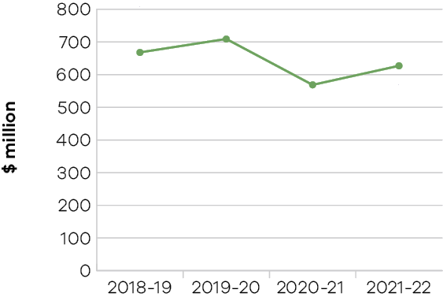
In 2021-22, the department supported $627 million of actual export sales. The result was driven by ongoing activities to ensure Victorian businesses remained engaged in export markets and to strengthen international business connections with the easing of border and travel restrictions.
Trade has been significantly disrupted by the COVID-19 pandemic and prolonged Australian travel and border restrictions. Ongoing challenges of supply chain disruptions and tightening of freight channels to export markets have profoundly impacted Victoria’s exporters and continue to have lasting effects on businesses. These effects have increased the desire for businesses to engage with the government to support them in their international business endeavours.
The department experienced strong demand and uptake for export programs delivered during 2021-22 and businesses continued to benefit from the government investment in the Export Recovery Package in 2020-21. The department delivered initiatives such as the Global Victoria Trade Alliance in collaboration with over 25 partners, including international chambers of commerce, peak industry bodies and business associations, to extend the department’s reach and deliver more activities to more businesses. The department also delivered in-market promotional campaigns to strengthen connections for Victorian businesses and provided further support through investment in agriculture export development programs. These initiatives have resulted in over 3700 Victorian businesses participating in export programs and other key initiatives.
The department also supported businesses in international markets through the 23 Victorian Government Trade and Investment network offices, including Melbourne headquarters. The network provided tailored support to assist firms in realising and capturing export sales with renewed interest in new business opportunities emerging from traditional export markets post-pandemic.

Indicator: Victoria’s share of international student enrolments

Table 7: Victoria’s proportion of international student enrolments in Australia
Measure (unit of measure) | 2018-19 | 2019-20 | 2020-21 | 2021-22
Victoria’s proportion of all international student  enrolments in Australia  (per cent) | 32.1 | 32.3 | 32.2 | 31.7
Note: Financial year data on international student enrolments is not available. Figures in the table are calendar year data reflecting the academic year and capturing peaks and troughs of enrolment periods. Data includes student visa holders enrolled onshore and offshore.

Figure 5: Victoria’s proportion of international student enrolments in Australia
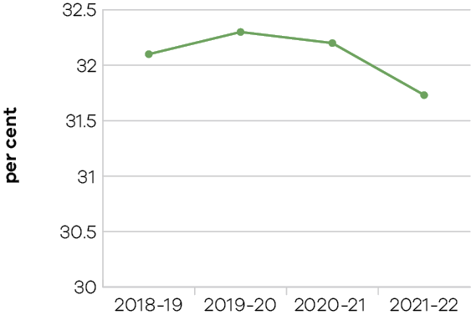
Victoria’s national market share of international students remained strong in 2021, at 31.7 per cent, down from 32.2 per cent in 2020. This result reflects the broad impact of Australia’s closed international borders on all states and territories. New South Wales also remained steady at 38.2 per cent (no annual change). Queensland showed the largest market share loss at 13.9 per cent (down from 14.6 per cent).
The international education sector has been significantly impacted by the COVID-19 pandemic and prolonged Australian border closures. While international education remained Victoria’s largest services export in 2020 (latest state-level ABS data available), education exports decreased by 23 per cent to $10.5 billion – down from a record high $13.7 billion in 2019. This has had flow-on effects for the wider Victorian economy given the sector’s critical role as an enabler of talent attraction, innovation and economic growth.
The 2021 academic year saw an annual decline in commencements and enrolments across all education sub-sectors and key markets. This data includes student visa holders located onshore and offshore. In 2021, there were around 227,200 international student enrolments with Victorian providers. This represents a decline of 20 per cent on 2020 (around 282,600 enrolments) and a 26 per cent decrease on 2019 figures (around 307,200 enrolments).
This downward trend was even starker with international student commencements (enrolments beginning in a new course or new provider). In 2021, there were around 86,600 international student commencements with Victorian providers – a decline of 30 per cent on 2020 (around 123,000 commencements) and a 46 per cent decrease on 2019 figures (around 160,900 commencements).
Since Australia’s borders opened to fully vaccinated international students on 15 December 2021, Victoria’s international education sector has stabilised. However, relative to the broader economy, the recovery trajectory is anticipated to be slow as multiple missed international student intakes require years to flow through the system.
The Victorian Government is developing a new international education recovery plan, which outlines how the government will support recovery of Victoria’s international education sector to 2025. The plan will build on the government’s International Education Short-Term Recovery Plan 2020/21, which delivered a suite of initiatives to stabilise the sector.
Since 2020, the Victorian Government has committed over $180 million in support for Victoria’s international education sector and its students. This includes expanding Victoria’s international presence and sector support through the Global Education Network, offshore Study Melbourne Hubs, International Research Partnerships Program, and International Education Resilience Fund. While expanding Study Melbourne’s global reach, the government has continued to attract and support students back onshore, including through Study Melbourne international marketing campaigns, the Pathway to Victoria Scholarships Program, and the suite of student support and empowerment programs delivered by Study Melbourne across Victoria.
These initiatives showcase why Melbourne has been named Australia’s best student city and among the world’s best for the eighth consecutive year – a position maintained despite the pandemic (QS Best Student Cities 2023).

Performance against output performance measures
Table 8 represents performance against the Trade and Global Engagement output. This output promotes business growth opportunities by connecting organisations to global business opportunities in priority markets and supporting the establishment and deepening of strategic commercial partnerships. It also positions Victoria as a destination of choice for international students.

Table 8: Output – Trade and Global Engagement
Performance measures | Unit of measure | 2021-22 actual | 2021-22 target | Performance variation (%) | Result
Quantity
Actual export sales generated as a result  of participation in government programs | $ million | 627 | 550 | 14.0% | *
Higher result due to a number of ongoing trade facilitation projects being realised in the financial year. Stimulus support programs during the COVID-19 pandemic including the Export Recovery Plan also performed better than anticipated.
Clients engaged in export and trade programs | number | 3,706 | 2,000 | 85.3% | *
Higher result due to the strong interest in government support initiatives for exporters, particularly for in-market engagement initiatives as exporters re-engage in export markets and driven by stimulus funding provided under the Export Recovery Plan during the COVID-19 pandemic.
Number of Victorian companies assisted  by Wine Industry initiatives | number | 65 | 60 | 8.3% | *
Higher result due to the interest in new market engagement opportunities and initiatives for wineries.
Significant interactions with Victorian agri-food companies and exporters, international customers  and trading partners that facilitate export and investment outcomes for Victoria | number | 312 | 250 | 24.8% | *
Higher result due to the level of interest in market engagement activities for agribusiness companies.
Victoria’s proportion of all international student enrolments in Australia | per cent | 31.7 | 30 | 5.7% | *
Higher result as Victoria has maintained a strong national market share, despite the impacts of COVID-19 on the international education sector and overall international student enrolments declining.
Visits to the Global Victoria website | number | 137,004 | 100,000 | 37.0% | *
Higher result due to continued interest levels in government support and events for exporters as well as the ongoing delivery of online and virtual activities by Global Victoria.
Quality
Client satisfaction with export assistance offered | per cent | 92 | 90 | 2.2% | *
International student satisfaction with  Study Melbourne student programs | per cent | 94 | 75 | 25.3% | *
Higher result reflects better-than-anticipated satisfaction survey results.
Cost
Total output cost | $ million | 88.7 | 39.2 | 126.3% | #
The 2021-22 result was higher than the 2021-22 budget mainly due to additional funding received for the International Education Resilience Fund.
Note:
* Performance target achieved or exceeded
– Performance target not achieved – within 5 per cent variance
# Performance target not achieved – exceeds 5 per cent variance

Objective 4: Build prosperous and liveable regions and precincts
This objective seeks to ensure that Victoria’s precincts, suburbs and regions are developed to create places where all Victorians have an opportunity to participate in communities that are well-connected, prosperous, vibrant and diverse.

Progress towards achieving this objective
In 2021-22, the department reported progress against this objective using the following objective indicators and outputs:

Objective Indicators
- Precincts developed and delivered
- Community satisfaction in public places
- Community satisfaction with the performance of councils as measured through the Local Government Community Satisfaction Survey

Outputs
- Business Precincts
- Local Government and Suburban Development
- Regional Development

Indicator: Precincts developed and delivered
Through its whole of government oversight in Business Precincts, the department delivered on the identification of, planning for and development in key areas of opportunity. This established a long-term focus on precincts and their importance to Victoria’s economic performance, as well as the future liveability of our urban centres.
The department supported the Werribee, Monash and La Trobe National Employment and Innovation Clusters (NEICs). Further specific activities to develop and deliver business precincts are described below.

Footscray
The department engaged with key stakeholders to plan for development of the precinct to leverage the Victorian Government’s unparalleled investment in education, health, sporting facilities and transport infrastructure in Footscray and Melbourne’s inner west.
The department prepared the Footscray Opportunity and Directions Paper which was released in December 2021, outlining opportunities to guide future investment. Business Precincts is leading the development of a Footscray Roadmap.

Parkville
The department successfully conducted discussions across government to support Parkville to become a global top ten biomedical precinct, and a driver of healthcare advances, economic growth and job creation for Victoria.
The department finalised the partner funding agreement for the Australian Institute for Infectious Disease. This will lead the fight against future pandemics in partnership with the University of Melbourne, Doherty Institute and the Burnet Institute.
The department commenced development of a Precinct Opportunity Statement.

Docklands
The department continued plans to enhance Docklands Studios Melbourne’s capacity to secure and service high value local and international screen productions.
Considerable progress has been made on delivering on the State’s $225 million commitment towards the redevelopment of Marvel Stadium. Early works are complete, and main works are underway with completion scheduled for 2023. The project will enhance Victoria’s major stadia infrastructure and better position Melbourne to host domestic and world-class sporting and entertainment events over the next 30 years.

Fishermans Bend
The department entered into a funding agreement with Development Victoria for the delivery of Stage One of the Fishermans Bend Innovation Precinct, to transform the 32-hectare former General Motors Holden (GMH) site to an innovation precinct focused on advanced manufacturing, engineering and design. Stage One works will include delivery of site remediation, civil and civic infrastructure and key roads, including access to the University of Melbourne’s campus.
The department facilitated 17 significant property developments in Fishermans Bend in partnership with the Department of Environment, Land, Water and Planning (DELWP) – with a total development value of $2.2 billion, totalling 155,000 sqm of employment floor space (providing for approximately 5000 permanent jobs) and
3900 new dwellings (including 200 social and affordable housing dwellings).
The department released the Advancing Manufacturing – the Fishermans Bend Opportunity and the Water Sensitive City Strategy (in partnership with DELWP, Melbourne Water, South East Water, City of Melbourne, City of Port Phillip, Water Sensitive Cities Australia and the Office of the Victorian Government Architect).
The department commenced delivering the $4.7 million Gateway to GMH project in partnership with the City of Melbourne.

Indicator: Community satisfaction in public places

Table 9: Community satisfaction in public places
Measure (unit of measure) | 2018-19 | 2019-20 | 2020-21 | 2021-22
Appearance of public areas  (per cent) | 72 | 72 | 73 | 71
Community consultation and engagement  (per cent) | 56 | 55 | 56 | 54
Planning for population growth in the area  (per cent) | 52 | 51 | 53 | 52

Figure 6: Appearance of public areas
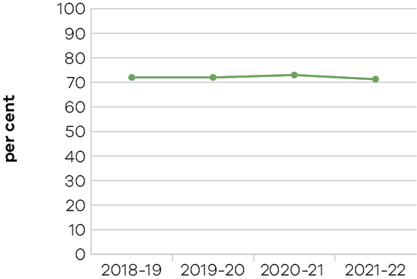

Figure 7: Community consultation and engagement
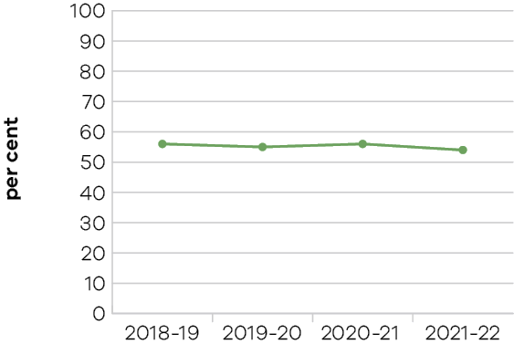

Figure 8: Planning for population growth in the area
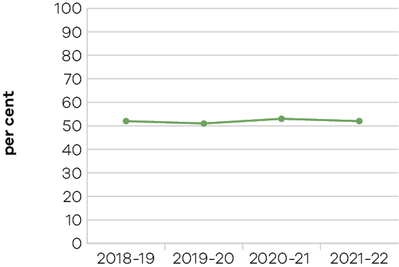
Community satisfaction with the appearance of public areas as well as community consultation and engagement declined in 2021-22. While planning for population growth remained stable over the four-year period, the community satisfaction with this measure declined in 2021-22, reverting back to its 2018-19 level.

Indicator: Community satisfaction with performance of councils measured through the Local Government Community Satisfaction Survey

Table 10: Community satisfaction with performance of councils
Measure (unit of measure) | 2018-19 | 2019-20 | 2020-21 | 2021-22
Satisfaction with overall council performance  in the last 12 months  (per cent) | 60 | 58 | 61 | 59
Satisfaction with council decisions made  in the interest of the community  (per cent) | 55 | 53 | 56 | 54
Satisfaction with value for money in services  and infrastructure provided by council  (per cent) | N/A | N/A | 54 | 53

Figure 9: Satisfaction with overall council performance in the last 12 months

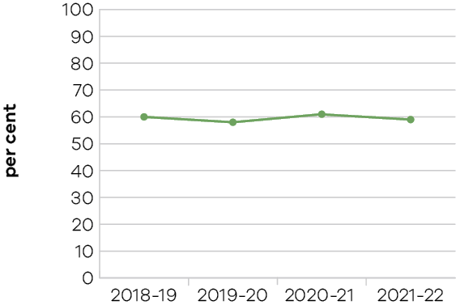
Figure 10: Satisfaction with council decisions made in the interest of the community
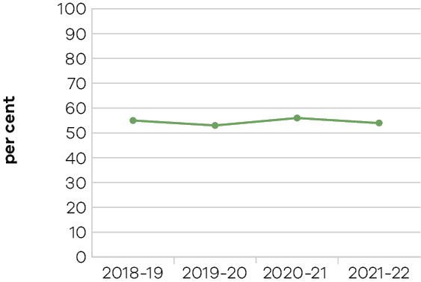

Figure 11: Satisfaction with value for money in services and infrastructure provided by council
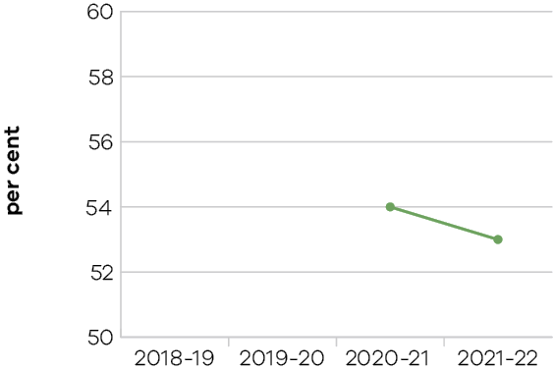
Overall, satisfaction with councils’ overall performance and service delivery decreased in 2021-22. Specifically, satisfaction with councils’ overall performance dropped two points this year to 59 per cent, down from 61 per cent in 2021.
Performance of the metropolitan council group continues to rate significantly higher than the state-wide average, while regional centre councils are on par with the state-wide average. Interface and small and large rural council groups continue to rate lower than the state-wide average.
The 2022 survey saw a decline in performance across most service areas, with 26 of 28 service areas recording a decrease in performance satisfaction from 2021.
The top performing individual service areas were arts and libraries and appearance of public areas. In contrast, unsealed roads, slashing and weed control, and planning and building permits were the lowest performing service areas.

Suburban Revitalisation
In 2021-22, the Suburban Revitalisation program supported eight Suburban Revitalisation Boards. The Suburban Revitalisation Boards were chaired by members of Parliament, with representatives from local government, businesses, community organisations, and other institutions. There was $13.7 million invested in Suburban Revitalisation projects in Boronia, Lilydale, Melton, Noble Park, Reservoir, Tarneit, Frankston, and Broadmeadows. These projects delivered on local priorities to improve liveability, as well as economic and social outcomes. Since the COVID-19 pandemic began, more than $32 million has been invested in 187 Suburban Revitalisation projects with a combined value exceeding $88 million.
In addition, the Suburban Revitalisation program delivered activities in another 40 locations across Melbourne including in Thomastown, Lalor, Springvale and Altona. The program also piloted three 20-Minute Neighbourhood sites in Strathmore, Sunshine West and Croydon South.

Metropolitan Partnerships
The department continued to support the six Metropolitan Partnerships to engage with regional and local communities and advise the government on community priorities. These drove action through placed-based pilots and projects to test new approaches and develop solutions to local challenges.
During 2021-22, the Metropolitan Partnerships engaged 1872 people across 54 engagement activities on regional priorities including addressing loneliness and improving social connection, transport, mental wellbeing, employment and skills, business resilience and local living.
In addition, the Metropolitan Partnerships supported 16 projects from round 3 of the Metropolitan Partnership Development Fund, valued at $1.75 million. It committed a further 12 projects in round 4 valued at $3 million, to drive local action and assist social and economic outcomes in local communities.
The department supported the Metropolitan Development Advisory Panel to provide strategic advice to the government to assist Melbourne’s recovery from the COVID-19 pandemic and ongoing metropolitan development.

Regional Development
In 2021-22 the Victorian Government, through the department, worked to ensure that Victoria’s rural and regional communities were enabled and shared in the benefits of the state’s economic growth, and were supported during the COVID-19 pandemic.
COVID-19 continued to bring significant challenges to rural and regional Victoria, including impacts on tourism, export sales and investment that are still being felt. Significant effort has gone into addressing these impacts, through a variety of programs and initiatives.
Despite challenges caused by COVID-19, the majority of performance measures for the Regional Development output exceeded targets for 2021-22. The department achieved the following outcomes:
- generated $136 million of export sales against a target of $110 million
- supported 297 economic and service delivery projects in rural and regional Victoria against a target of 175
- facilitated the creation of 2427 new jobs against a target of 1770
- secured $1410 million of new investments against a target of $1400 million.
The department fell slightly short (by 5.6 per cent) of its target for participant satisfaction with the implementation of regional development programs. Applicants reported high levels of satisfaction with the accessibility and clarity of information about the grant program, the level of support they received to develop applications and the extent to which they were kept informed of progress. Notwithstanding, lower levels of satisfaction were related to the time taken to receive decisions on applications. This lower result reflects administrative changes to the program introduced in 2021‑22 to ensure appropriate rigour in approvals and decision‑making, which led to some delays while changes were incorporated into practice.
In 2021-22, the department continued to support delivery of projects through the Regional Jobs and Infrastructure Fund (RJIF), with 56 projects supported through the RJIF. This included:
- nineteen projects supported through the Regional Jobs Fund
- thirteen projects supported through the Regional Infrastructure Fund
- twenty-four projects supported through the Investment Fast-Track Fund.
Additionally, the department supported 77 Visitor Economy Recovery and Reform Plan projects, 32 Regional Industry Groups and Chambers of Commerce Program projects, 13 Regional Partnerships projects, 72 Regional Community Events Fund projects, and 47 projects through various other funds and programs. In total, 297 projects were supported in 2021-22.
The department continued to support delivery of the Geelong City Deal, a 10-year plan to revitalise Geelong and unlock the potential of the Great Ocean Road economy. This will deliver approximately $500 million in government investment to the region, including the Geelong Convention and Exhibition Centre project, and is estimated to create up to 1000 jobs upon implementation of the projects under the City Deal.
In 2021-22, the department developed the Regional Economic Development Strategies, which utilise an evidence-based framework to identify strategies to drive growth and improve economic development in regional Victoria. The department also developed the Regional Workforce Pilots, which outline solutions for regional and rural communities experiencing high demand for skilled workers and increasing challenges in attracting them.

Performance against output performance measures
Table 11 represents performance against the Business Precincts output. This output delivers activities to build vibrant and prosperous precincts that drive economic growth and opportunities. The department works collaboratively with government, industry and community stakeholders to identify opportunities for the development and delivery of initiatives to strengthen our economy, create jobs and improve liveability for all Victorians.

Table 11: Output – Business Precincts
Performance measures | Unit of measure | 2021-22 actual | 2021-22 target | Performance variation (%) | Result
Quantity
Precincts in the design or delivery phase | number | 4 | 4 | 0.0% | *
Quality
Key stakeholders satisfied with the services provided in relation to precincts | per cent | 90 | 80 | 12.5% | *
Higher result due to proactive partnership relationships across government and external stakeholders, better communication with an increased focus on service delivery.
Timeliness
Delivery of financial obligations for departmental  Public Private Partnership projects in accordance  with contractual timelines | per cent | 85 | 85 | 0.0% | *
Cost
Total output cost | $ million | 40.6 | 16.6 | 144.6% | #
The 2021-22 result was higher than the 2021-22 budget mainly due to a funding realignment from capital funding to operating funding, in accordance with accounting standards.
Note
* Performance target achieved or exceeded
– Performance target not achieved – within 5 per cent variance
# Performance target not achieved – exceeds 5 per cent variance
Table 12 represents performance against the Local Government and Suburban Development output. This output delivers activities in partnership with the local government sector to support effective and efficient local governance, leadership, infrastructure and service provision. The department also works collaboratively to develop Melbourne’s suburbs through the Suburban Revitalisation Program and the six Metropolitan Partnerships and improve suburban liveability. Through this output, the department administers programs to support local governments to increase accountability and provide support to the Victorian Local Government Grants Commission.

Table 12: Output – Local Government and Suburban Development
Performance measures | Unit of measure | 2021-22 actual | 2021-22 target | Performance variation (%) | Result
Quantity
Attendance at public library community programs | number (000) | 805 | 2,263 | -64.4% | #
Lower result as attendance at public library programs was significantly impacted during 2021-22 by COVID-19 and restrictions on the operation of public library services.
Average number of monthly page views  on knowyourcouncil.vic.gov.au | number (000) | 146 | 160 | -8.8% | #
Lower result due to the conclusion of lockdowns in December 2021, as the number of monthly page views returned to pre-pandemic numbers. Pandemic related lockdowns saw an increase in traffic to the site and an elevated target for 2021-22.
Community Leadership Program training  places offered to women | number | 0 | 40 | -100.0% | #
Lower result reflects a change in the mode of delivery. In procuring the expertise of the Institute of Community Directors Australia to deliver the Women Leading Locally program, the department has re-scoped the delivery model to two cohorts of 60 women, rather than three cohorts of 40. The department is on track to offer 120 places in the Women Leading Locally program across 2022-23 and 2023-24.
Community meetings held with Metropolitan Partnerships | number | 18 | 18 | 0.0% | *
Councils with approved roadside weeds  and pests control plan | number | 56 | 56 | 0.0% | *
Meetings held annually with Victorian councils regarding the Victorian Local Government  Grants Commission financial assistance grants allocation model | number | 19 | 19 | 0.0% | *
Meetings held with Local Government  Mayoral Advisory Panel | number | 4 | 4 | 0.0% | *
Metropolitan Partnership Development  Fund projects completed | number | 8 | 7 | 14.3% | *
Higher result as one project was completed ahead of schedule.
Number of visitors to Metropolitan Public Libraries | number (million) | 8.0 | 18.8 | -57.4% | #
Lower result as visitation to libraries was significantly impacted during 2021-22 by COVID-19 and restrictions on the operation of public library services.
Number of visitors to Regional Libraries | number (million) | 3.1 | 12 | -74.2% | #
Lower result as visitation to libraries was significantly impacted during 2021-22 by COVID-19 and restrictions on the operation of public library services.
Projects in the planning or delivery phase to support and facilitate the revitalisation of Broadmeadows  and Frankston | number | 32 | 6 | 433.3% | *
Higher result than originally planned due to additional funding provided as part of COVID-19 recovery (15 in Frankston, and 17 in Broadmeadows).
Quality
Council satisfaction with the communication, support and advice received from Local Government Victoria in relation to the Local Government Performance Reporting Framework | per cent | 84 | 80 | 5.0% | *
Participants satisfied with their experience of Metropolitan Partnership community meetings | per cent | 85 | 80 | 6.3% | *
Higher results due to the quality of the community meetings delivered which has led to a higher satisfaction rate.
Submissions that fully meet the objectives within the Growing Suburbs Fund program guidelines | per cent | 78 | 80 | -2.5% | –
Timeliness
Average number of days for Municipal Emergency Resource Program grant payments to be made following completion of agreed milestones in the funding agreement | days | 21 | 21 | 0.0% | *
Average number of days for Public Library Services grant payments to be made following completion  of agreed milestones in the funding agreement | days | 21 | 21 | 0.0% | *
Projects completed in accordance with approved milestones within the Growing Suburbs Fund  funding agreements | per cent | 80 | 80 | 0.0% | *
Roadside Weeds and Pests program grant payments made within 21 days of completion of agreed milestones in the funding agreement | per cent | 100 | 100 | 0.0% | *
Victoria Local Government Grants Commission allocations finalised to support the completion  of council budgets within statutory timeframes | per cent | 100 | 100 | 0.0% | *
Cost
Total output cost | $ million | 217.9 | 145.4 | 49.9% | #
The 2021-22 result was higher than the 2021-22 budget mainly due to additional funding received for COVID-19 programs, including the COVIDSafe Outdoor Activation Program.
Note:
* Performance target achieved or exceeded
– Performance target not achieved – within 5 per cent variance
# Performance target not achieved – exceeds 5 per cent variance
Table 13 represents performance against the Regional Development output. This output guides engagement with industry and communities to identify opportunities to support job growth and new investment in regional Victoria, including support and services to grow regional jobs and capability in regional communities.

Table 13: Output – Regional Development
Performance measures | Unit of measure | 2021-22 actual | 2021-22 target | Performance variation (%) | Result
Quantity
Actual export sales generated for regional businesses as a result of participation in government programs | $ million | 136 | 110 | 23.6% | *
Higher result due to unexpectedly high export values, and the success of government programs in regional Victoria in supporting businesses to generate new exports.
Economic development and service delivery  projects supported | number | 297 | 175 | 69.7% | *
Higher volume of project delivery reflecting COVID-19 recovery initiatives and program design.
Jobs in regional Victoria resulting from government investment facilitation services and assistance | number | 2,427 | 1,770 | 37.1% | *
Higher result as a larger number of new jobs were created than anticipated. This has been difficult to predict given the impacts of COVID-19 on business conditions and performance.
New investment in regional Victoria resulting from government facilitation services and assistance | $ million | 1,410 | 1,400 | 0.7% | *
Quality
Participant satisfaction with implementation  of Regional Development Victoria programs | per cent | 85 | 90 | -5.6% | #
Lower result due to extended approval timelines as new arrangements were incorporated into administrative processes. RJIF project approval processes were changed in 2021-22 to ensure appropriate rigour in process and decision-making
Cost
Total output cost | $ million | 247.2 | 256.0 | -3.4% | *
Note:
* Performance target achieved or exceeded
– Performance target not achieved – within 5 per cent variance
# Performance target not achieved – exceeds 5 per cent variance

Objective 5: Grow vibrant, active and creative communities
This objective seeks to increase the economic, social and cultural value of the creative, sport and recreation industries to Victoria, grow the number and yield of visitors, position Victoria as a major events destination, and ensure the best cultural and sporting experiences are accessible to everyone.

Progress towards achieving this objective
In 2021-22, the department reported progress against this objective using the following objective indicators and outputs:

Objective Indicators
- Attendances at Creative Industries agencies and funded Major Performing Arts organisations
- Employment in the Creative Industries sector
- Employment in the Visitor Economy sector
- Tourists attracted to Victoria
- Increase rates of community engagement, including through participation in sport and recreation
- Wagering turnover on Victorian racing as a proportion of the national market

Outputs
- Creative Industries Access, Development and Innovation
- Creative Industries Portfolio Agencies
- Cultural Infrastructure and Facilities
- Sport, Recreation and Racing
- Tourism and Major Events

Indicator: Attendances at Creative Industries agencies and funded Major Performing Arts organisations

Table 14: Attendances at Creative Industries agencies
Measure (unit of measure) | 2018-19 | 2019-20 | 2020-21 | 2021-22
Attendances at creative industries portfolio agencies  (number (‘000)) | 12,786 | 9,417 | 2,646 | 4,934

Figure 12: Attendances at Creative Industries portfolio agencies
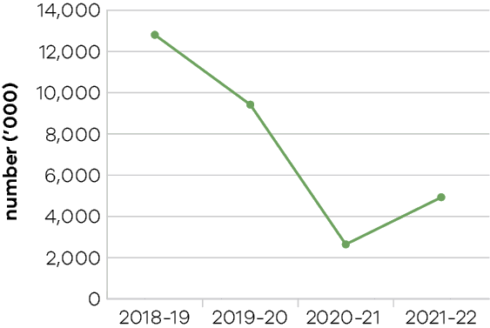
In 2021-22, Victoria’s state-owned arts and cultural institutions – Arts Centre Melbourne (ACM), Australian Centre for the Moving Image (ACMI), Geelong Arts Centre, Melbourne Recital Centre, Museums Victoria, National Gallery of Victoria (NGV), and State Library Victoria – were attended by approximately 4.9 million visitors, a reduction from record levels set prior to the pandemic. The decline in attendances was largely due to continuing COVID-19 related public health restrictions, resulting in extended closures and program cancellations. Examples of disruptions
for three agencies are:
- ACMI was closed for most of quarter one, 2021‑22, and reopened in October 2021.
- ACM’s indoor venues experienced closures for almost five months resulting in attendances
being only 14 per cent of target for the first half of the year.
- Museums Victoria venues closed for 68 (out of 92) days in quarter one due to COVID-19 and resulting restrictions that impacted visitation, including from school groups.
Despite the significant impact of restrictions, agencies continued to keep Victorians engaged, connected and entertained through a range of on-site programs, including:
- an array of music performances, festivals and other events hosted at the Sidney Myer Music Bowl, including concerts by Crowded House and Carols by Candlelight
- theatre crowds returning to the Arts Centre Melbourne in significant numbers, with successful productions including An American in Paris and The Picture of Dorian Gray
- NGV Exhibitions including:
- Queer – examined queer stories told through works of art spanning historical eras and diverse media
- Gabrielle Chanel: Fashion Manifesto – explored Chanel’s designs through a display of more than 100 garments
- The Melbourne Winter Masterpiece Exhibition, The Picasso Century exhibition that was exclusively developed for the NGV and featured over 80 works by Picasso – making its world premiere in Melbourne
- ACMI’s blockbuster exhibition Light: Works from Tate’s collection which celebrated the use of light across art history.

Table 15: Attendances at funded Major Performing Arts organisations
Measure (unit of measure) | 2018-19 | 2019-20 | 2020-21 | 2021-22
Attendances at funded Major Performing Arts organisations (number (‘000)) | 1,127 | 1,169 | 287 | 279

Figure 13: Attendances at funded Major Performing Arts organisations
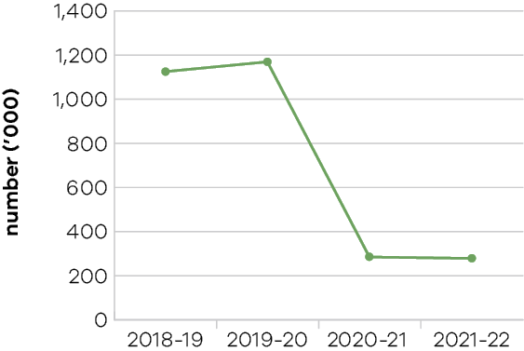
Funded major performing arts companies recorded reduced audiences in 2021-22 due to the COVID-19 pandemic. Many performances were either postponed or showed to reduced audiences particularly within the first few months of 2021-22. Disruption to programming and audience hesitancy also contributed to reduced attendances.
In 2021-22, $15.9 million was allocated to the Sustaining Creative Workers and Organisations initiative to sustain activity, including live performance support and market development funding for major performing arts companies.
Victorian Government funded major performing arts companies in 2021-22 were Ilbijerri Theatre Company, Back to Back Theatre, Melbourne Theatre Company, The Australian Ballet, Opera Australia, Orchestra Victoria, Melbourne Symphony Orchestra, Malthouse Theatre, Circus Oz and Victorian Opera.

Indicator: Employment in the Creative Industries sector

Table 16: Employment in the Creative Industries sector
Measure (unit of measure) | 2018-19 | 2019-20 | 2020-21 | 2021-22
Number of primary jobs in the creative industries  (number) | 289,000 | 292,000 | 304,000 | 309,000

Figure 14: Number of primary jobs in the creative industries
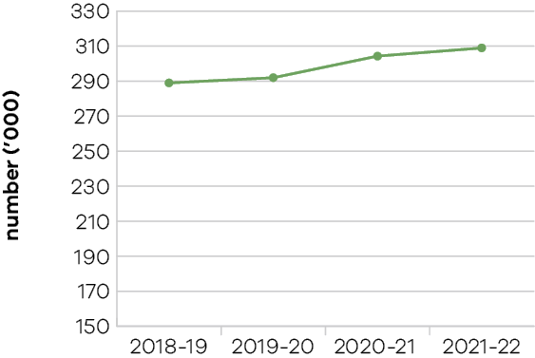
During 2021-22, an average of 309,000 people were employed in creative or cultural activities as their primary jobs, representing 8.8 per cent of total employment across Victoria.
Creative industry employment grew by 1.6 per cent, while the total Victorian employment increased by 4.6 per cent from 2019-20 to 2020-21. While the proportion of employment in the creative industries relative to overall Victorian employment decreased, several high value, physical screen productions commenced in 2021-22, which resulted in
better-than-expected growth in FTEs employed in that sector.
Following extensive consultation, Creative State 2025, the Victorian Government’s creative industries policy launched in July 2021. The strategy comprises 25 actions across five strategic priorities and is designed to support:
- More and better job opportunities and pathways
- Innovative creative products and experiences
- Industry stability and growth
- Equitable access to the creative industries, and
New audiences and markets.
This $288 million investment will create 60,000 project jobs across the creative industries in the next four years. This represents 40,000 project jobs in the screen industry and 20,000 project jobs in
the broader creative sector.
Over $500 million was provided by the Victorian Government in 2021-22 to support creative businesses and deliver a range of relief and rescue packages and initiatives supporting continued employment in the creative industries in Victoria. Initiatives included:
- over $300 million in business support grants for creative sector businesses to maintain operations
- tailored support for the live music industry, for example $10 million for the Live Music Venues and On the Road Again Metro programs, providing support for over 130 live music venues and creating more than 100 new live music events across Metro and Inner Metro Melbourne
$15.9 million for the Sustaining Creative Workers and Organisations program.
The Melbourne Arts Precinct Transformation achieved some key milestones, with the award of the winning design for The Fox: NGV Contemporary gallery, and the establishment of the Melbourne Arts Precinct Corporation to lead delivery of the project and take forward the recommendations of the Federation Square Review. The project also received an additional $241 million to bring the restoration of the State Theatre into the scope of the current delivery program, taking the State’s total investment to $1.7 billion.

Indicator: Employment in the Visitor Economy

Table 17: Employment in the Visitor Economy
Measure (unit of measure) | 2018-19 | 2019-20 | 2020-21* | 2021-22
Number of jobs in the visitor economy sector (number)* | 263,300 | 232,000 | 120,000 | Data expected in 2023
*This is the latest available data from the State Tourism Satellite Accounts 2020-21, produced by Tourism Research Australia, May 2022.

Figure 15: Number of jobs in the visitor economy sector
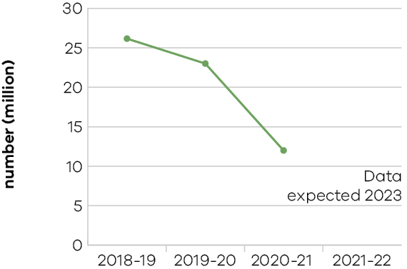
Tourism employment in Victoria declined in 2020-21, driven by the COVID-19 pandemic and associated health restrictions on both international and domestic travel.
The pandemic also caused ongoing structural workforce issues across large parts of the visitor economy sector, including workforce shortages and challenges attracting new and retaining existing workers. Many workers sought employment in more lucrative and secure industries during the pandemic and are not returning at the same rate as restrictions have progressively eased. Quarantine requirements contributed to acute workforce challenges, which caused some businesses to cease or limit operations.
Looking at the distribution of direct tourism jobs across Victorian industries in 2020-21, four main industries accounted for 79 per cent of jobs: cafes, restaurants and takeaway services (44 per cent), retail trade (15 per cent), accommodation (10 per cent), and clubs, pubs, taverns and bars (nine per cent).
The Victorian Visitor Economy Recovery and Reform Plan (the Plan) is a state-wide strategy, with a goal of achieving $35 billion in annual visitor expenditure and supporting the industry to create 300,000 jobs by June 2024. The Plan is underpinned by a $633 million investment in supply and demand initiatives to support development of visitor experiences and attract international, interstate and intrastate visitors across regional Victoria and Melbourne. The department delivered initiatives under the Plan in 2021-22 to support future jobs growth, including:
- commenced delivery of programs and initiatives to address skills gaps and workforce development issues
- provided funding to Regional Tourism Boards to deliver industry development programs, regional workforce plans, regional destination management plans and local area action plans
- delivered stimulus to the regions by investing in 49 shovel ready regional tourism infrastructure projects
- provided $120 million to deliver flagship projects across regional Victoria that will create a halo effect and spur private sector investment
- delivered the $100 million competitive round of the Regional Tourism Investment Fund to facilitate new and innovative tourism infrastructure projects, supporting the key pillars that are
a competitive advantage for Victoria: Nature, Epicurean, Arts and Culture, and First Peoples-led Experiences
- supported the Victoria Tourism Industry Council to deliver industry development and support programs for Greater Melbourne
- delivered Greater Melbourne Tourism Recovery Forums to engage industry to reactivate tourism and support recovery across Greater Melbourne.

Indicator: Tourists attracted to Victoria

Table 18: Tourists attracted to Victoria
Measure (unit of measure) | 2018-19 | 2019-20 | 2020-21 | 2021-22
Number of domestic overnight visitors  (number (million)) | 27.8 | 28.3 | 13.4 | 18.2
Number of international visitors  (number (million)) | 3.1 | 2.8 | 0.01 | 0.16
Visitor expenditure: domestic  ($ billion) | 21.5 | 23.2 | 9.7 | 15.4
Visitor expenditure: international  ($ billion) | 8.5 | 8.1 | 0.08 | 1.1
Visitor expenditure: regional Victoria (domestic)  ($ billion) | 10.4 | 11.3 | 7 | 9.9
Visitor expenditure: regional Victoria (international)  ($ million) | 582 | 538 | n/a** | n/a**
* All figures are for the year ending March 2022 from the National Visitor Survey and International Visitor Surveys (published by Tourism Research Australia).
**International visitor data is currently limited to state-wide results.

Figure 16: Number of domestic overnight visitors

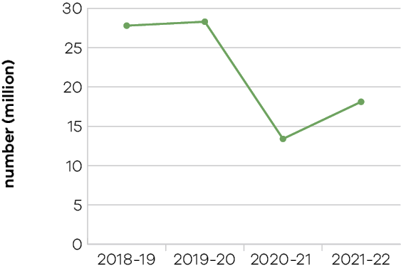
Figure 17: Number of international visitors
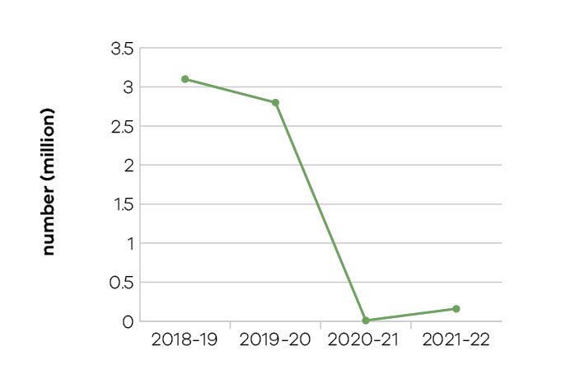

Figure 18: Visitor expenditure: domestic

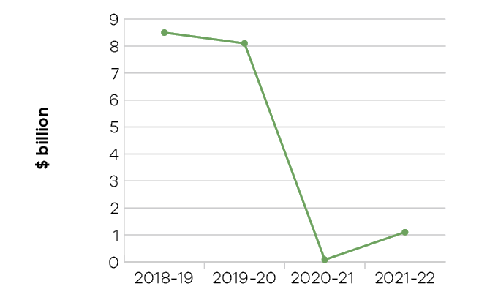
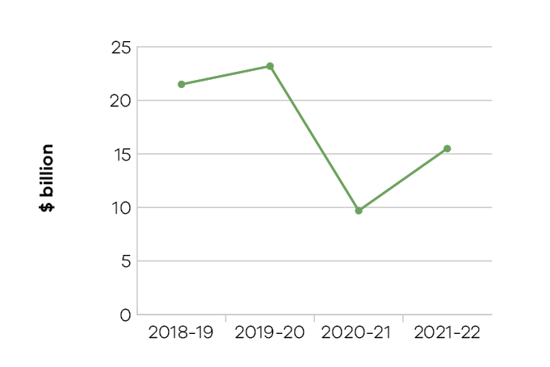
Figure 19: Visitor expenditure: international

Figure 20: Visitor expenditure: regional Victoria (domestic)

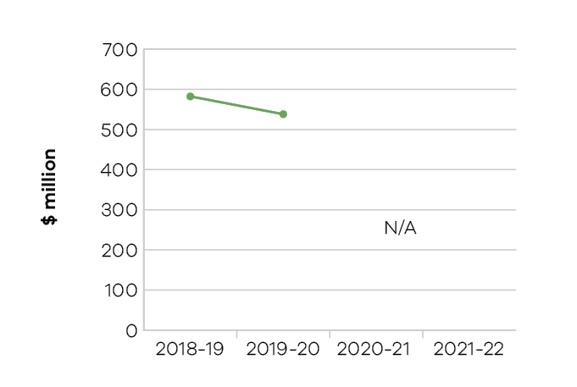
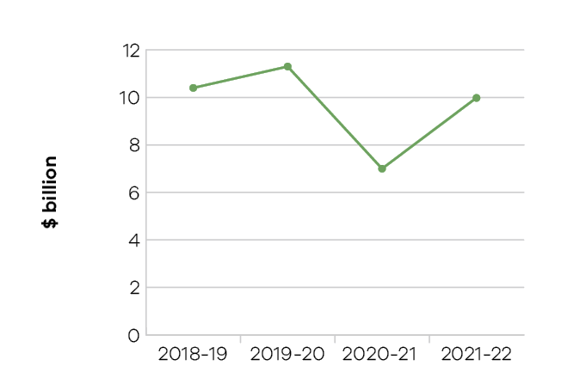
Figure 21: Visitor expenditure: regional Victoria (international)
Tourism is an important industry for Victoria. In the year ending March 2022, Victoria received approximately 57.5 million domestic (overnight and daytrip) and international overnight visitors combined, who collectively spent an estimated $16.5 billion.
Early signs of recovery are evident as restrictions have been progressively lifted and some measures improved relative to the performance of 2021 (a period of limited travel). The improvement in tourism performance is also reflected in improved optimism and confidence for a sustained recovery to the sector after a difficult two years due to COVID-19.
- Domestic overnight expenditure in Victoria in the year ending March 2022 is estimated to be $10.6 billion. Although overnight expenditure remained 32 per cent below the year ending March 2019, this measure has experienced significant improvement when compared to the year ending March 2021, increasing by 64 per cent.
- Daytrip visitors spent an estimated $4.8 billion in the year ending March 2022. Although daytrip expenditure remains 20 per cent below the year end March 2019, this measure increased by 46 per cent compared to the year ending March 2021.
Regional Victoria is leading the state’s overall recovery with stronger performances for year-to-date results, driven by local intrastate demand as people chose to travel closer to home due to restrictions and other concerns in the past year, with some indicators above pre-pandemic levels.
Notably, domestic overnight spend in regional Victoria increased by $2.0 billion compared to the year ending March 2021. Tourism recovery in Melbourne is also gaining momentum as restrictions ease and confidence builds.
The Victorian Visitor Economy Recovery and Reform Plan is a state-wide strategy, with a goal of achieving $35 billion in annual visitor expenditure and supporting 300,000 jobs by June 2024. Delivery of the initiatives continued in 2021-22, including:
- launching a further round of travel vouchers, providing 150,000 vouchers across the Victorian Travel Voucher Scheme and the Seniors Travel Voucher Scheme
- securing a strong pipeline of major and business events, including the Picasso Century at the NGV, the Bledisloe Cup international rugby matches in 2022 and 2023, and the International Congress for Psychology 2028
- staging major events, including the Formula One Australian Grand Prix, Australian Open and Moulin Rouge. The department worked across government and supported industry to resume COVIDSafe events under the Public Events Framework and continued to support when the framework ended
- executing marketing activities to support recovery, delivered by Visit Victoria, including Stay Close, Go Further campaign, which highlighted the creativity, culture and beauty of Victoria and encouraged more Victorians to explore their own backyard; Visit Melbourne – Get Set campaign, which reminded Australians about the depth and breadth of experiences on offer in Melbourne and beyond.

Indicator: Increase rates of community engagement, including through participation in sport and recreation

Table 19: Increase rates of community engagement, including through participation in sport and recreation
Measure (unit of measure) | 2018-19 | 2019-20 | 2020-21 | 2021-22
Percentage of adult Victorians participating  in sport at least once per year (per cent) | 91.6 | 91.2 | 89.7* | 90.4**
* This figure has been updated from the previous report reflecting the availability of participation data for the full
2020-21 calendar year.
** This figure is for six months only, noting financial year 2021-22 data is not yet available.

Figure 22: Percentage of adult Victorians participating in sport at least once per year
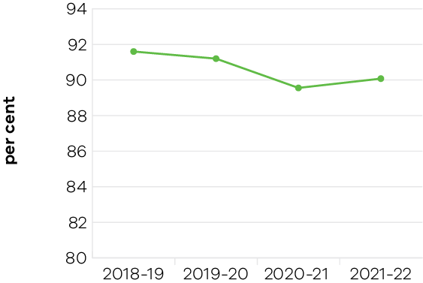

Participation
The COVID-19 pandemic has continued to impact participation in sport and active recreation in Victoria. Participation rates have broadly remained stable, with evidence suggesting more Victorians have participated in informal physical and recreational activities over the past two years, such as, visiting parks and nature reserves, and accessing online content to get or stay active while at home.
Support was provided to community sport and recreation organisations to promote participation opportunities for Victorians and ensure they are well‑placed to return to play as restrictions have eased. The Sporting Club Grants program assisted sport clubs in accessing new uniforms and equipment to support increased participation; skill development opportunities to uplift capability of coaches, officials and committee members; and dedicated support to increase community participation, particularly among under-represented groups.
A second funding round of the Together More Active program was delivered in 2021-22 to support the sector’s peak bodies and regional-based organisations to support programs that will improve access and participation outcomes over two years.
The Get Active Kids Voucher Program encourages increased participation in sport and recreation activities within Victoria’s disadvantaged communities. This program provides vouchers of up to $200 to meet the costs of membership and registration, uniforms and equipment – costs identified as a significant barrier for many Victorian families looking to support their children to participate. In 2021-22, 42,666 vouchers were issued through this program to support the participation of more Victorian children in organised sport and recreation.
Australia’s highly successful Tokyo 2020 Summer Games (held from 23 July to 8 August 2021) campaign comprised 114 Victorians in the Olympic team (24 per cent of the national team) and 45 Victorians in the Paralympic team (27 per cent of the national team). This included 83 Victorian Institute of Sport (VIS) scholarship holders. Twenty-one Victorians represented Australia at the Beijing 2022 Winter Olympic and Paralympic Games. Among them, six athletes were VIS scholarship holders.
High-performing athletes, coaches and support staff benefitted from government investment in the world class network of 44 state sport facilities that support 52 professional teams. Many of Victoria’s professional sporting teams enjoyed success across major domestic competitions in 2021-22. Championship winning teams included Melbourne Victory (A-League Women), Melbourne Boomers (Women’s National Basketball League), Western United (A-League Men), Melbourne Football Club (Australian Football League) and Melbourne Aces (Australian Baseball League).
Investment in state facilities supported events of national and international significance, showcasing athletes performing at their best and inspiring Victorians to participate in sport and active recreation. Seventy-eight events of state or national significance were facilitated through the Significant Sporting Events Program, promoting pathways for Victorian athletes to compete at state, national or international level whilst supporting the sports and event sector recovery from the COVID-19 pandemic.

Infrastructure
The department supported significant investment into community sport and recreation infrastructure to improve the facilities, spaces and environments that Victorians utilise. In 2021-22, $99.43 million was allocated to support 200 community sport and recreation projects. Community sport and recreation infrastructure is estimated to deliver over
$7 billion in benefits to Victoria per annum (including economic, social and wellbeing and health benefits).
Increased participation in sport was supported through completion of the 10 year long and nearly $1 billion redevelopment of Melbourne Park, with the Australian Open secured until 2044. Additionally, the Australian Golf Centre was delivered at Sandringham Golf Links. Upgrades were completed at John Cain Arena, Mars Stadium and Melbourne Ballpark, and stage two of the Essendon Football Club Community Education and Event Centre
was finalised.

Indicator: Wagering turnover on Victorian racing as a proportion of the national market

Table 20: Wagering turnover on Victorian racing as a proportion of the national market
Measure (unit of measure) | 2018-19 | 2019-20 | 2020-21 | 2021-22
Wagering turnover on Victorian racing as a proportion  of the national market (per cent) | 38.5 | 37.5 | 36.8 | 36.5

Figure 23: Wagering turnover on Victorian racing as a proportion of the national market
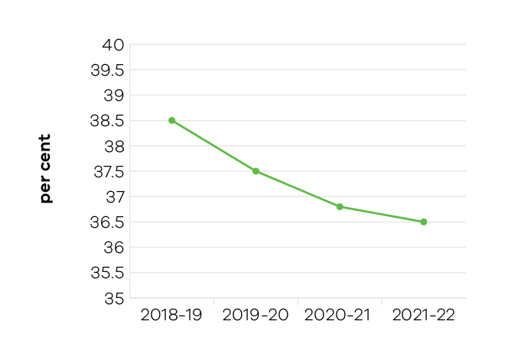
Government support for racing is based on its economic, social and cultural contribution to communities across Victoria. The objective indicator of Tabcorp customers nationwide who bet on Victorian racing as a proportion of the national market is used to determine the health of the Victorian racing industry. The measure includes all racing turnover held by Tabcorp on Victorian racing events.
While Victoria has approximately 25 per cent of the national population and continues to host around 25 per cent of the national racing program, it attracts a greater percentage of the national wagering pool. The significant proportion of the national market (36.5 per cent in 2021-22) reflects confidence in the integrity and quality of the Victorian racing product.
The year-on-year declining percentage can in part be attributed to greater competition from both New South Wales and Queensland with respect to their racing programs and prize money levels, as well as the closure of retail TAB outlets during the early months in 2021-22.

Performance against output performance measures
Table 21 represents performance against the Creative Industries Access, Development and Innovation output. This output supports the creative industries to deliver economic, social and cultural benefit through talent and leadership; the creative and business ecology; innovation and social impact; participation and place making; and international engagement.

Table 21: Output – Creative Industries Access, Development and Innovation
Performance measures | Unit of measure | 2021-22 actual | 2021-22 target | Performance variation (%) | Result
Quantity
Attendances at major performing arts organisations | number (000) | 279 | 1,000 | -72.1% | #
Lower result as live attendances at performances have been significantly impacted by varied operating conditions during COVID-19 including multiple lockdowns and capacity restrictions on venues.
Creative Learning Partnerships | number | 19 | 14 | 35.7% | *
Higher result due to confirmation of partnership funding from the Department of Education and Training enabling five more projects to be supported.
Design organisations supported | number | 23 | 22 | 4.5% | *
International market development and exchange initiatives | number | 11 | 12 | -8.3% | #
Lower result as there was no international engagement funding round due to COVID-19.
Organisations recurrently funded | number | 154 | 154 | 0.0% | *
Project companies and artists funded | number | 1,187 | 450 | 163.8% | *
Higher result due to additional COVID-19 grants administered during the reporting period.
Project companies and artists funded which are regionally based | per cent | 22 | 23 | -4.3% | –
Regionally based organisations recurrently funded | number | 56 | 56 | 0.0% | *
Quality
Creative Victoria grant recipients who met or exceeded agreed milestones | per cent | 82 | 85 | -3.5% | –
Public information rated ‘informative’ or ‘very informative’ by grant applicants | per cent | 88 | 90 | -2.2% | –
Timeliness
Performance and grant agreements acquitted within timeframes specified in the funding agreement | per cent | 86 | 83 | 3.6% | *
Cost
Total output cost | $ million | 84.2 | 54.8 | 53.6% | #
The 2021-22 result was higher than the 2021-22 budget mainly due to additional funding received for a number of initiatives including the Live Music Restart package.
Note:
* Performance target achieved or exceeded
– Performance target not achieved – within 5 per cent variance
# Performance target not achieved – exceeds 5 per cent variance
Table 22 represents performance against the Creative Industries Portfolio Agencies output. This output promotes, presents and preserves our heritage and the creative industries through Victoria’s creative industries agencies: Arts Centre Melbourne, Australian Centre for the Moving Image (ACMI), Docklands Studios Melbourne, VicScreen (Film Victoria), Geelong Arts Centre, Melbourne Recital Centre, Museums Victoria, National Gallery of Victoria (NGV), and the State Library Victoria.

Table 22: Output – Creative Industries Portfolio Agencies
Performance measures | Unit of measure | 2021-22 actual | 2021-22 target | Performance variation (%) | Result
Quantity
Additional employment from production supported by Film Victoria | number | 11,360 | 11,358 | 0.0% | *
Agency website visitation | number (000) | 22,974 | 21,200 | 8.4% | *
Higher result due to website visitation increasing in the second half of financial year as interest and booking for events and programs resumed, including popular exhibitions and events. Website usage was higher than target due to an increase in online events and forums.
Attendances at Arts Centre Melbourne | number (000) | 1,272 | 2,200 | -42.2% | #
Lower result due to extended lockdowns and health restrictions, although attendances have improved in the second half of 2021-22.
Attendances at Australian Centre for the Moving Image | number (000) | 414 | 800 | -48.3% | #
Lower result as ACMI was closed for the majority of quarter one, 2021 and reopened in October 2021. ACMI’s cinemas were also closed for a period of time in 2022 due to unexpected works which impacted programs and visitation during that period.
Attendances at Geelong Arts Centre | number (000) | 57 | 100 | -43.0% | #
Lower result due to extended COVID-19 lockdowns during the first half of 2021-22 and ongoing redevelopment works at the venue.
Attendances at Melbourne Recital Centre | number (000) | 68 | 230 | -70.4% | #
Lower result due to COVID-19 related restrictions, including closure of the building for the majority of quarter one and ongoing disruptions for the remaining quarters.
Attendances at Museums Victoria | number (000) | 1,213 | 2,000 | -39.4% | #
Lower result due to the impacts of COVID-19 and the associated venue closures during 2021. Nevertheless, Melbourne Museum has seen a return to pre-COVID-19 visitation levels, following the opening of Triceratops exhibition.
Attendances at National Gallery of Victoria | number (000) | 1,079 | 2,235 | -51.7% | #
Lower result due to COVID-19 related restrictions, including closure for the majority of quarter one and ongoing impacts for the remaining quarters, although visitation has increased in the second half of 2021-22.
Attendances at State Library Victoria | number (000) | 832 | 2,250 | -63.0% | #
Lower result due to COVID-19 related restrictions, including closure for the majority of quarter one, although visitation has grown in the second half of 2021-22.
Direct Full-Time Equivalent (FTE) roles from production supported by Film Victoria | number | 3,092 | 2,335 | 32.4% | *
Higher result as several high value, physical screen productions commencing in this financial year have exceeded estimated return on investment expectations.
Members and friends of agencies | number | 58,523 | 57,000 | 2.7% | *
Students participating in agency education programs | number | 267,012 | 550,000 | -51.5% | #
Lower result due to health restrictions causing agency closures during school terms, negatively impacted student visitation and participation in programs.
Value of film, television and digital media production supported by Film Victoria | $ million | 406 | 350 | 16.0% | *
Higher result as several high value, physical screen productions commencing in this financial year have exceeded estimated return on investment expectations.
Volunteer hours | number | 26,275 | 98,900 | -73.4% | #
Lower result as a significant proportion of volunteer work is onsite and cannot be undertaken remotely. COVID-19 health restrictions limited access to volunteers working onsite during 2021-22.
Quality
Agency collections storage meeting industry standard | per cent | 83 | 86 | -3.5% | –
Visitors satisfied with visit: Arts Centre Melbourne | per cent | 90 | 90 | 0.0% | *
Visitors satisfied with visit: Australian Centre  for the Moving Image | per cent | 98 | 95 | 3.2% | *
Visitors satisfied with visit: Geelong Arts Centre | per cent | 98 | 98 | 0.0% | *
Visitors satisfied with visit: Melbourne Recital Centre | per cent | 97 | 95 | 2.1% | *
Visitors satisfied with visit: Museums Victoria | per cent | 91 | 96 | -5.2% | #
Lower result as Museums Victoria was closed for most of quarter one, and slightly lower visitor satisfaction may reflect response to limited access to onsite visits.
Visitors satisfied with visit: National Gallery of Victoria | per cent | 96 | 95 | 1.1% | *
Visitors satisfied with visit: State Library Victoria | per cent | 97 | 90 | 7.8% | *
Higher result as visitors responded positively to programs and events and the newly redeveloped facility.
Cost
Total output cost | $ million | 458.2 | 393.7 | 16.4% | #
The 2021-22 result was higher than the 2021-22 budget mainly due to additional recovery funding for Creative Industries Portfolio agencies.
Note:
* Performance target achieved or exceeded
– Performance target not achieved – within 5 per cent variance
# Performance target not achieved – exceeds 5 per cent variance
Table 23 represents performance against the Cultural Infrastructure and Facilities output. This output supports Victorian cultural venues and state-owned facilities through strategic assessment and provision of advice on portfolio infrastructure proposals and projects. The output includes consolidation of portfolio asset management plans and management of funding programs for maintenance and minor capital works.

Table 23: Output – Cultural Infrastructure and Facilities
Performance measures | Unit of measure | 2021-22 actual | 2021-22 target | Performance variation (%) | Result
Quantity
All facility safety audits conducted | number | 16 | 16 | 0.0% | *
Infrastructure development projects underway | number | 14 | 10 | 40.0% | *
Quality
State-owned tenanted cultural facilities  maintained to agreed service standards | per cent | 100 | 90 | 11.1% | *
Higher result as state-owned tenanted cultural facilities maintained to agreed service standards with no critical asset failures.
Success measures of projects achieved | per cent | 100 | 90 | 11.1% | *
Higher result as all projects are on track against success measures.
Timeliness
Cultural Facilities Maintenance Fund projects  delivered within agreed timeframes | per cent | 79 | 90 | -12.2% | #
Lower result due to multi-year projects supported by the Cultural Facilities Maintenance program as of 2021-22, which are more likely to be delivered across multiple years.
Cost
Total output cost | $ million | 59.7 | 65.3 | -8.6% | *
The 2021-22 result was lower than the 2021-22 budget mainly due to the timing of payments for regional creative infrastructure projects.
Note
* Performance target achieved or exceeded
– Performance target not achieved – within 5 per cent variance
# Performance target not achieved – exceeds 5 per cent variance
Table 24 represents performance against the Sport, Recreation and Racing output. This output provides strategic leadership and investment in the sport, recreation and racing industries through innovation, sector and industry development and funding support. It supports community participation and inclusion in the sport, recreation and racing sectors by strengthening the capacity of sport and recreation organisations to deliver participation opportunities, improving community sport and recreation facilities across the state and guiding the development and management of state-level sporting facilities and events, to encourage participation by all Victorians.
This output also supports the development of the Victorian racing industry through strategic investment in world class racing and training infrastructure, the promotion of animal welfare and integrity initiatives and encourages participation and investment in the breeding industry to cement Victoria’s position as Australia’s premier racing state.

Table 24: Output – Sport, Recreation and Racing
Performance measures | Unit of measure | 2021-22 actual | 2021-22 target | Performance variation (%) | Result
Quantity
Combat sports licences, registrations  and permits issued | number | 583 | 550 | 6.0% | *
Higher result due to a higher-than-anticipated number of combat sports events, leading to an increase in applications for licences, registrations and permits.
Community Facility Grants: number approved | number | 200 | 140 | 42.9% | *
Higher result due to the delivery of additional rounds of community infrastructure programs for the Community Cricket Program and the Local Sport Infrastructure program.
Funded State Sport and Recreation Associations that have a minimum of 40 per cent women on their boards | number | 91 | 90 | 1.1% | *
Local Sports Infrastructure grant recipients  which are regionally based | per cent | 55.2 | 45 | 22.7% | *
Higher result due to a higher number of applications received and grants approved to recipients that are regionally based.
Organisations submitting nominations for the Community Sport and Recreation Awards | number | 70 | 70 | 0.0% | *
Projects in progress that relate to the planning  and development of state level facilities | number | 29 | 20 | 45.0% | *
Higher result due to additional planning studies and infrastructure projects commencing in 2021-22.
Racing industry development initiatives | number | 9 | 9 | 0.0% | *
Racing matters processed (including licences,  permits and grant applications) | number | 266 | 300 | -11.3% | #
Lower result due to fewer grant applications being processed for the 2021 Spring Raceday Attraction Program. This was due to crowd restrictions in place due to COVID-19.
Significant Sporting Events Program – Events Facilitated | number | 78 | 75 | 4.0% | *
Sport and recreation organisations undertaking programs or activities to enhance participation | number | 109 | 112 | -2.7% | –
Sporting club grants to recipients which are based  in low socio-economic areas as identified by the  SEIFA index | per cent | 51 | 45 | 13.3% | *
Higher result due to a higher-than-anticipated proportion of eligible applications being received from low-SEIFA areas for the program.
Sporting club grants to recipients which  are regionally based | per cent | 44 | 35 | 25.7% | *
Higher result due to a higher-than-anticipated proportion of eligible applications being received from regional areas for the program.
Sporting club grants: number approved | number | 935 | 750 | 24.7% | *
Higher result due to additional grants that were approved as part of the COVID-related ‘Event Support Stream’
Sports with athletes on Victorian Institute of Sport  (VIS) scholarships | number | 49 | 45 | 8.9% | *
Higher result due to the increased investment to the VIS enabling it to increase the number of sport programs and VIS athletes under scholarship.
Victorian categorised athletes supported by the VIS | per cent | 93 | 45 | 106.7% | *
Higher result due to the increased investment in the VIS allowing it to offer all Victorian categorised athletes a VIS scholarship.
Victorian Institute of Sport scholarship holders on national teams/squads | per cent | 70 | 60 | 16.7% | *
Higher result due to a higher percentage of eligible VIS scholarship athletes being selected on national teams/squads.
Quality
Contract management of outdoor recreation camps meets agreed key performance indicators | per cent | 89 | 90 | -1.1% | –
Timeliness
Community Cricket Program milestones delivered  within agreed timeframes | per cent | 95 | 90 | 5.6% | *
Higher result due to a focus on relationship management with grant recipients resulting in higher proportion of funded projects completing milestones within agreed timeframes.
Cost
Total output cost | $ million | 742.9 | 497.4 | 49.4% | #
The 2021-22 result was higher than the 2021-22 budget mainly due to additional funding for a range of Sport and Recreation grant programs, primarily COVID-19 support for the sector.
Note:
* Performance target achieved or exceeded
– Performance target not achieved – within 5 per cent variance
# Performance target not achieved – exceeds 5 per cent variance

Table 25 represents performance against the Tourism and Major Events output. This output maximises employment and the long-term economic benefits of tourism and major events to Victoria by developing and marketing the State as a competitive destination.

Table 25: Output – Tourism and Major Events
Performance measures | Unit of measure | 2021-22 actual | 2021-22 target | Performance variation (%) | Result
Quantity
Always Live events held | number | 3 | 50 | -94.0% | #
Lower result as the events are postponed due to COVID-19 related restrictions on events, travel and mass gatherings.
Business program grants delivered | number | 12 | 12 | 0.0% | *
Major sporting and cultural events held | number | 15 | 21 | -28.6% | #
Lower result due to COVID-19 related restrictions on events, travel and mass gatherings.
Tourism infrastructure projects facilitated | number | 30 | 30 | 0.0% | *
Visit Victoria’s total engaged digital audience | number (million) | 5.8 | 6.2 | -6.5% | #
Lower result due to the ongoing impacts of COVID-19 which have subdued interest in travel, however, strong growth was recorded in the last quarter of the year following an increase in travel activity.
Visitor expenditure: domestic | $ billion | 15.4 | 23.2 | -33.6% | #
Lower result due to the ongoing impacts of COVID-19 which have prevented or subdued travel.
Visitor expenditure: international | $ billion | 1.1 | 9 | -87.8% | #
Lower result due to the ongoing impacts of COVID-19 which have prevented or subdued travel.
Visitor expenditure: regional Victoria (domestic) | $ billion | 9.9 | 11.1 | -10.8% | #
Lower result due to the ongoing impacts of COVID-19 which have prevented or subdued travel.
Visitor expenditure: regional Victoria (international) | $ million | n/a | 600 |  | *
International visitor data is currently limited to state-wide results.
Visitor expenditure: regional Victoria  (intrastate overnight) | $ billion | 6.1 | 5.7 | 7.0% | *
Higher result as the ongoing impacts of COVID-19 have resulted in an increase in longer intrastate overnight trips and associated expenditure in lieu of Victorians travelling interstate and overseas.
Visitors (domestic overnight) | number (million) | 18.2 | 29.5 | -38.3% | #
Lower result due to the ongoing impacts of COVID-19 which have prevented or subdued travel.
Visitors (international) | number (million) | 0.2 | 3.2 | -93.8% | #
Lower result due to the ongoing impacts of COVID-19 which have prevented or subdued travel.
Visitors: regional Victoria (intrastate overnight) | number (million) | 12.6 | 16.4 | -23.2% | #
Lower result due to the ongoing impacts of COVID-19 which have prevented or subdued travel.
Quality
Value of media coverage generated: domestic | $ million | 58.6 | 23 | 154.8% | *
Higher result due to a strong focus on the domestic market for the majority of the year while international borders were closed.
Value of media coverage generated: international | $ million | 44.5 | 47 | -5.3% | #
Lower result due to the impacts of COVID-19, limiting marketing opportunities in international markets, however, strong growth was recorded in the last quarter of the year
Timeliness
Completion of post-event reports and economic  impact assessments of each event (where required) within agreed timeframes | per cent | 100 | 100 | 0.0% | *
Cost
Total output cost | $ million | 405.6 | 197.9 | 105.0% | #
The 2021-22 result was higher than the 2021-22 budget due to additional COVID-19 support for the Tourism and Events sectors in 2021-22.
Note
* Performance target achieved or exceeded
– Performance target not achieved – within 5 per cent variance
# Performance target not achieved – exceeds 5 per cent variance

Objective 6: Promote productive and sustainably used natural resources
This objective supports more productive, globally competitive, sustainable and jobs-rich agriculture, food and fibre, and resources sectors. The department delivers the objective in collaboration with partners, local communities
and industry to deliver outcomes that provide benefits to all Victorians.

Progress towards achieving this objective
In 2021-22, the department reported progress against this objective using the following objective indicators and outputs:

Objective Indicators
- Value of Victorian agriculture production
- Value of Victorian food and fibre exports
- Metres drilled for minerals exploration in Victoria
- Level of production of minerals and extractives

Outputs
- Agriculture
- Agriculture Industry Development and Regulation
- Agriculture Research
- Biosecurity and Agriculture Services
- Sustainably manage forest and game resources
- Resources
The department supports a productive, globally competitive and sustainable Victorian economy for the state’s innovative and resilient agriculture, food and fibre sector. The department works with community and industry to enhance productivity; connect the sector with international markets and create jobs; support growth; maintain effective biosecurity; and improve the welfare of domestic and production animals.

Indicator: Value of Victorian agriculture production

Table 26: Value of Victorian agriculture production
Measure (unit of measure) | 2018-19 | 2019-20 | 2020-21 | 2021-22
Gross value of Victorian agriculture production  ($ billion) | 15.9 | 17.8 | 17.5 | Data available May 2023

Figure 24: Gross value of Victorian agriculture production
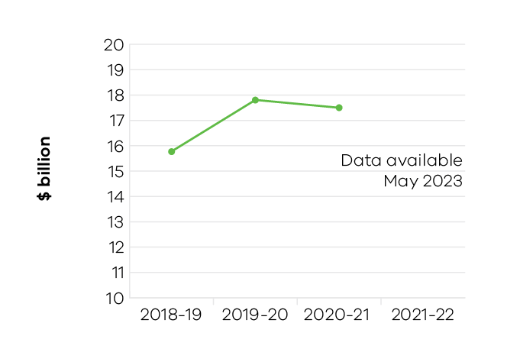
Despite the challenges of the last two years, agriculture has remained one of the strongest performers in the Victorian economy. Business conditions for agriculture were largely supportive during both 2020-21 and 2021-22, despite disruptions arising from COVID-19 and other factors. Overall, Victorian agriculture has experienced relatively stable production in recent years, increasing from $15.9 billion in 2018-19 to $17.5 billion in 2020-21 (an increase of 10.1 per cent).
The latest available figures show that in 2020-21 Victorian agriculture’s gross value of production decreased 1.6 per cent ($291.6 million) to $17.5 billion, even though business conditions were mostly supportive for agriculture during this time. This decline was largely due to a nine per cent decrease in livestock production, in particular a $641.8 million reduction in beef and sheep disposals. The reduction in livestock disposals largely reflects a return to good seasonal conditions in 2020-21, leading farmers to rebuild their herds after several years of poor seasonal conditions. This herd rebuilding occurred at the expense of livestock disposals but established conditions for strong production in future years. The second reason for the reduction in livestock disposals was limited access to abattoirs, due to COVID-19 related labour shortages throughout 2020‑21. Both these effects were experienced Australia-wide, with national livestock disposals declining five per cent in 2020-21 compared to 2019‑20.
In Victoria, declines in livestock production were offset by a $271.4 million increase in the value of Victorian broadacre cropping compared to 2019-20 (including a 31.2 per cent increase in the value of wheat), and a $118.1 million increase in the value of horticulture production (despite poor seasonal conditions combined with labour shortages).
In 2021-22, horticulture producers faced challenges including disproportionate commodity to input prices, seasonal labour shortages and cool damp climatic conditions.
In 2021-22, the Victorian Government responded to several climatic and biosecurity challenges. An intense storm impacted Central Highlands potato producers. Japanese encephalitis virus affected pork producers, and potential disruptions to almond pollination arose from the incursion of Varroa mite in New South Wales. In managing Japanese encephalitis, the department conducted monitoring (23 detections), provided information on management, and applied nationally-agreed movement restrictions to infected pig properties.
Improved conditions helped many businesses recover from unfavourable conditions in prior years such as significant floods, storms, and dry seasonal conditions. Recovery support continued to assist producers with advice given for stock health, nutrition, feed budgeting, fencing, pasture recovery, grazing management, soil erosion, horticulture, dams and waterways.
The department is delivering the Agriculture Sector Pledge that commits to protect and enhance the future of the Victorian agriculture sector, respond to climate change and reduce emissions. The program delivers a long-term shared vision, flagship research trials, and practical information, tools and services to help farmers reduce emissions while maintaining productivity. Milestones include the commencement of the On-Farm Action Plan Pilot to support 250 farm businesses to measure and implement actions to reduce emissions, and the development of the first Victorian Agriculture and Climate Change Statement – a shared vision for agriculture’s role in a net-zero climate resilient economy.
In delivering the Primary Production Adaptation Action Plan, the department supports the sector to reduce climate change risks, build resilience and harness opportunities for business continuity and growth. It achieves this through building climate resilience of value chains, facilitating research and innovation, and supporting the sector to further build climate change adaptation information, skills and capacity.
The department continued to deliver critical research and innovation in 2021-22. Research and innovation in major industries of dairy, grains and horticulture, as well as in emerging industries, was delivered through multi-disciplinary collaborations with industries. For example, the DairyBio initiative, a partnership with the dairy industry delivered accelerated precision breeding of forages with commercial partners using genomic selection and hybrid breeding.
This resulted in a significant boost to genetic gain – up to five times – and an increase in yields of 20 per cent. The department also recently commenced a new agreement with the Grains Research and Development Corporation.
This confirms the commitment to a mission-driven five-year strategic partnership and builds on the current bilateral agreement that is expected to return six dollars of benefit for every dollar spent
on research.
The department is shaping the future of agriculture through delivery of skills programs in Science Technology, Engineering and Mathematics (STEM) and digital agriculture to schools and PhD students, agriculture industries and regional communities. In 2020-21, over 800 students participated in AgSTEM workshops delivered remotely under COVID-19 restrictions.

Indicator: Value of Victorian food and fibre exports

Table 27: Value of Victorian food and fibre exports
Measure (unit of measure) | 2018-19 | 2019-20 | 2020-21 | 2021-22
Food and fibre exports from Victoria  ($ billion) | 14.2 | 14.5 | 14 | Data available May 2023

Figure 25: Food and fibre exports from Victoria
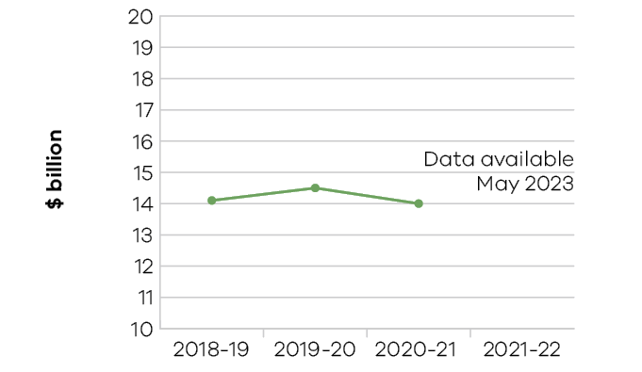
The government has a target to grow Victorian food and fibre exports to $20 billion per annum by 2030. The 2020-21 Food and Fibre Export Performance Report showed that food and fibre exports from Victoria were valued at $14.0 billion, with export value decreasing by $476 million (down three per cent) on 2019-20. Over the last two years, COVID-19 has caused uncertainty and disruption for many in the agriculture industry. COVID-19 resulted in supply chain disruptions, increased freight costs and reduced demand, which created challenges for Victorian exporters. In 2020-21, Victoria’s food and fibre exports declined three per cent, due mainly to reduced meat exports. This reflected lower domestic stock levels following the drought and bushfires, restocking following the return to good seasonal conditions, workforce shortages at abattoirs, and disruptions to supply chains.
Meat remained Victoria’s largest value export commodity, but these exports decreased by $1.3 billion to be valued at $3.3 billion in 2020-21. Sheep meat exports ($1.4 billion) and beef exports ($1.3 billion) were the most valuable meat export commodities, comprising 83 per cent of all meat exports.
Grain export value increased by 132 per cent, with volumes growing three-fold on the previous year, making it the largest export product by volume (totalling just over 5.8 million tonnes). Grain exports from Victoria increased by $1.4 billion to $2.5 billion in 2020-21. Wheat exports ($988 million) and barley ($347 million) were the most valuable grain exports, comprising 53 per cent of total Victorian grain exports. Grains experienced the largest growth in export value with record crop production. There were significant increases in grains exports to Vietnam, the Philippines, Belgium and Sri Lanka.
Victoria’s top five export markets were China, the United States, Japan, New Zealand, and Indonesia. Export value to China decreased by more than $1 billion which had an overall impact on export values. Nevertheless, China remained the most valuable export market for Victorian food and fibre exports.

Indicator: Metres drilled for minerals exploration in Victoria

Table 28: Metres drilled for minerals exploration in Victoria
Measure (unit of measure) | 2018-19 | 2019-20 | 2020-21 | 2021-22
Metres drilled for minerals exploration in Victoria (metres) | 337,654 | 388,662 | 467,585 | N/A*
Source: Geological Survey of Victoria (GSV) mineral companies’ exploration reports that GSV is required to audit.
* Data unavailable at time of writing.

Figure 26: Metres drilled for minerals exploration in Victoria
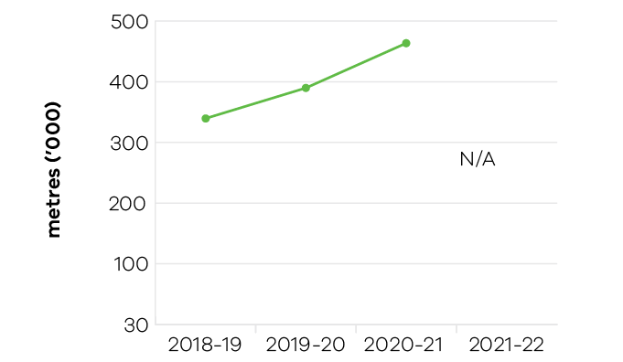
The level of metres drilled for minerals exploration in Victoria during 2020-21 was 467,585 metres. This represents an increase of 78,923 metres or 20.3 per cent compared to 2019-20. Increased levels of minerals drilled in 2020-21 was predominantly due to increased exploration of previously identified, but currently undeveloped, mineral resources (i.e. those under retention licences) such as the Cayley Lode and Thursday’s Gossan Prospects in western Victoria, and the Four Eagles Prospect north of Bendigo. Increases in exploration drilling at existing mining licences (i.e. operations) such as the Fosterville and Ballarat East mines, and increased mineral exploration drilling activity for new resources across the State also contributed to the rise.
Metres drilled for mineral exploration on mining licences at 240,808 accounts for 52 per cent of the total drill metres. This reflects existing operations investing in exploration with the aim of replacing the resource that has been mined to deliver future production opportunities. Mineral exploration drilling on exploration licences accounts for 30 per cent of the drill metres in 2020-21 and combined with retention licences, it has increased year on year since 2014-15. This highlights the increasing level of interest and investment to discover new mineral resources in Victoria.
The level of metres drilled for minerals exploration has more than quintupled since 2014-15, reflecting the renewed interest for exploring in Victoria. The Stavely minerals initiative in western Victoria and the north central Victorian goldfields ground release, supported by world class pre-competitive geoscience data and knowledge (generated and made available by the Geological Survey of Victoria), are attracting further exploration investment to the State. This is demonstrated through the $162 million increase in mineral exploration since 2014-15, with Victoria experiencing record levels of exploration investment. Total exploration expenditure for 2020-21 was $184.9 million (source: ABS).

Indicator: Level of production of minerals and extractives

Table 29: Level of production of minerals and extractives
Measure (unit of measure) | 2018-19 | 2019-20 | 2020-21 | 2021-22
Annual production of brown coal  (1000 tonnes) | 42,256 | 40,372 | 42,263 | N/A*
Annual production of gold  (ounces) | 567,501 | 790,054 | 722,239 | N/A*
Annual production of antimony  (tonnes) | 2,016 | 3,141 | 3,551 | N/A*
Annual production of mineral sands  (tonnes) | 0 | 0 | 0 | N/A*
Annual production of extractives  (million tonnes) | 62.91 | 64.58 | 63.68 | N/A*
Source: Earth Resources Regulation 2020-21 Statistical Report.
Note: The restatement of prior year data in some cases is due to review adjustments that align with the published ERR statistical report.
* Data unavailable at time of writing.

Figure 27: Annual production of brown coal (1000 tonnes)

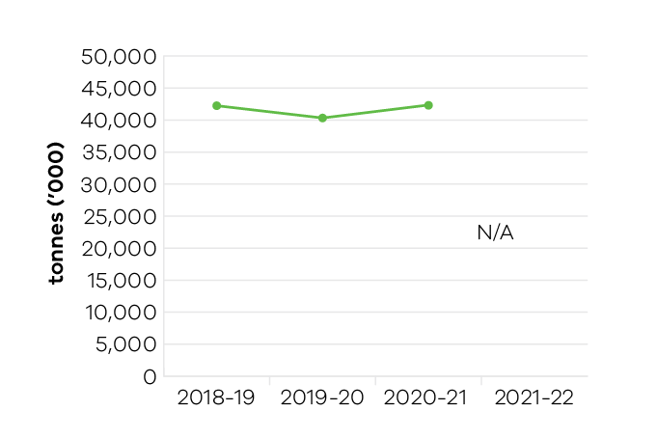

Figure 28: Annual production of gold (ounces)

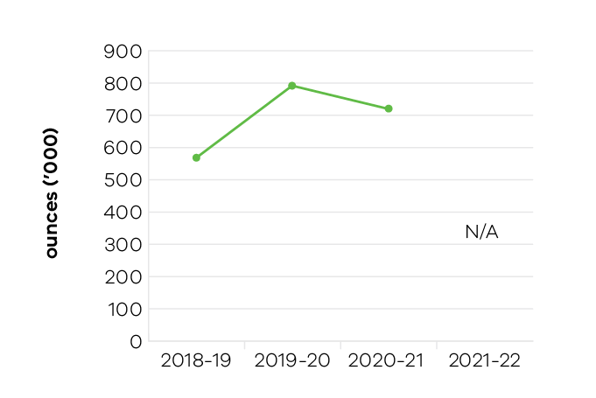

Figure 29: Annual production of antimony (tonnes)
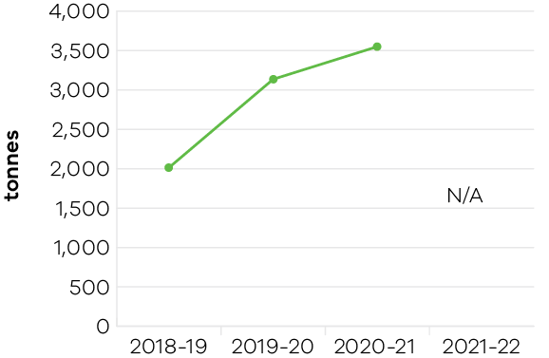

Figure 30: Annual production of mineral sands (tonnes)
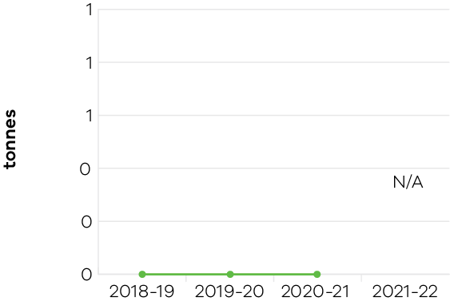

Figure 31: Annual production of extractives (million tonnes)
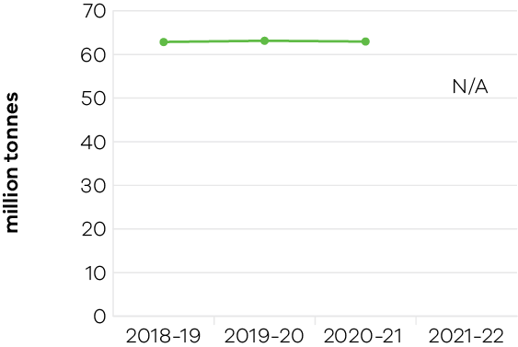
Gold production in Victoria remains at a high level with 722,239 ounces produced in 2020-21. This represents a 98.3 per cent increase since 2017-18. Since 2014‑15, annual gold production has increased by 521,367 ounces or three and half times the 2014-15 production level. This mainly reflects the successful exploration and development activities at the Fosterville gold mine in central Victoria. Future success in the gold industry will be driven by new exploration in the Stavely region in western Victoria, new activity generated from the north central Victorian Goldfields Ground Release (completed 29 October 2021) and further development of existing mines.
Victoria’s ‘Big Build’ is seeing record levels of investment in critical infrastructure covering major construction and transport initiatives. This continues to drive the current demand for extractives materials. The demand is projected to grow to over 100 million tonnes by 2050. Secure supplies of sand, stone and gravel resources will support ongoing construction investment. During 2020-21, extractives production slightly decreased to 63.7 million tonnes from 64.6 million tonnes in 2019-20. However, this represents an increase in production of 25.6 per cent since 2014-15.
Brown coal production increased by 4.7 per cent during 2020-21 to 42.3 million tonnes. Brown coal production is expected to decrease in the future, reflecting the impact of increasing renewable energy sources for electricity generation and the closure of the Yallourn coal mine in 2028.
There was no production of mineral sands resources during 2020-21, however, there remains significant potential for new mineral sands projects in Victoria in the Murray Basin.
Antimony is produced from Australia’s only antimony mine at Costerfield in central Victoria. Production increased from a low base by 13 per cent in 2020-21.

Performance against output performance measures
Table 30 represents performance against the Agriculture output. This output delivers services to the agriculture, food and fibre sectors to enhance productivity, connect the sector with international markets, create jobs, support growth and maintain effective biosecurity. It delivers effective, and efficient regulation, compliance, emergency management, biosecurity research and development, and diagnostic services to protect and enhance market access by addressing trade barriers and managing the risks of pests, diseases and chemical use. The department undertakes research and development to develop new technologies and practices and provides services to enhance their adoption to increase farm productivity and supply chain efficiencies. It provides policy advice and support to industries and businesses to innovate, manage economic and climatic volatility, natural disasters and biosecurity emergencies, and meet consumer and community expectations for food quality, food safety and animal welfare and environmental standards.
The output also creates the conditions to grow the natural resources economy by ensuring resources are sustainably allocated and used for both recreational and commercial purposes.

Table 30: Output – Agriculture
Performance measures | Unit of measure | 2021-22 actual | 2021-22 target | Performance variation (%) | Result
Agriculture Industry Development and Regulation
This sub-output supports a more productive, competitive, sustainable and jobs-rich food and fibre sector by delivering policy advice, regulation and support to meet consumer and community expectations for agriculture industry development, pets and animal welfare, regulatory policies and frameworks.
Quantity
Farms and related small businesses facing  significant adjustment pressures supported  to make better-informed decisions by the  Rural Financial Counselling Service | number | 1,357 | 1,700 | -20.2% | #
Lower result due to favourable seasonal conditions and commodity prices for agriculture, resulting in less financial stress for farmers and less need for them to request assistance from the Rural Financial Counselling Service.
Inspections or audits of scientific establishments undertaken to provide assurance of compliance with relevant industry standards for animal welfare | number | 25 | 25 | 0.0% | *
Number of small scale local and craft producers attending workshops / mentoring programs | number | 63 | 50 | 26.0% | *
Higher result is in-line with COVID-19 restrictions, as some physical workshops became online workshops. This allowed for higher participation numbers.
Strategies developed to maintain and / or grow export opportunities, pathways and capability and overcome identified trade barriers | number | 3 | 3 | 0.0% | *
Visits of the Responsible Pet Ownership program  to Victorian kindergartens and primary schools | number | 254 | 3,100 | -91.8% | #
Lower result as the Responsible Pet Ownership education program did not operate while COVID-19 restrictions prevented the program from attending schools and kindergartens. The program resumed visits on 26 April 2022 for school term 2.
Young farmer scholarships awarded | number | 13 | 12 | 8.3% | *
Higher result due to an additional scholarship which was able to be awarded this financial year within the allocated annual budget. Where applications are received for less than the maximum scholarship allowable, this provides the opportunity to provide additional scholarships.
Quality
Grant recipients who met or exceeded  agreed milestones | per cent | 77 | 75 | 2.7% | *
Timeliness
Performance and grant agreements acquitted within timeframes specified in the funding agreement | per cent | 87 | 90 | -3.3% | –
Cost
Total output cost | $ million | 183.7 | 163.1 | 12.6% | #
The 2021-22 result was higher than the 2021-22 budget due to funding for the Seasonal Agriculture Workforce Support Program.
Agriculture Research
This sub-output supports more productive, competitive, sustainable and jobs-rich food and fibre sectors by delivering research and innovation to develop innovative new technologies and farming systems that increase food and fibre productivity and product quality.
Quantity
Commercial technology licence agreements finalised | number | 16 | 16 | 0.0% | *
Genetic improvement of dairy cows achieved through breeding contributing to increased milk production and dairy productivity | per cent | 1 | 1 | 0.0% | *
Key bioscience platform technologies established | number | 1 | 1 | 0.0% | *
Postgraduate-level/PhD students in training | number | 66 | 65 | 1.5% | *
Value of co-investment from external (non-state) funding sources attracted to the Department’s research projects that support productive agriculture | $ million | 40.8 | 41 | -0.5% | –
Quality
Satisfaction rating of industry investors in agriculture productivity research and development | number | 9.2 | 7 | 31.4% | *
Higher result due to the continued success of the Agriculture Victoria Research partnership model where research is jointly designed, delivered and evaluated through a direct engagement and long-term partnership model with industry.
Scientific and technical publications subjected to independent peer review in international and national journals that promote productive agriculture | number | 262 | 260 | 0.8% | *
Timeliness
Provision of technical advice, diagnostic identification tests on pests and diseases including suspected exotics within agreed timeframes | per cent | 80.3 | 85 | -5.5% | #
Lower result due to the impact of COVID-19 on diagnostic staffing levels.
Research project milestones and reports  completed on time | per cent | 91 | 90 | 1.1% | *
Cost
Total output cost | $ million | 122.3 | 123.2 | -0.7% | *
Biosecurity and Agriculture Services
This sub-output delivers biosecurity, agriculture and emergency management services and regulatory programs which support the food and fibre sector to achieve sustainable growth while managing risks and minimising adverse impacts to the economy, environment and public health and safety.
Quantity
Animal pest, disease and residue control programs maintained to ensure Victorian agricultural produce complies with food safety and biosecurity standards required to access markets | number | 4 | 5 | -20.0% | #
Lower result due to the Surveillance for Transmissible Spongiform Encephalopathy (TSE) diseases in cattle and sheep project not reaching its target for 2021-22. This was due to a combination of factors including a reduced capacity and capability of private vets to collect samples, ongoing impacts of the COVID-19 pandemic and staff being redirected to emergency responses.
Client interactions with land health services | number | 1,724 | 1,700 | 1.4% | *
Clients engaged with agriculture productivity services | number | 4,005 | 3,910 | 2.4% | *
Improved agricultural services, programs  and products developed | number | 10 | 10 | 0.0% | *
Known state prohibited weed sites monitored and treated in line with the relevant weed action plan | per cent | 95 | 95 | 0.0% | *
New or amended Interstate Certificate Assurance  (ICA) or other market access accreditations developed to restore or enable trade | number | 11 | 2 | 450.0% | *
Higher result due to pest and disease incursions and changing interstate market access conditions. Whilst this additional work is unplanned, it is business critical to minimise likely disruptions to Victorian producers accessing domestic markets.
Plant pest, disease and residue control programs maintained to ensure Victorian agricultural produce complies with food safety and biosecurity standards required to access markets | number | 6 | 6 | 0.0% | *
Properties inspected for invasive plant and animal priority species | number | 1,919 | 2,700 | -28.9% | #
Lower result due to the impacts of COVID-19 restrictions and the redirection of resources to high priority activities including emergency responses.
Quality
Client satisfaction rating of agricultural services | number | 8.5 | 8 | 6.3% | *
Higher result due to a greater emphasis on design of client focussed services.
National biosecurity, agriculture/veterinary chemical use and animal welfare programs implemented  in accordance with agreed plans | per cent | 100 | 96 | 4.2% | *
Preparedness activities implemented, in line with agreed plans, to ensure response readiness for emergency animal and plant pest, disease  and natural disaster incidents | per cent | 90 | 90 | 0.0% | *
Timeliness
Animal health certificates issued within specified timeframes to support international market access | per cent | 99 | 95 | 4.2% | *
Initial action taken to respond to reported emergency animal and plant pest, disease and natural disaster incidents complies with national agreements and obligations | per cent | 98 | 100 | -2.0% | –
Plant health certificates issued within specified timeframes at the Melbourne Wholesale Fruit and Vegetable Market to support domestic market access | per cent | 98 | 95 | 3.2% | *
Cost
Total output cost | $ million | 118.5 | 113.3 | 4.6% | –
The 2021-22 result was higher than the 2021-22 published budget due to additional expenditure incurred in 2021-22 for the National Agreement Red Imported Fire Ant Eradication program.
Sustainably manage forest and game resources
This sub-output creates the conditions to ensure the natural resources economy, including forestry and game resources, are sustainably allocated and used for both recreational and commercial purposes.
Quality
Key statutory obligations relevant to the Game Management Authority complied with (tabling annual report, audits, business plan and board appointments) | per cent | 100 | 100 | 0.0% | *
Key statutory obligations relevant to VicForests complied with (tabling annual reports, audits,  corporate plan and board appointments) | per cent | 100 | 100 | 0.0% | *
Timeliness
Facilitate the delivery of game projects  in line with key project milestones | per cent | 100 | 100 | 0.0% | *
Facilitate the delivery of the Victorian Forestry  Plan in line with key project milestones | per cent | 100 | 100 | 0.0% | *
Cost
Total output cost | $ million | 87.1 | 65.1 | 33.8% | #
The 2021-22 result was higher than the 2021-22 budget mainly due to the funding profile for the Plantations Program.
Note:
* Performance target achieved or exceeded
– Performance target not achieved – within 5 per cent variance
# Performance target not achieved – exceeds 5 per cent variance
Table 31 represents performance against the Resources output. This output develops and delivers policy, programs and regulation to enable investment and generate jobs through the sustainable development of the State’s earth resources, including extractives, minerals and petroleum.
The department acquires and provides access to high-quality geoscience data and knowledge to inform government decision making and attract new investment and jobs to the State. It develops and implements legislative and regulatory reforms in the earth resources sector to improve outcomes for all stakeholders.
Supporting investment in resources and low emission technologies, the department fosters innovation, productivity, jobs and trade in the State’s earth resources sector. Through strategic resource and related land use planning, new opportunities are able to be identified for Victoria’s earth resources, along with supporting major infrastructure development in the State.
The department also regulates the earth resources sector through transparent, consistent and timely regulatory processes that provide industry with confidence to invest and have regard to the needs of communities and minimise impacts to the environment.

Table 31: Output – Resources
Performance measures | Unit of measure | 2021-22 actual | 2021-22 target | Performance variation (%) | Result
Quantity
Community and stakeholder engagement  information forums | number | 59 | 55 | 7.3% | *
Higher result due to the impact of additional information sessions associated with the North Central Victorian Goldfields ground release during November 2021.
Quality
Exploration and mining licences which are active | per cent | 87.5 | 82.5 | 6.1% | *
Higher result due to the higher level of exploration activity across the State generating a higher number of active licences.
Timeliness
Delivery of key CarbonNet milestones, in line with funding agreements and agreed project deliverables | per cent | 70 | 100 | -30.0% | #
Lower result mainly due to delays in finalising contracts supporting the regulatory work program.
Extractive Industries Work Authority work plans processed within regulatory timeframes | per cent | 80.9 | 95 | -14.8% | #
Lower result due to the regulator implementing improvements as part of the Better Approvals for Regulators program and building staff capability and capacity.
Facilitate the delivery of resources projects in line  with grant agreements and project milestones | per cent | 65.5 | 100 | -34.5% | #
Lower result mainly due to the impact of the Yallourn coal mine flood emergency in the first half of the year and information data constraints impacting the Extractives Supply and Demand work program.
Industry geoscience data packages released for minerals and petroleum sectors consistent with  agreed timelines | number | 11 | 10 | 10.0% | *
Higher result due to the Geological Survey of Victoria releasing an additional extractives based LiDAR survey in December 2021.
Mineral licence applications and work plans processed within regulatory timeframes | per cent | 73.6 | 95 | -22.5% | #
Lower result due to the resolution of legacy caseload (backlog) licensing applications impacting performance against statutory timeframes. Improvements to the licensing process are being implemented in 2022-23.
Regulatory audits completed within agreed timelines | per cent | 98.2 | 98 | 0.2% | *
Cost
Total output cost | $ million | 57.1 | 66.2 | -13.7% | *
The 2021-22 result was lower than the 2021-22 budget mainly due to timing of payments for the CarbonNet Program.
Note:
* Performance target achieved or exceeded
– Performance target not achieved – within 5 per cent variance
# Performance target not achieved – exceeds 5 per cent variance

