July 2018

The CarbonNet Project (CarbonNet) is preparing to conduct geophysical and geotechnical investigations in Bass Strait. The information obtained will inform the location of a planned offshore appraisal well site.
In late 2018/early 2019 CarbonNet plans to undertake geophysical and geotechnical investigations in Commonwealth waters in Bass Strait. An Environment Plan for the activities is being prepared for regulatory approval.
What do geophysical and geotechnical investigations involve?
The investigations are divided into two phases:
- Geophysical investigations – involves seabed imaging to investigate the layering and thickness of the seabed sediments (shallow geology) to a minimum depth of 30m; assessing water depths in the project area (bathymetry); shallow seismic profiling of underwater topography and seabed obstructions (such as unmarked shipwrecks, buried pipelines, lost shipping containers, reefs, boulders and debris). Geophysical investigations also detect dropped objects such as cables and anchors.
The activities are likely to be conducted using a small, locally-based vessel.

About the CarbonNet Project
The CarbonNet Project is investigating the potential for establishing a commercial-scale carbon capture and storage (CCS) network. The network would bring together multiple CO₂ capture projects in Victoria’s Latrobe Valley, transporting CO₂ via a shared pipeline and injecting it into deep underground, offshore storage sites in the Gippsland region of Victoria. The project is jointly funded by the Commonwealth and Victorian governments. CCS is an important part of global action to address climate change.
For further information on CarbonNet see: http://earthresources.vic.gov.au/carbonnet

- Geotechnical investigations – involves taking shallow cores of unconsolidated seabed sediment (sands, silts, clays) and underlying rock to establish shallow geological conditions (around 25m) at potential drill rig locations. Subsea soil strength and soil stratigraphy is also tested.
Geotechnical investigations are performed using a medium sized vessel capable of transporting and deploying the equipment required for this task.
All work will take place in Commonwealth waters with both activities expected to take less than one week each to complete.
Environmental performance requirements will be set out in the Environment Plan and the activities will be undertaken in accordance with Australian Maritime Standards, regulated by the Australian Maritime Safety Authority.
The geophysical and geotechnical investigations are being managed by AGR (Australia) Pty Ltd (AGR) as the Drilling Management Contractor for CarbonNet.
AGR has drilled over 40 offshore wells in Australia.

Why are geophysical and geotechnical investigations necessary?
The geophysical and geotechnical investigations will provide detailed data and imaging of seabed conditions to inform the site for a proposed offshore appraisal well (OAW).
The investigations will confirm the site is suitable for placement of a drilling rig.
Geophysical and geotechnical investigations are commonly used in the resources industry to provide a deeper understanding of seabed conditions and shallow geology.
Location
The investigation area is located within Greenhouse Gas Assessment Permit VIC-GIP-002 in Commonwealth waters offshore Gippsland (see Figure 1). The geotechnical investigations will be undertaken in a subset of this area avoiding existing pipelines.
At its closest point, the investigation area is 6 km from the coastline between the townships of Golden Beach and Paradise Beach. The furthest point is approximately 11 km offshore.
Environment Plan
Preparation of an Environment Plan (EP) is underway, which will be submitted to the regulator, the National Offshore Petroleum Safety and Environmental Management Authority (NOPSEMA).
The EP is a comprehensive document detailing the existing subsea environment, potential impacts, and describes how activities will be conducted to manage, minimise or avoid environmental risks to the ‘ALARP’ standard (As Low As Reasonably Practicable).
All activities will be subject to industry best practice standards and undertaken in accordance with all relevant State and Commonwealth environmental and safety legislation and regulations.
An EP summary will be published online and made publicly available.
A separate EP will be prepared for the offshore appraisal well, addressing that activity and its potential impacts and risks.
Is the shallow seismic assessment the same as the Pelican seismic survey?
No. The Pelican 3D Marine Seismic Survey (MSS) undertaken in February 2018 collected data over a much larger area, over several weeks and targeted deep geological formations.
In contrast, the shallow seismic assessment will cover a much smaller area, operate for approximately 24 hours in Commonwealth waters, and have a sound source less than five per cent of that used in the Pelican MSS.
Shallow seismic provides near-surface geological information and detects potential hazards.
What will happen next?
The Environment Plan will continue to be developed, informed by stakeholder feedback, and submitted to the regulator.
Pending approval, the investigations will take place in late 2018/early 2019, subject to fair sea state conditions and the availability of vessels suited to undertaking the investigations.
For further information about geophysical and geotechnical investigations
If you have any questions about the geophysical and geotechnical investigations or would like further information please contact the AGR project team via the telephone number or email address below.

Email: carbonnet.drilling@agr.com.

Phone: 1800 312 966
For further information about the CarbonNet Project
To find out more about the CarbonNet Project and to subscribe to our e-Newsletter please visit: www.earthresources.vic.gov.au/carbonnet.
Department of Economic Development, Jobs, Transport and Resources
1 Spring Street Melbourne Victoria 3000
Telephone: 136 186

© Copyright State of Victoria, Department of Economic Development, Jobs, Transport and Resources July 2018

Except for any logos, emblems, trademarks, artwork and photography this document is made available under the terms of the Creative Commons Attribution 3.0 Australia license.

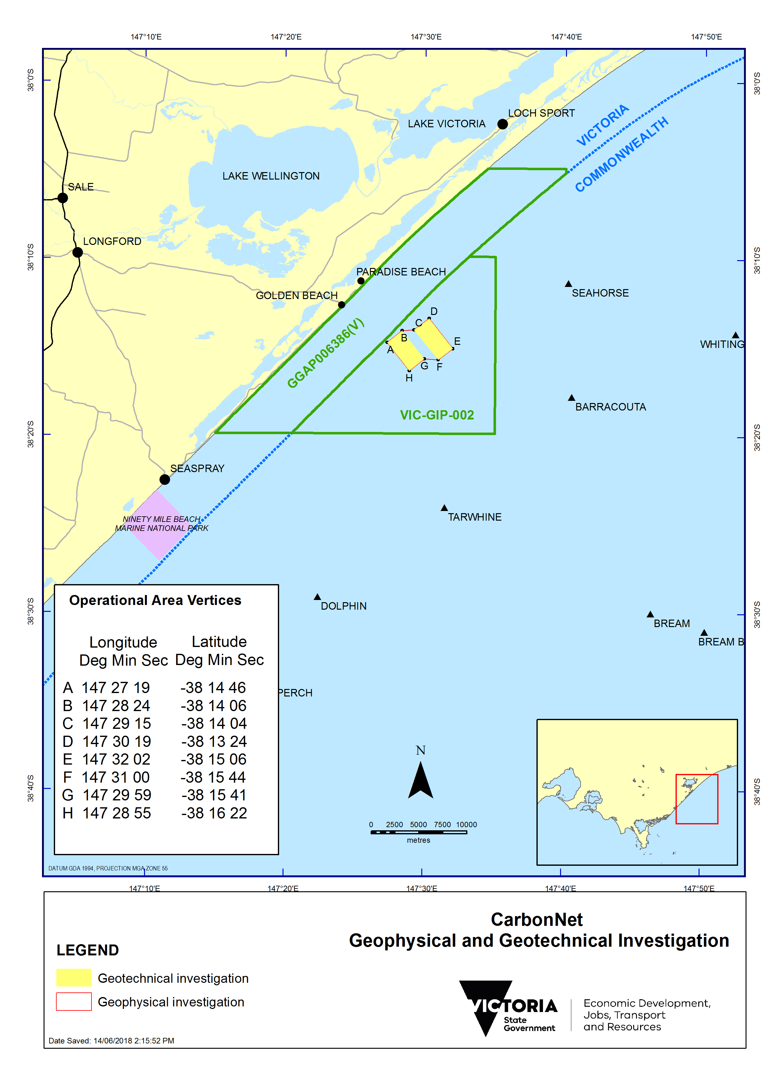
Figure 1: Investigation area for geophysical and geotechnical activities.

